Machine Learning Regression Analysis
CE 475 Term Paper

Prediction of Target Variable Y from Six Independent Features (X1-X6)
May 2026

Methodology

This project addresses a supervised regression problem: predicting a continuous target variable Y from six independent features (X1 through X6). The training dataset comprises 100 labeled samples, while the test set contains 20 unlabeled samples (IDs 101-120) for which Y values must be predicted.
A multi-model comparison strategy was adopted to identify the most accurate regression approach. Eight distinct regression algorithms were evaluated, spanning linear, instance-based, kernel-based, and ensemble methods. This breadth of coverage ensures that the best-performing paradigm is captured regardless of the underlying data structure.

Models Attempted
The following eight regression models were selected for evaluation. The choice was driven by the need to test fundamentally different learning paradigms:
Model | Type | Pros | Cons
Ridge Regression | Linear | Stable with multicollinearity | Cannot capture non-linearity
Lasso Regression | Linear | Feature selection via L1 | May underfit complex data
ElasticNet | Linear | Combines L1+L2 penalties | Requires tuning of two params
K-Nearest Neighbors | Instance | No training phase, flexible | Sensitive to scale and k
SVR (RBF) | Kernel | Handles non-linearity well | Slow on large datasets
Random Forest | Ensemble | Robust, low variance | Can overfit small datasets
Gradient Boosting | Ensemble | Sequential error correction | Prone to overfitting
XGBoost | Ensemble | Regularized boosting, fast | Complex hyperparameter space

Rationale for Model Selection
An initial exploratory data analysis revealed two critical characteristics of the dataset:
- Weak linear correlations: All features exhibit absolute Pearson correlation coefficients below
0.35 with the target Y, suggesting that simple linear models may be insufficient.
- High target skewness: Y has a skewness of 4.08 (range: -152 to 13,578), indicating a heavilyright-skewed distribution with potential outliers.
- Small sample size: With only 100 training samples and 6 features, overfitting is a primaryconcern, favoring regularized and ensemble methods.
Given these observations, the model selection emphasized non-linear and ensemble methods (Random Forest, Gradient Boosting, XGBoost, SVR) while retaining linear baselines (Ridge, Lasso, ElasticNet) for comparison. Polynomial feature engineering (degree 2) was applied to linear models to enable them to capture interaction effects.

Implementation

Development Environment
The entire project was implemented in Python using a virtual environment to ensure reproducibility. The following core libraries were utilized:
Library | Version | Purpose
Python | 3.x | Core language
NumPy | 2.4.4 | Numerical computation
Pandas | 3.0.2 | Data manipulation
scikit-learn | latest | ML models & evaluation
XGBoost | 3.2.0 | Gradient boosting
Matplotlib | 3.10.8 | Visualization
Seaborn | 0.13.2 | Statistical plots
openpyxl | 3.1.5 | Excel I/O

Data Preprocessing Strategy
The preprocessing pipeline consisted of two sequential stages, each carefully designed to address specific data characteristics:
Stage 1 - Standard Scaling: All six features were standardized to zero mean and unit variance using scikit-learn's StandardScaler. This is essential for distance-based models (KNN, SVR) and gradient-based optimizers. The scaler was fitted exclusively on training data and then applied to test data to prevent data leakage.
Stage 2 - Polynomial Feature Engineering: For linear models (Ridge, Lasso, ElasticNet), degree-2 polynomial features were generated, expanding the feature space from 6 to 27 dimensions. This includes all pairwise interactions (e.g., X1*X2) and squared terms (e.g., X1^2), enabling linear models to capture non-linear relationships without changing their fundamental architecture.

Evaluation Strategy
A rigorous 5-fold cross-validation (CV) scheme was employed as the primary evaluation method. The training data (100 samples) was split into 5 folds, with each fold serving as the validation set once. Three metrics were computed for each model:
- Mean Absolute Error (MAE): Average absolute deviation of predictions from actual values.
- Root Mean Squared Error (RMSE): Penalizes larger errors more heavily than MAE.
- R-squared (R2): Proportion of variance explained by the model (1.0 = perfect).
Cross-validation was chosen over a simple train/test split because the dataset is small (100 samples). A single split could yield unstable estimates due to the random partition. CV provides more robust performance estimates by averaging over all possible splits.

Model Training & Prediction Pipeline
The pipeline follows a systematic workflow: (1) load data from Excel via openpyxl, (2) preprocess features, (3) evaluate all 8 models via 5-fold CV, (4) select the model with the lowest mean MAE, (5) retrain the selected model on all 100 training samples, and (6) predict Y values for the 20 test samples. This final retraining step maximizes the information available to the best model before generating predictions.

Exploratory Data Analysis
The correlation heatmap below reveals the pairwise relationships between all features and the target variable. Notably, X1 shows the strongest negative correlation with Y (r = -0.35), while X5 has the strongest positive correlation (r = 0.24). All other features have near-zero correlation with Y.
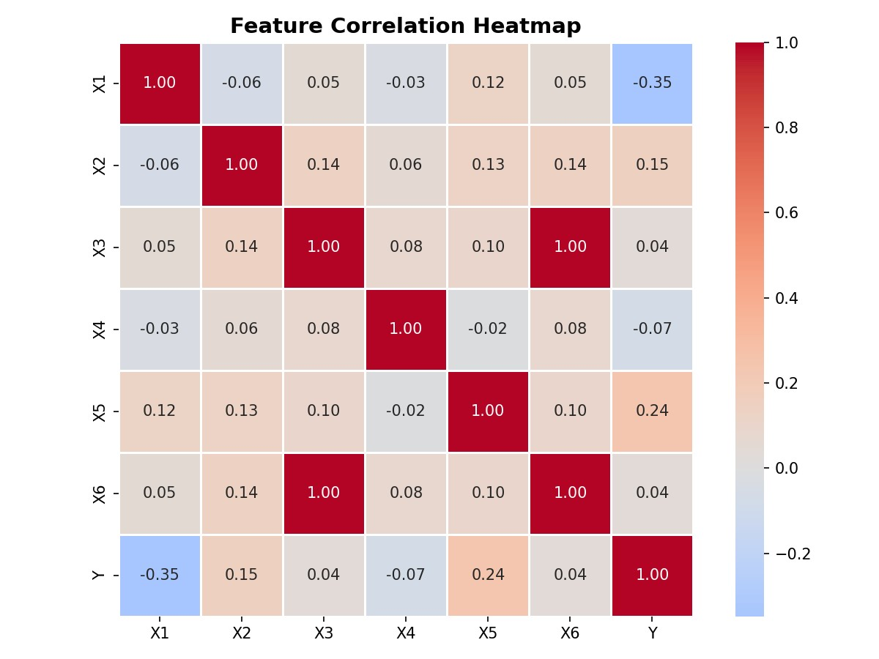
Figure 1: Feature Correlation Heatmap
The target variable distribution confirms the extreme right skew (skewness = 4.08). The majority of Y values cluster below 500, with a long tail extending to 13,578. This distribution challenges models that assume normally distributed residuals.
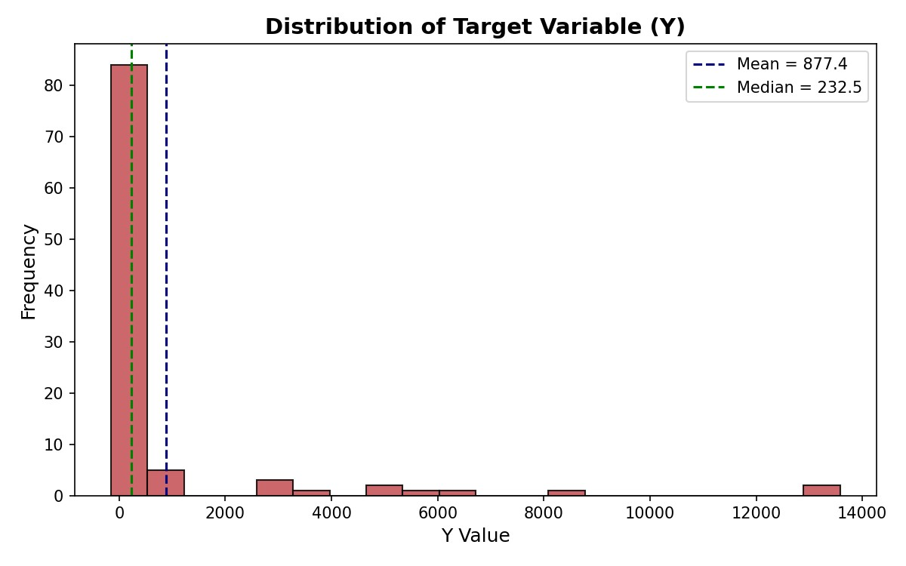
Figure 2: Target Variable (Y) Distribution

Results

Cross-Validation Performance
The 5-fold cross-validation results are summarized in the table below. Models are ranked by their mean MAE (lower is better):
Model | MAE (mean) | MAE (std) | RMSE (mean) | R2 (mean)
SVR (RBF) | 767.30 | 723.73 | 1900.30 | -0.082
XGBoost | 817.15 | 597.61 | 2076.61 | -3.034
Random Forest | 842.63 | 650.46 | 1862.72 | -0.834
Gradient Boosting | 930.68 | 917.47 | 2154.29 | -1.341
K-Nearest Neighbors | 973.92 | 580.59 | 1993.39 | -1.046
ElasticNet | 1064.78 | 498.30 | 1798.72 | -0.607
Ridge Regression | 1411.86 | 653.30 | 2125.01 | -2.507
Lasso Regression | 1436.03 | 672.00 | 2153.47 | -2.656
Key observations from the results:
- SVR (RBF Kernel) achieved the lowest mean MAE (767.30), outperforming all other models. Itskernel-based approach effectively captures the non-linear patterns in the data.
- XGBoost (MAE = 817.15) and Random Forest (MAE = 842.63) followed closely, confirming thatensemble tree methods handle this type of data well.
- Linear models performed worst: Ridge (1411.86) and Lasso (1436.03) had the highest MAEvalues despite polynomial feature engineering, confirming that the underlying relationship is fundamentally non-linear.
- All models produced negative R2 values, indicating that the dataset is inherently difficult tomodel. The extreme skewness and potential outliers in Y make it challenging for any model to explain variance consistently across all folds.
- High standard deviations in MAE across folds (e.g., SVR std = 723.73) suggest significantvariability in prediction difficulty across different data subsets, likely driven by the skewed outliers in Y.

Visual Model Comparison
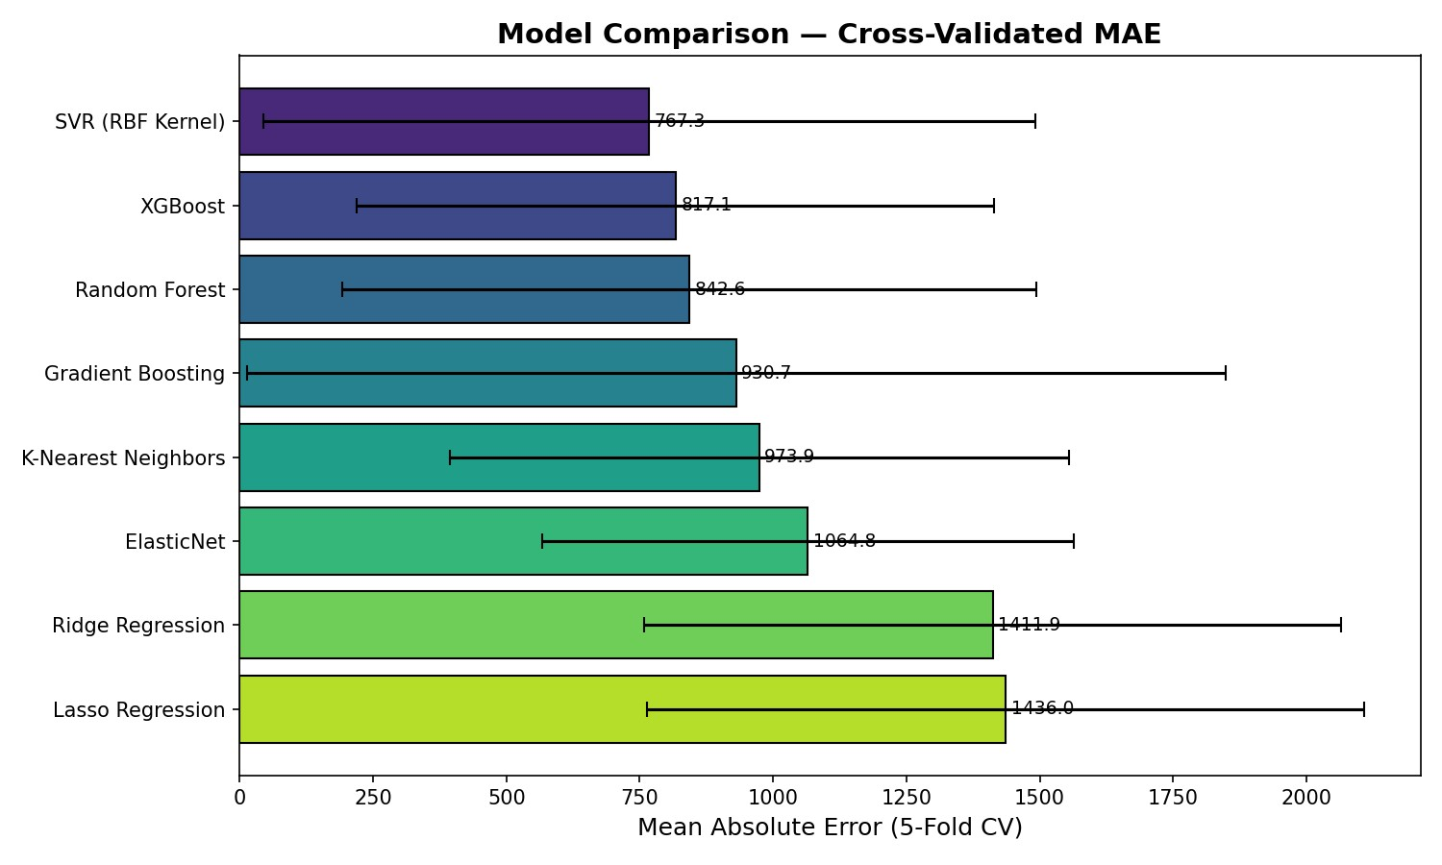
Figure 3: Model Comparison by Cross-Validated MAE

Best Model Diagnostics - SVR (RBF Kernel)
The scatter plot below compares actual vs. predicted Y values for the best model on a holdout set (80/20 split). Points closer to the red dashed line indicate more accurate predictions.
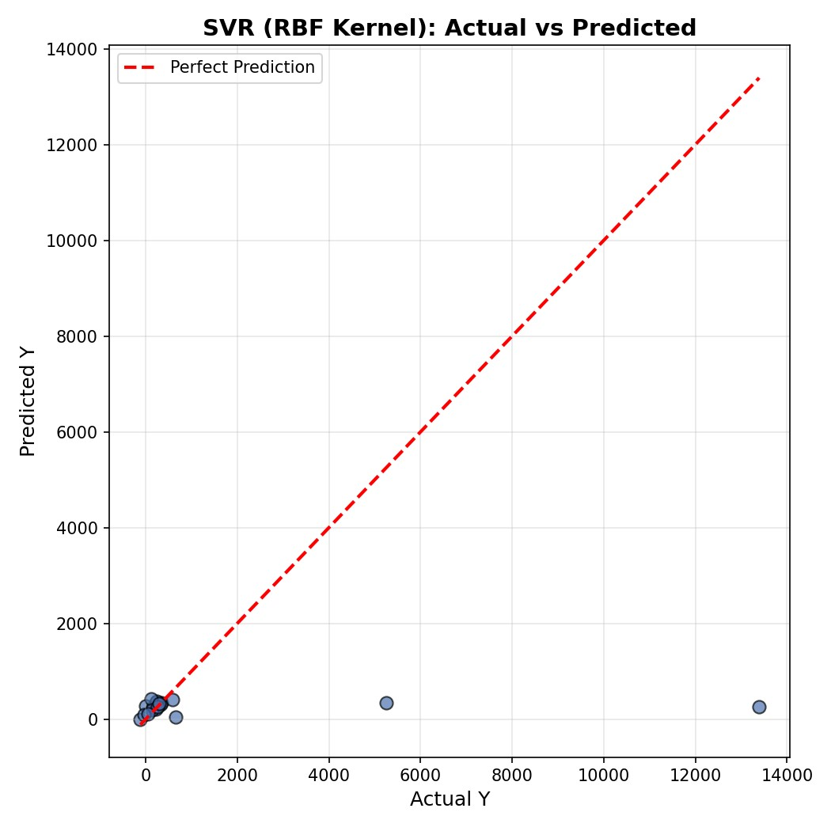
Figure 4: SVR (RBF) - Actual vs Predicted Values
The residual distribution shows the spread of prediction errors. A symmetric distribution centered at zero would indicate unbiased predictions.
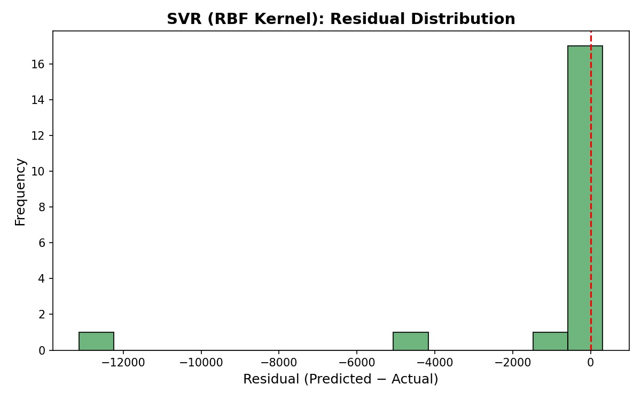
Figure 5: SVR (RBF) - Residual Distribution

Feature Importance Analysis
Feature importance was extracted from the three tree-based models to understand which input variables contribute most to predictions. While SVR does not provide direct feature importances, the tree-based models offer valuable insights.
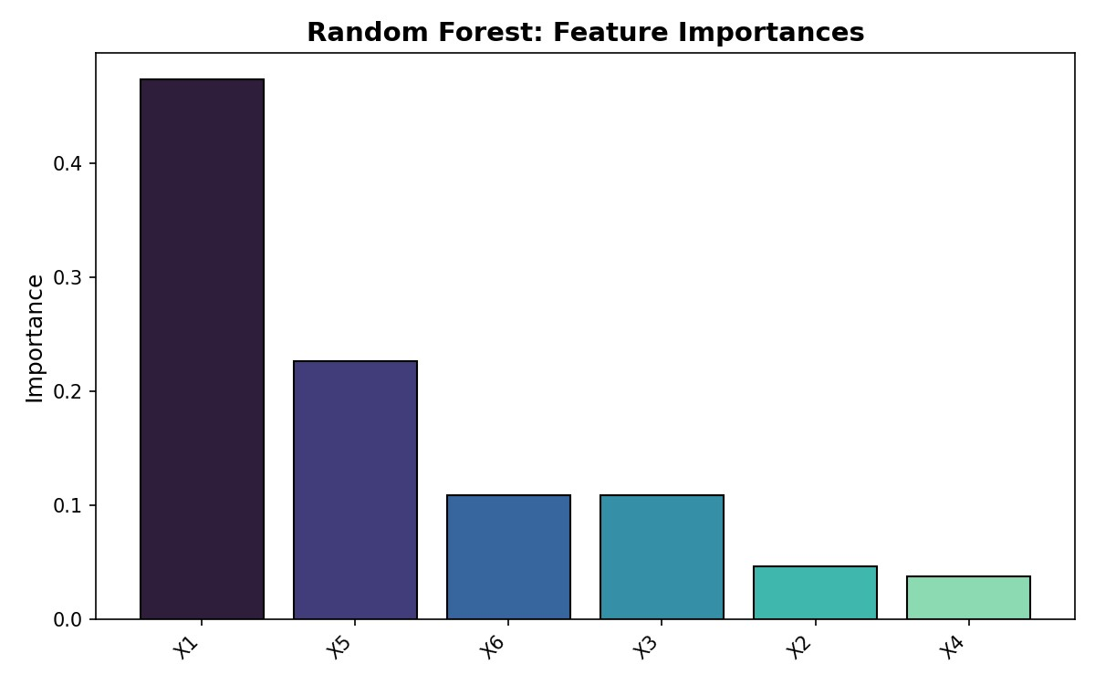
Figure: Random Forest Feature Importances
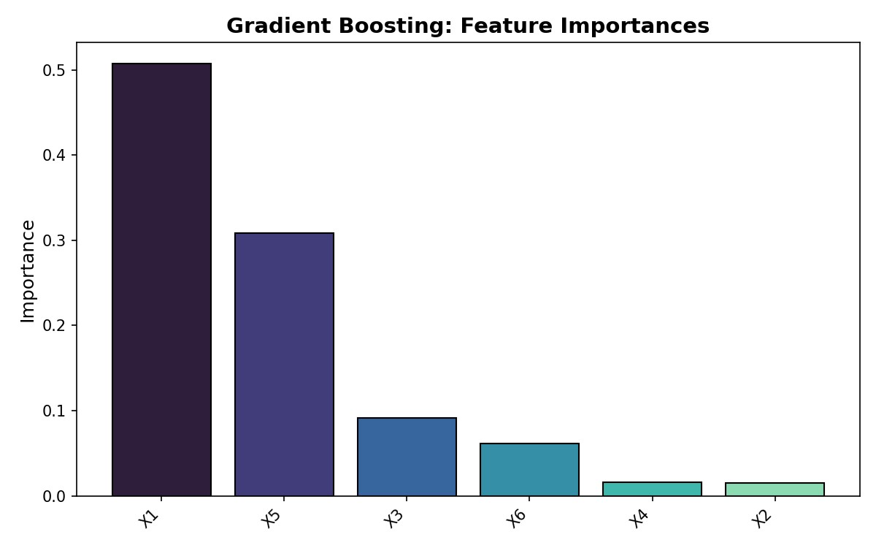
Figure: Gradient Boosting Feature Importances
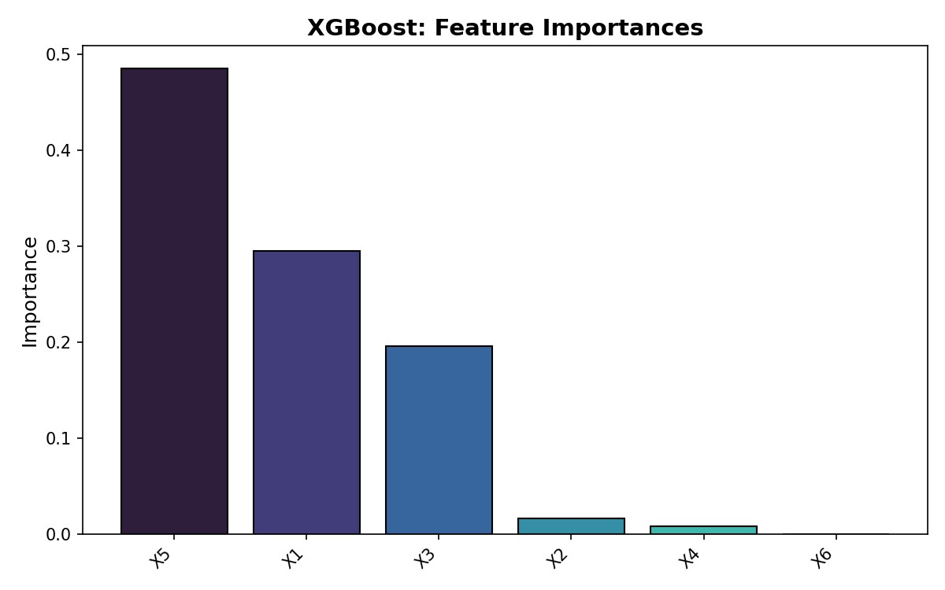
Figure: XGBoost Feature Importances
Across all tree-based models, feature importance rankings provide complementary views of which variables drive predictions. The consistency (or divergence) of these rankings helps validate which features are genuinely important versus model-specific artifacts.

Conclusion

Summary of Findings
This project systematically evaluated eight regression models for predicting a continuous target variable Y from six features (X1-X6). The key findings are:
- SVR with RBF kernel emerged as the best-performing model with a cross-validated MAE of767.30, demonstrating the effectiveness of kernel methods for capturing non-linear patterns in small datasets.
- Non-linear models consistently outperformed linear ones, even when linear models wereaugmented with polynomial features. This confirms that the data contains inherently non-linear relationships.
- The extreme skewness of Y (4.08) and the small sample size (100) posed significant challenges.
All models produced negative R2 values, highlighting the difficulty of this prediction task.

Challenges and Limitations
Several factors limited the achievable prediction accuracy:
- Small dataset: 100 training samples provide limited statistical power for learning complexpatterns, particularly for high-capacity models like XGBoost and neural networks.
- Target distribution: The heavy right skew means that a few extreme Y values disproportionatelyinfluence error metrics. Log-transformation or robust loss functions could potentially improve results.
- Feature informativeness: The weak correlations between features and Y (all |r| < 0.35) suggestthat the provided features may not fully capture the underlying process generating Y. Additional features or domain knowledge could enhance predictions.

Lessons Learned
This project reinforced several important machine learning principles:
- Always apply cross-validation, especially with small datasets. A single train/test split can yieldmisleading results due to sampling variability.
- Data preprocessing matters: StandardScaler is crucial for distance-based models, andpolynomial features can significantly boost linear models. However, the scaler must be fitted only on training data to prevent data leakage.
- Trying multiple model families is essential. No single algorithm dominates across all problemtypes. In this case, SVR outperformed complex ensemble methods, demonstrating that model complexity does not always correlate with accuracy.
- Understanding data characteristics (skewness, correlations, outliers) before model trainingguides better preprocessing and model selection decisions.

Future Work
Potential improvements include: (1) hyperparameter optimization via GridSearchCV or Bayesian optimization, (2) log-transformation of Y to address skewness, (3) feature engineering based on domain knowledge, (4) ensemble stacking of top models, and (5) collecting additional training data if possible.

