**Previous Studies:**

1. Testing RESTful APIs using curl

**1-Abstract:**

Curl is used in command lines or scripts to transfer data. It is also used in cars, television sets, routers, printers, audio equipment, mobile phones, tablets, setup boxes, media players and is the internet transfer backbone for thousands of software applications affecting *billions of humans* daily.

**Who made curl?**

curl is free and open source software and exists thanks to thousands of contributors and sponsors. The curl project follows well established open source best practices.

**2-advantages:**

## Used for download:

## In curl you give it the URL that we want to download, it’s used a lot in mac and Linux environments because they use the command Line a lot.

## Used for testing APIs.

## 3-disadvantages:

## Manual testing:

## Users of curl have to test their APIs every single time to see the response, so if they change the code it gets really messy and time consuming.

* Uses command line:

- Which is not ideal since most users prefer a graphical interactive interface rather than a command line.

4-**comparasion**:

|  |  |  |  |  |
| --- | --- | --- | --- | --- |
| Testing tool | Automated testing to increase productivity | GUI testing | Used for download | Used for testing API |
| Curl | ✘ | ✘ | ✔ | ✔ |
| Our testing tool | ✔ | ✔ | ✘ | ✔ |

**5-Refrences:**

# 1-Curl([Initial release date](https://www.google.com/search?sxsrf=ALeKk03l7-zM5kgLQpAFcuwWUHuQI-uBow:1582370745154&q=slack+initial+release+date&stick=H4sIAAAAAAAAAOPgE-LSz9U3qEopMM4x0FLOKLfST87PyUlNLsnMz9Mvzk8rKU8sSrVKLChITSxSSEksSV3EKlWck5icrZCZl1mSmZijUJSak5pYnAqWBADyFRFvUAAAAA&sa=X&ved=2ahUKEwjOwauxhuXnAhXynFwKHSDEC0gQ6BMoADApegQICxAC&sxsrf=ALeKk03l7-zM5kgLQpAFcuwWUHuQI-uBow:1582370745154): August 2013),

, [Online] Available: <https://curl.haxx.se/> . [Access February.6, 2020].

**License**: Free Software: MIT/X derivate license

**Original author(s)**: Daniel Stenberg

**Written in**: C

**Stable release**: 7.68.0 (8 January 2020; 26 days ago)

1. **Team collaboration using slack**

**Developed by**: Slack Technologies

**Initial release date**: August 2013

**Written in**: Electron (C++, JavaScript, etc.)

**1-Abstract:**

Slack is a collaboration hub that can replace email to help you and your team work together seamlessly. It’s designed to support the way people naturally work together, so you can collaborate with people online as efficiently as you do face-to-face.

In Slack, team members send messages and share files in channels, create channels for teams, projects, office locations, or anything else that’s relevant to your organization. For example, the manager of the project can create a new channel named with the project’s name and add all the stakeholders to communicate together using text messages and videos call and even files.

**2-advantages:**

## Organized conversations

## In Slack, team members send messages and share files in channels. Create channels for teams, projects, office locations, or anything else that’s relevant to the organization. You can also make channels private for conversations that shouldn’t be open to all members, or you can use shared channels to collaborate with an organization outside your own.

## Searchable history

## When messages and files are shared in public channels, information flows transparently throughout Slack. You can search your team's conversation history in Slack to find relevant messages, files, channels, and people. With Slack’s searchable history, conversations can become common institutional knowledge.

## Connected apps

## Add apps to your workspace to connect services or tools you're already using to Slack. With the right apps installed, you can do your work without ever leaving your Slack workspace. Find thousands of apps to help you stay productive, organized, and efficient in the Slack App Directory.

## Slack Calls [video and audio]

## You can start a voice or video call with any other members of your workspace right from Slack. Share your screen to show your teammates exactly what you see on your computer — you can even draw on your screen while you’re screen sharing.

## 3-disadvantages:

* Inner tools to help the team to get work done are not available in slack in this case you need to connect with outer apps and tool.
* The project manager does not have a specific way to manage and monitor the project’s progression, instead he has to read all the chat messages and conclude by himself.

4-**comparasion**:

|  |  |  |  |  |  |  |  |
| --- | --- | --- | --- | --- | --- | --- | --- |
| Tool | chat | calls | Connected apps | Inner tool to increase productivity | Monitoring team work and collect data to help manager make dictions | Channel’s or project | Project area |
| Slack | ✔ | ✔ | ✔ | ✘ | ✘ | ✔ | Generic |
| Our platform | ✔ | ✘ | ✘ | ✔ | ✔ | ✔ | Software Engineering filed |

**5-Refrence:**

# 1-Slack ([Initial release date](https://www.google.com/search?sxsrf=ALeKk03l7-zM5kgLQpAFcuwWUHuQI-uBow:1582370745154&q=slack+initial+release+date&stick=H4sIAAAAAAAAAOPgE-LSz9U3qEopMM4x0FLOKLfST87PyUlNLsnMz9Mvzk8rKU8sSrVKLChITSxSSEksSV3EKlWck5icrZCZl1mSmZijUJSak5pYnAqWBADyFRFvUAAAAA&sa=X&ved=2ahUKEwjOwauxhuXnAhXynFwKHSDEC0gQ6BMoADApegQICxAC&sxsrf=ALeKk03l7-zM5kgLQpAFcuwWUHuQI-uBow:1582370745154): August 2013),

,[Online] Available :<https://slack.com/intl/en-sd/features> . [Access February.8, 2020].

1. AUTOMATED TESTING IN DEVELOPMENT PHASE

**1-Abstract:**

In software development, the applications are tested in the testing phase of software development process. So, testing of application is not possible without complete development of module/application. It takes additional time in the complete software development. so, this paper proposed the model for a tool that provides the way to developers to test his code/application in the development phase itself. The model also helps in java API (application programmable interface) testing. With this tool, the developer can able to test his code/module automatically considering all the aspects of testing. In this approach, predefined test cases are loaded for testing, and thousands of test cases are run at the same time and application is tested by the developer. so, it helps in regression testing. Hence it helps in reducing the software development period. Ultimately it saves the people resources, hardware and software resources.

**2-inroduction:**

The software development process consists of different phase’s i.e. Requirement, analysis, planning, design, implementation, testing, deployment & maintenance. so, the software organization has main focus on implementation and testing to satisfy the actual working of software. In current trend the development and testing are completely different phases. so, in software development process we have to switch next phase after completing previous phase. This scenario is strictly applicable to implementation and testing phase. The proposed model is demonstrating the strategy in which both phases i.e. implementation and testing are to be carried out at same phase considering testing as automated testing. The tool based on the proposed model will help to implement same strategy. so, the testing of software can be carried out at same phase i.e. development phase. This will reduce the 80% of testing efforts. By which all testing aspects will take into consideration. And tool based on the same strategy will help in the regression testing.

**3-** **API (Application Programmable Interface) Testing**

The basic process of testing an API is to create the test harness which calls functions in API with interesting data [3]

Automation in API testing helps in running and accessing many test cases. Several aspect of API testing can be automated:  
⎫ Defining test cases.  
⎫ Data selection.  
⎫ Execution of large test cases.  
⎫ Result checking.[2]

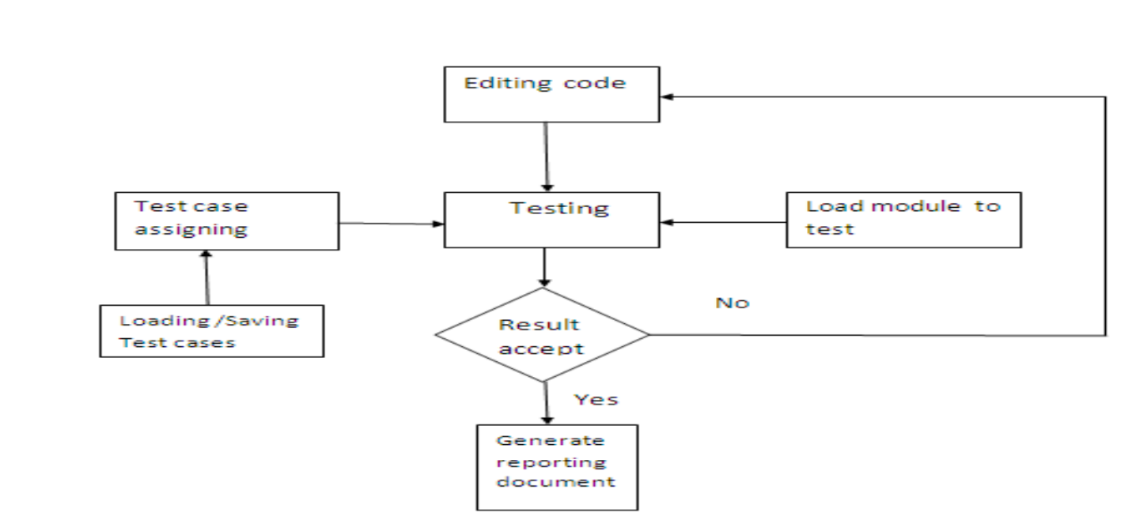  
Fig. 1: Automated testing in development.

**4-Advantages**• Task Reduced: This module helps to reduce the task of testing the software as majority of testing is done at the time of the development.  
• Faster: Automated Testing run tests significantly faster than human beings.  
• Comprehensive: This module can build a suite of tests that covers every feature those are required in application.

**5-Comparison**:

|  |  |  |  |  |  |
| --- | --- | --- | --- | --- | --- |
| **Tool** | **Define Test cases** | **Data Selection** | **Execution** | **Result checking** | **Testing level** |
| **Our tool** | **✔** | **✔** | **One case per time or automate all test cases** | **✔** | Black Box testing  [Restful API] |
| **This tool** | ✔ | ✔ | Execution of large test cases. | **✔** | White Box testing [  Source code] |

**6-Refrences:**

A-about this paper:

* Sunil L. Bangare et al. / International Journal of Engineering Science and Technology (IJEST)
* SUNIL L. BANGARE1, SACHIN M. KAMBLE2, PALLAVI S. BANGARE3,  
  ABHIJIT V. NAIK4  
  **1, 2, 3, 4** Department of Information Technology, STES’s Sinhgad Academy of Engineering,  
  Pune-48, Maharashtra, India.  
  [sunil.bangare@gmail.com](mailto:sunil.bangare@gmail.com)

B-references used by this paper:

[1] R. S. Pressman, “Software Engineering”, ISBN 0073655783.  
[2] Kirk Sayre and Jesse Poore, “Automated Testing of Generic Computational Science Libraries”, Proceedings of the 40th  
[3] Hawaii International Conference on System Sciences-2007.  
[4] A Jorgensen and Whittaker. An application program interface (API) testing methods STARTEast conference May 2000.  
[5] Ed Triou, Zafar Abbas, and Sravani Kothapalle, “Declarative Testing: A Paradigm for Testing Software Applications”, 2009 Sixth  
International Conference on Information Technology.  
[6] S. L. Bangare, A. R. Khare, P. S. Bangare, “Measuring the quality of Object oriented software Modularization: Defining metrics and  
algorithm”, International Journal on Computer Science and Engineering (IJCSE), ISSN: 0975-3397 Vol. 3 No.  
[7] S. L. Bangare, A. R. Khare, P. S. Bangare, “Code parser for object Oriented software Modularization”, International Journal of  
Engineering Science and Technology, ISSN: 0975-5462, Vol. 2 (12), 2010, 7262-7265.  
[8] S. L. Bangare, A. R. Khare, P. S. Bangare, “Quality measurement of modularized object oriented software using metrics”, ACMInternational Conference ICWET-2011 at Mumbai, ACM 978-1-4503-0449-8/11/02, ISBN: 978-1-4503-0449-8.  
[9] <http://msdn.microsoft.com/en-us/magazine/cc163892.aspx>

1. **Generating documentations from tests:**
2. **Background:**

Software documentation provides users and developers that interact with software code with information about how the code is designed to work. Documentation for an

an application programming interface (API) may inform developers about the parameters a method expects to receive, and the types of output provided by the method. In addition, documentation provides information about error conditions, exceptions that can be thrown by a method, and expected environment conditions for invoking the method. Environment conditions may include global variables that have been initialized, other methods that a developer is expected to call first, setup steps that are expected to be performed so that the method can execute successfully, and any other conditions that affect the outcome of invoking an API.

0002. Several attempts have been made to improve software documentation, including automated methods for generating documentation. Most of these methods focus on generating documentation either from a product specification of the (e.g., from Unified Modeling Language (UML) descriptions software), or from the software code itself. Some programming languages and development tools allow developers to include marked up comments within the Software code that other tools can extract to create documentation automatically. Such tools typically use static analysis of the Software code to form a model of what the software code is doing that can be described through documentation.

1. **abstract:**

A documentation system is described herein that automatically generates documentation for software code from tests that verify the correct operation of the software code. Software development teams often write automated tests (software that tests the software being shipped), such as unit tests.

When written correctly, these tests are a written contract of

what the Software is Supposed to do. The documentation

system can use static and dynamic analysis in combination with annotations in the test code to extract the contract from these tests and leverage the extracted information to automatically generate the documentation. The system can then display this information in a textual graphical way. Thus, the documentation system generates documentation that more accurately reflects how software code is expected to

operate, without introducing significant burdens into the Software development cycle

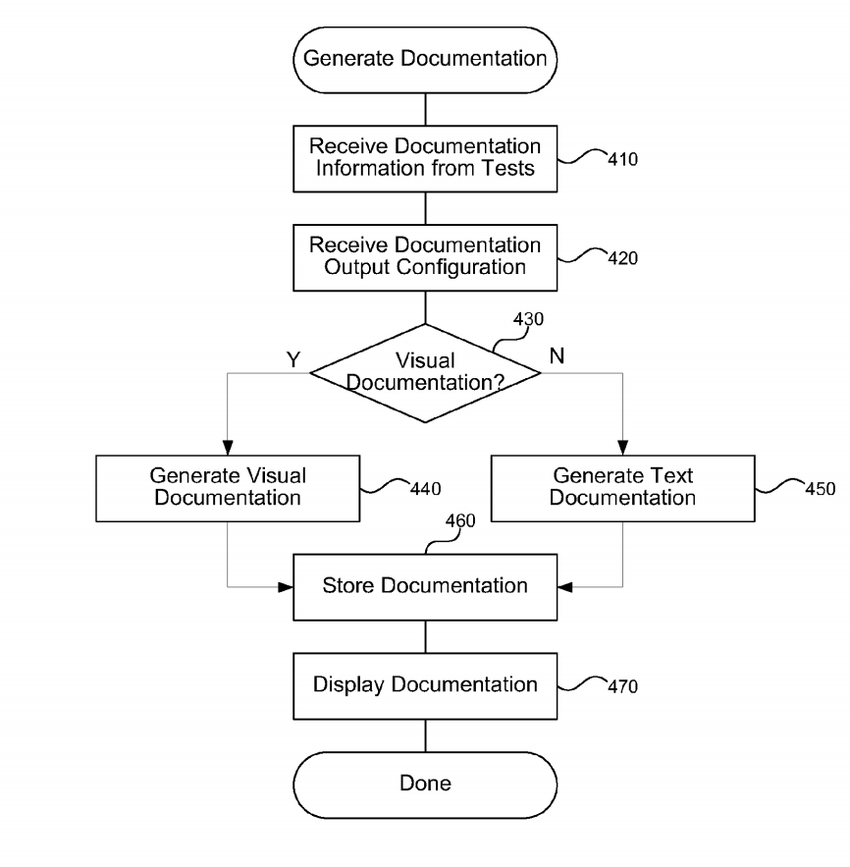

1. **advantages:**

* automatically generate docs
* make use of passed tests cases as inputs to doc engine
* no need to write doc manually

1. **disadvantages:**

* Often the product is developed in multiple versions. Each version has related documentations in this tool there is no version management and control.
* This tool has the task of receiving an entry as data and producing a document as output without of care of continuous delivery of documents.

1. **Comparison:**

|  |  |  |  |  |  |
| --- | --- | --- | --- | --- | --- |
| **Tool** | **Auto generation** | **Passed test cases as input** | **Version control** | **Continues delivery and integration** | **API(Application Program interface ) types** |
| **Our tool** | **✔** | **✔** | **✔** | **✔** | Restful API  based on response |
| **This tool** | ✔ | ✔ | ❌ | ❌ | Code API  based on source code |

1. **References:**

United States

Patent Application Publication

**Pub. No**.: US 2012/0102458 A1

**Pub. Date**: Apr. 26, 2012

**Inventors**: Meijer et al

**Assignee**: Microsoft Corporation, Redmond, WA (US)

**Appl. No**.: 12/909,851

**Filed**: Oct. 22, 2010.