Advanced DevOps Challenge — Submission Notes
This is my write-up for the Advanced challenge. The repo’s README.md and docs/ folder have the full technical reference (architecture diagrams, decision log, cost analysis, runbooks) — this is more of a walkthrough of what I actually built, the calls I made along the way, and what actually went wrong while getting it working.

What I built
Three services — an API, a background worker, and Postgres — deployed across three properly isolated Kubernetes namespaces (development, staging, production), each with its own resource quotas, network policies, and RBAC. On top of that: a full Prometheus/Grafana/Loki monitoring stack, External Secrets Operator for credential management, a CI/CD pipeline that actually deploys through all three environments with a manual approval gate in front of production, and disaster recovery scripts I tested for real rather than just describing.
Everything runs on a local kind cluster rather than real AWS EKS. The task explicitly allows this, and it meant I could actually iterate and test everything within the time limit instead of burning hours waiting on EKS control planes to come up, and it meant zero AWS billing risk for a task where no production traffic ever needed to touch it. Every piece — Terraform, the Kubernetes manifests, the CI/CD pipeline — is written so the path to real EKS is a small, specific set of changes, and I documented exactly what those changes would be rather than pretending kind and EKS are the same thing.

The three environments, briefly
Development gets 1 replica of everything and default settings. Staging gets 2 API replicas. Production gets 3-10 API replicas and 2-6 worker replicas under a HorizontalPodAutoscaler, a restricted Pod Security Standard instead of baseline, and its own resource quota ceiling. The full comparison table is in README.md — the point I want to make here is that these aren’t arbitrary numbers, they come from the actual Terraform ResourceQuota definitions and Kustomize overlay patches, and I checked real cluster resource usage (kubectl top nodes) throughout to make sure they were realistic rather than guessed.

Monitoring
Prometheus, Grafana, and Loki, with 5 custom dashboards and 12 alert rules (CPU/memory pressure, pod crashes, deployment failures, HPA maxed out, Postgres down, worker stalled, resource quota exhaustion, and a few more). I picked Loki over a full ELK stack specifically because this runs on an 8GB laptop — Elasticsearch alone wants more memory than that leaves for everything else combined, and Loki gives the same “centralized logs searchable from Grafana” outcome without the footprint. That’s a documented tradeoff, not an oversight.
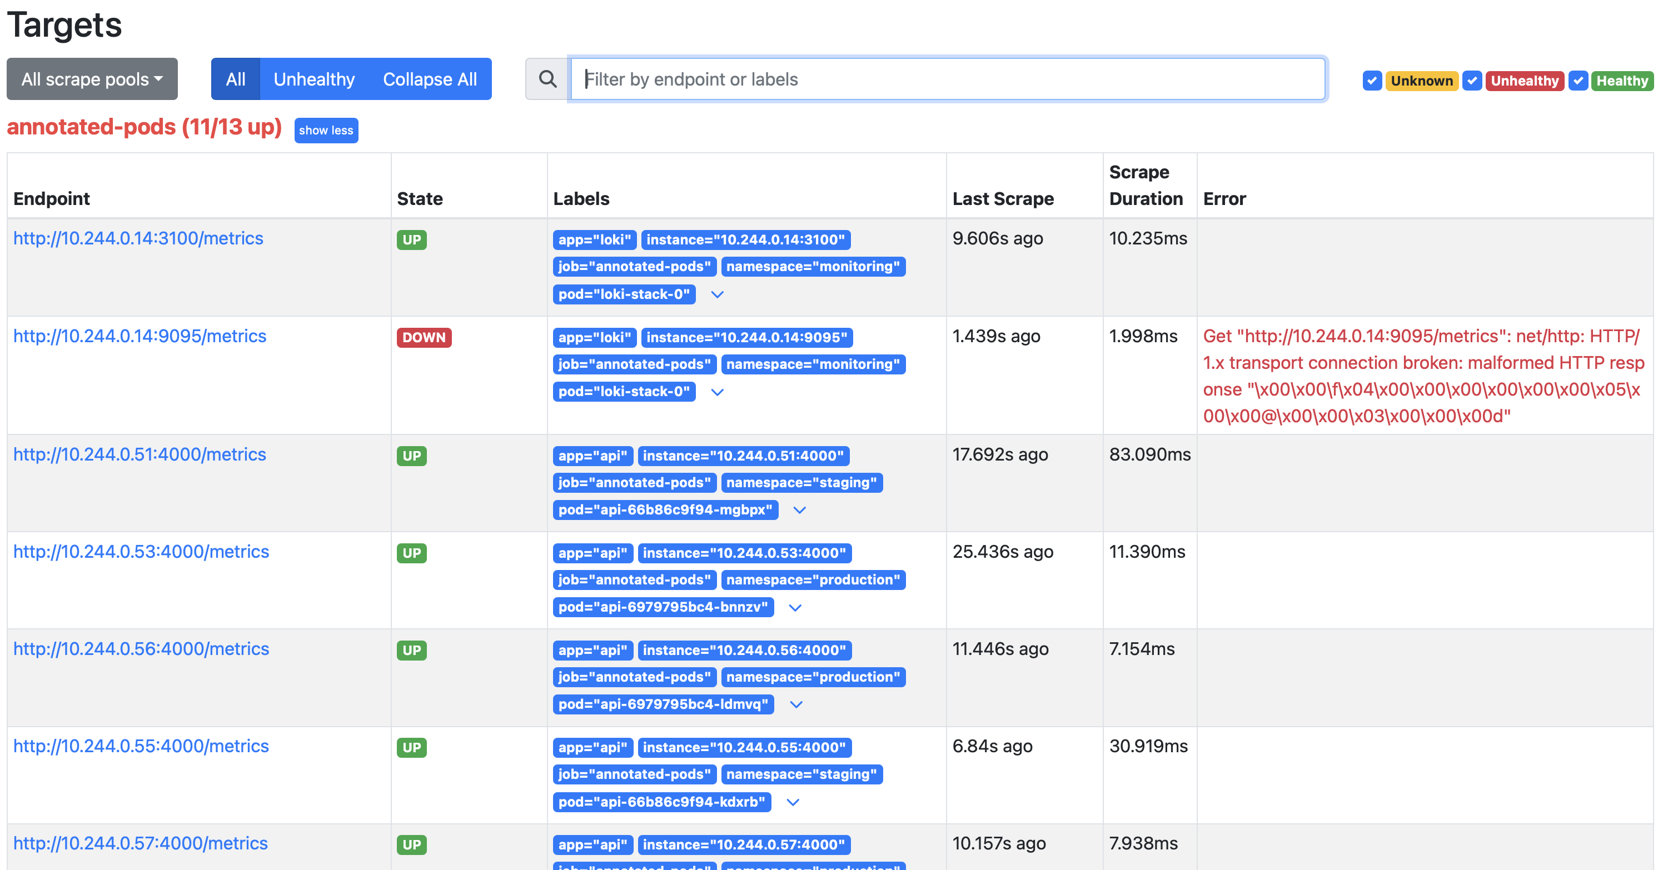
Prometheus targets showing real scrape jobs across all three namespaces
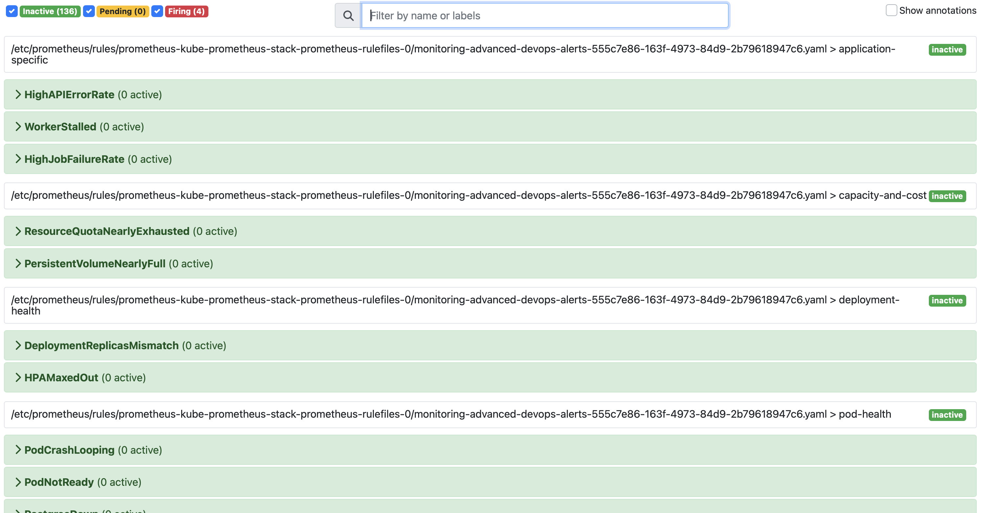
All 12 custom alert rules loaded and evaluating cleanly
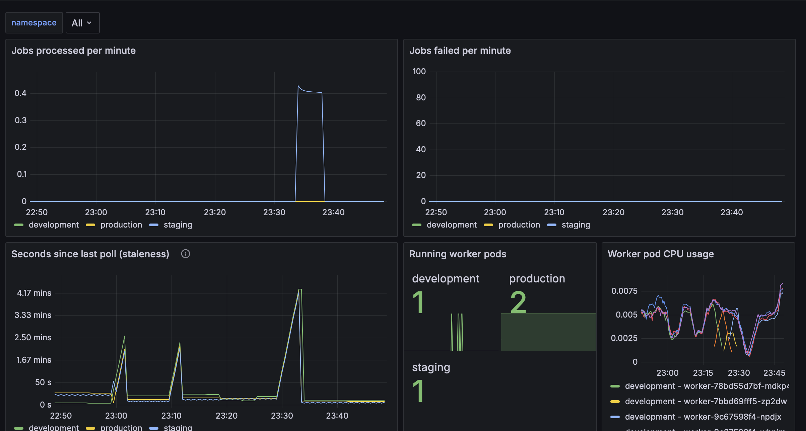
One of the 5 custom Grafana dashboards, showing real per-namespace worker data

Secrets, and a rotation I actually had to fix
I stood up External Secrets Operator with a separate namespace standing in for what would be AWS Secrets Manager in production — real ExternalSecret objects syncing on a 1-minute refresh interval, not just a design doc.
The part worth calling out: I set this up after Postgres was already running with a different, statically-set password. Rotating the secret didn’t actually fix authentication — Postgres only applies POSTGRES_PASSWORD at first database initialization, so the live database kept expecting the old password no matter what the newly-synced Secret said. I had to run an explicit ALTER USER against each environment’s running Postgres to bring it in line, then restart the pods that read the secret as environment variables (which also don’t live-reload). I wrote the exact sequence into docs/runbooks/secret-management.md because it’s exactly the kind of thing that looks fine in a demo and then quietly breaks the first time someone rotates a credential for real.

CI/CD — and where it actually broke
The pipeline runs on a self-hosted GitHub Actions runner registered on the same machine as the kind cluster, because a GitHub-hosted runner has no network path to a cluster that only exists inside this machine’s Docker daemon. That part worked on the first try. Getting the actual build job green took three more attempts, and I think the failures are worth being honest about since they’re genuinely instructive:
- aquasecurity/trivy-action@0.28.0 — I’d written the version without the v prefix the project’s git tags actually use. Simple typo, immediate failure at job setup.
- aquasecurity/trivy-action@v0.29.0 — fixed the prefix, but that specific release pins an internal dependency (aquasecurity/setup-trivy@v0.2.2) that no longer exists upstream — the tag had been deleted or renamed since that release was cut. Not something I could have caught by reading my own YAML more carefully; I had to check the newer release’s action.yaml and confirm it pins its internal dependency by commit SHA instead of a floating tag before trusting it wouldn’t rot the same way.
- The real one: docker build -t ghcr.io/${{ github.repository }}/... failed outright once it got past the action-resolution problems, because github.repository preserves this repo’s actual name (Dedeepya-10/Devops-task), and Docker/GHCR image references have to be all lowercase. GitHub Actions’ expression language has no built-in lowercase function, so I added a step that computes it once via tr and stores it in $GITHUB_ENV, and made scripts/deploy.sh do the same lowercasing independently so it behaves identically whether it’s invoked by CI or run by hand.
After that fix, the full pipeline ran clean end to end: lint/test both services, build, Trivy scan, push to GHCR, deploy to development, deploy to staging, pause for my manual approval on production, then deploy to production. I checked afterward that the production pods were actually running the image tagged with that exact commit SHA — not just that the job said “success.”
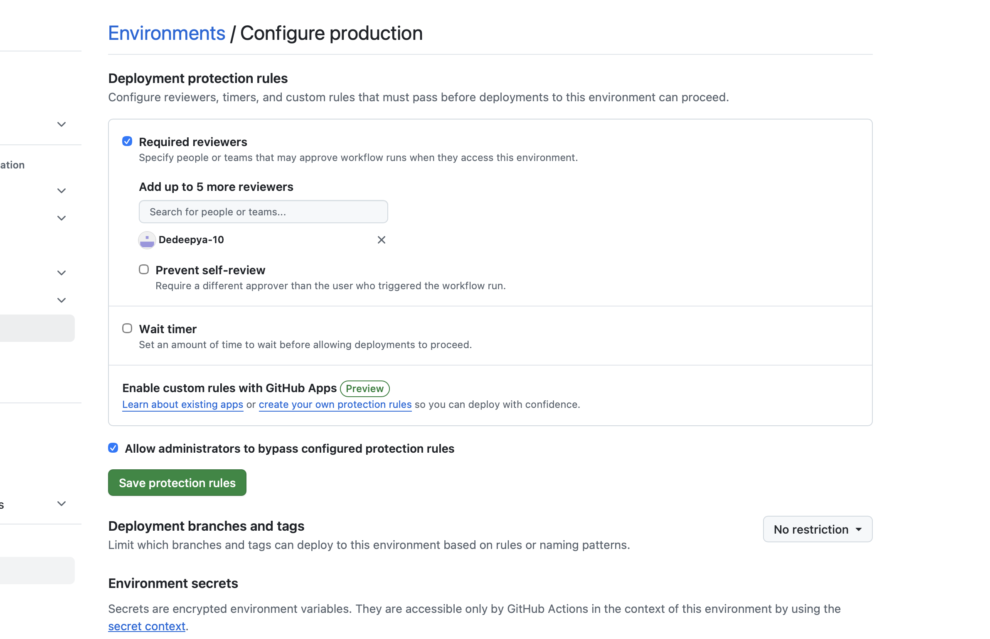
Production environment protection rule requiring manual approval

Disaster recovery — actually tested, not just described
I didn’t want to just write a runbook that claims backup/restore works — I ran it. Created two real items through the API in the staging environment, backed up the database, deliberately truncated the tables to simulate real data loss, confirmed the data was actually gone, restored from the backup, and confirmed the exact same rows came back (same IDs, same timestamps). That whole cycle took under two minutes. The full transcript is in docs/runbooks/disaster-recovery.md, including the RTO/RPO targets and the honest limitation that a single-node local cluster can’t test real multi-AZ cluster failover — that part is a documented design for real EKS + RDS Multi-AZ, not something I could actually exercise here.

Cost analysis
Actual cost right now is $0, since this runs locally. docs/cost-analysis.md has a full projected AWS cost breakdown (~$313/month) if this exact architecture were deployed to real EKS, split by environment, plus five concrete cost optimization strategies — the biggest one being that this uses one shared cluster with three namespaces instead of three separate clusters, which alone avoids roughly $146/month in duplicate EKS control plane costs.

What I’d add given more time
- Real Alertmanager routing to Slack/PagerDuty instead of just the Prometheus/Alertmanager UI
- postgres_exporter for actual query-level database metrics
- Scheduled backups instead of manually-triggered ones
- The two-Deployment blue-green pattern (separate blue/green Deployments with a Service selector flip) instead of the rolling-update-based cutover I used, if true zero-rollout-time rollback or gradual traffic splitting becomes an actual requirement

