Round 2 Task Submission — Notes
This is my write-up for the Round 2 task (CI/CD Pipeline & Automation). Same as last time, the README.md has the full technical reference — this is the walkthrough of what I actually did and why, plus the screenshots.

What this round adds
Round 1 was all manual: I built the image myself, pushed it to ECR myself, ran Terraform myself. The point of Round 2 was to take all of that and put it behind a GitHub Actions workflow, so a normal git push to main is the only thing anyone has to do — the pipeline handles testing, building, pushing, and redeploying to EC2 on its own.

Testing strategy
The task asked for at least one of unit tests, linting, or security scanning. I added two — ESLint and a couple of Jest/Supertest tests — since neither takes much effort on an app this small, and they catch different kinds of mistakes. ESLint catches syntax and style problems before the app even runs. The Jest tests actually hit the two routes (/ and /health) through Supertest and check the response shape, which matters because the Docker HEALTHCHECK and the deploy job’s own health check both depend on /health actually returning what it’s supposed to.
To make the app testable without spinning up a real server, I split server.js into two files — app.js exports the Express app itself, and server.js just imports it and calls .listen(). Supertest can then hit the app directly in-process without binding a port.
Both run as a required step before anything gets built:
npm run lint
npm test
If either one fails, the workflow stops there — it never reaches the build or deploy jobs, so a broken commit can’t end up running in production.

The pipeline itself
Three jobs, each depending on the last one succeeding:
- Lint & test — runs on every push and every pull request.
- Build & push to ECR — only runs on an actual push to main (not on PRs). Builds the image with docker buildx build --platform linux/amd64 and pushes it to ECR under two tags: latest and the commit SHA. Tagging with the SHA means I can always tell exactly which commit is running on the server, instead of latest just silently pointing at whatever was pushed most recently.
- Deploy to EC2 — SSHes into the instance, pulls the SHA-tagged image, removes the old container, starts the new one, and checks /health before finishing.
Here’s a run where all three passed:
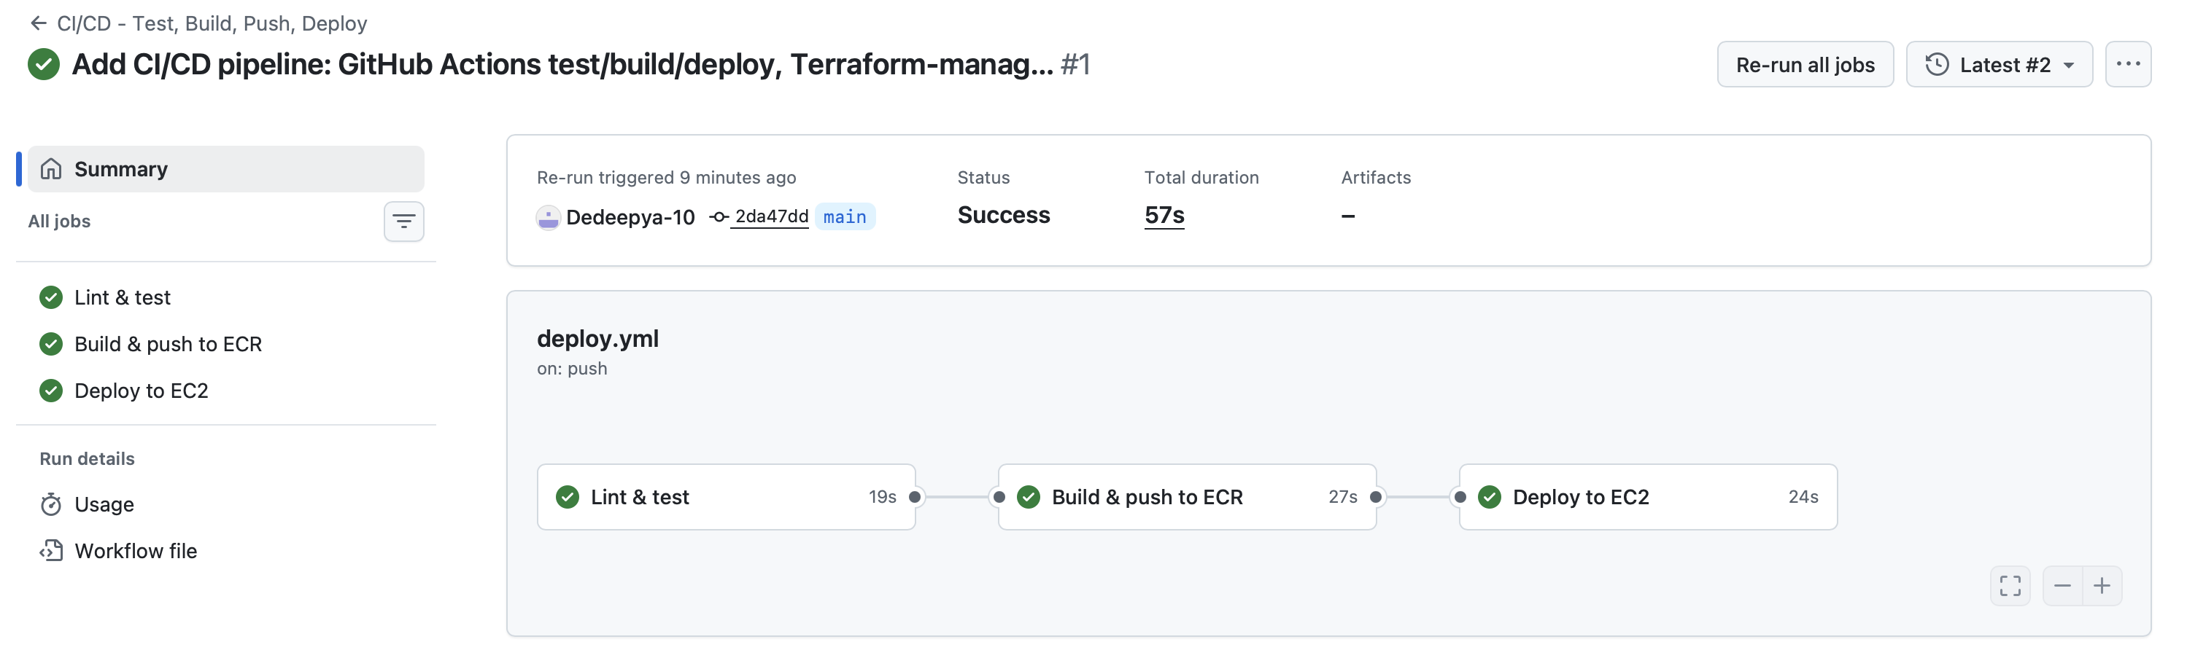
Workflow run showing all three jobs green

Monitoring / how I checked it actually worked
A few different signals, not just “the workflow went green”:
- docker inspect’s health status on the instance reports healthy
- The container’s own logs show a clean startup (App listening on port 3000, no crash loop)
- The container ID changes after each deploy, which is a simple way to confirm the box is actually running a freshly-deployed container and not something left over from before
- Hitting /health from outside the box, after deployment, to confirm it’s reachable over the network and not just responding to localhost on the instance itself
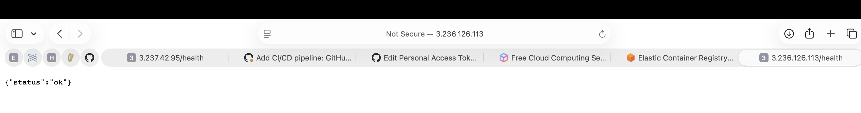
Health endpoint responding after the automated deploy
And the image in ECR with the new commit-SHA tag next to latest:
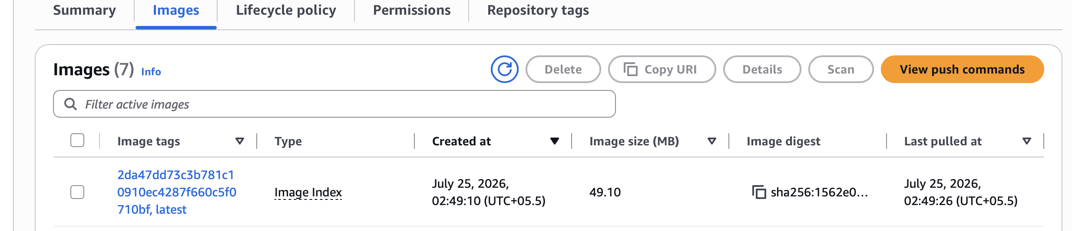
ECR showing the image tagged with the commit SHA and latest

The SSH access problem, and how I solved it
This was the part I spent the most time thinking about. GitHub-hosted runners don’t come from a small, predictable IP range — there’s no single CIDR block I could add to the security group once and be done with it. The easy way out would’ve been to just open port 22 to the whole internet, but that felt wrong to hand in as “the answer.”
What I did instead: the deploy job looks up its own public IP right at the start of the run, adds a security-group rule scoped to just that one IP for just port 22, does the SSH deploy, and then removes that rule again in a cleanup step. That cleanup step is marked if: always(), so it still runs and closes the door even if the deploy itself fails partway through — the instance isn’t left with an open port because something crashed mid-run.

Terraform changes
The task specifically asked for Terraform to manage the SSH key pair instead of one created by hand. In Round 1 I’d created the key pair directly with aws ec2 create-key-pair on the CLI. For Round 2 I replaced that with a tls_private_key resource feeding into an aws_key_pair, and exposed the private key as a (sensitive) Terraform output. That output is what gets copied into the EC2_SSH_KEY GitHub Secret.
This turned out to matter more than I expected — with the manual approach, if the instance ever got recreated, there was no built-in way to know whether the .pem file sitting on my laptop still matched the key the new instance actually trusted. With Terraform generating it, the secret and the instance can’t silently drift apart, since they both come from the same terraform apply.

Challenges I ran into
The security group one above was the main design challenge. A couple of smaller ones came up while actually getting this working:
- The first access token I used to push didn’t have the workflow scope, and GitHub specifically blocks pushes that touch .github/workflows/* without it — a plain repo scope isn’t enough for that one path. Had to regenerate the token with workflow added.
- The AWS access key used for AWS_ACCESS_KEY_ID / AWS_SECRET_ACCESS_KEY needed to come from an account with MFA enabled, which meant there was a bit of a wait between having everything else ready and actually getting a full green run — the build-and-push and deploy jobs both failed with “Credentials could not be loaded” until those two secrets existed. Not a bug, just a sequencing thing.
- Reused the Round 1 lesson about arm64 vs amd64 here too — the build step in the workflow always passes --platform linux/amd64 explicitly, same reason as before: the EC2 instance is a standard x86_64 box, and Docker images aren’t portable across CPU architectures by default.

What I’d improve given more time
- Right now a failed deploy doesn’t automatically roll back to the previous image — you’d have to notice and redeploy the last-known-good SHA by hand. A rollback step (or blue/green deployment, which the task called out as optional) would be the natural next thing to add.
- Logs currently live on the instance itself and in the GitHub Actions run history. Shipping them to CloudWatch would make them easier to search after the fact instead of having to SSH in.

