Round 1 Task Submission — Notes
This is my write-up for the Junior DevOps Engineer Round 1 task. The README.md in this repo has the full technical reference (commands, variables, outputs), so I’m not repeating all of that here — this is more of a walkthrough of what I actually did, in the order I did it, plus the screenshots.

The app
I kept it deliberately simple, like the task suggested. It’s a small Express server with two routes — / returns a JSON message with a timestamp, and /health is just there for the Docker healthcheck. Nothing fancy, since the point of this task is the container/infra side, not the app itself.

Docker
For the Dockerfile I went with a two-stage build. First stage installs dependencies with npm ci (using a committed package-lock.json, so the install is reproducible instead of possibly grabbing newer patch versions of Express or its dependencies). Second stage just copies over node_modules and the app code into a clean node:20-alpine image and runs it as the built-in node user instead of root. Added a HEALTHCHECK that hits /health too.
Built and ran it locally first before touching AWS at all:
docker build -t devops-task-app:local .
docker run -d -p 3000:3000 devops-task-app:local
curl http://localhost:3000/
curl http://localhost:3000/health
Both came back fine, and docker inspect showed the container as healthy.

Pushing to ECR
Wrote a small script (scripts/build-and-push.sh) that creates the ECR repo if it’s not there yet, logs in, builds, and pushes — so it’s a one-liner instead of four separate commands every time.
./scripts/build-and-push.sh us-east-1 devops-task-app latest
Here’s the repo with the image actually sitting in ECR:
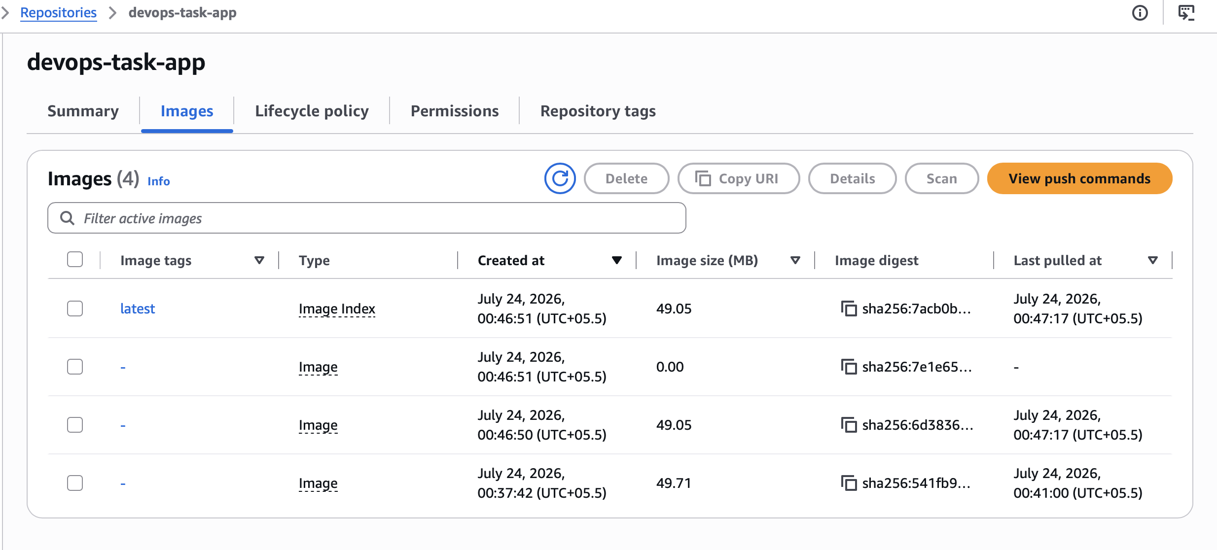
ECR repository showing the pushed image

Terraform / EC2
The Terraform config sets up a security group (SSH + HTTP + HTTPS), an IAM role so the EC2 instance can pull from ECR without me having to bake any credentials into it, and the EC2 instance itself, which uses a user_data script to install Docker and start the container automatically on boot.
Ran it against my real AWS account:
terraform init
terraform plan -var="ecr_repository_url=...devops-task-app" -var="key_name=devops-task-key" -var="allowed_ssh_cidr=<my-ip>/32"
terraform apply -var="ecr_repository_url=...devops-task-app" -var="key_name=devops-task-key" -var="allowed_ssh_cidr=<my-ip>/32"
and it actually came up:
Apply complete! Resources: 5 added, 0 changed, 0 destroyed.
Outputs:
app_url = "http://3.237.42.95:80"
instance_id = "i-076e236d1553839d0"
instance_public_dns = "ec2-3-237-42-95.compute-1.amazonaws.com"
instance_public_ip = "3.237.42.95"
security_group_id = "sg-0b9733cc1be3a1fe5"
And the app responding for real, not just locally:
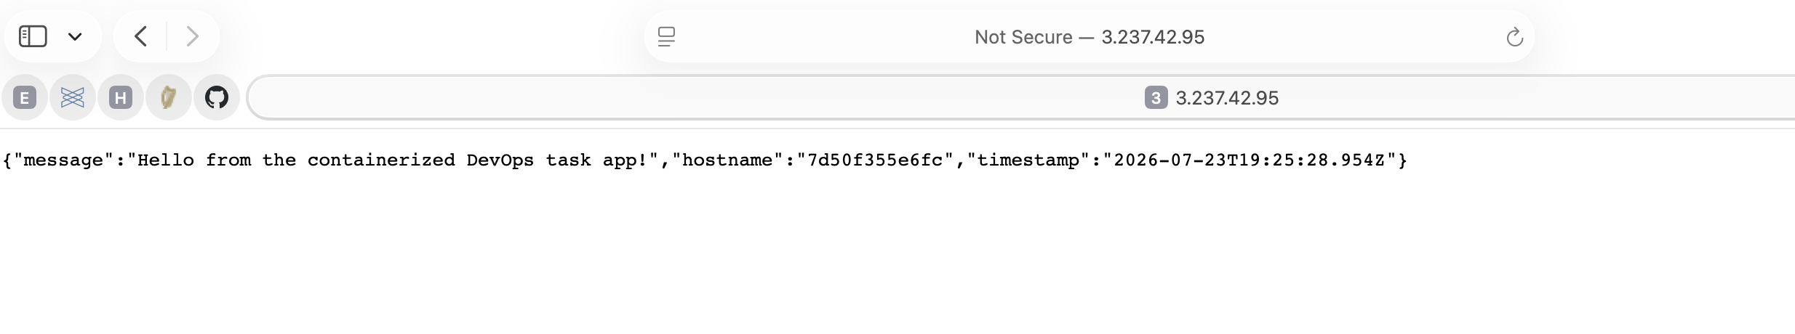
App running in the browser at the EC2 public IP
Checked the health endpoint too, since that’s what the Docker HEALTHCHECK is actually polling:
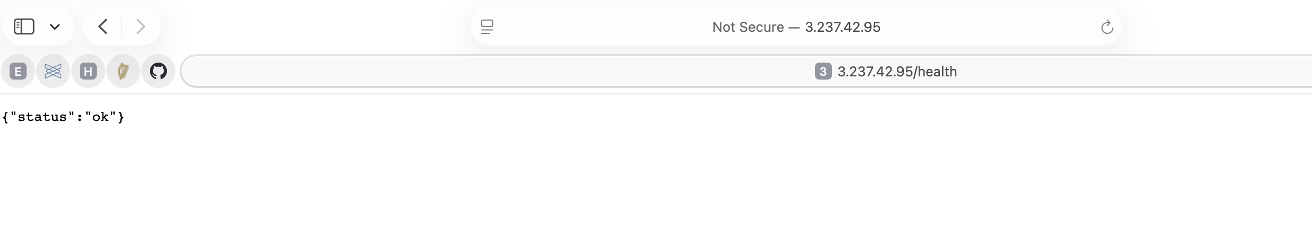
Health endpoint returning status ok

What went wrong along the way
This is the part I actually learned the most from, so I want to be honest about it instead of pretending everything went smoothly.
The first time I deployed, the container kept restarting on the EC2 instance and refused to serve anything. Turned out I’d built the image on my Mac (Apple Silicon), which defaults to an arm64 image, but the EC2 instance is a normal x86_64 box. Docker pulled the image fine, it just couldn’t run it — exec format error in the container logs gave it away. Rebuilt with docker buildx build --platform linux/amd64 ... --push and it started working immediately. I also updated the push script so it always targets linux/amd64 now, since otherwise this would trip up anyone else building from an M-series Mac.
Before that, docker login to ECR was failing with a weird error about a missing docker-credential-desktop binary. I’d tried installing Docker Desktop earlier and it left behind a setting in ~/.docker/config.json pointing at a credential helper that didn’t actually exist on my machine (I ended up using Colima instead of Docker Desktop). Deleting that one line fixed it.
And before I could even get that far, aws sts get-caller-identity kept returning InvalidClientTokenId even though I’d just run aws configure with a fresh IAM user’s access key. Turned out my credentials file still had a leftover aws_session_token from an old student/lab AWS account, and aws configure doesn’t clear fields it isn’t explicitly asked to set — so the CLI was mixing my new permanent key with an old, dead session token. Removed that stale line and authentication started working right away.
None of these were Docker/Terraform/AWS problems exactly — they were more “my machine had leftover config from earlier experiments” problems. But I think they’re worth including since the task specifically asked for challenges and how I solved them.

A few assumptions I made
- Used the account’s default VPC instead of building a custom one, since this is a small free-tier task and a new VPC felt like unnecessary overhead.
- Left allowed_ssh_cidr configurable but didn’t hardcode it open to 0.0.0.0/0 — I set it to my own IP for the actual deployment.
- No Elastic IP, so the IP above will change if the instance ever gets recreated. Not a big deal for this exercise, but worth knowing.
- App runs on port 3000 inside the container, mapped to port 80 on the host so the URL doesn’t need a port number in it.

