SIMATS ENGINEERING
ASSESSMENT TOOL 2
COURSE NAME: Ethical Hacking COURSE CODE: ITA14
CO2: Foot printing Tools: Conducting Competitive Intelligence, DNS Zone Transfers, Introduction
Name: K. Dedeepya
Reg no: 192324252
1. As a Security Analyst, perform an OSINT-based email enumeration assessment on the target domaintesla.com using the Harvester in Kali Linux. Collect publicly available email addresses, subdomains, hosts, and IP addresses associated with the organization. Categorize the discovered email addresses into likely roles such as Support, Sales, Human Resources, Administration, and Technical Teams. Analyse how the gathered information could assist an attacker during the reconnaissance phase and explain how it could be used for spear-phishing, credential harvesting, and impersonation attacks. Finally, recommend at least five countermeasures to reduce information leakage and social engineering risks, and submit a report with screenshots, commands executed, findings, risk analysis, and recommendations.
Aim
To perform an OSINT-based email enumeration assessment on the target domain tesla.com using the Harvester in Kali Linux.
Objective
To collect publicly available information such as email addresses, subdomains, hosts, and IP addresses associated with the target organization and analyse the security risks.
Tool Used
- Kali Linux
- The Harvester
Command Executed: The Harvester -d tesla.com -b all
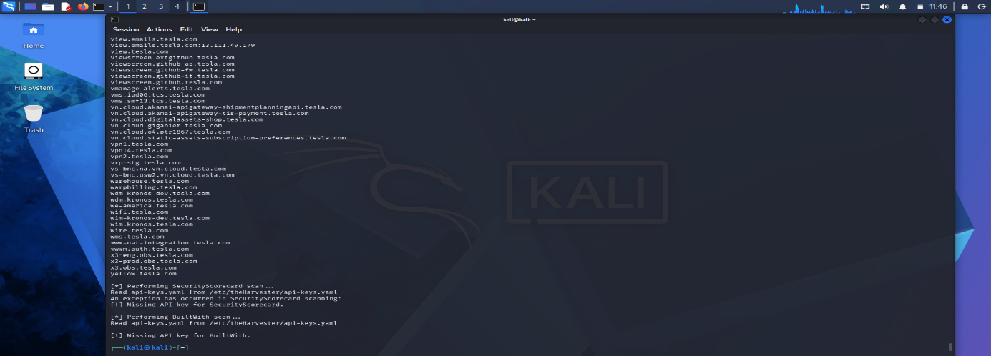
Procedure
- Opened Kali Linux Terminal.
- Verified the Harvester installation.
- Executed the Harvester command against tesla.com.
- Allowed the scan to collect information from multiple public sources.
- Recorded the discovered information.
- Saved screenshots of the command and results.
Findings
Item | Observation
Target Domain | tesla.com
Tool Used | theHarvester
Emails Found | None from scanned public sources
Subdomains | Multiple subdomains discovered
Hosts | Multiple public hosts identified
IP Addresses | Limited public IP information
Sample Subdomains
- wifi.tesla.com
- wire.tesla.com
- wms.tesla.com
- www.auth.tesla.com
Email Categorization
No publicly available email addresses were identified during the scan. Therefore, no categorization into Support, Sales, Human Resources, Administration, or Technical Teams could be performed.
Risk Analysis
An attacker could use the discovered information to:
- Identify organizational infrastructure.
- Discover publicly accessible subdomains.
- Prepare targeted spear-phishing campaigns.
- Create convincing phishing emails.

Countermeasures
- Reduce public exposure of employee email addresses.
- Enable SPF, DKIM, and DMARC.
- Implement Multi-Factor Authentication (MFA).
- Conduct regular security awareness training.
- Review public DNS records regularly.
- Monitor OSINT exposure.
- Apply least-privilege access control.
Conclusion
The Harvester successfully collected publicly available information related to tesla.com. Although no email addresses were found, several subdomains were identified that could be useful during the reconnaissance phase of an attack. Organizations should minimize information leakage and strengthen employee awareness to reduce social engineering risks.
2. As a cybersecurity awareness consultant, you are required to conduct a phishing awareness simulation using Go Phish and dummy employee accounts provided in the lab. Create an email template, launch a campaign, monitor user interactions, and generate a report showing delivery rate, email open rate, and click rate. Based on the results, provide recommendations to improve user awareness against phishing attacks.
Aim
To conduct a phishing awareness simulation using Go Phish and evaluate user interactions.
Objective
To understand how phishing campaigns are created, launched, monitored, and analysed.
Tool Used
- Kali Linux
- Go Phish
Procedure
- Downloaded Go Phish.
- Extracted the ZIP file.
- Started the Go Phish server.
- Logged into the Go Phish dashboard.
- Created an Email Template.
- Created a Landing Page.
- Created a User Group with dummy employees.
- Created a Sending Profile.
- Launched the phishing campaign.
- Monitored campaign statistics.
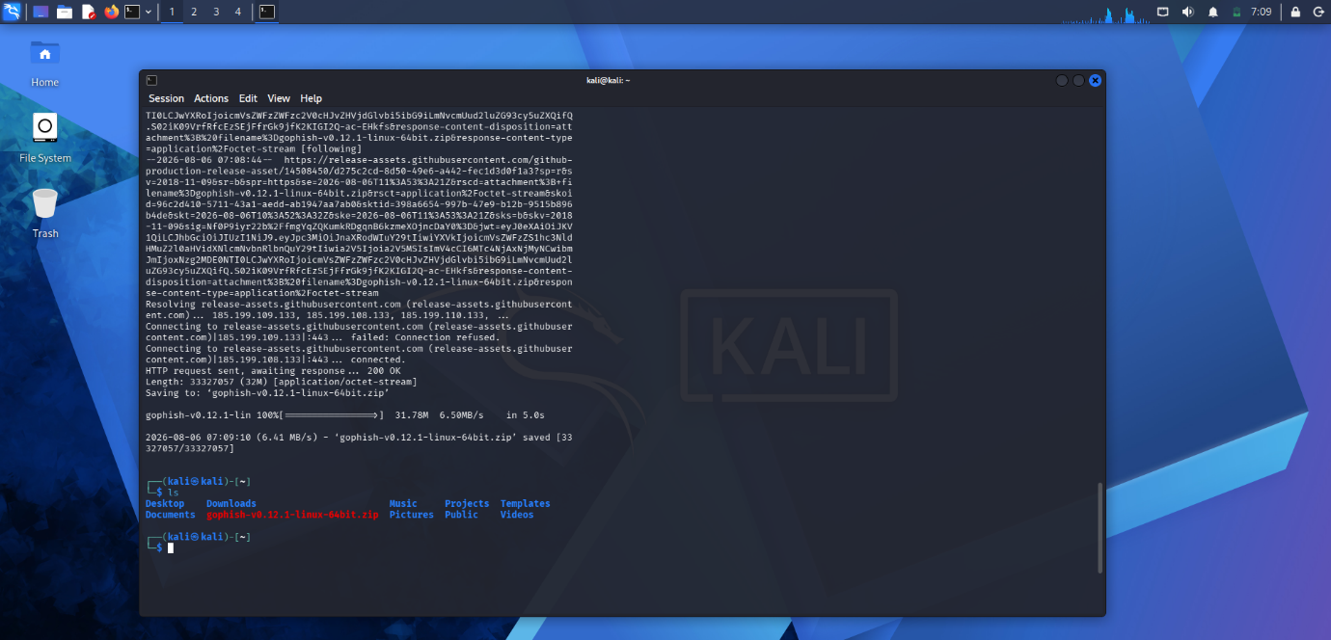
Email Template
Subject: Password Expiration Notice
Body
Dear Employee,
Your password will expire today.
Please click the link below to update your password.
{{.URL}}
Thank you,
IT Support
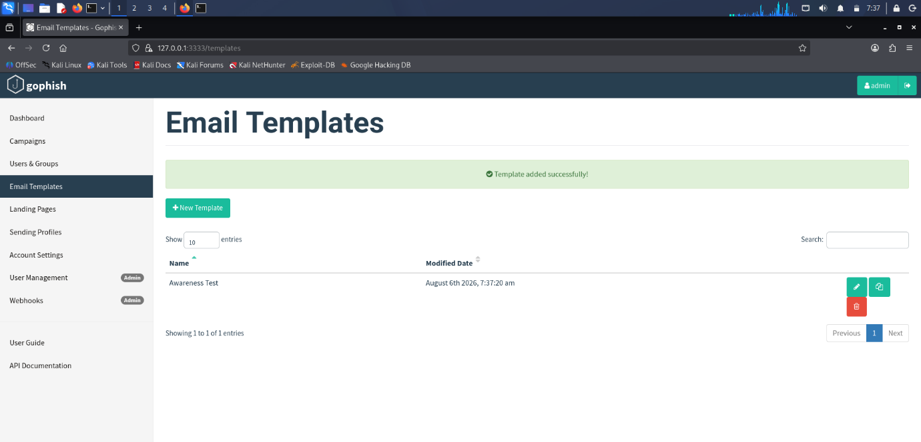
Landing Page: A simple password update page was created to simulate a login form.
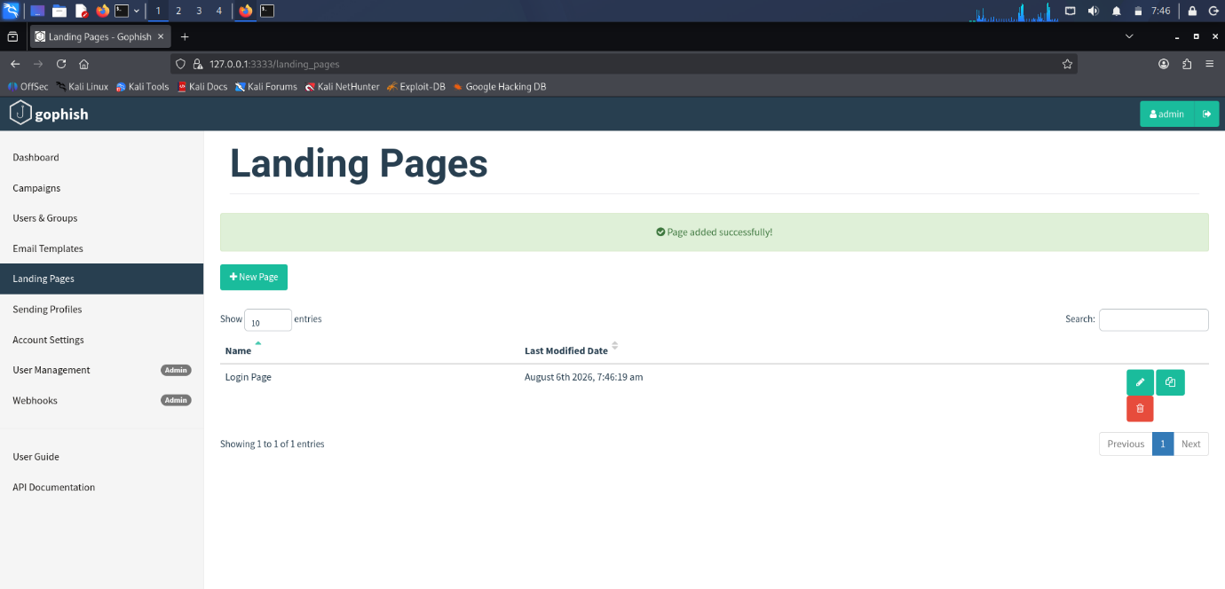
User Group: Dummy users were created.
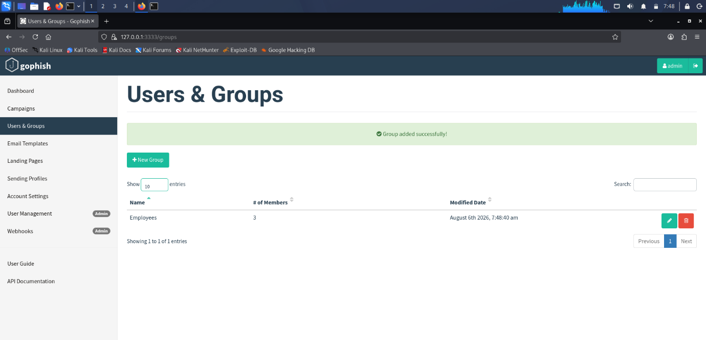
Campaign Details:
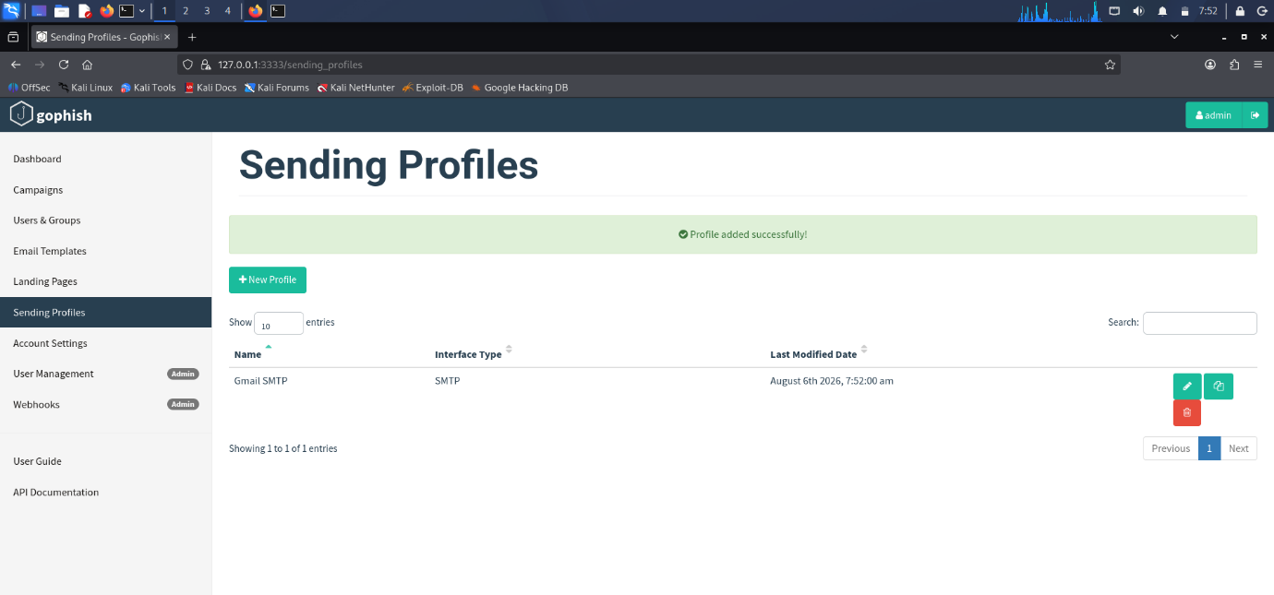
Campaign Statistics:
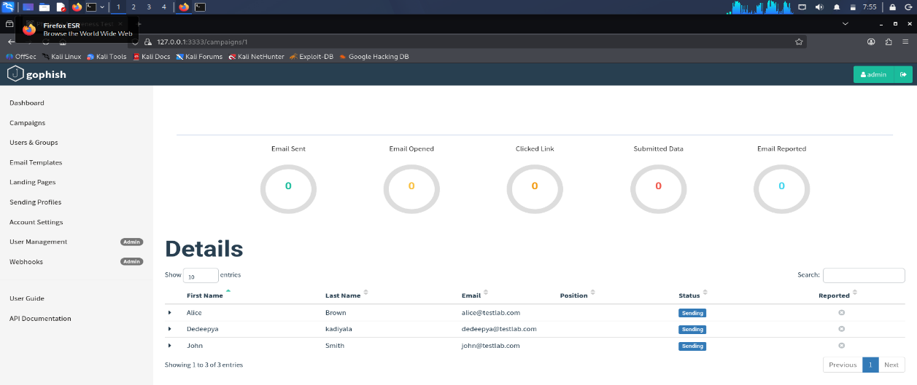
Recommendations
- Conduct regular phishing awareness training.
- Enable Multi-Factor Authentication.
- Verify email sender addresses.
- Use email filtering solutions.
- Encourage reporting of suspicious emails.
Conclusion
Go Phish demonstrated how phishing campaigns can be created and monitored. The simulation highlighted the importance of user awareness and technical controls in preventing phishing attacks. The collected campaign statistics can help organizations identify areas where additional training is needed.
3. Using Nmap Aggressive Scan (-A) on scanme.nmap.org, gather detailed information about the target including operating system details, open ports, and service versions. Assume you are an attacker and describe how the collected information could be leveraged to conduct a social engineering attack against the IT support team. Prepare a report explaining the attack methodology and defensive recommendations.
Aim
To perform an aggressive Nmap scan against scanme.nmap.org and analyse the collected information.
Tool Used
- Kali Linux
- Nmap
Command Executed
Bash: nmap -A scanme.nmap.org
Procedure
- Opened Kali Linux Terminal.
- Executed the Nmap Aggressive Scan command.
- Collected service versions, operating system details, and open ports.
- Recorded the results.
- Saved screenshots.
Findings
Item | Observation
Target | scanme.nmap.org
Scan Type | Aggressive Scan (-A)
Open Ports | 22 (SSH), 80 (HTTP), 9929 (Nping Echo), 31337 (Filtered) (use your actual results if they differ)
Service Detection | Enabled
OS Detection | Linux (estimated)
Traceroute | Performed
Attack Methodology
An attacker could use the collected information to:
- Identify running services.
- Determine the operating system.
- Learn software versions.
- Contact the IT support team pretending to troubleshoot identified services.
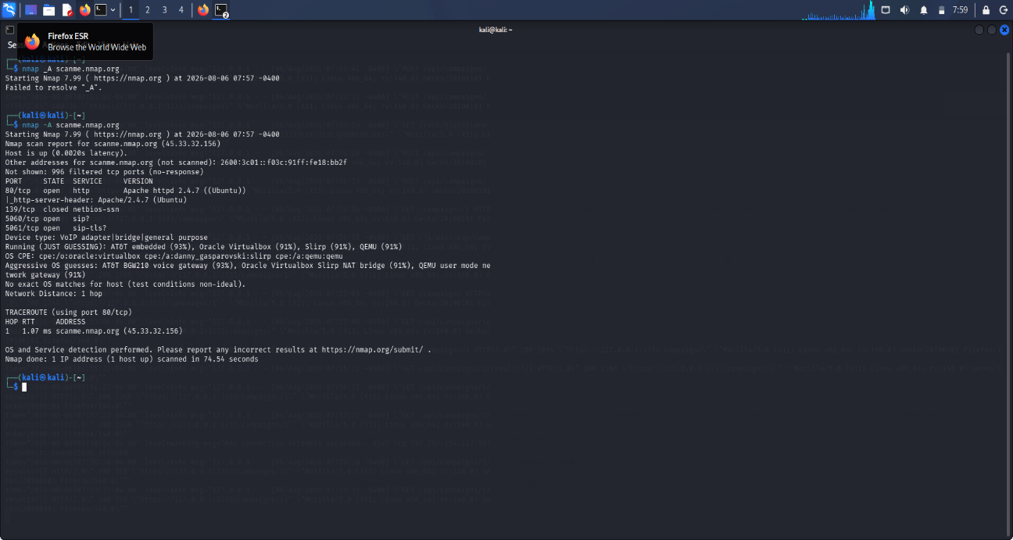

Risk Analysis
The exposed service information increases the likelihood of successful targeted social engineering attacks because attackers can craft convincing messages using real technical information obtained during reconnaissance.
Defensive Recommendations
- Limit unnecessary service exposure.
- Regularly patch operating systems and services.
- Restrict information leakage.
- Train employees to verify support requests.
Conclusion
The Nmap Aggressive Scan successfully identified publicly accessible services and operating system information. Although the scan targeted a safe demonstration host, it illustrates how attackers can use reconnaissance data to support social engineering attacks. Strong security practices and user awareness significantly reduce these risks.

