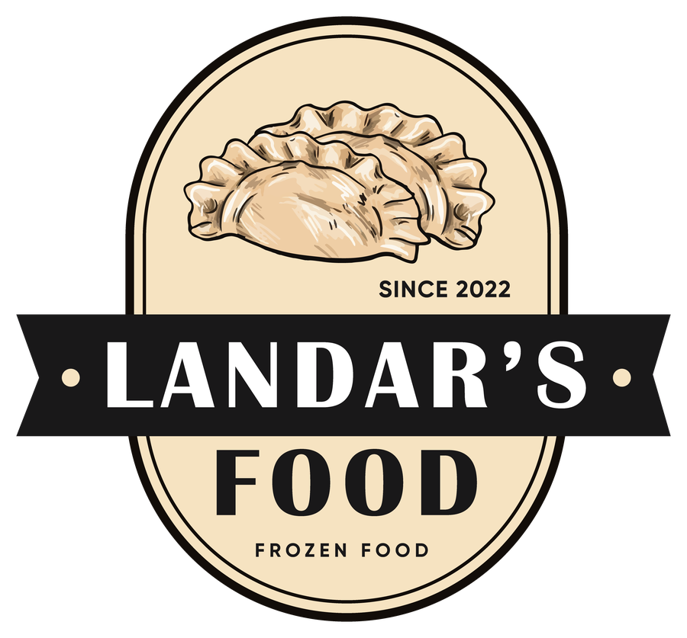 | Landar’s Food  AUTHENTIC UKRAINIAN STREET FOOD | 

ALL MEALS | £9.99 | DRINK INCLUDED | Coca-Cola · Sprite · Water
Freshly prepared traditional Ukrainian street food, handmade with quality ingredients and authentic family recipes.
POTATO VARENYKY 250g Traditional Ukrainian boiled dumplings filled with mashed potatoes. 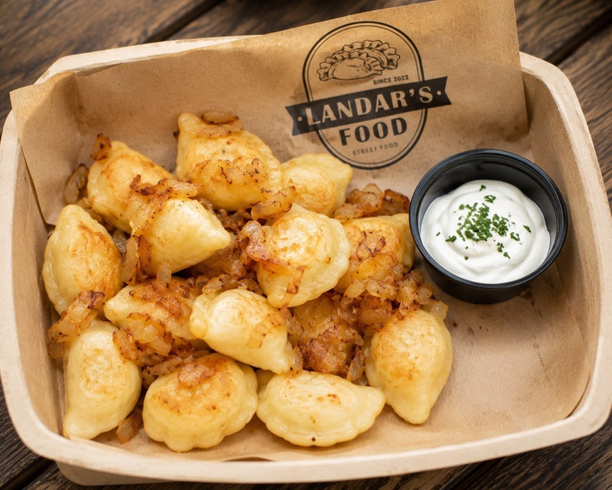  INGREDIENTS · Wheat flour, eggs, potatoes, onion, butter (milk).  SERVED WITH · Sour cream (milk) · fried onion · butter (milk)  Allergens : wheat · eggs · milk  CHEBUREKI 2 PIECES - 250g Traditional crispy fried pastries with handmade fillings. 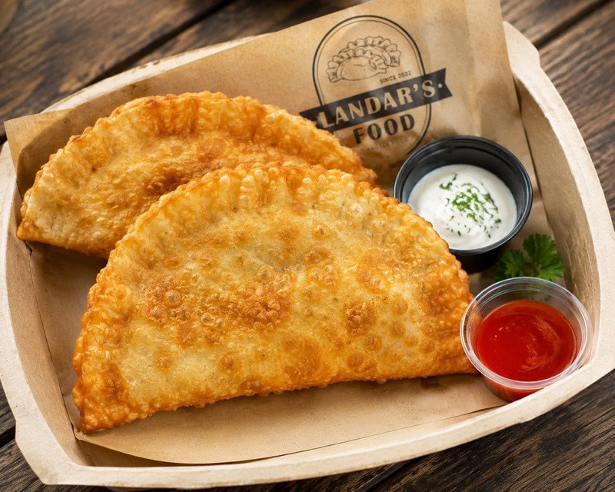  CHOOSE YOUR FILLING  Cheese & Spring Greens  Chicken & Cheese  Beef & Pork  INGREDIENTS · Wheat flour, eggs, cheese (milk), spring greens, chicken, beef, pork, onion, vegetable oil.  SAUCES : Garlic sauce · sour cream (milk) · ketchup · sweet chilli  Allergens : wheat · eggs · milk  DEEP FRIED PELMENI 250g Golden crispy pork & beef dumplings fried to perfection. 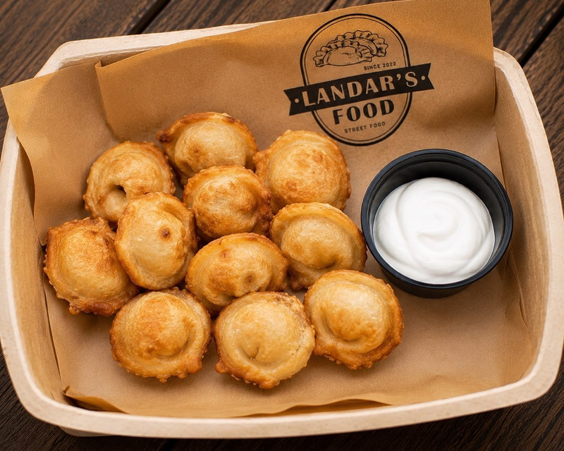  INGREDIENTS · Wheat flour, eggs, pork, beef, onion, vegetable oil.  SERVED WITH · Sour cream & ketchup sauce (milk)  Allergens : wheat · eggs · milk  SHASHLIK CHICKEN OR PORK Grilled meat skewers with your choice of chicken or pork. 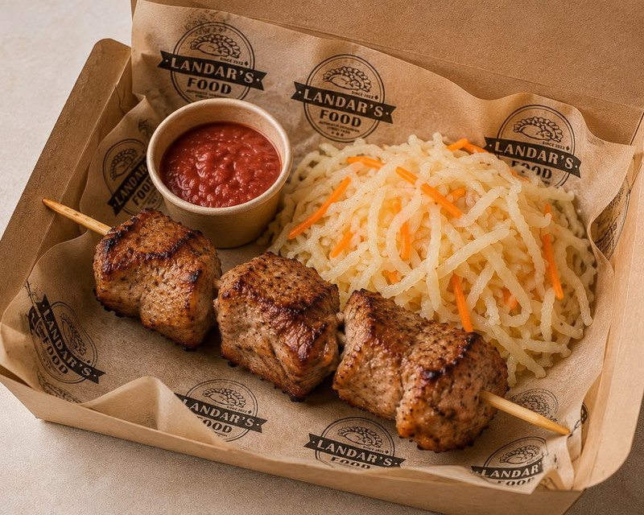  CHOOSE YOUR MEAT  Chicken  Pork  INGREDIENTS · Chicken : mustard, salt, pepper, garlic, mix herbs  Pork : vinegar, onion. salt, pepper, paprika  Allergens : mustard (chicken) |  | SWEET COTTAGE CHEESE VARENYKY 250g Traditional Ukrainian boiled dumplings filled with sweet cottage cheese. 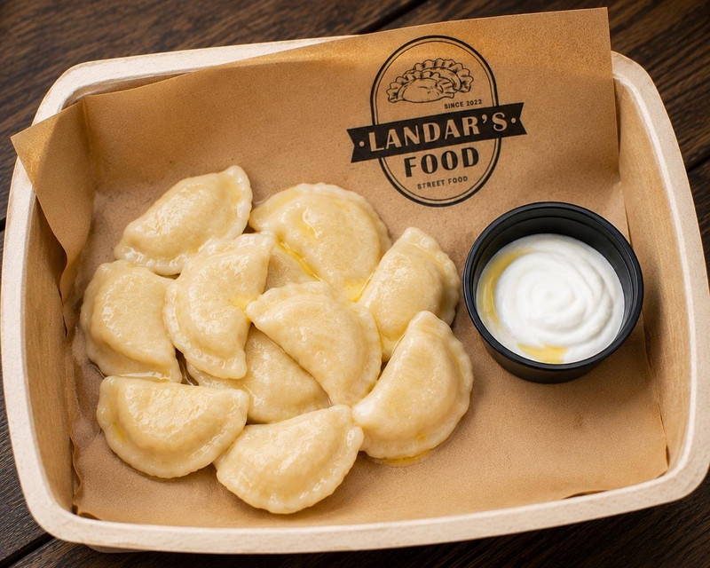  INGREDIENTS · Wheat flour, eggs, cottage cheese (milk), sugar, butter (milk).  SERVED WITH · Sour cream (milk) · butter (milk)  Allergens : wheat · eggs · milk  BOILED PELMENI 250g Traditional Ukrainian pork & beef dumplings. 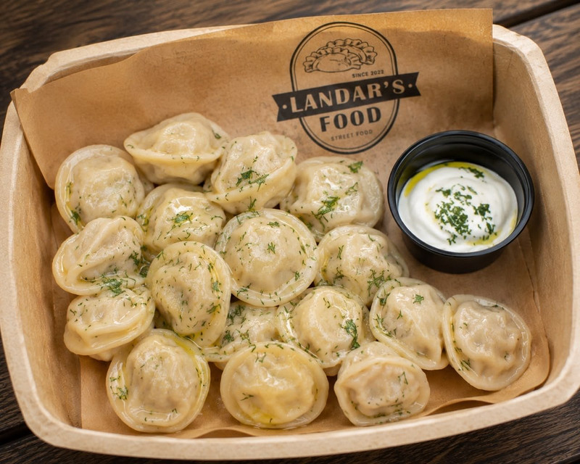  INGREDIENTS · Wheat flour, eggs, pork, beef, onion.  SAUCES : Sour cream (milk) · ketchup · mayonnaise (eggs) · mustard  Allergens : wheat · eggs · milk · mustard  SYRNYKY 4 PIECES - 250g Golden fried cottage cheese pancakes. 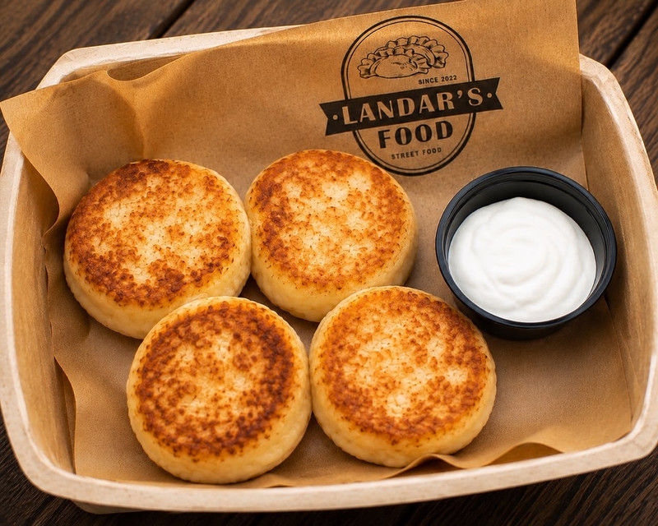  INGREDIENTS · Cottage cheese (milk), eggs, wheat flour, sugar.  TOPPINGS : Sour cream (milk) · strawberry topping  Allergens : milk · eggs · wheat  FILLED CREPES 2 PIECES - 250g Traditional thin crepes with your choice of filling. You may mix different flavours in one portion. 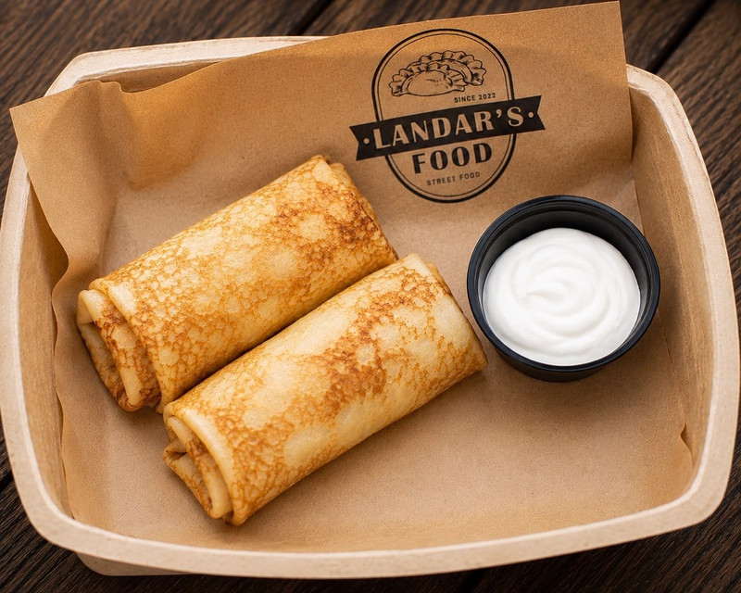  CHOOSE YOUR FILLING  SAVOURY  Beef & Fried Onion  Chicken & Fried Mushrooms  Chicken & Cheese (milk)  SWEET  Sweet Vanilla Cottage Cheese (milk)  Caramelised Apples & Cinnamon  INGREDIENTS · Wheat flour, eggs, milk, butter (milk).  Allergens : wheat · eggs · milk


 | Landar’s Food  AUTHENTIC UKRAINIAN STREET FOOD | 

JERKY & DRINKS | JERKY · WATER · SOFT DRINKS

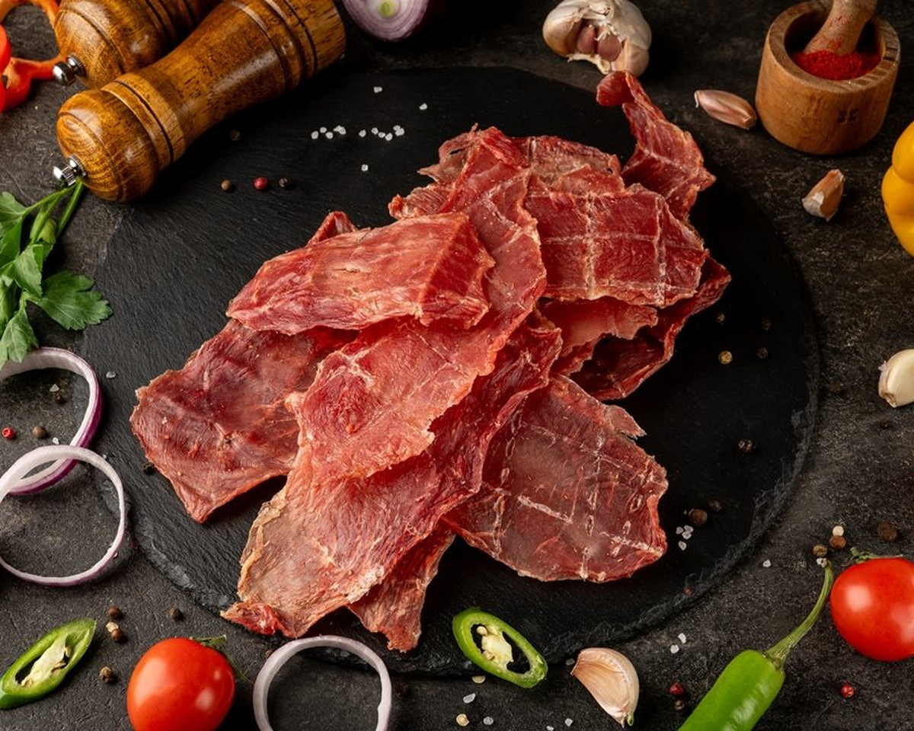 |  | JERKY  £6 / 100g  CHOOSE YOUR VARIETY  Chicken  Chicken & Cheese  Pork with mild spices  (not spicy)  Beef  Turkey

WATER £2 / 0.5L 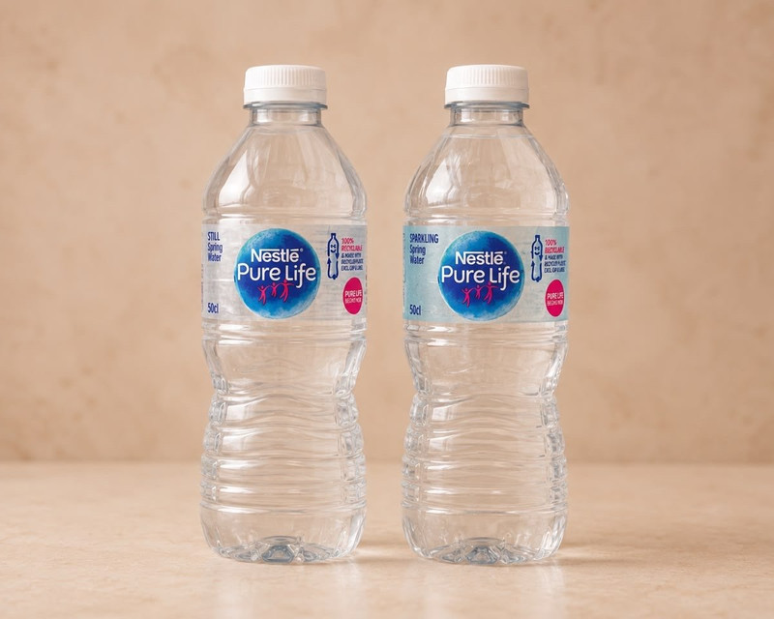  CHOOSE  Sparkling  Still |  | SOFT DRINKS £2 / 0.5L 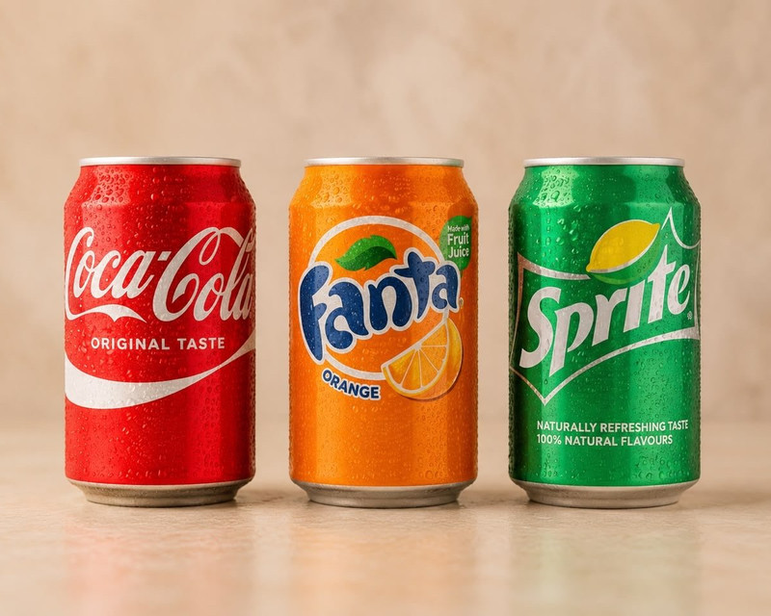  COCA-COLA / FANTA / SPRITE  Coca-Cola  Fanta  Sprite


