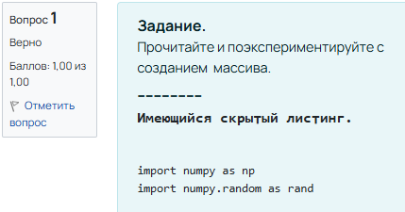

zeros_arr = np.zeros((3, 4))

print("Массив из нулей:\n", zeros_arr)

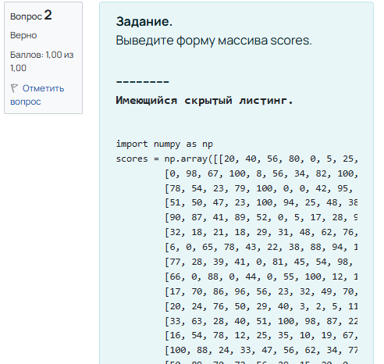

import numpy as np

scores = np.array([[20, 40, 56, 80, 0, 5, 25, 27, 74, 1],

[0, 98, 67, 100, 8, 56, 34, 82, 100, 7],

[78, 54, 23, 79, 100, 0, 0, 42, 95, 83],

[51, 50, 47, 23, 100, 94, 25, 48, 38, 77],

[90, 87, 41, 89, 52, 0, 5, 17, 28, 99],

[32, 18, 21, 18, 29, 31, 48, 62, 76, 22],

[6, 0, 65, 78, 43, 22, 38, 88, 94, 100],

[77, 28, 39, 41, 0, 81, 45, 54, 98, 12],

[66, 0, 88, 0, 44, 0, 55, 100, 12, 11],

[17, 70, 86, 96, 56, 23, 32, 49, 70, 80],

[20, 24, 76, 50, 29, 40, 3, 2, 5, 11],

[33, 63, 28, 40, 51, 100, 98, 87, 22, 30],

[16, 54, 78, 12, 25, 35, 10, 19, 67, 0],

[100, 88, 24, 33, 47, 56, 62, 34, 77, 53],

[50, 89, 70, 72, 56, 29, 15, 20, 0, 0]])

print(scores.shape)

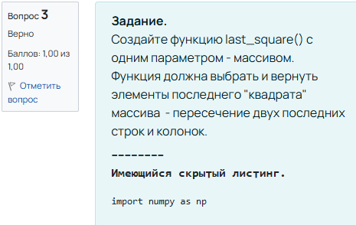

import numpy as np

def last_square(arr):

return arr[-2:, -2:]

scores = np.array([[20, 40, 56, 80, 0, 5, 25, 27, 74, 1],

[0, 98, 67, 100, 8, 56, 34, 82, 100, 7],

[78, 54, 23, 79, 100, 0, 0, 42, 95, 83],

[51, 50, 47, 23, 100, 94, 25, 48, 38, 77],

[90, 87, 41, 89, 52, 0, 5, 17, 28, 99],

[32, 18, 21, 18, 29, 31, 48, 62, 76, 22],

[6, 0, 65, 78, 43, 22, 38, 88, 94, 100],

[77, 28, 39, 41, 0, 81, 45, 54, 98, 12],

[66, 0, 88, 0, 44, 0, 55, 100, 12, 11],

[17, 70, 86, 96, 56, 23, 32, 49, 70, 80],

[20, 24, 76, 50, 29, 40, 3, 2, 5, 11],

[33, 63, 28, 40, 51, 100, 98, 87, 22, 30],

[16, 54, 78, 12, 25, 35, 10, 19, 67, 0],

[100, 88, 24, 33, 47, 56, 62, 34, 77, 53],

[50, 89, 70, 72, 56, 29, 15, 20, 0, 0]])

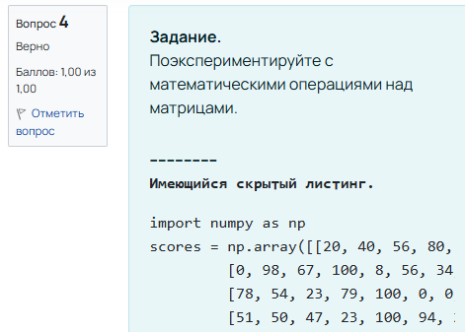

result_mul = scores * a

print("Поэлементное умножение scores и a:\n", result_mul)

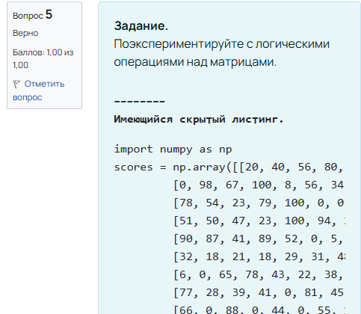

logical_or = (scores < 20) | (scores > 90)

print("Элементы scores, которые меньше 20 или больше 90:\n", logical_or)

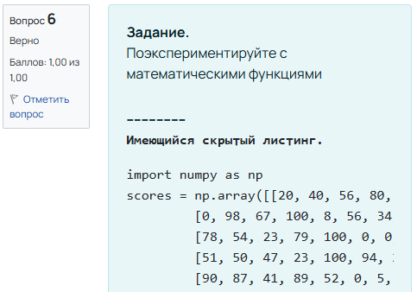

exp_b = np.exp(b)

print("Экспонента элементов массива b:\n", exp_b)

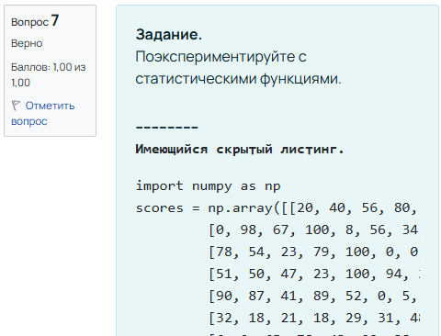

mean_scores = np.mean(scores)

print("Среднее значение массива scores:", mean_scores)