Visual Novel Engine for Unity

By Michael Long ([Foolish Mortals](http://foolish-mortals.net)), [michael@foolish-mortals.net](mailto:michael@foolish-mortals.net)

The best way to learn is to open up the ‘ExampleDrawingScene’

## Setup

1. 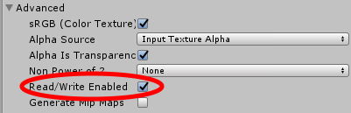Select the Sprite you wish to draw on, and in the Import Settings check ‘Read/Write Enabled’.

**THIS IS NECESSARY FOR DRAWING TO WORK**

1. Drag the read/write enabled sprite onto the scene, and attach a 2D collider of some sort to it (probably a BoxCollider2D)
2. 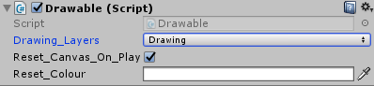Attach the Drawable.cs script to your Sprite GameObject
3. Set the layer of your Sprite GameObject to something unique, and then set the ‘Drawing_Layers’ property of the Drawable script to match that layer
4. **Optional**: use the helper methods in DrawingSettings.cs to change both the colour and width of the drawing pen

**If you want a larger/smaller canvas:** Create your own transparent PNG images with the right dimensions to suit your own needs, and use that.

**IF YOU WANT TO BE ABLE TO USE TRANSPARENCY/THE ERASER:** Start with a completely transparent PNG image. JPEGs cannot be transparent, and if your starting image is not transparent, you cannot apply the alpha properly. I may look more into this when I have the time.

## Code

You must reference the namespace FreeDraw to reference any of the scripts.

### Static Properties

Drawing.Pen_Colour: Changes the drawing colour

Drawing.Pen_Width: Changes the width of the current drawing pen. An integer given in pixels, it is actually the pen radius.

## Known Issues

Changing the scale or rotation of your Sprite object will result in errors. I’ll fix it when I have the time.

https://i.gyazo.com/a362529597980965d95e3a1e30c046d6.pngTo fix the error to the right, try changing the ‘Compression’ in the Sprite import settings to ‘None’

## License

[CC0](http://creativecommons.org/publicdomain/zero/1.0/)This asset and code is available and free for any use, including commercial. You do not need to credit me (unless you want to). Shoot me an email if you end up using this code, and I can feature it on the asset page.