
FreeDraw for Unity
By Michael Long (Foolish Mortals), michael@foolish-mortals.net
The best way to learn is to open the ‘ExampleDrawingScene’

Setup
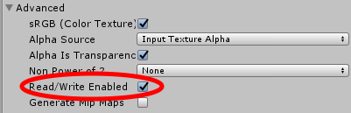
- Select the Sprite you wish to draw on, and in the Import Settings check ‘Read/Write Enabled’.
THIS IS NECESSARY FOR DRAWING TO WORK
- Drag the read/write enabled sprite onto the scene, and attach a 2D collider of some sort to it (probably a BoxCollider2D)
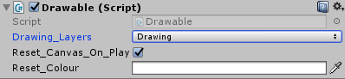
- Attach the Drawable.cs script to your Sprite GameObject
- Set the layer of your Sprite GameObject to something unique, and then set the ‘Drawing_Layers’ property of the Drawable script to match that layer
- Optional: use the helper methods in DrawingSettings.cs to change both the colour and width of the drawing pen
If you want a larger/smaller canvas: Create your own transparent PNG images with the right dimensions to suit your own needs, and use that.
IF YOU WANT TO BE ABLE TO USE TRANSPARENCY/THE ERASER: Start with a completely transparent PNG image. JPEGs cannot be transparent, and if your starting image is not transparent, you cannot apply the alpha properly. I may look more into this when I have the time.

Code
You must reference the namespace FreeDraw to reference any of the scripts.

Static Properties
Drawing.Pen_Colour: Changes the drawing colour
Drawing.Pen_Width: Changes the width of the current drawing pen. An integer given in pixels, it is actually the pen radius.

Known Issues
Changing the scale or rotation of your Sprite object will result in errors. I’ll fix it when I have the time.
To fix the error to the right, try changing the ‘Compression’ in the Sprite import settings to ‘None’

License
This asset and code is available and free for any use, including commercial. You do not need to credit me (unless you want to). Shoot me an email if you end up using this code, and I can feature it on the asset page.

Implementing your own brushes
FreeDraw only comes with the default ‘pen’ brush. To implement your own brush, open Drawable.cs, then:
- Carefully read the comments in the BrushTemplate()
- Copy and paste the BrushTemplate() function to create your own brush function
- Delegates are used to call your function, therefore your new function must also only take in a Vector2 as a parameter, and return nothing
- To change what brush you’re using, create a helper method such as SetPenBrush() in Drawable.cs, then either call that function from a button, or create a new function in DrawingSettings to a hook a button to it
- The initial brush type is set in Drawable.cs‘s Awake() function

Different Controls
Examine Drawable.cs’s Update() function for details on how it functions. It uses a Physics2D OverlapPoint() call to determine if the mouse is over the Collider2D of the image (the image MUST have a collider2D of some sort). You can change what button activates drawing by changing the following line:
bool mouse_held_down = Input.GetMouseButton(0);

Changelog
2024-8-21
Implemented FILL brush type. Thanks to Francesco Filippini for contributing this code!
Changed brush icons

