16th-MAY-2022
-----------------------------------------------------------------------
Display Property
----------------------------------
used to specify how elements displayed on the page.

each element has defalut value.most of them have block and inline values.

we have so many display values,
1)inline : used to display the elelements in one line ,but it doesn't add space to after and before the element.
disply:inline

2)inline-block : used to display the elements in one line[inline element] , and it adds some space to after and before the element.

3)block : used to display the elements in one by one[block elemet], with adding space before and after the element

4)none : the text will be disappered.

5)flex,grid,table,list-item =====================: same as block

5)contents,inline-grid,inline-flex,inline-table ===========> same as inline-block

6)run-in : based on text it will display in block or inline-block

7)initial : it takes deflaut value.

8)inherits : take the features from parent tag
=====================================================================================================
Align prorty:
----------------------------------------------------------------------------------------------
1)Align elements center
used to set the element to center for that we use margin as auto
margin:auto

ex: we have div width of 60%
margin:auto means in 100% width ,60 is div ,40 is margin distrubute equally to the left and right margin,like 20 and 20

2)Align text:
we use text-align property
text-align:center -> used to set the text in center
we can also have left,right,top,bottom,center,center left etc...

3)Align the image center

set the width of image ,then margin left and right to auto, disply the element in block;

img {display:block;
width:40%;
margin-left:auto;
margib-right:auto
}

4)We use position to align left/right
5)we can also use float to align left and right
6)clearfix : if one element is taller than another element and it's floated. one element overflow outside of the container , to fix this we use clearfix attribute:

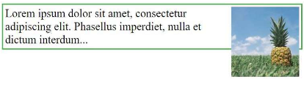

In above picture , we have content after that we have one image, if we see the image size is big and it overflowing out of contaienr
Selector:pseudoclass {
Content:””;
Clear:both;
Display:table;
}

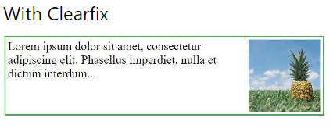

- center vertically using padding : we can align the element vertically center using padding top and bottom values
Padding:40px 0px;

- center vertically using line-height - > this property has the same value of height property;
Div {
Line-height:200px;
Height:200px;
Border:3px solid black;
}

- center vertically using position and transform property :
Div {
Margin:0px;
Position:absolute;
Top:50%;
Bottom:50%;
Transform:translate(-50%,-50%)
}
We can mention any values for top,bottom and transform.if want to put it in center use 50% only

