docker –version
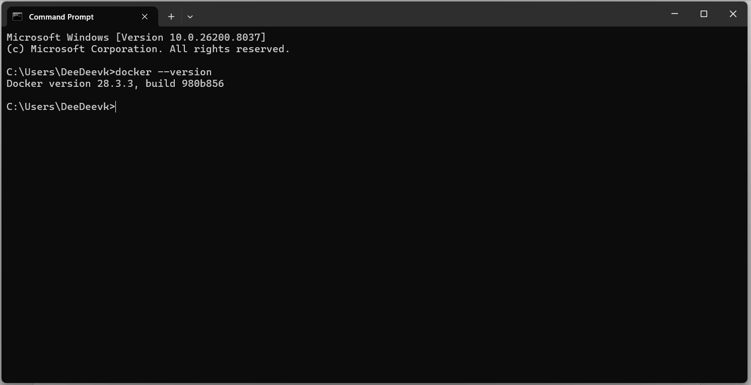
docker run app-test
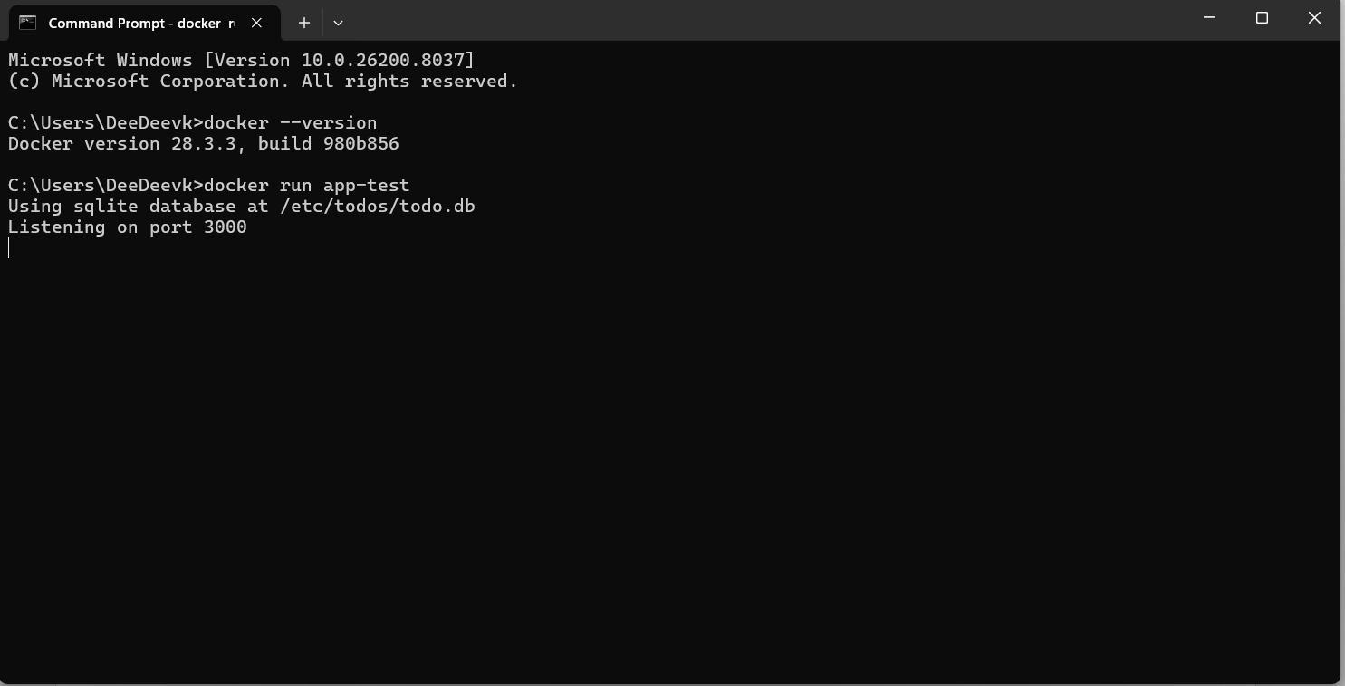
docker pull nginx
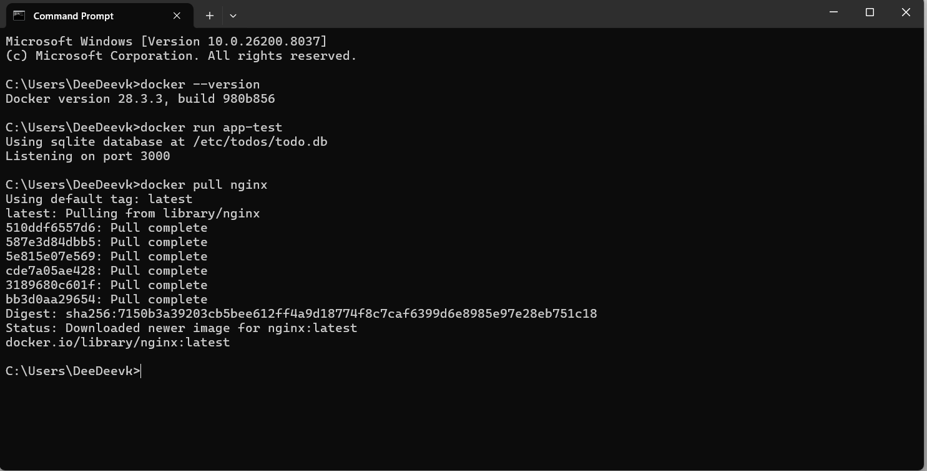
docker images
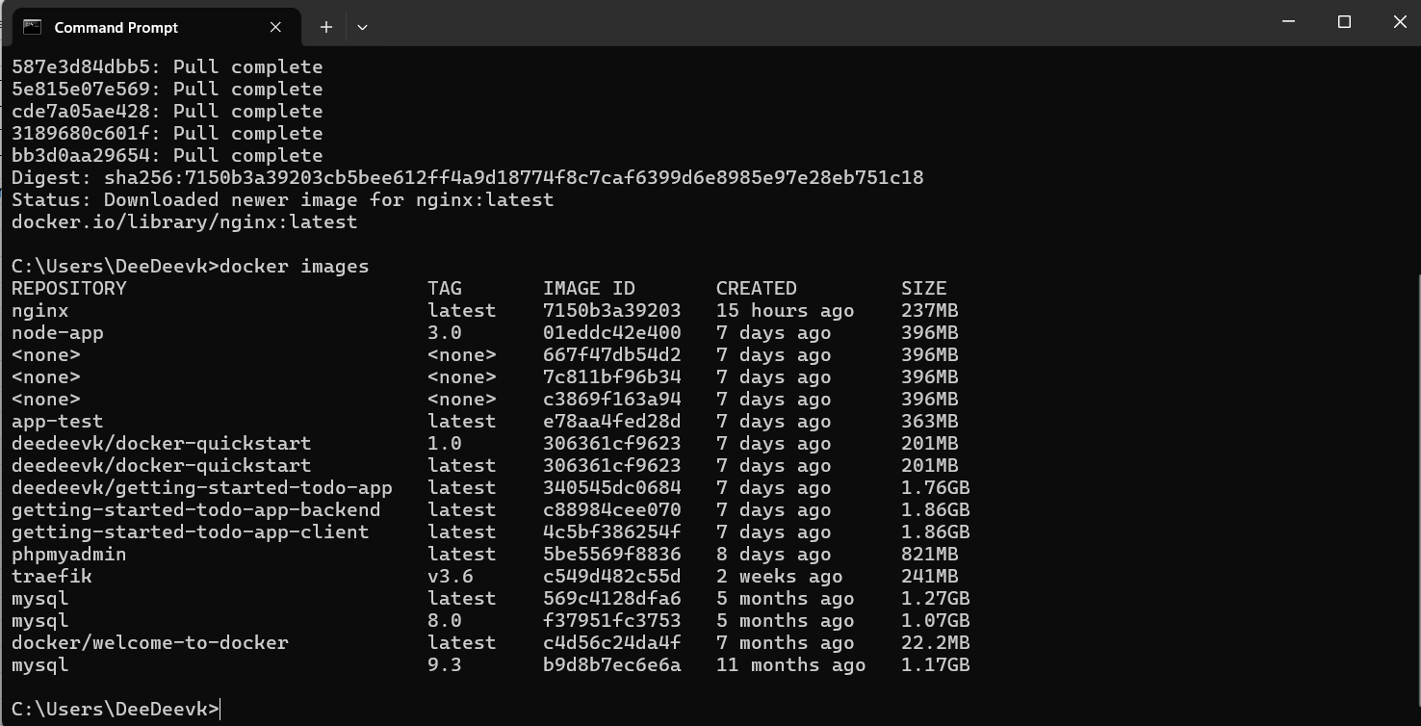
docker run -d nginx
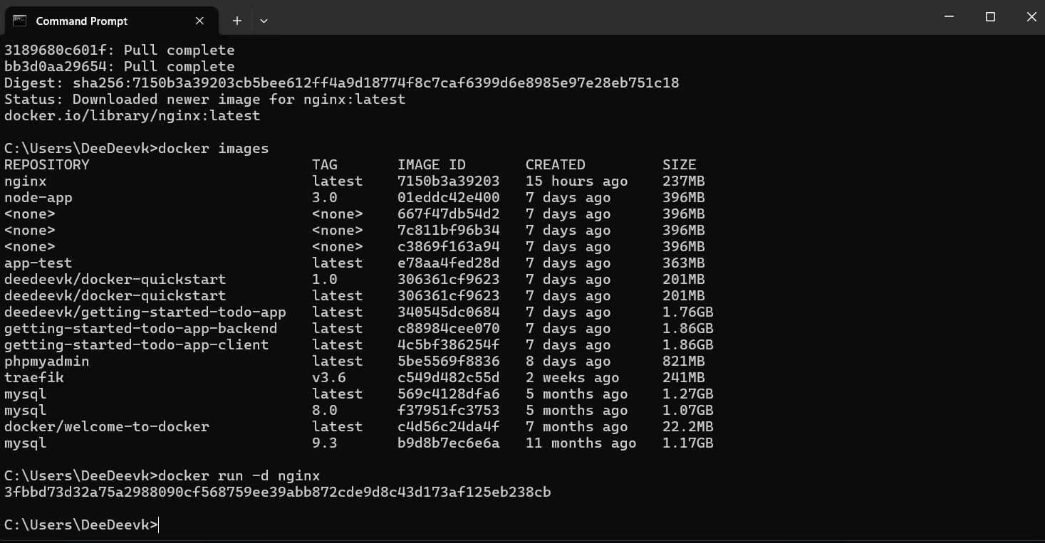
docker ps
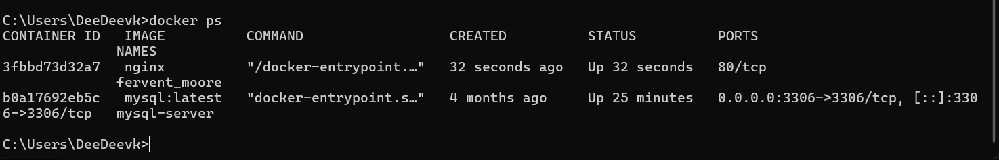
docker ps -a
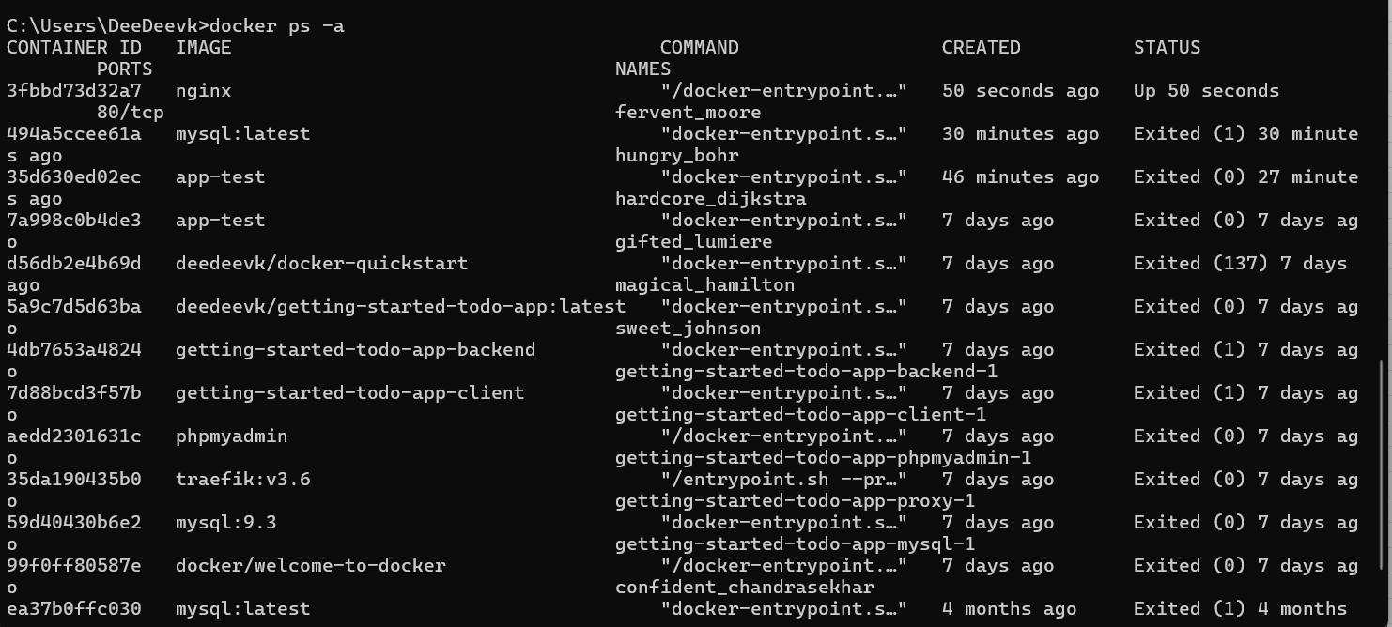

docker logs 3fbbd73d32a7
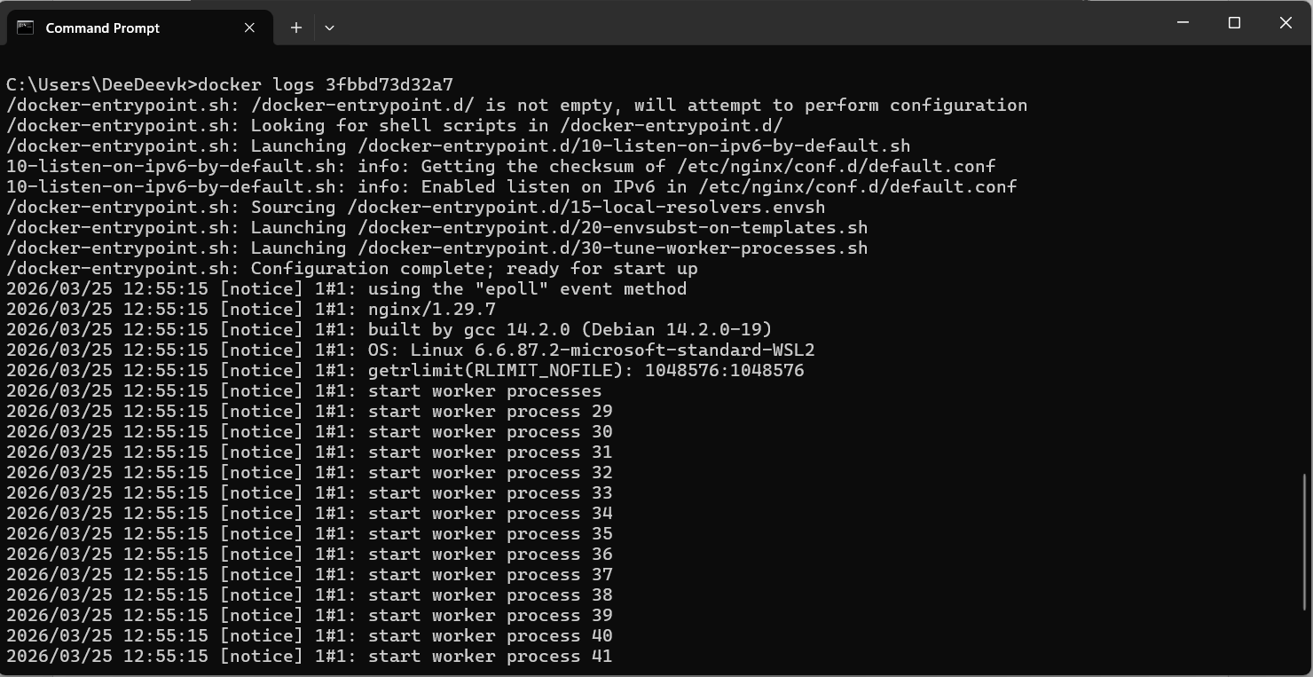
docker exec -it 3fbbd73d32a7 bash
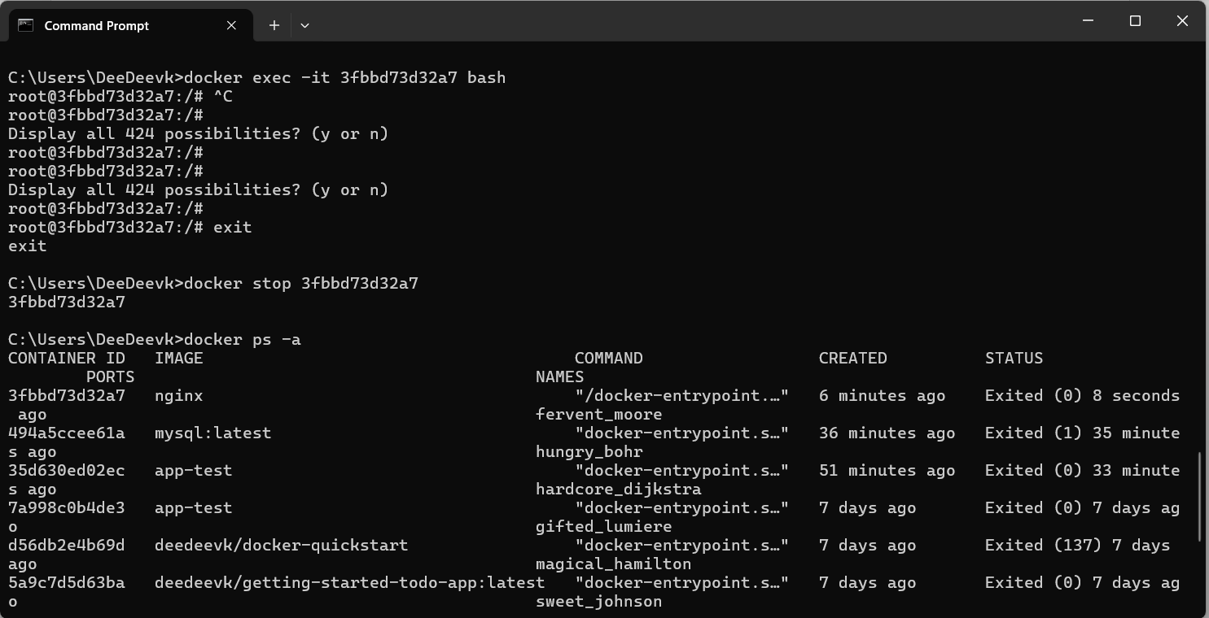
docker stop 3fbbd73d32a7
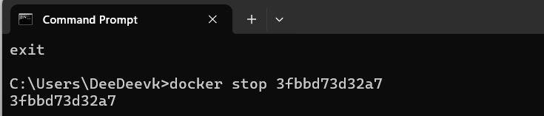
docker restart 3fbbd73d32a7
docker rm aedd2301631c
docker rmi sha256:7c811bf96b34bc4960f243baaae899282b4b230a77a1391b0d00467985ee8bf7
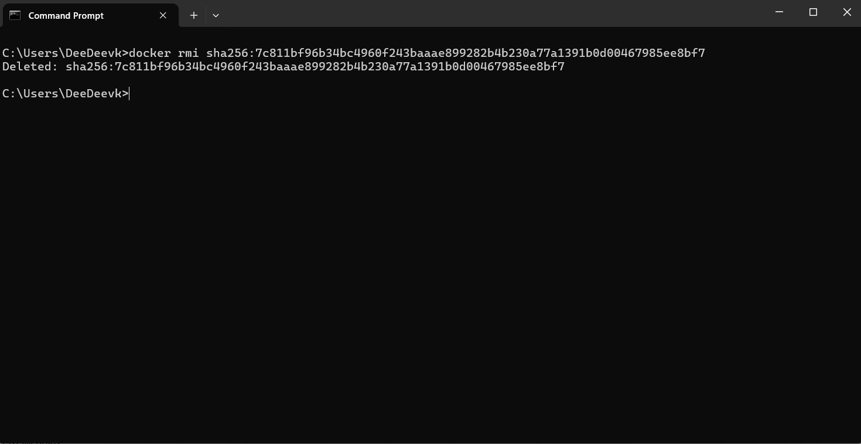

Docker image prune -a
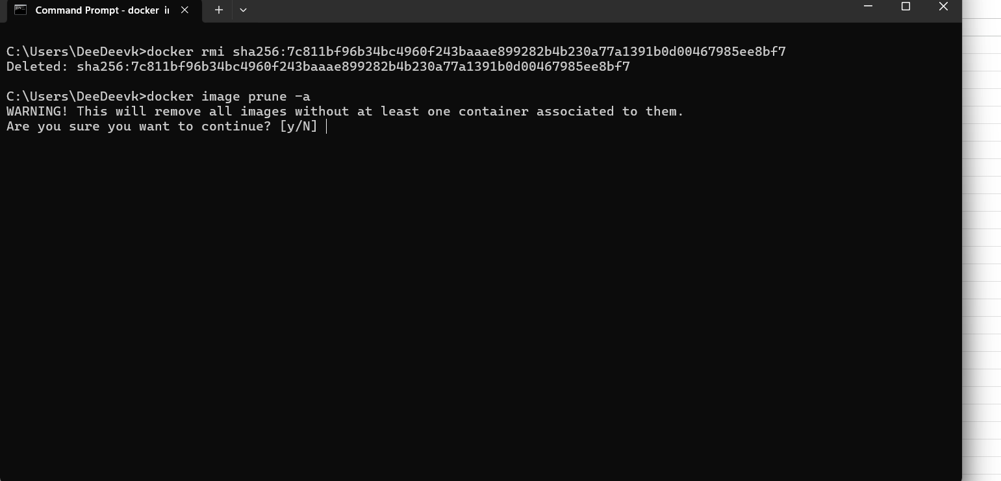
docker run -d -p 8080:80 nginx
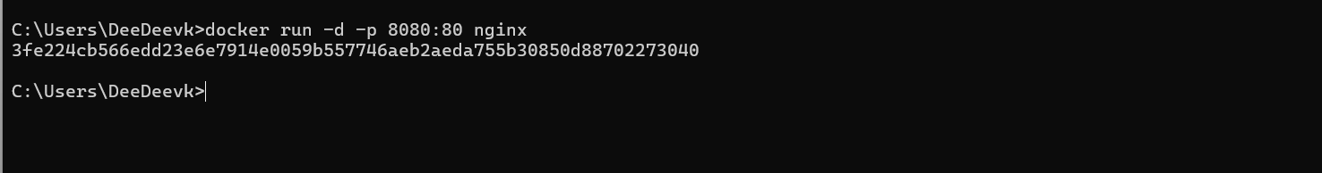
docker inspect 3fe224cb566e
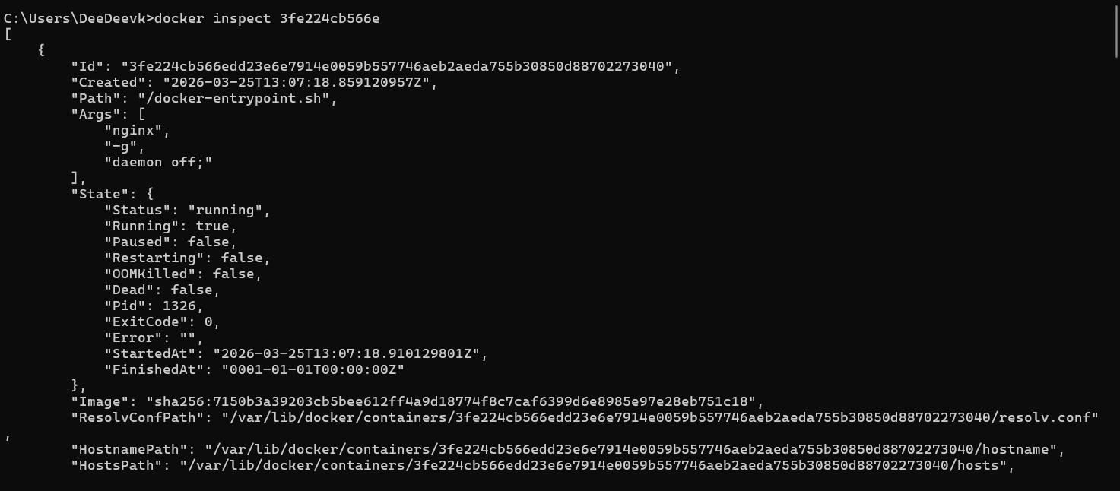
docker run -d -v mydata:/data nginx
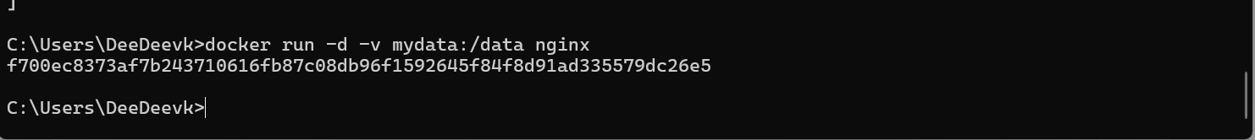
docker volume ls
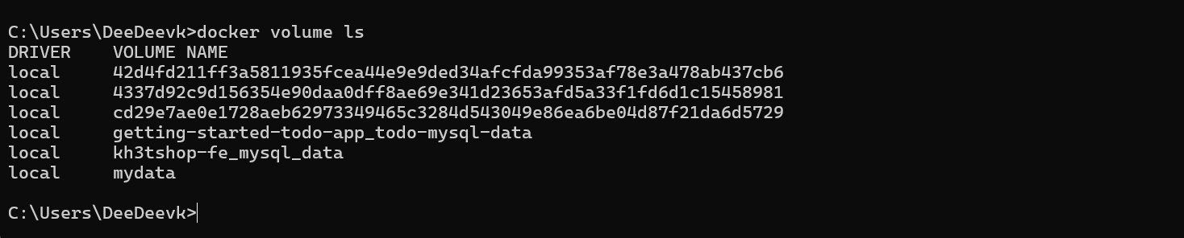
docker volume prune
docker run -d --name my_nginx nginx
docker stats
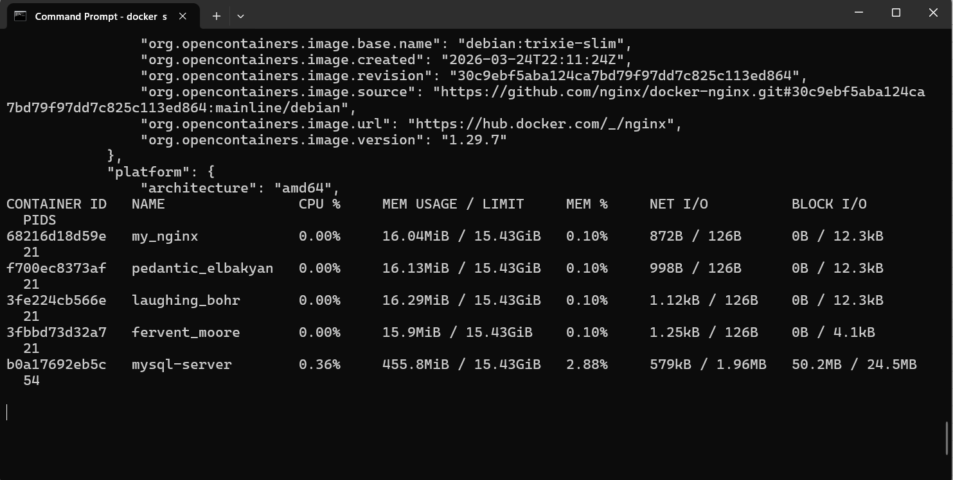

docker network ls
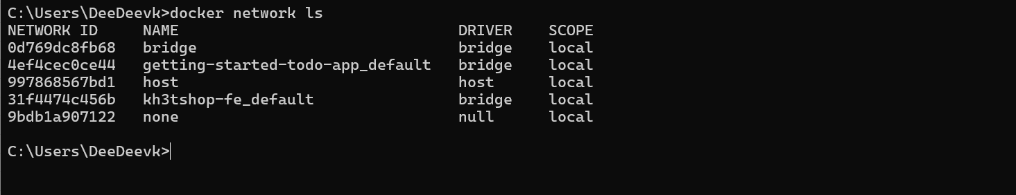
docker network create my_network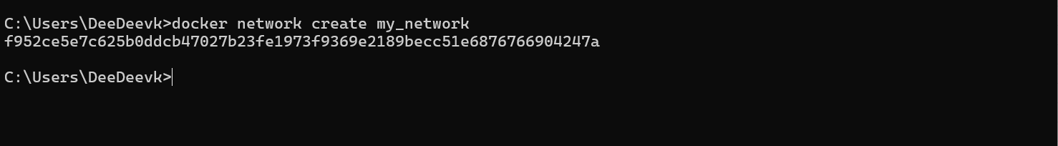
docker run -d --network my_network --name my_container nginx
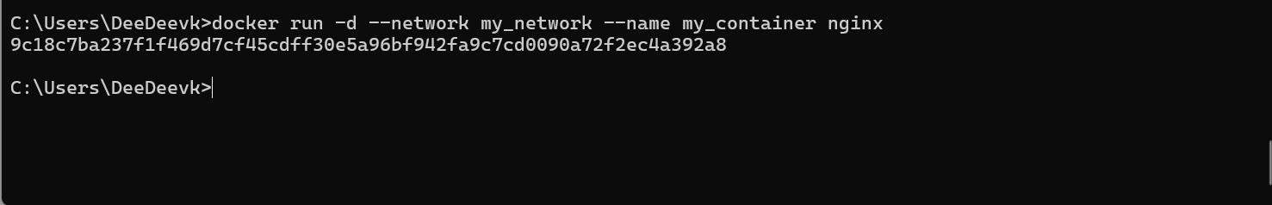
docker network connect my_network my_nginx
docker run -d -e MY_ENV=hello_world nginx
docker logs -f my_nginx
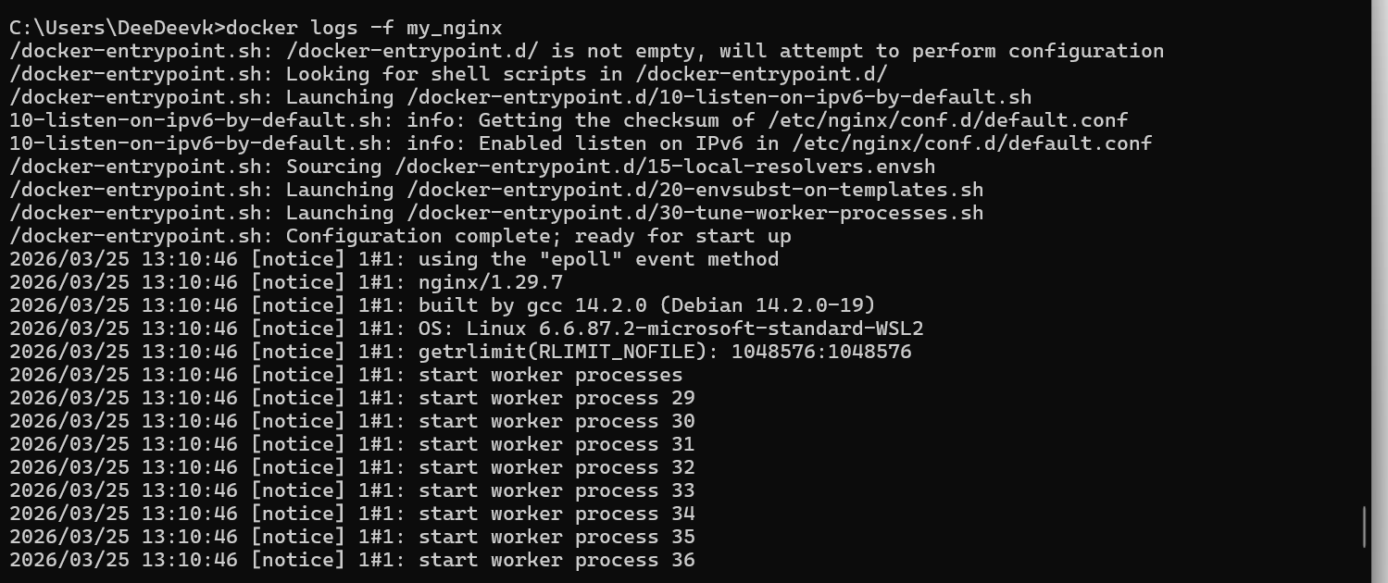
docker build -t my_nginx_image .
