**LOGIC GATES**

Logic gates are an important concept if you are studying electronics. These are important digital devices that are mainly based on the Boolean function. **Logic gates** are the basic building blocks of any digital system. Logic gates are used to carry out logical operations on single or multiple binary inputs and give one binary output. In simple terms, logic gates are the electronic circuits in a digital system.

## Types of Basic Logic Gates

There are several basic logic gates used in performing operations in digital systems. The common ones are;

* **OR Gate**
* **AND Gate**
* **NOT Gate**
* **XOR Gate**

Additionally, these gates can also be found in a combination of one or two. Therefore we get other gates such as NAND Gate, NOR Gate, EXOR Gate, EXNOR Gate.

### OR Gate

**I**n OR gate the output of an OR gate attains the state 1 if one or more inputs attain the state 1.

### Logic diagram

OR Logical Diagram

The Boolean expression of OR gate is Y = A + B, read as Y equals A ‘OR’ B.

**Truth Table**

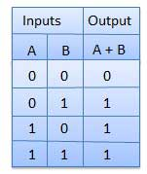

### AND Gate

In AND gate the output of an AND gate attains the state 1 if and only if all the inputs are in state 1.

### AND Logical Diagram

The Boolean expression of AND gate is Y = A.B

### Truth Table

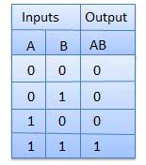

### NOT Gate

In NOT gate the output of a NOT gate attains the state 1 if and only if the input does not attain the state 1. NOT gate is also known as **Inverter**.

### Logic diagram

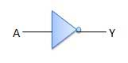

It has one input A and one output Y.

NOT gate

### Truth Table

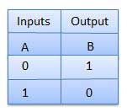

The three gates (OR, AND and NOT), when connected in various combinations, give us basic logic gates such as NAND, NOR gates, which are the universal building blocks of digital circuits.

### NAND Gate

This basic logic gate is the combination of AND and NOT gate.

### Logic diagram

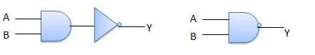

### Truth Table

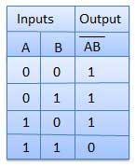

### NOR Gate

This gate is the combination of OR and NOT gate.

### Logic diagram

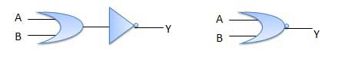

### Truth Table

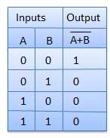

### Exclusive-OR gate (XOR Gate)

In XOR gate the output of a two-input XOR gate attains the state 1 if one adds only input attains the state 1.

### Logic diagram

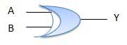

### Truth Table

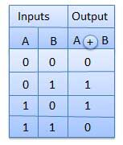

### Exclusive-NOR Gate (XNOR Gate)

In XNOR gate the output is in state 1 when its both inputs are the same that is, both 0 or both 1.

### Logic diagram

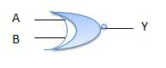

### Truth Table

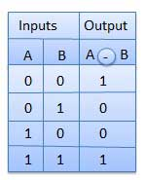

**Summary**

|  |  |  |  |  |  |  |  |
| --- | --- | --- | --- | --- | --- | --- | --- |
| Inputs | | Truth Table Outputs For Each Gate | | | | | |
| A | B | AND | NAND | OR | NOR | EX-OR | EX-NOR |
| 0 | 0 | 0 | 1 | 0 | 1 | 0 | 1 |
| 0 | 1 | 0 | 1 | 1 | 0 | 1 | 0 |
| 1 | 0 | 0 | 1 | 1 | 0 | 1 | 0 |
| 1 | 1 | 1 | 0 | 1 | 0 | 0 | 1 |

**Digital logic circuits**

Digital logic functions can be defined and displayed as either a Boolean Algebra expression or as a logic gate truth table. So here are a few examples of how we can use Boolean Algebra to simplify larger digital logic circuits.

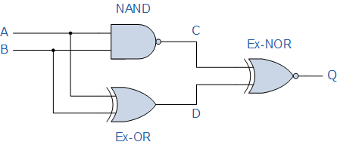

Logical diagram

Truth Table

|  |  |  |  |  |
| --- | --- | --- | --- | --- |
| Inputs | | Output at | | |
| A | B | C | D | Q |
| 0 | 0 | 1 | 0 | 0 |
| 0 | 1 | 1 | 1 | 1 |
| 1 | 0 | 1 | 1 | 1 |
| 1 | 1 | 0 | 0 | 1 |

Find the Boolean algebra expression for the following system.

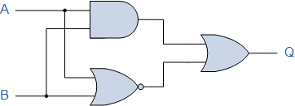

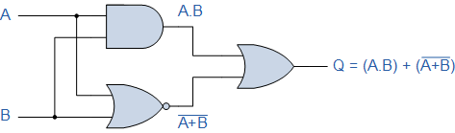

Truth table

|  |  |  |  |  |
| --- | --- | --- | --- | --- |
| Inputs | | Intermediates | | Output |
| B | A | A.B | A + B | Q |
| 0 | 0 | 0 | 1 | 1 |
| 0 | 1 | 0 | 0 | 0 |
| 1 | 0 | 0 | 0 | 0 |
| 1 | 1 | 1 | 0 | 1 |

**APPLICATIONS**

The applications of basic logic gates are so many however they mostly depend on their truth tables otherwise form of operations. Basic logic gates are frequently used in circuits like a lock with push-button, the watering system automatically, burglar alarm activated through light, safety thermostat & other types of electronic devices.

The main advantage of basic logic gates is, these can be used in a different combination circuit. In addition, there is no boundary to the number of logic gates that can be utilized in a single electronic device. But, it can be limited because of the specified physical gap within the device. In digital ICs (integrated circuits) we will discover a collection of the logic gate region unit.

By using mixtures of basic logic gates, advanced operations are often performed. In theory, there’s no limit to the number of gates that may be clad along during a single device. However, in the application, there’s a limit to the number of gates that may be packed into a given physical area. Arrays of the logic gate area unit are found in digital integrated circuits (ICs). As IC technology advances, the desired physical volume for every individual gate decreases, and digital devices of an equivalent or smaller size become capable of acting with more complicated operations at ever-increasing speeds.