Directions to Canandaigua Academy
Canandaigua, New York

The Canandaigua Academy (Canandaigua High School) is located one block east of Main Street on East Street at the north end of the City of Canandaigua.
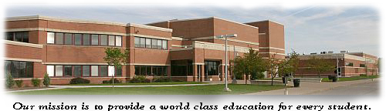

The Canandaigua pool is an eight lane, electronically timed pool with non turbulent lane lines and separate diving well for continuous warm up/down. South (~7.4 miles) from exit 44 on the NYS Thruway on Rt.332 (Main St. in Canandaigua), Turn left (East) on Chapel Street to the end at East Street (~1 mile), Turn left (North) ¼ mile and Right into the High School Parking lot. The pool is just inside the building entrance.

