**SMART Irrigation**

**SYSTEM**

# pngegg

**Created by :**

**Deepayan Das**

**Divyashekhar Sinha**

# CONTENTS

1. **INTRODUCTION**
2. **MOTIVATION**
3. **DESCRIPTION**
4. **APPLICATIONS**
5. **FUTURE SCOPE**
6. **COMPONENTS**
7. **METHODOLOGY**
8. **CONCLUSION**

**9. REFERENCES**

# INTRODUCTION

India is basically an agricultural country, and all its resources depend on the agricultural output. Even in the modern span of industrialization, agriculture is the key area that decides the economic growth of the country. Agriculture also accounts for 8.56% of the country's total exports.

Agriculture is the most important field as compared to others in India. Irrigation is the science of planning and designing an efficient, low-cost, economic irrigation system designed in such a way to fit natural conditions. By the construction of proper distribution system and providing of adequate water supply will increase the yield of crops. Agriculture is the unquestionably the largest livelihood provider in India. With rising population, there is a need for increased agricultural production. In order to support greater production in farms, the requirement of the amount of fresh water used in irrigation also rises. Currently, agriculture accounts 83% of the total water consumption in India. Unplanned use of water inadvertently results in wastage of water. This suggests that there is an urgent need to develop 3 systems that prevent water wastage without imposing pressure on farmers. Over the past 15 years, farmers started using computers and software systems to organize their financial data and keep track of their transactions with third parties and also monitor their crops more effectively. In the Internet era, where information plays a key role in people's lives, agriculture is rapidly becoming a very data intensive industry where farmers need to collect and evaluate a huge amount of information from a diverse number of 4 devices (eg. sensors, farming machinery etc.) in order to become more efficient in production and communicating appropriate information.

MOTIVATION

Smart Irrigation System has the ability to save water. Traditional watering methods can waste as much as 50% of the water used due to inefficiencies in irrigation, evaporation and overwatering.

The automated plant irrigation system will help to reduce the work load on farmers and help to keep the farmlands well irrigated at all times. Most of the farmers all over the world suffer to maintain their crops with proper watering methods, but find themselves helpless. The sensor data collected by the system is uploaded to the cloud, and farmers can access the data using their mobile devices. This allows farmers to monitor the soil moisture level, temperature, humidity, and rainfall in real-time, enabling them to make informed decisions regarding irrigation and crop management.

DESCRIPTION

Smart irrigation is a method of using science and technology to save water in irrigation. It contains weather sensors, soil sensors and various controllers. The sensor monitors the current weather conditions and the actual ground humidity, and the controller controls the water valve to open or close.

APPLICATIONS

SAVE TIME: This system will do all the watering for you.

SAVE WATER: An automatic system uses less water than watering by hand.

SAVE MONEY: Your water bills will be lower and your plants will live longer.

REST EASY: assurance of quality, value, and performance.

FUTURE SCOPE

This smart irrigation system extends watering time for plants, and provides ideal growth condition. It saves time and timer delay as per the environmental condition can be added for automatic watering. This smart irrigation system can be adjusted and modified according to the changing environment.

COMPONENTS

**HARDWARE COMPONENTS:**

* NodeMCU (ESP8266)
* Soil Sensor Module
* 5V Relay Module
* Water pump
* 9V battery
* Breadboard
* Male to Female, Male to Male and Female to Female Jumper wires.

**SOFTWARE COMPONENT:**

* Arduino IDE

**ADDITIONAL COMPONENTS:**

* Soil
* Water flow tube

**IOT PLATFORM USED:**

* Blynk-IoT

METHODOLOGY

The main objective is to apply the system for improvement of health of the soil and hence the plant via multiple sensors. Here we have to build an IoT based Irrigation System using the ESP8266 Module and Soil Moisture Sensor. It will not only automatically irrigate the water based on the moisture level in the soil but also send the data to a dedicated server to keep track of the land condition.

In order to work on difficulties, smart irrigation system has been used in which various sensors such as pH sensor, soil moisture sensor, temperature sensor where in our project we are using soil moisture sensor which is connected to the pins of Arduino microcontroller. The sensed values are stored in Adafruit server, if the sensed values is the water pump will be automatically switched ON and OFF upon value 0. By using these, system the farmer can access the details about the condition of the field anywhere at any time.

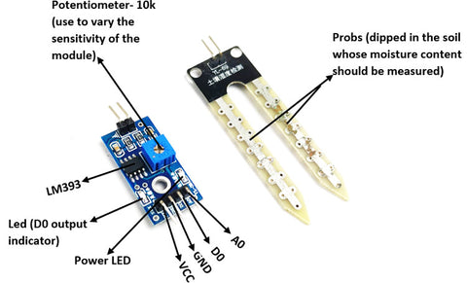

**Fig - 5V Relay**

**CIRCUIT DIAGRAM -**

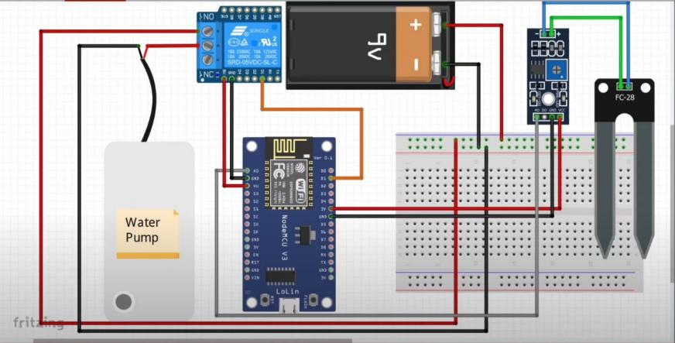

**FLOW DIAGRAM:**

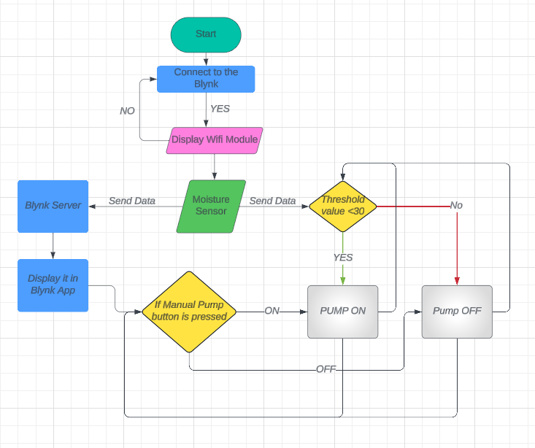

**PROJECT -**

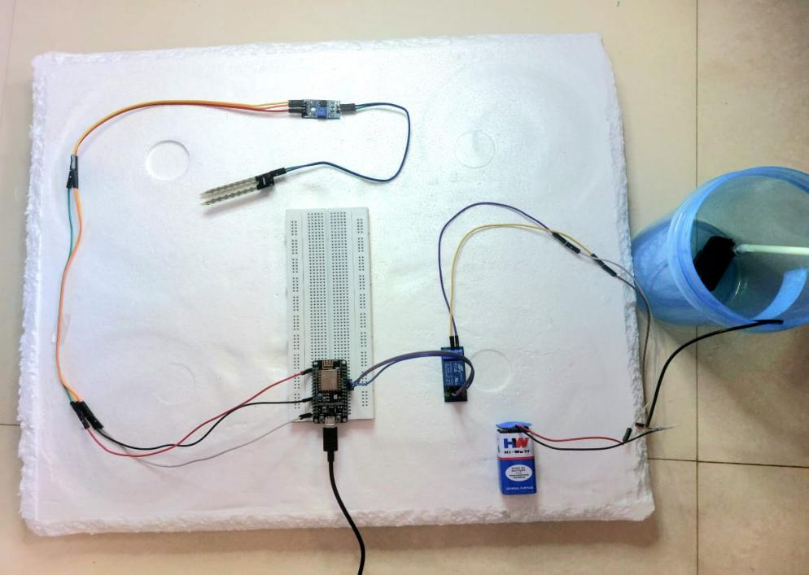

**CODE:**

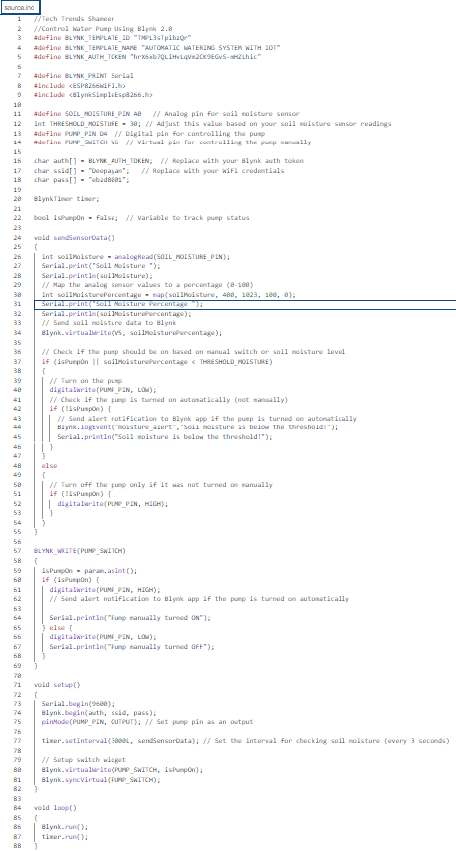

**IOT platform interface (blynk-IOT app):**

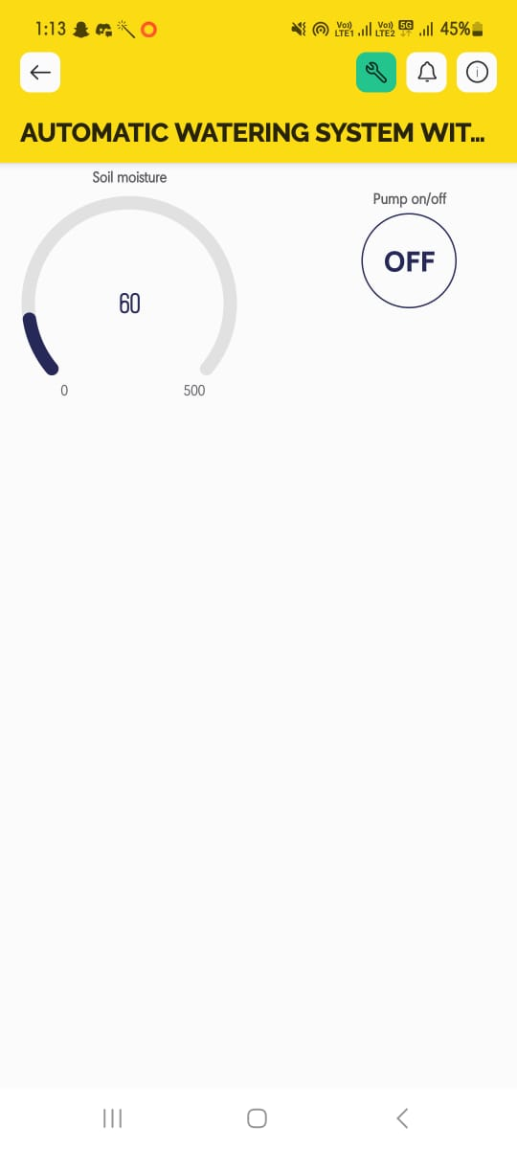

CONCLUSION

The automation in irrigation system is appropriate and price adequate for accessing water source of supply for agriculture management. The regular updates to the server can get proper knowledge to the system and can work perfectly for indefinite time period. Human factor energy and power can be reduced.

REFERENCES

* <https://www.irjet.net/archives/V10/i7/IRJET-V10I715.pdf>
* <https://www.sciencedirect.com/science/article/pii/S2772427122000791>
* <https://www.ncbi.nlm.nih.gov/pmc/articles/PMC8237332/>
* <https://www.researchgate.net/publication/313779760_IOT_based_Smart_Irrigation_System>