DeePAW HALF Technical Feasibility Study
Independent fixed density electronic structure reconstruction and direct VASP initialization
Feasibility conclusion
DeePAW-HALF is technically feasible for controlled use as a standalone fixed-density band and wavefunction generator and as an initializer for the validated VASP workflow. The numerical evidence supports a pilot deployment within the current collinear, full-complex scope. General production release should follow broader material coverage, additional parallel modes, and an in-memory density interface.

Report date September 2026
Assessment status Pilot ready within the validated scope

Executive Summary
The project has demonstrated the core scientific and engineering capabilities needed to replace the Python HAPPY reconstruction path with a compiled Fortran implementation. HALF reconstructs the fixed-density plane-wave Hamiltonian and overlap operator, solves the generalized eigenproblem on CPU or GPU, exports bands and wavefunctions, and exposes the same operations through a reusable library interface.
The strongest end-to-end evidence is the HfO2 validation. Standalone HALF and VASP produce visually coincident band dispersions on the same 100-point path. Their sampled band gaps differ by 0.557 meV, and their direct Gamma-point gaps differ by 2.661 meV. In VASP initialization tests, HALF reduces the electronic iteration count from 16 to 4 or 5 while preserving the converged energy within 2 x 10⁻⁵ eV per cell.
The implementation is therefore suitable for a controlled pilot focused on fixed-density reconstruction and VASP initialization. It should not yet be presented as a universal VASP replacement. The current scope excludes several spin and multi-k-point-group modes, and the first integration still obtains the density and PAW data through files. These constraints are explicit and can be enforced at runtime.

Decision Summary
Decision criterion | Finding | Assessment
Scientific correctness | HAPPY parity and HfO2 agreement with VASP are established for the validated operator and path | Feasible
GPU execution | Potential construction, matrix assembly, and dense eigensolution execute on the GPU | Feasible
VASP integration | Direct wavefunction initialization and in-memory geometry transfer are implemented | Feasible with scope controls
Operational packaging | CMake, CLI, C and Fortran APIs, CPU fallback, and validation outputs are available | Feasible
General production coverage | More materials, spin modes, and parallel layouts require validation or implementation | Not yet complete

Recommendation
Proceed with a controlled pilot that uses HALF for standalone band reconstruction and for VASP initial wavefunctions on supported calculations. Require automatic rejection of unsupported modes, retain the Python HAPPY oracle for regression testing, and make broader production deployment conditional on the validation gates in this report.

Study Scope and Evaluation Basis
This study evaluates whether the current implementation can support useful scientific work and downstream integration without relying on the Python HAPPY execution path. The assessment covers scientific parity, standalone outputs, performance evidence, host-code integration, build and deployment, and remaining delivery risk.

Included Scope
- Fixed-density reconstruction from a smooth charge density and matching PAW dataset.
- CPU Fortran and fully GPU-resident CUDA Fortran solution paths.
- Band structures, eigenpairs, fixed-density energies, forces, and wavefunction export.
- A command-line interface and a versioned library API for external electronic-structure programs.
- Direct VASP initialization with wavefunctions generated from the same fixed density.

Excluded from the Present Claim
- Universal coverage of every VASP calculation mode.
- A general self-consistent electronic-structure replacement for VASP.
- A production in-memory DeepAW density service.
- Large distributed GPU diagonalization beyond the validated single-GPU dense reference path.

Technical Solution
HALF consumes the predicted or converged smooth density together with the matching PAW dataset. It reconstructs the local effective potential, plane-wave basis, PAW projectors, and augmentation terms. The resulting Hamiltonian and overlap operators are solved at requested k points. The density remains fixed; HALF does not run an SCF cycle.
Stage | Function | Primary implementation
Input | Read the lattice, atoms, smooth density, grid, and PAW datasets | Fortran parsers and HDF5 bridge
Potential | Construct ionic, Hartree, exchange-correlation, and core-correction terms | CPU FFT or device-resident cuFFT path
Operator | Build kinetic, local, projector, and augmentation contributions | CPU Fortran or CUDA Fortran
Solve | Solve the complex generalized Hermitian eigenproblem | oneMKL on CPU or cuSOLVER on GPU
Output | Return bands, wavefunctions, energies, forces, and validation records | CLI artifacts and versioned library ABI

The GPU path keeps the potential grid, projectors, dense matrices, and eigensolver data on the device. Full Hamiltonian and overlap matrices are not copied to the host during a direct solve. This design removes the main transfer bottleneck and makes the dense eigensolver the dominant cost for large plane-wave bases.

Standalone Scientific Validation
The project uses HAPPY as the numerical oracle during the port. Matching inputs are compared at progressively deeper levels, including the basis, kinetic energies, local potential, overlap, reconstructed eigenvalues, total-energy terms, and forces. Performance measurements are accepted only after the corresponding numerical result passes.
Validation area | Observed result | Meaning
Silicon full operator | First eight eigenvalues agree with HAPPY at approximately 10⁻¹¹ eV | The complete PBE reconstruction path is numerically closed
HfO2 large matrix | Sixty bands agree with HAPPY at approximately 10⁻¹¹ eV | Multi-species PAW and augmentation terms are reproduced
Arbitrary k point | Eigenvalue differences remain at approximately 10⁻¹² eV | The implementation is not restricted to Gamma
Fixed-density total energy | Reported components agree with HAPPY below 4 × 10⁻¹² eV in the validated silicon case | Energy bookkeeping matches the reference
Finite-difference forces | Agreement within 2.3 × 10⁻⁹ eV per angstrom in the validated silicon case | The force path is consistent with the reference

Figure 1 HfO2 band structure generated directly by standalone DeePAW-HALF
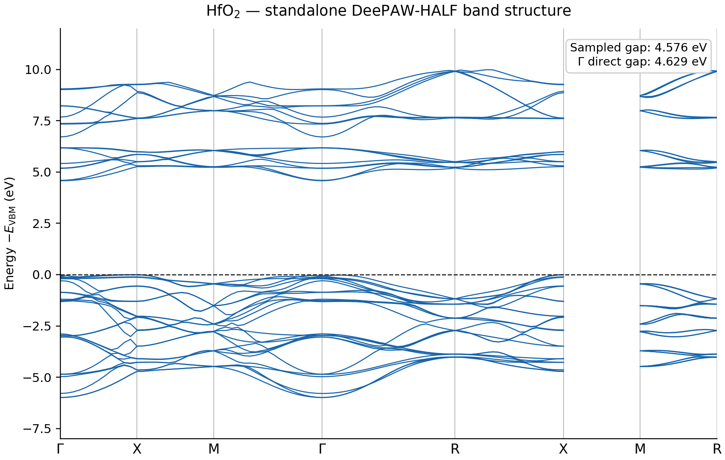
The standalone calculation produces a sampled band gap of 4.576341 eV and a direct Gamma-point gap of 4.629091 eV. No VASP execution is required to obtain this result.

Comparison with VASP
A separate VASP calculation was evaluated on the same 100 k points and with the same 60-band target. Each spectrum is referenced to its own valence-band maximum. The two dispersions overlap throughout the plotted valence and conduction regions.
Figure 2 HfO2 band structure from standalone HALF and VASP on the same k-point path
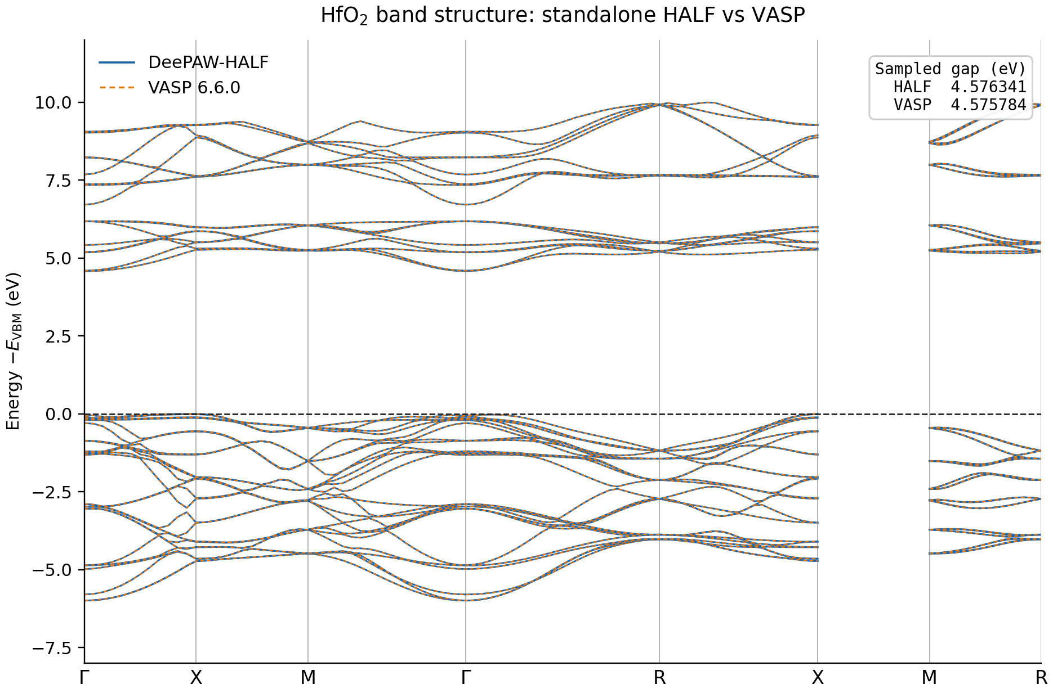
Metric | DeePAW-HALF | VASP 6.6.0 | Absolute difference
Sampled band gap | 4.576341 eV | 4.575784 eV | 0.557 meV
Direct Gamma-point gap | 4.629091 eV | 4.631752 eV | 2.661 meV

This agreement is sufficient for the present feasibility decision. It shows that the standalone implementation reproduces the reference band topology and band gap for the tested HfO2 case, rather than only matching an internal HAPPY intermediate.

VASP Integration Feasibility
The VASP adapter calls HALF after VASP has allocated its wavefunction storage. VASP provides the host plane-wave ordering, and HALF returns eigenvectors already mapped to that ordering. VASP then uses its existing distribution, projector, and orthogonalization routines. This limits the patch surface and keeps VASP responsible for its native data layout and PAW bookkeeping.

Integration Results
Measure | HALF initialization | Native atomic initialization | Result
Electronic iterations | 4 to 5 | 16 | 68.75 to 75 percent fewer iterations
Converged total energy | Reference result | Reference result | Difference below 2 × 10⁻⁵ eV per cell
Host data transfer | Geometry and dense grid metadata passed directly in memory | Not applicable | Stable handoff point for a future direct density API

The iteration reduction is the most portable integration result because it reflects the quality of the initial orbitals rather than a specific processor or accelerator. End-to-end acceleration will still depend on system size, k-point count, hardware, and the fraction of the total job spent in initialization.

Performance and Scaling Feasibility
The compiled implementation removes Python overhead and gives the dense linear algebra to optimized CPU or GPU libraries. The validated HfO2 large-matrix benchmark demonstrates that this architecture can produce material acceleration once the basis is large enough to amortize GPU startup and data-management costs.
Validated comparison | Observed acceleration | Interpretation
GPU HALF versus single-core Python HAPPY | 37.87x | Large complex eigensystems benefit strongly from device-resident assembly and solution
GPU HALF versus single-core CPU HALF | 25.82x | The generalized eigensolver and dense assembly dominate the large case
Single-core CPU HALF versus Python HAPPY | 1.47x | The native Fortran path remains a useful fallback
Four CPU MPI ranks versus one rank | 3.903x | Independent k points scale efficiently with exact eigenvalue agreement

These ratios are workload and hardware dependent. They establish feasibility, not a universal performance guarantee. Small matrices may favor the CPU because GPU initialization and dense-solver overhead can exceed the useful work.

Software and Operational Feasibility
HALF is packaged as both an executable and an installable shared library. The command-line interface supports inspection, single-k-point solutions, band paths, fixed-density energies, forces, and wavefunction output. The library uses a versioned C ABI with portable Fortran bindings and CMake and pkg-config metadata.
Capability | Current support | Operational value
Build system | CPU, CPU MPI, CUDA, and VASP integration presets | Repeatable builds across supported toolchains
Runtime selection | CPU or CUDA backend and supported eigensolver selection | One application interface for multiple deployments
External API | Opaque context, basis queries, operator assembly or application, and direct k-point solve | Integration model comparable to established numerical libraries
Validation artifacts | JSON, CSV, NPZ, figures, and regression tests | Machine-readable evidence and reproducible comparisons
Failure handling | Basis mismatch and unsupported modes produce explicit errors | Incorrect silent fallback is avoided

Constraints and Risks
Risk | Current condition | Required control
Scientific coverage | Validation is deep but concentrated in silicon and HfO2 | Add chemically diverse insulators, metals, magnetic systems, and stress cases before broad release
Unsupported host modes | Several spin and advanced parallel configurations are outside the current adapter scope | Reject unsupported inputs and expand one mode at a time with parity tests
Dense-solver scaling | The reference solver has cubic cost and rising device-memory demand | Introduce block iterative and matrix-free production solvers for larger systems
Input path | The first integration still reads density and PAW data from files | Add an in-memory density constructor after the scientific contract is frozen
Toolchain coupling | GPU builds depend on a compatible NVIDIA compiler and CUDA toolchain | Pin tested build profiles and run CI on each supported toolchain
VASP licensing | VASP source and derived integration builds are private licensed assets | Keep proprietary source out of public distributions and ship only the independent adapter code

Implementation Plan
- Pilot the current standalone band and VASP initialization paths on a controlled set of insulating and semiconducting materials. Record band gaps, orbital overlap checks, iteration counts, converged energies, and failure modes.
- Add the direct in-memory density interface so host programs can supply structure, grid, density, and PAW data without reparsing files. Keep the file path as a reproducible fallback.
- Extend host parallelism to additional k-point groups and add explicit device ownership tests. Continue to reject unsupported spin modes until their data contracts and validation suites are complete.
- Replace the dense reference solve with a block iterative production path for larger bases while retaining the dense solver as a numerical oracle for small and medium systems.
- Promote to production only after the expanded material suite passes fixed tolerances and the integration regression suite runs automatically on every supported build profile.

Production Readiness Gates
Gate | Acceptance evidence
Numerical breadth | A diverse material suite passes predefined eigenvalue, energy, force, and wavefunction-overlap tolerances
Host correctness | All supported VASP modes pass basis mapping, orthonormality, convergence, and restart comparisons
Operational reliability | Build, install, CLI, API, and error-path tests pass on every supported CPU and CUDA profile
Performance stability | Repeated measurements show the expected benefit for target workloads without correctness regressions
Interface completeness | The in-memory density path is validated and file-backed inputs remain reproducible

Final Feasibility Decision
DeePAW-HALF has passed the threshold for a controlled technical pilot. The implementation reproduces the fixed-density reference operator, generates standalone HfO2 bands that agree with VASP, improves VASP starting orbitals, and provides a credible CPU and GPU integration surface.
The recommended decision is to proceed with pilot integration and expanded validation. General production status should remain conditional on broader materials coverage, completion of the in-memory density path, and explicit support or rejection for every intended host mode.

