User Manual
Smart QR Attendance System for Educational Institutions
Department of Computer Science, University of Ibadan
Version 1.0 · [Month Year] · Prepared by [Your full name]

Contents
- 1. Introduction
- 2. What you need
- 3. Getting started
- 4. Administrator guide
- 5. Lecturer guide
- 6. Student guide
- 7. Messages and troubleshooting
- 8. Good security practice
- 9. Installation (for the system administrator)

1. Introduction
The Smart QR Attendance System replaces paper sign-in sheets and roll calls. A lecturer starts an attendance session and displays a QR code in class; students scan the code with their phone camera and confirm their attendance. The system checks every submission and keeps an attendance register for each course.
The system has three types of user:
Role | What they can do
Administrator | Create and manage user accounts, reset passwords, create courses, assign lecturers and view every attendance register.
Lecturer | Create and manage their own courses, enrol students, run QR attendance sessions, and view and export registers for their courses.
Student | Scan QR codes to record attendance and view their own attendance history and percentages.

2. What you need
- Lecturers and administrators: a computer with an up-to-date web browser (Chrome, Edge or Firefox). For classes, a projector or large screen to display the QR code.
- Students: a smartphone whose camera can read QR codes (most Android phones and iPhones do this in the normal camera app) and a web browser.
- Everyone: a connection to the network the system runs on (for example, the department Wi-Fi), and an account created by the administrator.

3. Getting started

3.1 Signing in
- Open the system's address in your browser (ask the administrator for it, for example http://192.168.0.10:5000).
- Enter your email address and password, then select Sign in.
- You are taken to the dashboard for your role.
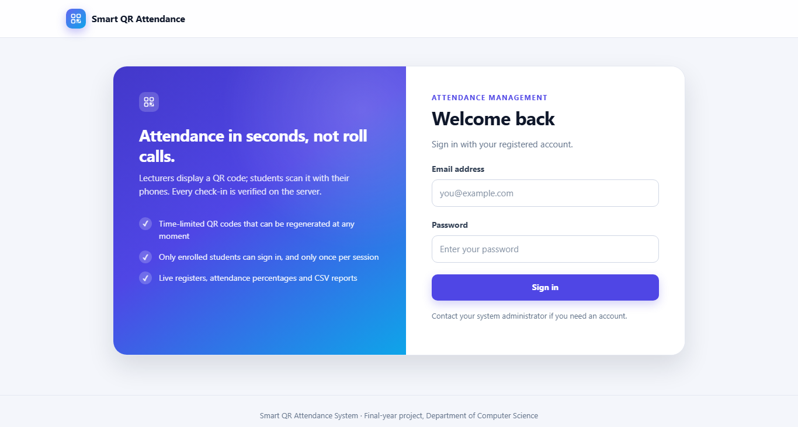
Figure 1: The sign-in page
If you see "Invalid email address or password", check both and try again. For security, the message does not say which of the two was wrong.

3.2 Changing your password
Select your name in the top-right corner, enter your current password and your new password twice, then select Change password. Passwords must be at least 8 characters long. Change the initial password the administrator gave you the first time you sign in.

3.3 Signing out
Select Sign out in the top-right corner. Always sign out when you finish on a shared computer.

4. Administrator guide
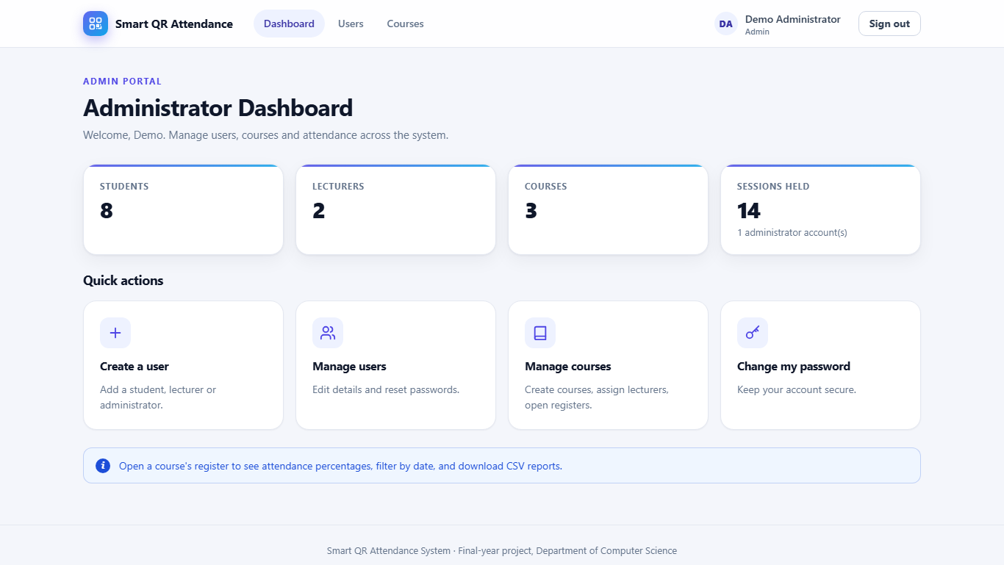
Figure 2: Administrator dashboard

4.1 Creating a user account
- Select Users in the top menu, then Create user.
- Enter the person's full name and email address and choose their role.
- For a student, enter their matriculation (student) number. It must be unique.
- Enter an initial password (at least 8 characters) twice, then select Save user.
- Give the person their initial password privately and ask them to change it when they first sign in.
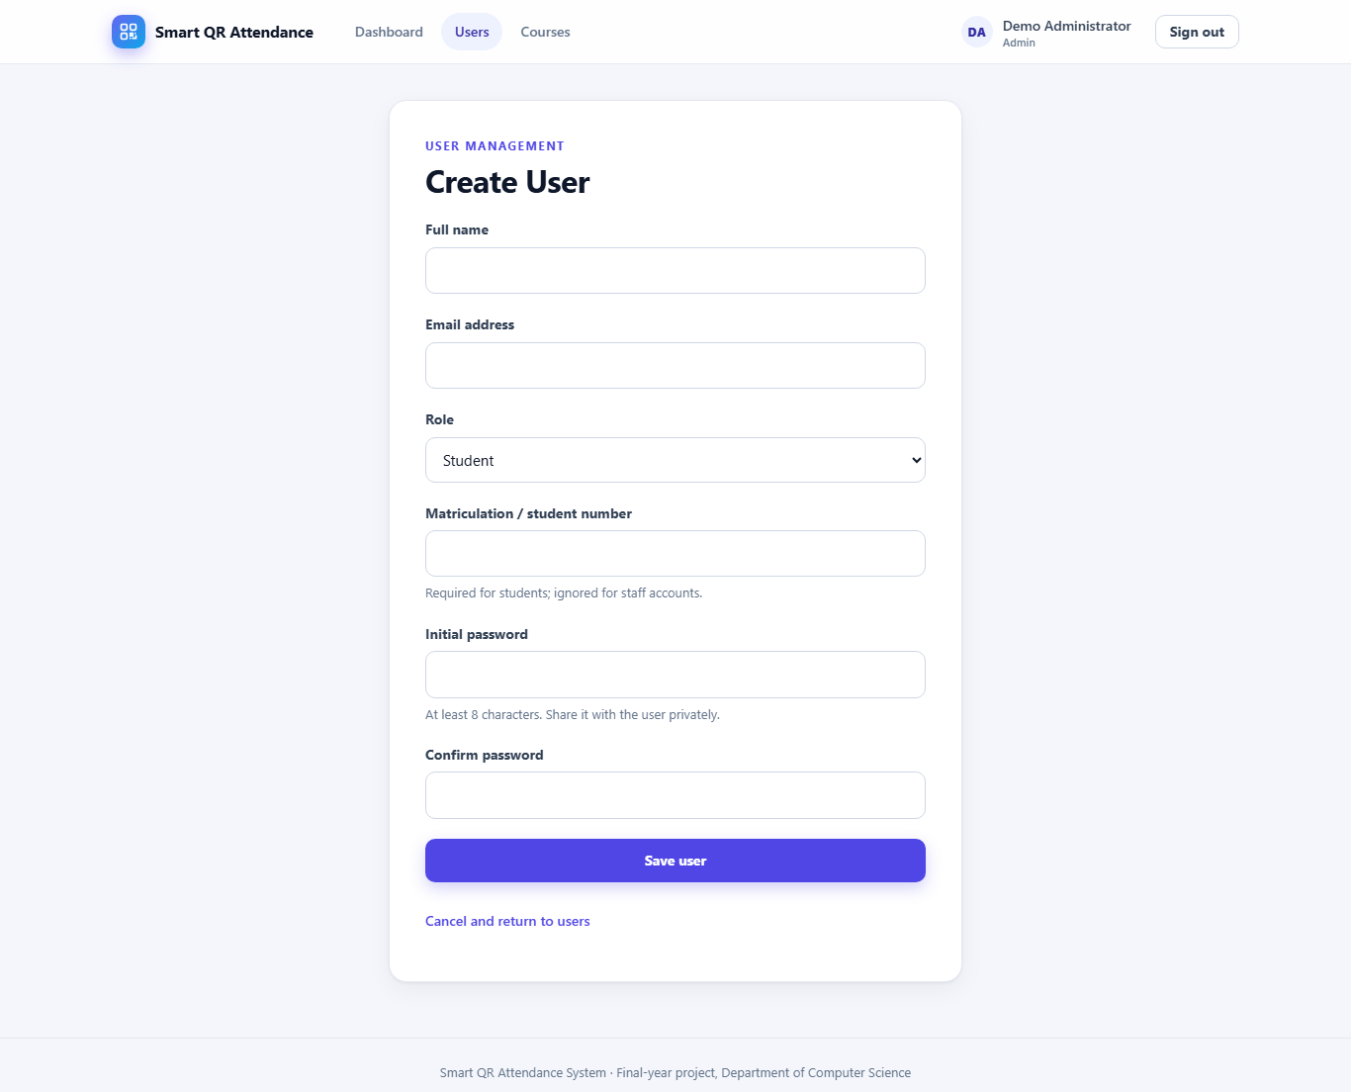
Figure 3: Creating a user account
If an email address or student number is already in use, or a required field is missing, the form explains the problem next to the field. A user's role cannot be changed after the account is created; create a new account instead.

4.2 Editing a user or resetting a password
- Select Users. Use the Show list to filter by role if needed.
- Select Edit to change a name, email address or student number, or Reset password to set a new password for a user who has forgotten theirs.

4.3 Managing courses
- Select Courses in the top menu.
- Select Create course, enter the course code and title, and choose the lecturer; or select Edit / reassign next to an existing course to change its details or lecturer.
- Select Register next to any course to view its attendance register (see Section 5.6).
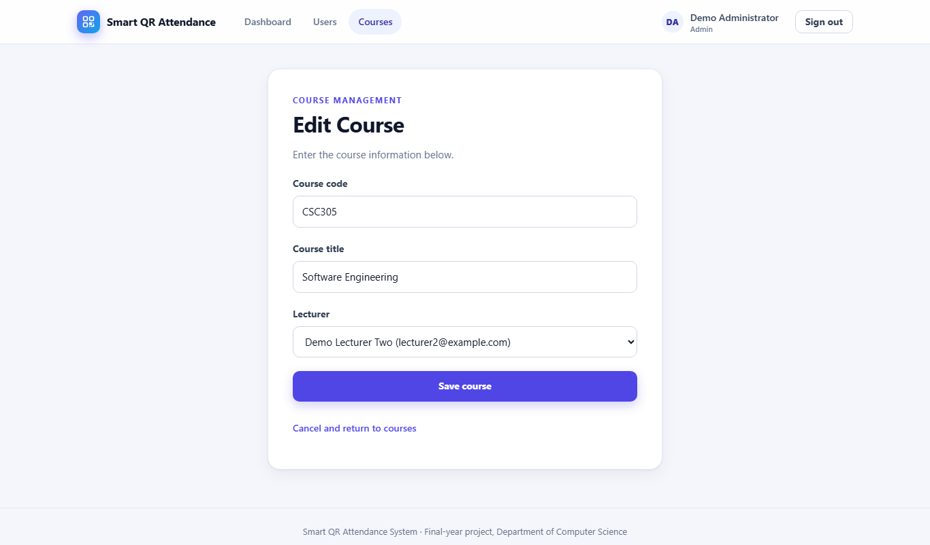
Figure 4: Assigning a course to a lecturer

5. Lecturer guide
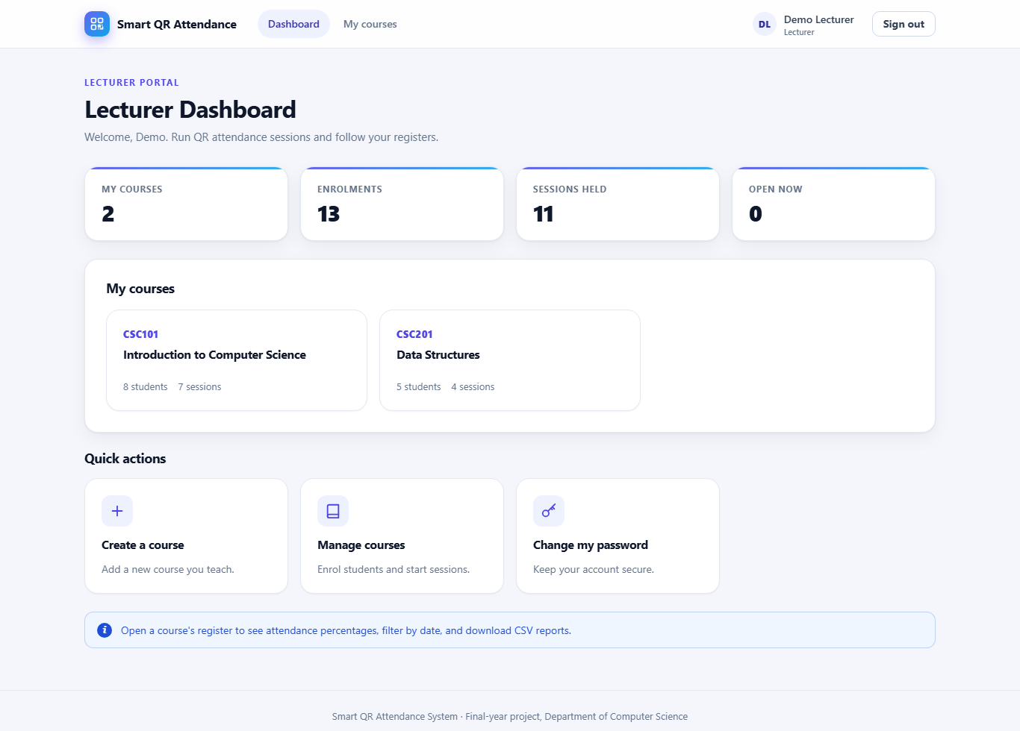
Figure 5: Lecturer dashboard

5.1 Creating a course
Select My courses, then Create course. Enter the course code (for example CSC301) and title, then select Save course. Course codes must be unique.

5.2 Enrolling students
- Select My courses, then the course title (or View).
- Under Enrol a student, choose the student from the list and select Enrol student.
- To remove a student, select Unenrol next to their name. A student who already has attendance recorded for the course cannot be removed, to protect the attendance history.
Only enrolled students can record attendance for a course.

5.3 Taking attendance with a QR code
- Open the course page. Under Attendance sessions, choose how long attendance will be accepted (5 minutes to 1 hour), then select Start attendance session.
- Display the page showing the QR code on the projector or screen.
- Ask students to scan the code with their phone cameras and confirm (Section 6).
- Watch the Present count rise and the countdown fall; the list of students present updates on the page.
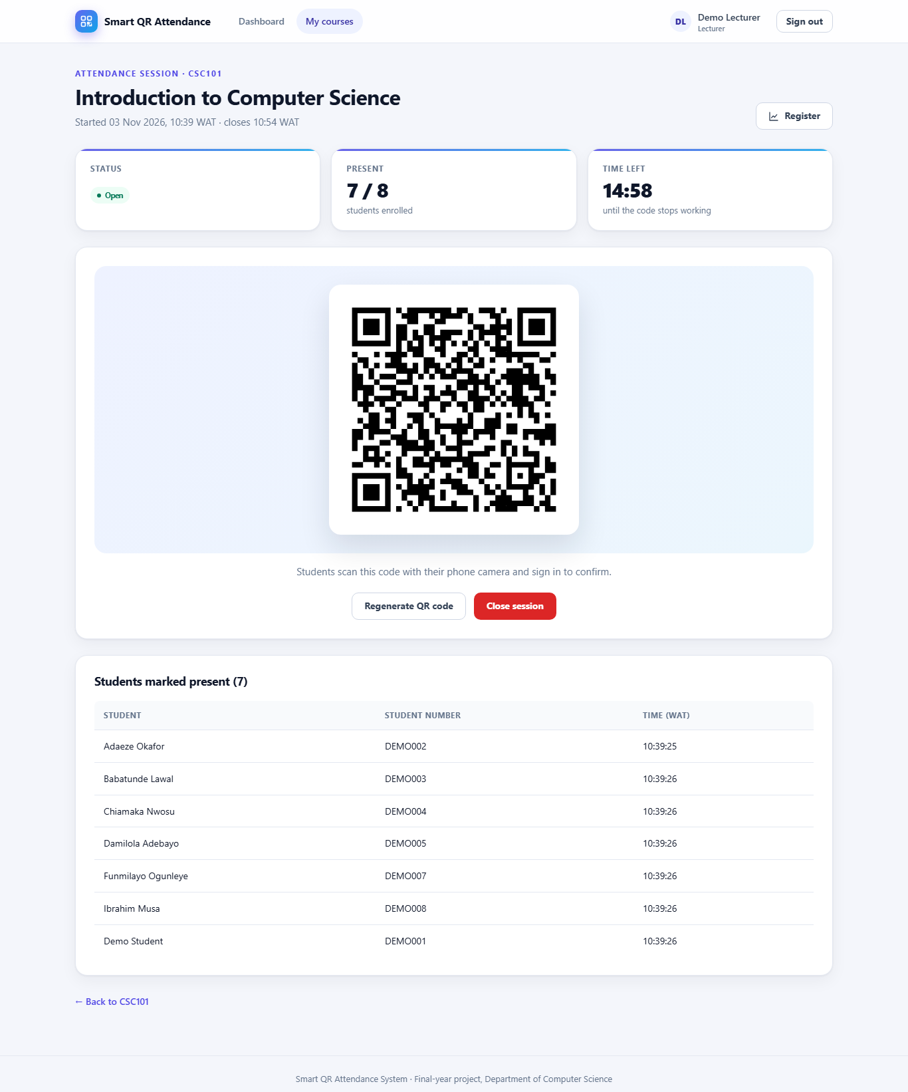
Figure 6: A live attendance session: QR code, countdown and students present
During the session you can:
- Regenerate QR code: issues a new code immediately; the old one stops working. Use this if you suspect a photo of the code is being shared with students who are not in the room.
- Close session: stops attendance immediately and records the actual end time. Otherwise the session closes automatically when the countdown reaches zero.
Only one session per course can be open at a time. If the page warns that the QR code points to localhost, students' phones cannot reach it: open the system using the computer's network address instead, as described in Section 9.

5.4 Showing the QR code on another computer
For security, a QR code can be displayed only in the browser that created it. If you move to another computer, open the session and select Issue new QR code.

5.5 Reviewing a session
Each session appears in the table on the course page with its date, time, status and the number of students present. Select View to see who was present and when they signed in.

5.6 Attendance registers and reports
- Select View attendance register on the course page (or Register in the course list).
- The register shows each student against each session: ✓ present, ✗ absent, and — for a session held before the student enrolled (which is not counted).
- Students below the minimum attendance (75%) are highlighted in red.
- To report on a period, enter From and To dates and select Apply filter.
- Select Download CSV to save the register as a file that opens in Excel or Google Sheets. The file uses the same date filter.
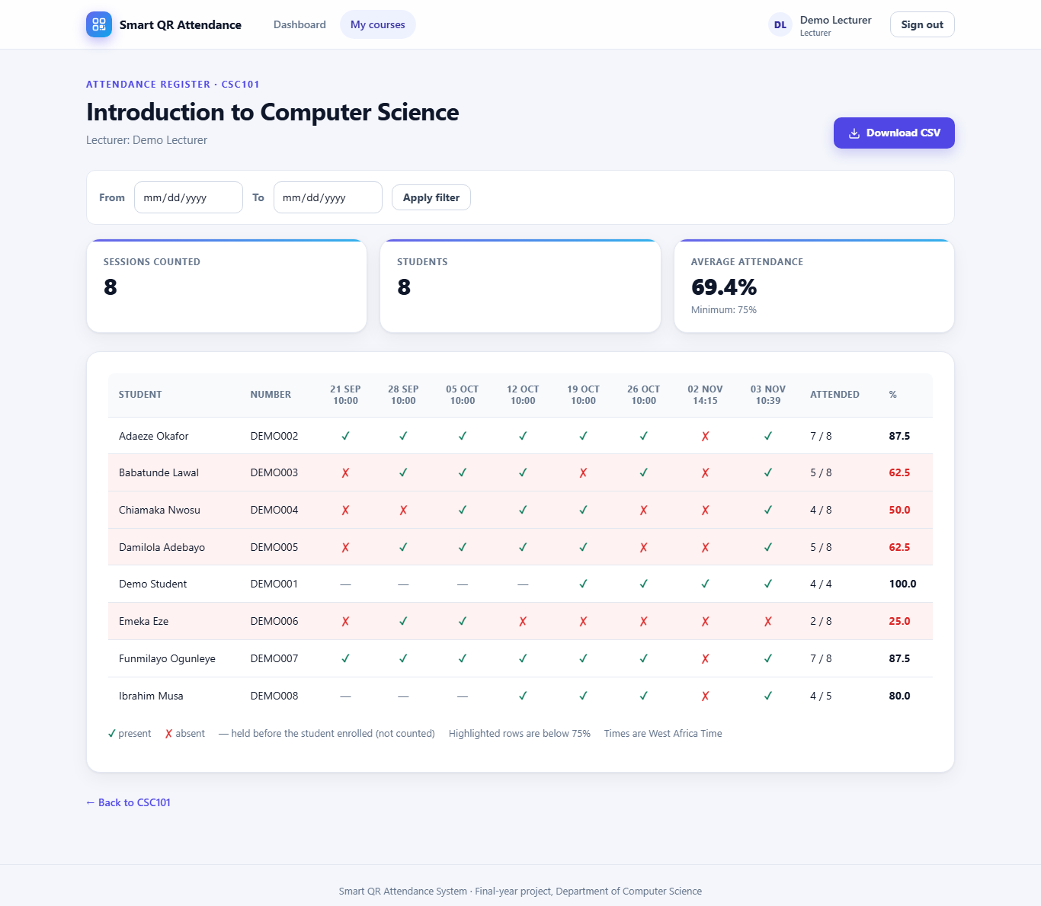
Figure 7: Attendance register with percentages
A session is counted only after it has ended. The percentage for each student is the number of sessions attended divided by the number of sessions held since they enrolled.

6. Student guide

6.1 Recording your attendance
- When your lecturer displays the QR code, open your phone's camera and point it at the code.
- Tap the link that appears.
- If asked, sign in with your email address and password. You are returned to the attendance page automatically.
- Check the course shown, then tap Mark me present.
- Wait for the green message "Your attendance has been recorded".
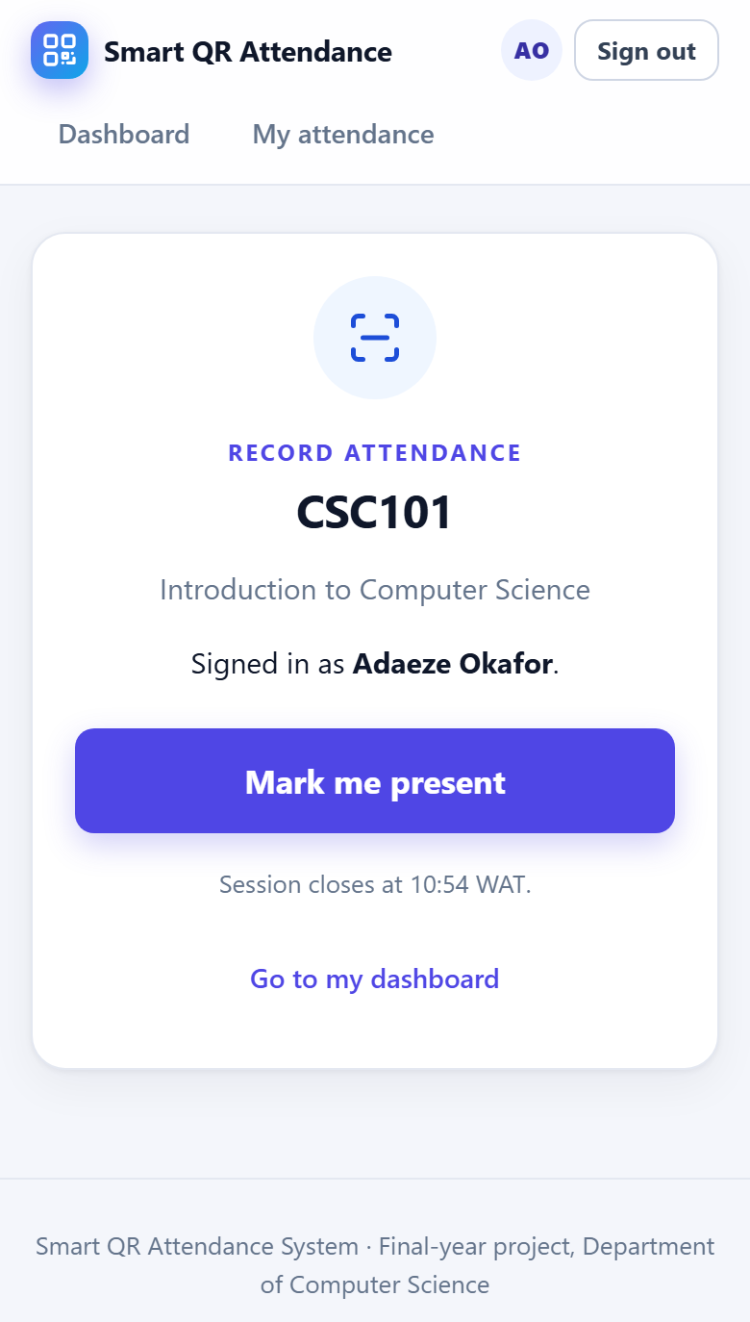
Figure 8: Confirming attendance after scanning
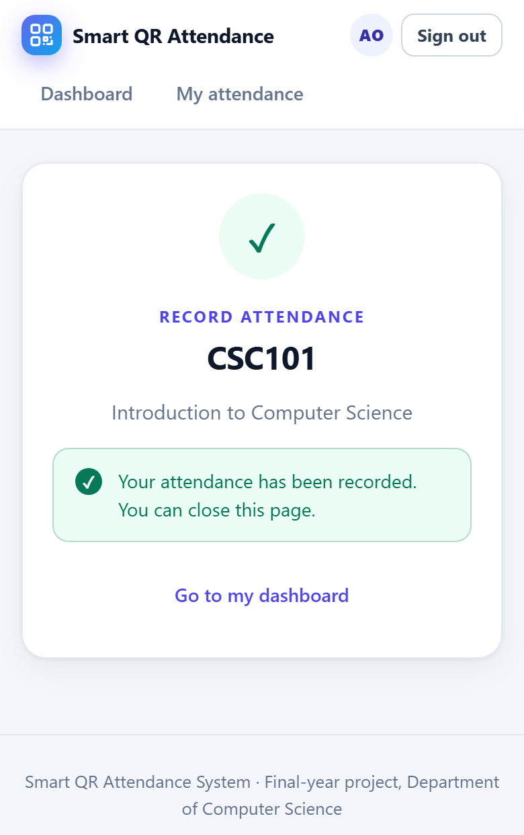
Figure 9: Attendance recorded
Simply opening the link does not record attendance: you must tap Mark me present before the session closes.

6.2 Viewing your attendance
Select My attendance in the top menu to see, for each course, the sessions you attended, your percentage and a warning if you are below the minimum. A session that is still in progress appears once it has ended.
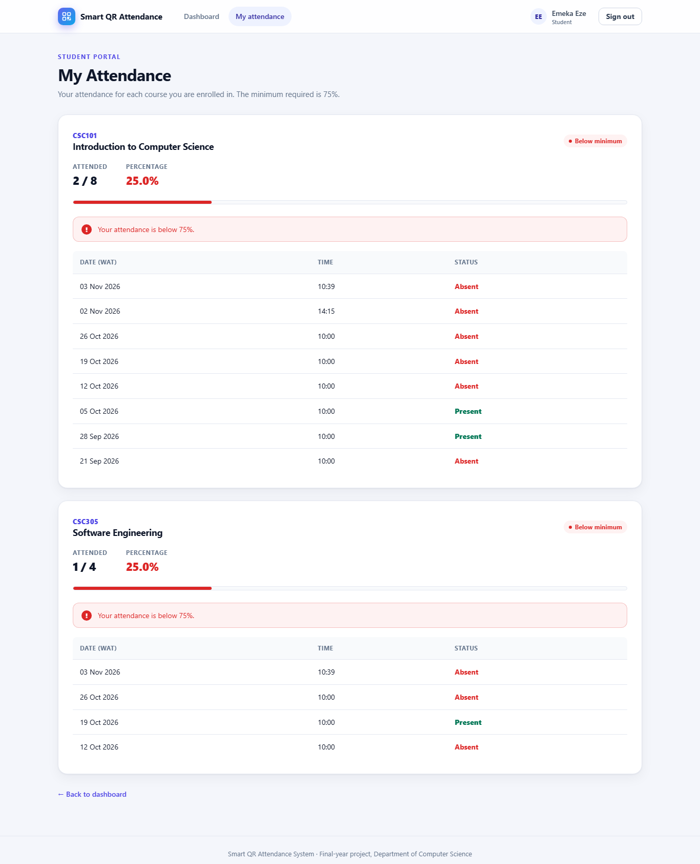
Figure 10: A student's attendance history

7. Messages and troubleshooting
Message or problem | What it means | What to do
Your attendance has been recorded | Success. | Nothing; you can close the page.
Your attendance for this session is already recorded | You (or another tap) already marked attendance for this session. | Nothing; you are marked present once.
This QR code is not valid | The code was mistyped, or the lecturer has issued a new code. | Scan the code currently on the screen.
This attendance session has expired | The time limit has passed. | Speak to your lecturer.
The lecturer has closed this attendance session | The lecturer ended the session. | Speak to your lecturer.
You are not enrolled in this course | Your account is not enrolled in that course. | Ask your lecturer or the administrator to enrol you.
Access denied | Your role cannot open that page. | Use the menu for your role.
Please try again (form expired) | The page was open too long or you signed in elsewhere. | Go back, refresh the page and try again.
The link from the QR code does not open | Your phone is not on the right network, or the lecturer's page is using a localhost address. | Join the class Wi-Fi; lecturers should see Section 5.3.
Forgotten password | — | Ask the administrator to reset it, then change it after signing in.

8. Good security practice
- Never share your password, and change the initial password the first time you sign in.
- Students: do not photograph or forward the QR code. Recording attendance for someone who is absent is academic misconduct.
- Lecturers: keep sessions short, and select Regenerate QR code if you suspect the code is being shared.
- Always sign out on shared or public computers.

9. Installation (for the system administrator)
Full instructions are in the README.md file supplied with the source code. In summary, on Windows with Python 3.12 or later:
Step | Command (PowerShell, in the project folder)
1. Create an environment | python -m venv venv  venv\Scripts\Activate.ps1
2. Install the software | pip install -r requirements.txt
3. Create the database | python init_db.py
4. Set a secret key (production) | $env:SECRET_KEY = "<a long random value>"
5. Run for a class on the local network | flask --app app run --host 0.0.0.0

Then open the system from the lecturer's computer using its network address (shown by the ipconfig command), for example http://192.168.0.10:5000, so that the QR code points to an address students' phones can reach. Back up the database by stopping the system and copying instance\attendance.db.

