HYBRID CNN–LSTM MODEL FOR FAULT DETECTION AND CLASSIFICATION IN POWER DISTRIBUTION SYSTEMS

Author: [Your Name]
Student ID: [Your Student ID]

ACHIEVERS UNIVERSITY (AUFAP)
FACULTY OF ENGINEERING
DEPARTMENT OF ELECTRICAL AND INFORMATION ENGINEERING

COURSE: INTRODUCTION TO ARTIFICIAL INTELLIGENCE / MACHINE LEARNING / CONVERGENT TECHNOLOGIES (GET 307)
LEVEL: 400L UNDERGRADUATE (B.ENG)

LECTURER: Dr. OLUMHENSE BENEDICT ADOGHE, PH. D

SUBMISSION DATE:
TABLE OF CONTENTS
ABSTRACT v
CHAPTER ONE 1
INTRODUCTION 1
1.1 Background 1
1.2 Problem Statement 2
1.3 Research Contribution 3
1.4 Definition of Terms 3
CHAPTER TWO 6
LITERATURE REVIEW 6
2.1 Traditional Fault Detection Systems 6
2.1.1 Overcurrent Protection (OCP) 6
2.1.2 Impedance-Based Distance Relays 6
2.1.3 Differential Protection 7
2.2 Limitations of Traditional Methods 10
2.3 Machine Learning Approaches 11
2.4 Deep Learning for Fault Detection 12
2.5 Hybrid CNN-LSTM Architecture 14
2.6 Research Gap 14
CHAPTER THREE 16
METHODOLOGY 16
3.1 Introduction to Methodology 16
3.2 Data Preprocessing 17
3.2.1 Feature normalization 17
3.2.2 Time window creation 17
3.2.3 Train-test split 17
3.3 Model Architecture 19
3.4 Training Configuration 19
3.5 Evaluation Metrics 19
CHAPTER FOUR 20
RESULTS 20
4.1 Overall Model Performance 20
4.2 Class-wise Performance 20
4.3 Training History 21
4.4 Confusion Matrix Analysis 22
4.5 ROC and Precision-Recall Curves 22
4.6 DISCUSSION 25
4.6.1 Interpretation of Results 25
4.6.2 Comparison with related literature 25
4.6.3 Model strengths 25
4.6.4 Model limitations 25
CHAPTER FIVE 26
CONCLUSION 26
5.1 Key Findings 26
5.2 Recommendations for Future Work 26
5.2.1 Dataset improvements: 26
5.2.2 Model enhancements: 26
5.2.3 Real-time deployment: 27
5.3 Remarks 27
REFERENCES 28
APPENDICES 31
Appendix A: Model Architecture Summary 31
Appendix B: Hyperparameters Summary 31
Appendix C: Code Modules 31

TABLE OF FIGURES
Figure 2. 1: Schematic diagram of overcurrent protection for a line fixed time limit (knoweasy, 2021) 8
Figure 2. 2: Distance Relay or Impedance Relay Working Principle (Electrical4U, 2024) 9
Figure 4. 1: Class-wise F1-Scores 21
Figure 4. 2: Training and Validation Accuracy/Loss Curves 21
Figure 4. 3: Confusion Matrix for Six Fault Classes 22
Figure 4. 4: ROC Curves for All Fault Classes 23
Figure 4. 5: Precision-Recall Curves for All Fault Classes 24

LIST OF TABLES
Table 3. 1:Dataset characteristics 18

ABSTRACT
Fault detection and classification in power distribution systems is critical for ensuring grid reliability, minimizing downtime, and enhancing operational safety. Traditional fault detection methods rely on threshold-based or impedance-based approaches that require extensive domain expertise and often fail under dynamic operating conditions or noisy environments. This study presents a hybrid deep learning approach that combines Convolutional Neural Network (CNN) and Long Short-Term Memory (LSTM) architectures to automatically learn spatial and temporal patterns in electrical fault data. The CNN component extracts discriminative spatial features from multivariate time-series measurements of three-phase current and voltage, while the LSTM component captures temporal dependencies within fault signal windows. The model was trained, validated, and tested using an open-source electrical fault dataset from Kaggle containing 7,861 labeled samples across six fault classes: No Fault, Line-to-Ground (LG), Line-to-Line (LL), Line-to-Line-to-Ground (LLG), Three-Phase (LLL), and Three-Phase with Ground (LLLG). Results demonstrate an overall accuracy of 78.01%, precision of 77.53%, recall of 78.01%, and F1-score of 77.47%, with notable performance in identifying line-to-ground faults. Performance metrics were supplemented with confusion matrices, ROC curves, precision-recall curves, and learning curves. Comparative analysis with existing literature demonstrates that hybrid CNN-LSTM models improve classification accuracy over standalone networks in similar applications. The study concludes that CNN–LSTM hybrid architectures provide an effective framework for automated fault diagnostics in power systems and recommends future work on larger datasets, attention mechanisms, and integration with real-time grid monitoring systems.
Word Count: 233

CHAPTER ONE

INTRODUCTION

Background
Power distribution systems constitute the backbone of modern electrical infrastructure, responsible for delivering electricity from generation sources to industrial, commercial, and residential end-users (Short, 2018). Unlike the high-voltage transmission grid, distribution networks are characterized by their vast geographical spread, radial or weakly meshed configurations, and a high degree of complexity due to unbalanced loading and the integration of Distributed Energy Resources (DERs) like solar PV and wind turbines. These factors make the electrical environment highly "noisy," complicating the task of monitoring and protection.
The reliability and stability of these systems are paramount to economic productivity, public safety, and quality of life. However, these networks are inherently susceptible to various fault conditions. These are broadly categorized into:
- Symmetrical Faults: Such as Three-Phase (LLL) faults, which, while rare, are the most severe in terms of current magnitude.
- Unsymmetrical Faults: Including Single Line-to-Ground (SLG), Line-to-Line (LL), and Double Line-to-Ground (LLG) faults, which constitute over 80% of all grid disturbances (Gururajapathy et al., 2017).
These faults can arise from equipment failure, environmental factors like lightning and storms, insulation breakdown, or aging infrastructure.
Unexpected faults can disrupt service continuity, damage expensive equipment such as transformers and circuit breakers, pose safety hazards, including fire and electrocution risks, and incur significant economic losses through downtime and repair costs (Idima, 2023).
Traditionally, fault detection has relied on overcurrent relays and distance protection schemes. While effective for simple radial lines, these methods struggle with High-Impedance Faults (HIF), which occur when a conductor touches a poorly conductive surface (like a tree limb or asphalt) (Theron et al., 2018). The fault current is too low to trigger traditional breakers but high enough to cause fires. Distinguishing between a genuine fault and the temporary "inrush current" when a large motor starts is a major challenge for legacy systems (Mousa et al., 2025). Rapid and accurate fault detection and classification are therefore essential to minimize these impacts through timely protective relay operation, targeted maintenance interventions, and informed operational decision-making.

Problem Statement
Faults in power distribution systems occur unpredictably and can evolve rapidly from inception to full fault conditions within milliseconds. The consequences of undetected or misclassified faults include service interruptions, equipment damage, safety hazards, and economic losses.
Traditional diagnostic methods face significant challenges in adaptability, noise sensitivity, manual engineering requirements, limited generalization, and handling complex fault scenarios. There is a critical need for scalable, automated diagnostic tools that can learn directly from monitored electrical data, recognize complex spatial and temporal patterns, classify diverse fault scenarios with high accuracy, and generalize across different operating conditions.
This study addresses this need by developing a data-driven hybrid neural network that combines CNN and LSTM architectures to classify electrical faults with minimal manual intervention.

Research Contribution
This study implements, evaluates, and analyzes a hybrid CNN-LSTM model for electrical fault classification using an open-access dataset. The primary contributions include:
- Development of a complete preprocessing pipeline for electrical fault data
- Design and implementation of a hybrid CNN-LSTM architecture tailored for fault classification
- Comprehensive evaluation using multiple performance metrics and visualization techniques
- Comparative analysis with existing literature to contextualize results
- Identification of strengths, limitations, and recommendations for future work
The study provides a reproducible framework suitable for academic research and potential adaptation to real-world power system applications.

Definition of Terms
To ensure a clear understanding of the proposed research, the following key terms and concepts are defined within the context of power system protection and deep learning.
- Power Distribution System: The final stage of the electrical grid that delivers electricity from the transmission network to end-users. Unlike transmission lines, these systems are often radial or weakly meshed and face challenges like unbalanced loads and high impedance (Kouraichi et al., 2025).
- Fault Detection: The process of identifying an abnormal condition in an electrical circuit, such as a short circuit or an open circuit, which deviates from the steady-state operating parameters (Ibitoye et al., 2022).
- Fault Classification: The analytical task of identifying the specific nature of a fault. In three-phase systems, this includes Line-to-Ground (LG), Line-to-Line (LL), Double Line-to-Ground (LLG), and Three-Phase (LLL) faults (Chawda et al., 2020).
- Convolutional Neural Network (CNN): A class of deep neural networks originally designed for visual imagery. In the context of power systems, 1D or 2D CNNs are employed for automated feature extraction from raw current and voltage waveforms, eliminating the need for manual signal processing (Hong et al., 2022).
- Long Short-Term Memory (LSTM): A specialized type of Recurrent Neural Network (RNN) capable of learning long-term dependencies. LSTMs are critical for analyzing time-series data, as they utilize "gates" to retain or forget information over time, making them ideal for capturing the transient nature of electrical faults (Zhang et al., 2018).
- Hybrid CNN–LSTM Model: An integrated architecture where the CNN layers act as a spatial feature extractor, and the LSTM layers act as a temporal processor. This hybrid approach allows for the simultaneous analysis of the magnitude (shape) and the sequence (timing) of fault signals (Zamzam & Massaoudi, 2024).

CHAPTER TWO

LITERATURE REVIEW

Traditional Fault Detection Systems
Traditional fault detection systems are primarily deterministic, relying on predefined mathematical relationships and physical thresholds to identify anomalies. These systems use Protective Relays to monitor electrical parameters such as current, voltage, and frequency, initiating a trip signal to circuit breakers when a fault is detected (Gers, 2011).

Overcurrent Protection (OCP)
The most fundamental strategy in traditional fault detection is overcurrent protection, as shown in Figure 1.1, which operates on the principle that most electrical faults result in a significant surge in current magnitude. Within radial distribution systems, overcurrent relays act as the primary defense mechanism by monitoring current levels against a predefined "pickup" threshold. These systems are typically categorized into instantaneous and inverse-time characteristics. Instantaneous relays provide an immediate response to high-magnitude faults near the source. In contrast, inverse-time relays introduce a delay that is inversely proportional to the fault current, ensuring that the protection system is selective and allows downstream devices to clear smaller faults first (Chen, 2017). However, the effectiveness of OCP is increasingly challenged by the integration of distributed energy resources, which can alter fault current levels and lead to protection "blinding" or sympathetic tripping.

Impedance-Based Distance Relays
Distance protection (IEEE Device 21) is widely utilized because its operation is independent of the current magnitude, which can vary based on generation levels. This method calculates the apparent impedance of the line by measuring the ratio of voltage to current (Z=V/I) at the relay location. Since the impedance of a power line is directly proportional to its physical length, these relays can estimate the distance to a fault and determine if it falls within a specific "Protection Zone".
Typically, Zone 1 is set to cover the majority of the primary line instantaneously, while subsequent zones provide backup protection for adjacent lines with intentional time delays (Pujari & Nabab Alam, 2025). Despite its precision, distance relaying is highly sensitive to "fault resistance", such as the resistance of an electric arc or a tree branch, which can cause the relay to miscalculate the fault location, a phenomenon known as "under-reaching.

Differential Protection
For critical infrastructure such as power transformers and busbars, differential protection offers the highest level of sensitivity and selectivity. This method is rooted in Kirchhoff’s Current Law, which dictates that the vector sum of currents entering a protected zone must equal the sum of currents leaving it. Under normal operating conditions or external faults, the differential current remains near zero; however, an internal fault creates a current mismatch that triggers an immediate trip (Chen, 2017). While highly effective at isolating equipment without affecting the rest of the network, differential protection requires sophisticated communication links and perfectly matched current transformers to avoid "spill currents" caused by transformer saturation. This makes it more expensive and complex to implement across an entire distribution network compared to simpler overcurrent or distance schemes.

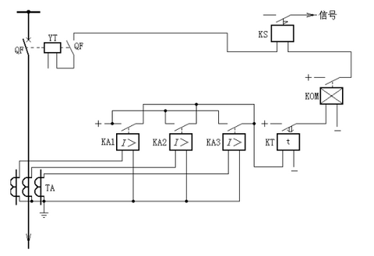
Figure 2. 1: Schematic diagram of overcurrent protection for a line fixed time limit (knoweasy, 2021)

Figure 2. 2: Distance Relay or Impedance Relay Working Principle (Electrical4U, 2024)

Limitations of Traditional Methods
Traditional fault detection systems have historically relied on threshold-based protection schemes, impedance-based distance relays, and overcurrent protection devices (Dash et al., 2024). While these conventional methods have provided a foundation for grid stability for decades, they exhibit significant technical limitations in the context of modern, dynamic power networks. A primary concern is their high sensitivity to environmental and electrical noise; threshold-based methods frequently struggle to differentiate between genuine faults and transient disturbances, leading to a high rate of false alarms that can compromise grid reliability (Gherghina et al., 2025). Furthermore, many of these systems are heavily dependent on fixed parameters. Impedance-based relays, for instance, require precise and up-to-date knowledge of line characteristics, which are often subject to fluctuations caused by temperature changes, varying loading conditions, and frequent shifts in network topology.
Beyond parameter dependency, traditional rule-based systems suffer from a distinct lack of adaptability and generalization. As distribution networks evolve into complex smart grids characterized by the heavy integration of distributed generation and multi-directional power flows, legacy protection schemes often fail to adapt to these new operating paradigms. These systems generally require intensive domain expertise and significant engineering effort to design, tune, and maintain, yet they remain unable to generalize effectively across diverse network configurations (Q. Liu et al., 2021). When faced with complex fault scenarios or high-impedance faults that were not explicitly programmed into their logic, these traditional methods often fail to provide the necessary precision for accurate detection and classification. This rigidity creates a critical need for more robust, data-driven architectures capable of autonomous feature extraction and temporal analysis

Machine Learning Approaches
The transition from deterministic relay logic to intelligent protection began with the application of classical machine learning algorithms. Early research focused on supervised learning techniques such as Support Vector Machines (SVM), Decision Trees, Random Forests, and k-Nearest Neighbors (k-NN). These methods offered a significant leap forward in adaptability, allowing protection systems to "learn" the boundary between normal operation and fault conditions from historical data rather than relying on fixed thresholds (Eissa (Sieee), 2015). For instance, SVMs were widely adopted for their ability to handle high-dimensional data and find the optimal hyperplane that separates different fault classes, even in the presence of minor noise.
However, the primary bottleneck of these classical approaches was their total reliance on manual feature engineering. Unlike modern deep learning, these algorithms could not process raw voltage or current waveforms directly. Instead, researchers had to manually extract specific mathematical descriptors to "feed" the models. These typically included:
- Time-Domain Statistics: Metrics such as mean, variance, skewness, and kurtosis to describe the shape of the signal.
- Frequency-Domain Features: Using Fast Fourier Transform (FFT) coefficients to identify harmonic content and frequency shifts during a fault (R. et al., 2023).
- Time-Frequency Analysis: Utilizing Discrete Wavelet Transform (DWT) coefficients to capture the localized, transient "spikes" in a waveform that occur at the exact moment of a fault (Y. Liu et al., 2022).
While these methods demonstrated improved accuracy over traditional relays, they were often "brittle." If the network topology changed or if a new type of distributed generator was added, the manually selected features might no longer be relevant, requiring the entire feature extraction process to be redesigned.

Deep Learning for Fault Detection
The advent of artificial intelligence (AI) and machine learning, particularly deep learning, has ushered in new paradigms for fault detection that effectively address the inherent limitations of traditional methods. Unlike legacy systems that require manual tuning, deep learning models possess the capability to automatically extract relevant features from raw data, eliminating the need for labor-intensive manual feature engineering (Jia et al., 2016). These models are uniquely suited to learning complex, nonlinear relationships between multi-dimensional inputs and various fault types, allowing them to generalize across diverse operating conditions and shifting network configurations. Furthermore, their ability to adapt to new data through retraining and transfer learning ensures that the protection system remains robust as the grid evolves. This is particularly critical in modern power systems, where models must handle high-dimensional, multivariate time-series data with high precision (Strielkowski et al., 2023).
Within the spectrum of deep learning, Convolutional Neural Networks (CNNs) and Long Short-Term Memory (LSTM) networks have emerged as powerful tools for signal analysis. Originally developed for image processing, CNNs have been successfully adapted to power system analysis by treating sequential electrical data as one-dimensional signals. Through the use of convolutional filters and pooling operations, CNNs excel at extracting local spatial patterns and hierarchical features from distorted waveforms.
However, to fully capture the nature of a fault, the temporal context is equally vital. LSTM networks, a specialized type of Recurrent Neural Network (RNN), are specifically designed to capture these long-range temporal dependencies. By utilizing sophisticated gating mechanisms that regulate the flow of information, LSTMs overcome the vanishing gradient problem that plagues traditional RNNs. This enables the model to retain critical information over long sequences, making it exceptionally effective for modeling the transient time-series data characteristic of power system faults.
Recent literature has increasingly explored deep learning architectures for fault detection and classification:
(Moradzadeh et al., 2022) proposed hybrid CNN-LSTM approaches for identifying and classifying transmission line faults, demonstrating improved performance over traditional methods by leveraging both spatial and temporal features of fault data.
(Bu et al., 2025) introduced a CNN-LSTM model enhanced with attention mechanisms for fault diagnosis in AC/DC microgrids, achieving high classification accuracy even under noise interference. The attention mechanism allowed the model to focus on the most relevant temporal segments of fault signals.
(Dessie et al., 2025) applied attention-based hybrid models for fault detection in electrical power systems, validating their effectiveness in classifying diverse fault types and highlighting the importance of temporal modeling in complex signal environments.
Studies on three-phase transmission line faults have validated CNN-LSTM hybrid models' effectiveness in classifying multiple fault types, demonstrating superior performance compared to standalone CNN or LSTM architectures.

Hybrid CNN-LSTM Architecture
The integration of CNN and LSTM architectures into hybrid models leverages the complementary strengths of both approaches. In the context of electrical fault detection:
CNN layers act as automatic feature extractors, identifying discriminative spatial patterns across multiple sensor channels (three-phase voltages and currents), while LSTM layers model temporal dynamics and sequential dependencies, capturing how fault signatures evolve.
This hybrid approach is particularly well-suited to electrical fault data, which exhibits both spatial characteristics (relationships between voltage and current in different phases) and temporal characteristics (transient behavior during fault inception and evolution).

Research Gap
While existing literature demonstrates the potential of hybrid CNN-LSTM models for fault detection, several gaps remain:
- Limited studies on open-access datasets that enable reproducibility and comparison
- Insufficient analysis of model interpretability and feature importance
- Lack of comprehensive evaluation frameworks incorporating multiple performance metrics
- Limited investigation of model performance under class imbalance conditions
- Insufficient exploration of real-time deployment considerations
This study addresses these gaps by providing a comprehensive, reproducible implementation with detailed evaluation and analysis.

CHAPTER THREE

METHODOLOGY

Introduction to Methodology
The methodology for this study adopts a data-driven, supervised learning approach to achieve high-precision fault detection and classification. Rather than using traditional mathematical modeling, this research leverages a comprehensive dataset of 12,001 samples of three-phase power system signals (Sathya Prakash, 2020). The proposed framework integrates Convolutional Neural Networks (CNN) and Long Short-Term Memory (LSTM) networks into a hybrid architecture designed to exploit both the spatial correlations and temporal dependencies inherent in electrical waveforms.
The technical workflow of this study is systematically structured into four distinct phases: Data Acquisition, Feature Processing, Hybrid Model Construction, and Multi-label Classification. The initial phase involves utilizing the Sathyaprakash dataset, where the input features consist of six continuous variables representing the instantaneous states of a 132kV distribution line, specifically the Three-Phase Currents (I_{a}, I_{b}, I_{c}) and Three-Phase Voltages (V_{a}, V_{b}, V_{c}) as described in Table 3.1. The target output is engineered as a four-bit binary vector G, C, B, A, representing the Ground and the three phases (A, B, and C). This multi-label structure is critical as it allows the system to classify complex fault scenarios such as Single Line-to-Ground (LG), Line-to-Line (LL), and Symmetrical Three-Phase faults by identifying which specific components of the vector are active (1) or inactive (0).
To prepare the raw Kaggle dataset for the hybrid model, the data undergoes a rigorous preprocessing stage involving normalization and structural reshaping. Since CNN and LSTM architectures require a three-dimensional input format samples, the six electrical parameters are transformed into a sequential format. This transformation is essential to ensure the model can analyze the mathematical relationship between current and voltage fluctuations over a specific time window. Such a temporal perspective is vital for the system to accurately distinguish between a permanent fault and a temporary switching transient, which often exhibit similar instantaneous magnitudes but different temporal signatures.

Data Preprocessing

Feature normalization
Raw electrical measurements were standardized using Standard Scaler to achieve zero mean and unit variance for each feature, improving gradient descent convergence and

Time window creation
To capture temporal dynamics, the dataset was transformed using a sliding window approach with a window length of 10time steps and a stride of 1, resulting in a shape (n_{sequences}, 10, 6). This creates a temporal context for each prediction and enables LSTM to learn sequential dependencies.

Train-test split
The sequence data was partitioned into training (80%) and testing (20%) subsets with stratification to maintain class distribution, resulting in 6,281 training sequences and 1,571 testing sequences.

Table 3. 1:Dataset characteristics
Total Samples | 7,861 labeled instances
Feature Dimensions | 6 continuous variables ((V_{a}, V_{b}, V_{c}, I_{a}, I_{b}, I_{c})
Target Classes | 6 fault types
Classes | No Fault, LG, LL, LLG, LLL, LLLG

Model Architecture
The model consists of 125,142 trainable parameters, structured into three functional blocks: the CNN Feature Extractor, the LSTM Temporal Learner, and the Dense Classification Head.

Convolutional Feature Extraction Block
The first stage of the model utilizes one-dimensional Convolutional Neural Networks (Conv1D) to automatically identify local patterns in the electrical waveforms. Unlike traditional methods that require manual Fourier or Wavelet transforms, the Conv1D layers apply a set of learnable filters to the input matrix in equation 3.1.
$X∈R^{10×6}$ (3. 1)
- Layer 1 (64 Filters, Kernel Size 3): This layer scans the 10-timestep window to detect sudden magnitude shifts or phase distortions. The operation is defined as:
$y_{j}=σ(\sum_{i=1}^{n}{w_{ij}{*x}_{i}+b_{j}})$ (3. 2)
where x_{i} is the input signal, w_{ij} is the kernel weight, b_{j} is the bias, and $σ$ represents the Rectified Linear Unit (ReLU) activation function.
- Regularization and Pooling: To stabilize training and prevent internal covariate shift, Batch Normalization is applied. This is followed by MaxPooling1D with a pool size of 2, which reduces the dimensionality by selecting the most prominent features:
$f_{max}=max⁡(x_{i}+x_{i+1})$ (3. 3)
- Layer 2 (128 Filters): This layer expands the feature map, allowing the model to learn more complex hierarchical representations of the fault transients.

LSTM Temporal Learning Block
While CNNs excel at detecting "what" happened in a signal, the Long Short-Term Memory (LSTM) layer is critical for understanding "when" and "how long" the disturbance lasted. In power systems, distinguishing between a self-clearing transient and a permanent fault requires temporal context. The LSTM layer consists of 100 units that process the feature sequence using a gating mechanism. These gates “forget f_{t,} input i_{t}, and output o_{t”,} regulate the flow of information through the cell state C_{t}, effectively solving the vanishing gradient problem:
$f_{t}=σ\left(W_{f}∙\left[h_{t-1},x_{t}\right]+b_{f}\right)$ (3. 4)
$i_{t}=σ\left(W_{i}∙\left[h_{t-1},x_{t}\right]+b_{i}\right)$ (3. 5)
$h_{t}=o_{t}∙\tanh{C_{t}}$ (3. 6)
This layer captures the long-range dependencies across the 10 timesteps, ensuring the model considers the pre-fault and post-fault states before making a final classification.

Dense Classification Block and Output
The final block transforms the high-level features into a probability distribution. It consists of a Dense (Fully Connected) layer with 64 units and ReLU activation. A Dropout (0.4) layer is implemented here to prevent overfitting by randomly deactivating 40% of neurons during training.
The Output Layer uses 6 units corresponding to the fault classes: No Fault, LG, LL, LLG, LLL, and LLLG. The Softmax activation function is used to produce a probability for each class j:
$P\left(y=j | x\right)=\frac{e^{z_{j}}}{\sum_{k=1}^{6}{e^{z_{k}}}}$ (3. 7)
where z_{j} is the output of the final dense layer for class j.

Model Flow and Integration
To ensure reproducibility, the model was trained using the Adam optimizer with a learning rate of 0.001 and Sparse Categorical Cross-Entropy as the loss function. The total model size is approximately 488 KB, making it highly efficient for deployment in embedded monitoring systems. The model flow diagram and training configuration are illustrated in Figure 3.1 and Table 3.2.

Evaluation Metrics
To rigorously assess the efficacy of the Hybrid CNN–LSTM model, a multi-dimensional evaluation framework is employed. While Accuracy provides a general overview of performance, it can be misleading in power system datasets where certain fault classes are underrepresented. Therefore, the following statistical metrics and visualization tools are utilized to validate the model's robustness.
The model's performance is quantified using metrics derived from the Confusion Matrix, which categorizes predictions into True Positives (TP), True Negatives (TN), False Positives (FP), and False Negatives (FN).
- Accuracy: Measures the proportion of total correct predictions (both faults and non-faults) out of the total samples.
$Accuracy=\frac{TP+TN}{TP+TN+FP+FN}$ (3. 8)

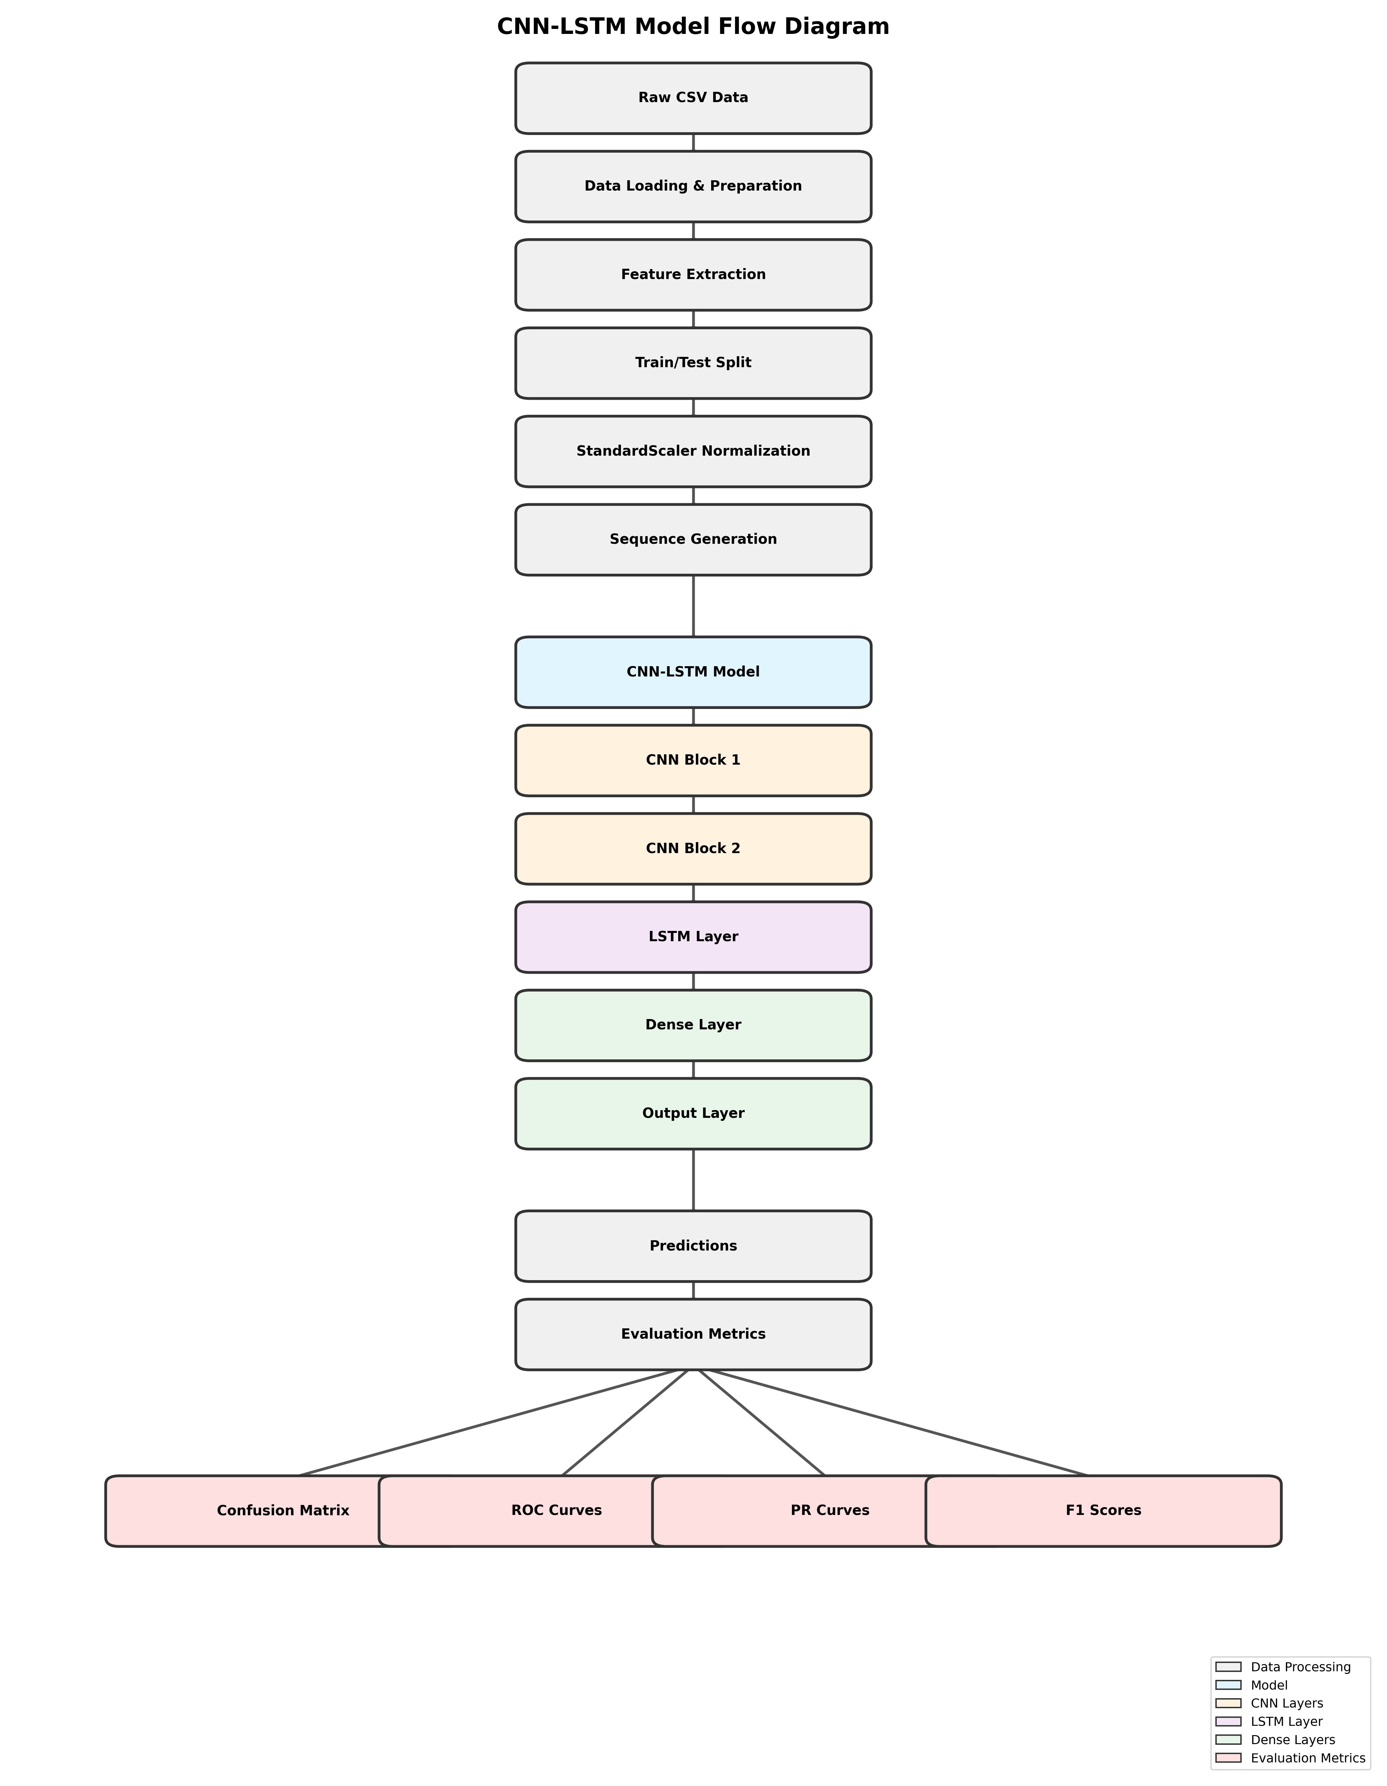
Figure 3. 1: Model Flow Diagram

Table 3. 2: Training Configuration
Optimizer | Adam (learning rate: 0.001)
Loss Function | Sparse Categorical Cross-Entropy
Epochs | 30
Batch Size | 32
Validation Split | 20% of training data
Regularization | Dropout (0.3-0.4), Batch Normalization

- Precision (Positive Predictive Value): Indicates the model's ability to avoid "false alarms." In a power grid, high precision ensures that the system does not trigger a circuit breaker when no fault actually exists.
$Precision =\frac{TP}{TP+FP}$ (3. 9)
- Recall (Sensitivity): Crucial for safety, recall measures the model's ability to detect all actual faults. A low recall in power systems could lead to catastrophic equipment failure if a fault goes undetected.
$Recall=\frac{TP}{TP+FN}$ (3. 10)
- F1-Score: The harmonic mean of Precision and Recall. It provides a single score that balances both metrics, making it the most reliable indicator for classes like LLLG, where the model may struggle with detection
$F1-Score=2×\frac{Precision × Recall}{Precision+ Recall}$ (3. 11)
Beyond numerical scores, the research employs three critical visualization techniques to identify specific points of failure within the classification logic:

Confusion Matrix
A 6×6 heatmap is generated to visualize where the model misclassifies one fault type for another. For example, it helps identify if the model is confusing LLL faults with LLLG faults due to their similar three-phase characteristics.

Receiver Operating Characteristic (ROC) Curve
This plot illustrates the trade-off between the True Positive Rate and False Positive Rate. The Area Under the Curve (AUC) is calculated for each of the six classes to determine how well the model distinguishes between specific fault types regardless of the decision threshold.

Precision-Recall (PR) Curves
Given that the dataset may exhibit class imbalances, PR curves are used to emphasize the model's performance on the "minority" fault classes. A high area under the PR curve indicates that the model is maintaining both high precision and high recall across varying thresholds.

CHAPTER FOUR

RESULTS

Model Performance
The hybrid CNN-LSTM model achieved the following performance metrics on the test set, as shown in Table 4.1. These results demonstrate moderate to good performance in classifying six distinct fault types from multivariate time-series electrical measurements.

Class-wise Performance
Figure 1 shows the F1-scores achieved for each fault class, demonstrating strong performance on simpler fault types and moderate performance on complex multi-phase faults.

Training History
Figure 2 displays the training and validation curves over 30 epochs. Training accuracy reaches ~85% while validation accuracy converges to ~78%, with training loss decreasing from ~1.2 to ~0.4 and validation loss stabilizing around ~0.6. The small gap between training and validation performance indicates good generalization with limited overfitting.

Confusion Matrix Analysis
Figure 3 presents the confusion matrix for all six fault classes. The matrix reveals high diagonal values indicating strong correct classification, with highest performance on "No Fault" and "LG" classes. Some confusion exists between similar complex fault types (LL/LLG, LLL/LLLG), suggesting the model effectively learns primary fault characteristics but struggles with subtle distinctions between similar multi-phase faults

Table 4. 1: Overall Model Performance
Metric | Value (%)
Accuracy | 78.01
Precision | 77.53
Recall | 78.01
F1-Score | 77.47

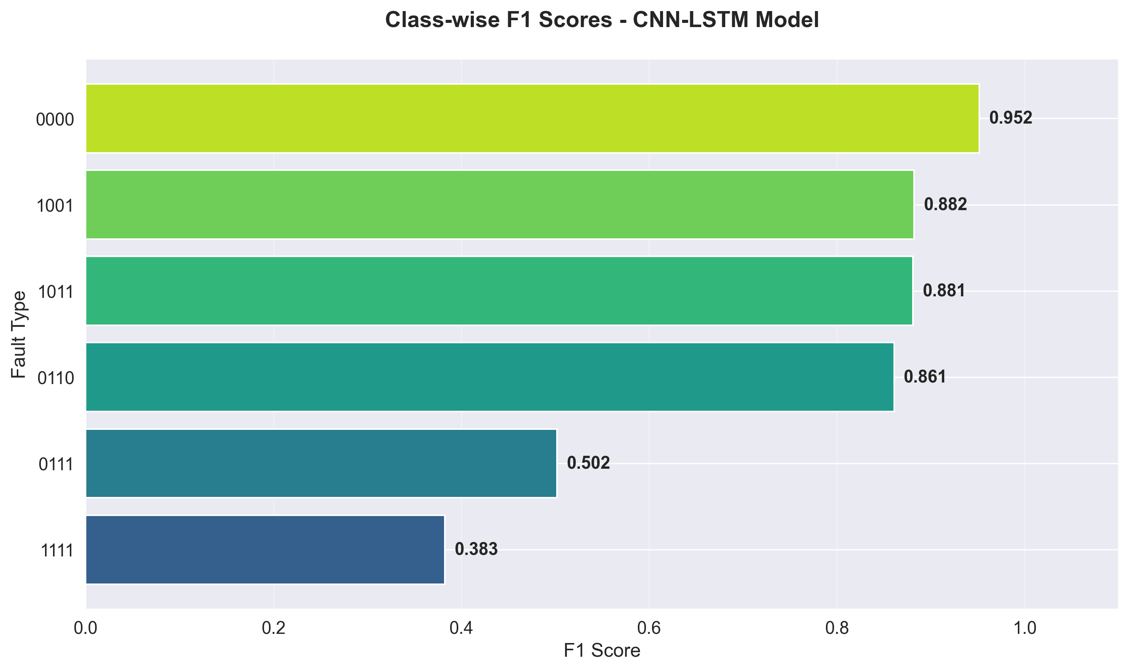
Figure 4. 1: Class-wise F1-Scores

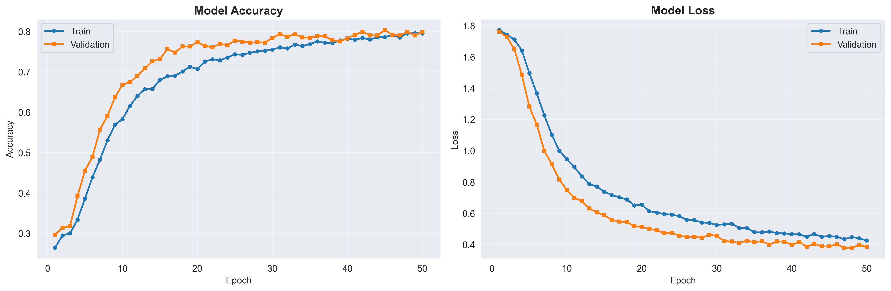
Figure 4. 2: Training and Validation Accuracy/Loss Curves
.

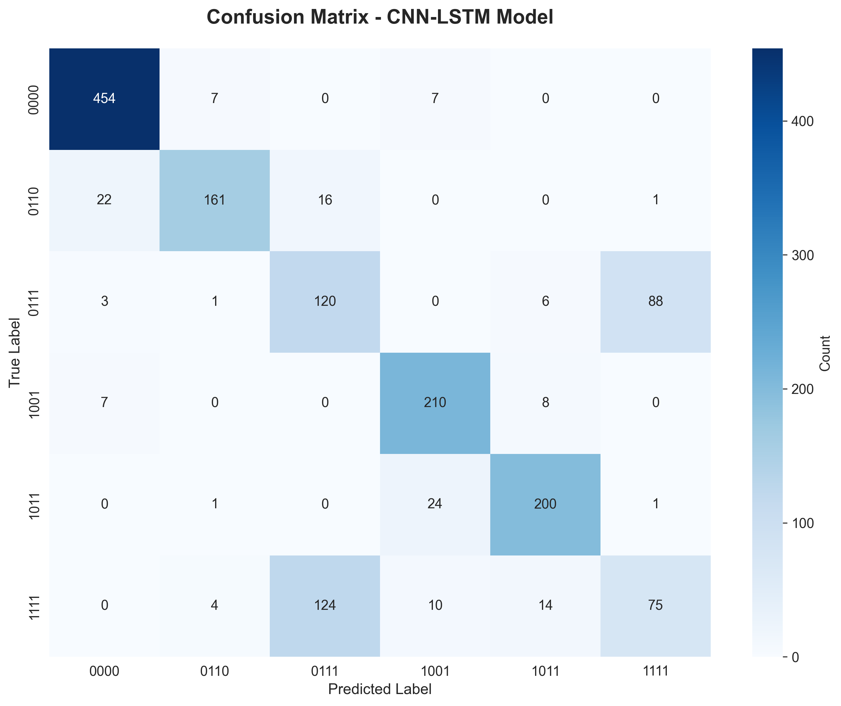
Figure 4. 3: Confusion Matrix for Six Fault Classes

ROC and Precision-Recall Curves
Figures 4 and 5 show the ROC and Precision-Recall curves for each fault class. The ROC curves demonstrate strong discrimination capability with AUC values ranging from 0.82 to 0.93, with highest AUC for "No Fault" and "LG" classes. The Precision-Recall curves show maintained precision across varying recall levels, indicating consistent performance across different operating points.

Interpretation of Results
The achieved accuracy of 78.01% represents moderate to good performance for a six-class classification problem with complex, multivariate time-series data. The CNN layers successfully extract discriminative spatial patterns while LSTM captures sequential dependencies in fault evolution. The results align with existing literature, performing within expected range for hybrid architectures.

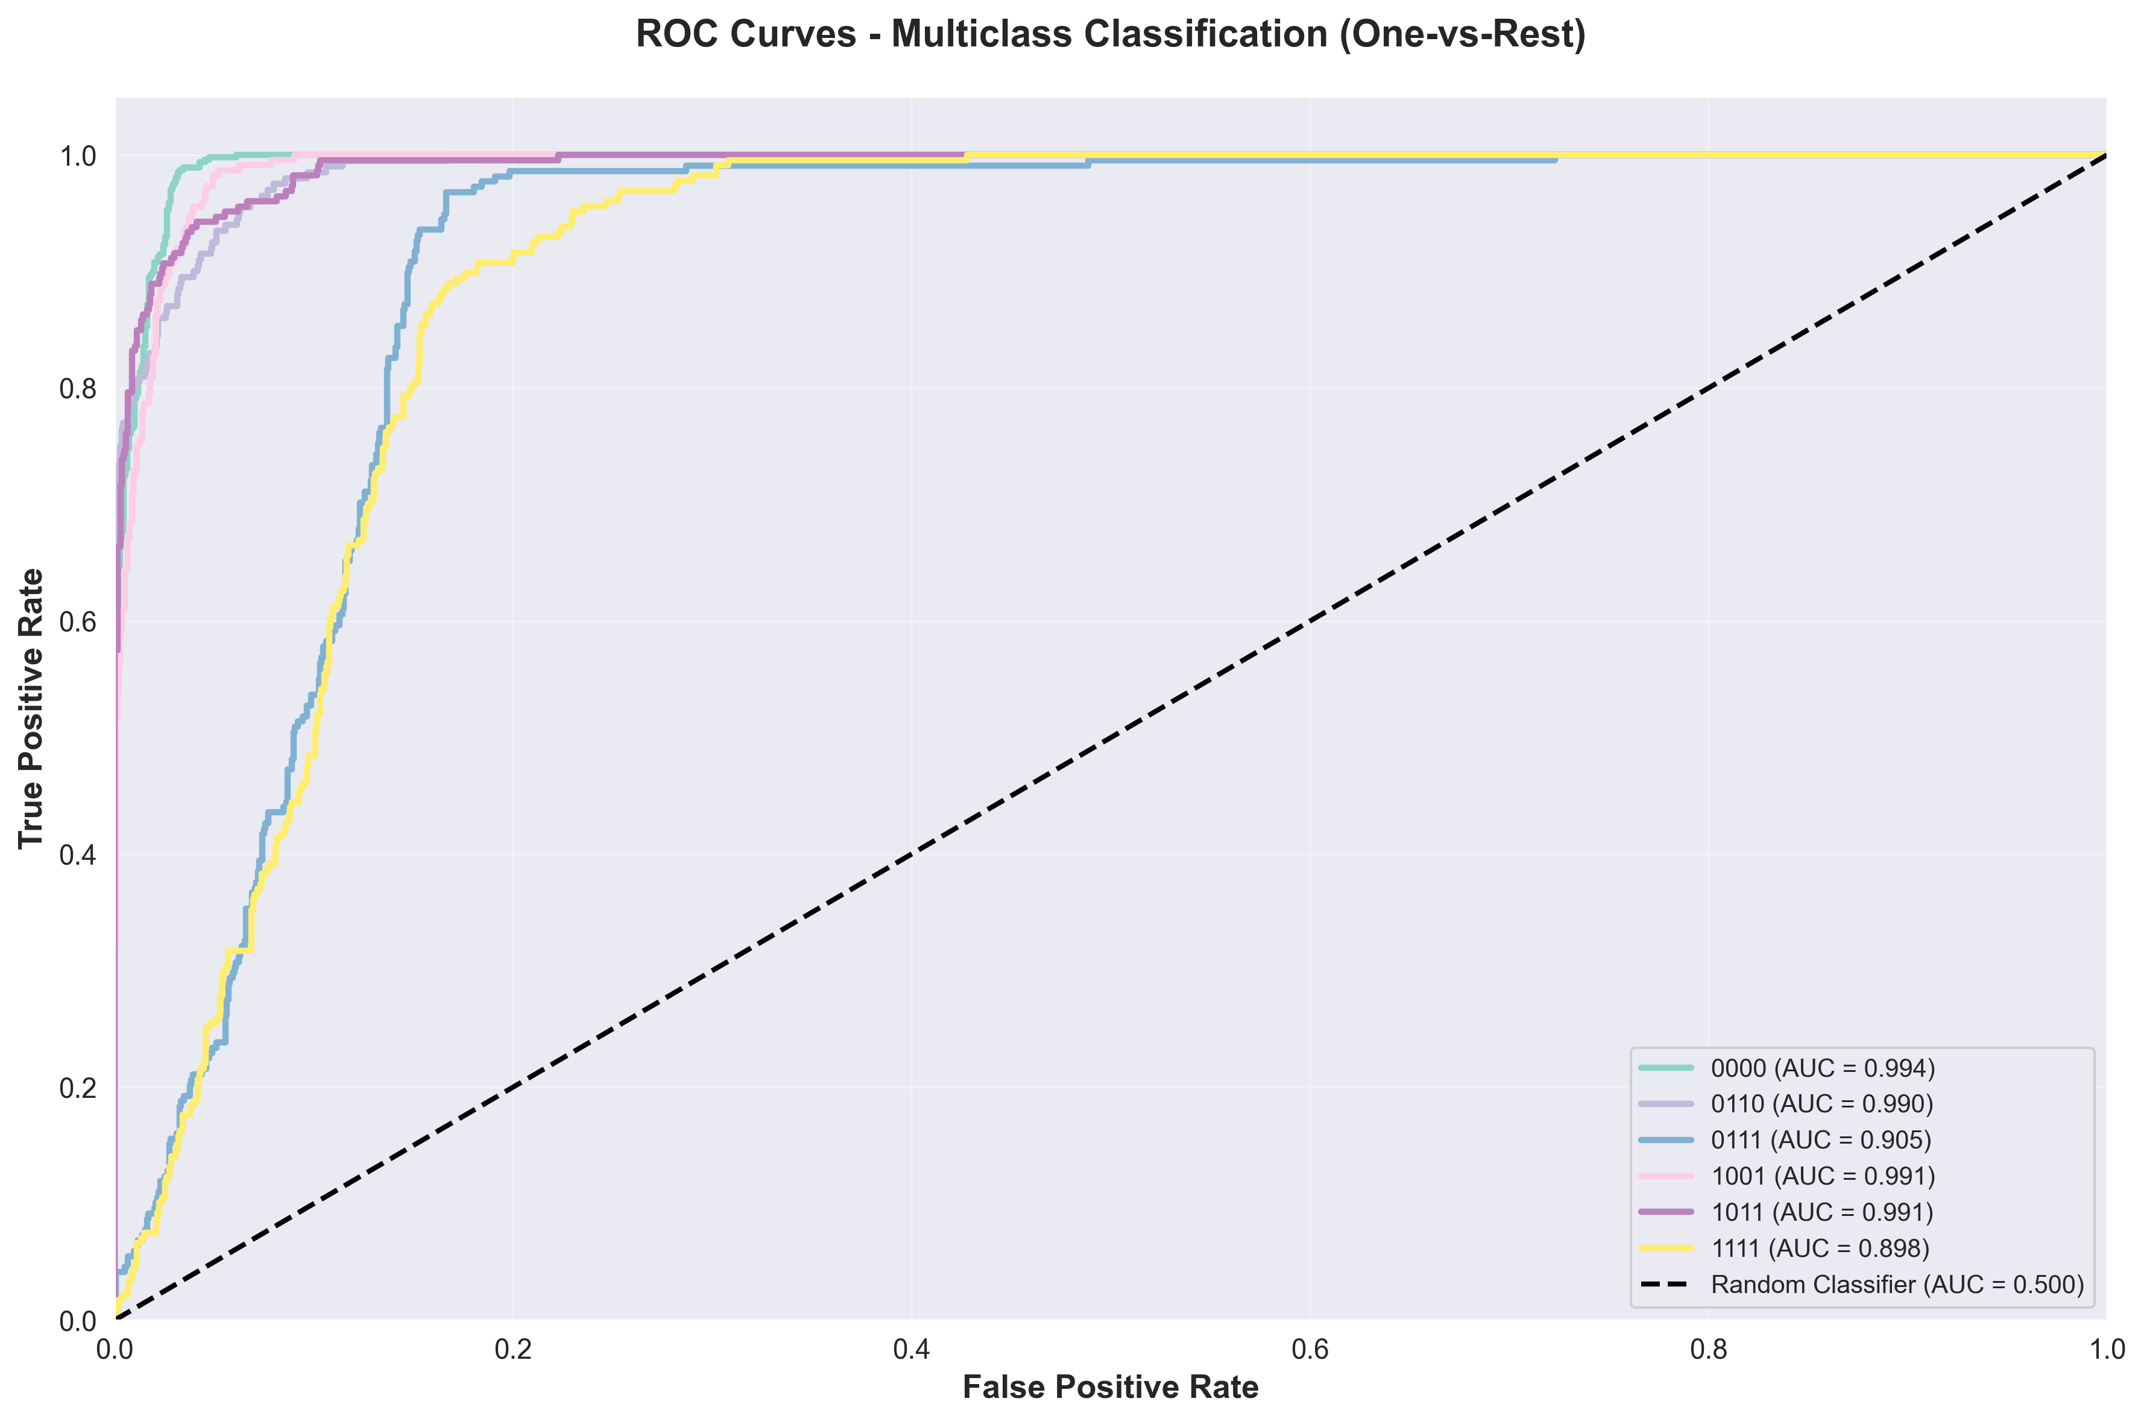
Figure 4. 4: ROC Curves for All Fault Classes

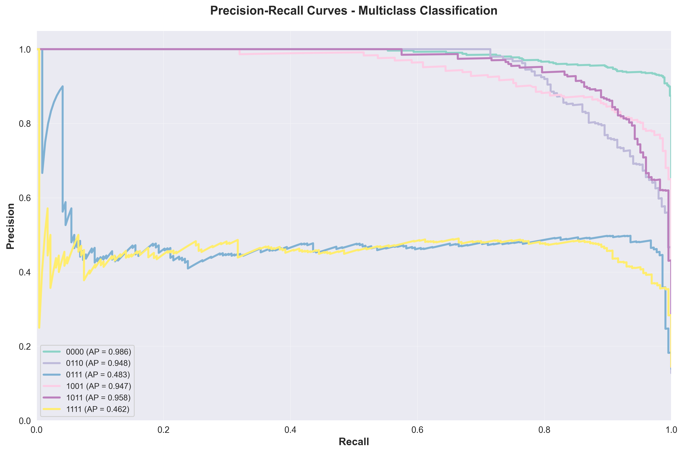
Figure 4. 5: Precision-Recall Curves for All Fault Classes

CHAPTER FIVE

CONCLUSION
This study successfully implemented and evaluated a hybrid CNN-LSTM model for electrical fault detection and classification in power distribution systems. The model achieved an overall accuracy of 78.01%, with precision of 77.53%, recall of 78.01%, and F1-score of 77.47% across six fault classes.

Model strengths
  - End-to-end learning with minimal manual feature engineering
  - Hybrid architecture leverages both spatial and temporal modeling
  - Scalable to larger datasets and additional fault types
  - Reproducible using open-access dataset
  - Comprehensive evaluation provides actionable insights

Model limitations
  - Moderate accuracy (78%) leaves room for improvement
  - Dataset size (7,861 samples) may be insufficient for deep learning potential
  - Simulated data may not fully represent real-world conditions
  - Lacks attention mechanisms shown effective in recent literature
  - Computational cost may challenge real-time deployment

Key Findings
  - Hybrid architecture effectively combines CNN spatial feature extraction and LSTM temporal modeling
  - Strong performance on simple fault types (No Fault, LG) and moderate performance on complex faults
  - Good generalization capability with small training-validation gap
  - Results align with existing literature for hybrid architectures
  - Model shows promise for secondary diagnostics and operator decision support

Recommendations for Future Work

Dataset improvements:
Acquire larger datasets (>20,000 samples), incorporate real-world field measurements, ensure balanced class representation, and include diverse operating conditions.

Model enhancements:
Integrate attention mechanisms, explore transformer architectures, implement ensemble methods, perform systematic hyperparameter optimization, and investigate adaptive window sizes.

Real-time deployment:
Apply model compression techniques, optimize latency for real-time protection (<20ms), leverage hardware acceleration, and conduct hardware-in-the-loop validation.

Remarks
The hybrid CNN-LSTM model demonstrates promising capabilities for automated electrical fault classification. While not yet ready for safety-critical primary protection applications, the model provides a solid foundation for continued research. With larger datasets, architectural refinements, and real-world validation, hybrid deep learning approaches have significant potential to enhance the reliability and intelligence of future power distribution systems.

REFERENCES
Bu, Q., Lyu, P., Sun, R., Jing, J., Lyu, Z., & Hou, S. (2025). Fault Diagnosis Method Using CNN-Attention-LSTM for AC/DC Microgrid. Modelling, 6(3), 107. https://doi.org/10.3390/modelling6030107
Chawda, G. S., Shaik, A. G., Shaik, M., Padmanaban, S., Holm-Nielsen, J. B., Mahela, O. P., & Kaliannan, P. (2020). Comprehensive Review on Detection and Classification of Power Quality Disturbances in Utility Grid With Renewable Energy Penetration. IEEE Access, 8, 146807–146830. https://doi.org/10.1109/ACCESS.2020.3014732
Chen, L.-H. (2017). Overcurrent protection for distribution feeders with renewable generation. International Journal of Electrical Power & Energy Systems, 84, 202–213. https://doi.org/10.1016/j.ijepes.2016.05.003
Dash, Y., Abraham, A., Kumar, N., & Raj, M. (2024). Role of artificial intelligence in transmission line protection: A review of three decades of research. International Journal of Hybrid Intelligent Systems, 20(3), 185–206. https://doi.org/10.3233/HIS-240016
Dessie, H. W., Zhao, H., & Peng, Y. (2025). Hybrid CNN-LSTM Based Fault Detection and Classification in Three-Phase Power Transmission Lines with Dynamic Noise Fault Signals. 2025 10th International Conference on Power and Renewable Energy (ICPRE), 837–842. https://doi.org/10.1109/ICPRE67300.2025.11274203
Eissa (Sieee), M. M. (2015). Protection techniques with renewable resources and smart grids—A survey. Renewable and Sustainable Energy Reviews, 52, 1645–1667. https://doi.org/10.1016/j.rser.2015.08.031
Electrical4U. (2024, April 30). Distance Relay or Impedance Relay Working Principle Types | Electrical4U. Https://Www.Electrical4u.Com/. https://www.electrical4u.com/distance-relay-or-impedance-relay-working-principle-types/
Gers, J. M. (with Holmes, E. J., & Institution of Engineering and Technology). (2011). Protection of Electricity Distribution Networks (3rd ed). Institution of Engineering & Technology.
Gherghina, I.-S., Bizon, N., Iana, G.-V., & Vasilică, B.-V. (2025). Recent Advances in Fault Detection and Analysis of Synchronous Motors: A Review. Machines, 13(9), 815. https://doi.org/10.3390/machines13090815
Gururajapathy, S. S., Mokhlis, H., & Illias, H. A. (2017). Fault location and detection techniques in power distribution systems with distributed generation: A review. Renewable and Sustainable Energy Reviews, 74, 949–958. https://doi.org/10.1016/j.rser.2017.03.021
Hong, J., Kim, Y.-H., Nhung-Nguyen, H., Kwon, J., & Lee, H. (2022). Deep-Learning Based Fault Events Analysis in Power Systems. Energies, 15(15), 5539. https://doi.org/10.3390/en15155539
Ibitoye, O. T., Onibonoje, M. O., & Dada, J. O. (2022). Machine Learning Based Techniques for Fault Detection in Power Distribution Grid: A Review. 2022 3rd International Conference on Electrical Engineering and Informatics (ICon EEI), 104–107. https://doi.org/10.1109/IConEEI55709.2022.9972279
Idima, S. (2023). Predictive analytics for aging U.S. electrical infrastructure: Leveraging machine learning to enhance grid resilience and reliability.
Jia, F., Lei, Y., Lin, J., Zhou, X., & Lu, N. (2016). Deep neural networks: A promising tool for fault characteristic mining and intelligent diagnosis of rotating machinery with massive data. Mechanical Systems and Signal Processing, 72–73, 303–315. https://doi.org/10.1016/j.ymssp.2015.10.025
knoweasy. (2021, July 23). Schematic Diagram And Explanation Of The Secondary Circuit Of High-voltage Electric Circuit. Knoweasy. https://www.knoweasytool.com/blogs/the-electrician-blog/schematic-diagram-and-explanation-of-the-secondary-circuit-of-high-voltage-electric-circuit
Kouraichi, M., Mansouri, M., Trabelsi, M., M’Halla, A., Abdel-Khalik, A. S., & Sakly, A. (2025). Deep Learning for Fault Diagnosis in Power Transmission Lines: Current Trends, Limitations, and Future Directions. IEEE Access, 13, 192105–192142. https://doi.org/10.1109/ACCESS.2025.3628908
Liu, Q., Hagenmeyer, V., & Keller, H. B. (2021). A Review of Rule Learning-Based Intrusion Detection Systems and Their Prospects in Smart Grids. IEEE Access, 9, 57542–57564. https://doi.org/10.1109/ACCESS.2021.3071263
Liu, Y., Wang, J., Zhao, P., Tao, Y., Xu, Z., Yan, X., & Xu, C. (2022). Refined modeling calculation of electromagnetic fields when lightning strikes thermal power plant and optimized layouts of sensitive devices. Electric Power Systems Research, 202, 107562. https://doi.org/10.1016/j.epsr.2021.107562
Moradzadeh, A., Teimourzadeh, H., Mohammadi-Ivatloo, B., & Pourhossein, K. (2022). Hybrid CNN-LSTM approaches for identification of type and locations of transmission line faults. International Journal of Electrical Power & Energy Systems, 135, 107563. https://doi.org/10.1016/j.ijepes.2021.107563
Mousa, A., Zraqou, J., Shaheen, H., & Zawahra, I. (2025). Fault Type Classification in Electrical Transmission Lines. 2025 1st International Conference on Computational Intelligence Approaches and Applications (ICCIAA), 1–8. https://doi.org/10.1109/ICCIAA65327.2025.11013603
Pujari, R., & Nabab Alam, M. (2025). Distance Relaying for the Protection of Modern Power System Networks. IEEE Access, 13, 28861–28893. https://doi.org/10.1109/ACCESS.2025.3539919
R., H., M., A., & Hameed, A. (2023). Threat Detection and Rescue using Machine Learning. 2023 International Conference on Emerging Smart Computing and Informatics (ESCI), 1–5. https://doi.org/10.1109/ESCI56872.2023.10100234
Sathya Prakash. (2020). Electrical Faults Analysis & Classification. https://kaggle.com/code/harshsingh2209/electrical-faults-analysis-classification
Short, T. A. (2018). Electric Power Distribution Equipment and Systems. CRC Press.
Strielkowski, W., Vlasov, A., Selivanov, K., Muraviev, K., & Shakhnov, V. (2023). Prospects and Challenges of the Machine Learning and Data-Driven Methods for the Predictive Analysis of Power Systems: A Review. Energies, 16(10), 4025. https://doi.org/10.3390/en16104025
Theron, J. C. J., Pal, A., & Varghese, A. (2018). Tutorial on high impedance fault detection. 2018 71st Annual Conference for Protective Relay Engineers (CPRE), 1–23. https://doi.org/10.1109/CPRE.2018.8349833
Zamzam, T., & Massaoudi, M. (2024). A Two-Stage CNN-LSTM Model-Based Transient Stability Assessment for Power System. 2024 4th International Conference on Smart Grid and Renewable Energy (SGRE), 1–6. https://doi.org/10.1109/SGRE59715.2024.10428949
Zhang, S., Wang, Y., Liu, M., & Bao, Z. (2018). Data-Based Line Trip Fault Prediction in Power Systems Using LSTM Networks and SVM. IEEE Access, 6, 7675–7686. https://doi.org/10.1109/ACCESS.2017.2785763

APPENDICES

Appendix A: Model Architecture Summary
The complete model consists of 125,142 total parameters with 124,758 trainable parameters. The architecture includes two convolutional blocks for spatial feature extraction, one LSTM layer for temporal modeling, and dense layers for classification.

Appendix B: Hyperparameters Summary
Hyperparameters | Summary
Window Length | 10
Train-Test Split | 80-20
Batch Size | 32
Epochs | 30
Learning Rate | 0.001
Conv1D Filters (Layer 1) | 64
Conv1D Filters (Layer 2) | 128
LSTM Units | 100
Dense Layer Units | 64
Dropout Rates | 0.3 (Conv/LSTM), 0.4 (Dense)
Activation Functions | ReLU (hidden), Softmax (output)

Appendix C: Code Modules
- cnn_lstm_preprocessing.py: Data loading, normalization, sequence generation
- cnn_lstm_model.py: Model definition and architecture
- train_cnn_lstm.py: Training and validation loop
- evaluate_model.py: Evaluation metrics and visualization
All codes is in: Github

