**Normalization:**

Normalization is a database design technique which organizes tables in a manner that reduces redundancy and dependency of data.

It divides larger tables to smaller tables and links them using relationships.

**BCNF:**

It is an advance version of 3NF that’s why it is also referred as 3.5NF. Even when a database is in 3rd Normal Form, still there would be anomalies resulted if it has more than one **Candidate**key. BCNF is stricter than 3NF. For a table to be in BCNF:

1. It should be in the **Third Normal Form**.
2. And, for any dependency A → B, A should be a **super key**

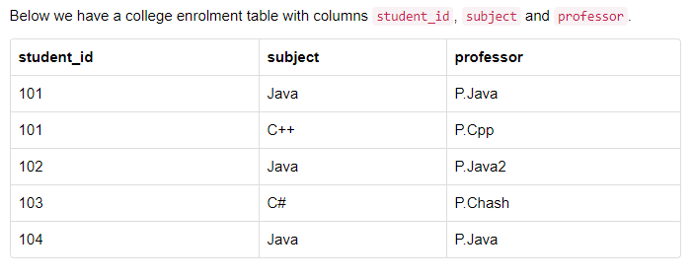

* This table satisfies the **1st Normal form** because all the values are atomic, column names are unique and all the values stored in a particular column are of same domain.
* This table also satisfies the **2nd Normal Form** as their is no **Partial Dependency**.
* And, there is no **Transitive Dependency**, hence the table also satisfies the **3rd Normal Form**.

In the table above, student_id, subject form primary key, which means subject column is a **prime attribute**.

But, there is one more dependency, professor → subject.

And while subject is a prime attribute, professor is a **non-prime attribute**, which is not allowed by BCNF.

To make this relation(table) satisfy BCNF, we will decompose this table into two tables, **student** table and **professor** table.

Below we have the structure for both the tables: **Student table** and **Professor Table**

