**Entity Relation Diagram:**

An entity relation diagram is a conceptual representation entities and the relationship between them. It displays the logical structure of databases. ER Diagram includes many specialized symbols, and its meanings make this model unique.

**Why use ERD?**

* ER model allows you to draw Database Design
* It is an easy to use graphical tool for modeling data
* Helps to describe entities, attributes, relationships
* ER diagrams are translatable into relational tables which allows you to build databases quickly
* It is a GUI representation of the logical structure of a Database
* Allows you to communicate with the logical structure of the database to users

**Important concepts in ERD:**

**Entity:**

* It may be a physical thing or simply a fact about the enterprise or an event that happens in the real world.
* An entity can be place, person, object, event or a concept, which stores data in the database.
* The characteristics of entities are must have an attribute, and a unique key. Every entity is made up of some 'attributes' which represent that entity.
* Entities can be classified as weak or strong.
* A **weak entity** is a type of entity which doesn't have its key attribute. It can be identified uniquely by considering the primary key of another entity. For that, weak entity sets need to have participation.
* **Strong** entity set always has a primary key.

**Attributes:**

* An attribute of an entity is a particular property that describes the entity. The set of all possible values of an attribute is the attribute domain.
* Attributes can be simple or composite. Simple: one component that is atomic. Composite: has multiple components, each of which is atomic or composite. Attributes may also be single-valued or multivalued.

**Relationship:**

* A relationship is an association between entities
* Relationships can be classified as unary, binary and ternary

When drawing an ERD diagram, 2 factors of importance are **connectivity** and **cardinality.**

**Cardinality:**

The [**cardinality**](javascript:openWin('../../glossary/cardinality.htm');) of a relationship is the number of instances of entity B that can be associated with entity A. There is a minimum cardinality and a maximum cardinality for each relationship, with an **unspecified** maximum cardinality being shown as **N**. Cardinality limits are usually derived from the organizations policies or external constraints.

**Connectivity**

Defines the numerical attributes of the relationship between two entities or entity sets.

Different types:

* One-to-One Relationships (1:1)
* One-to-Many Relationships (1:M)
* May to One Relationships (M:1)
* Many-to-Many Relationships (M:N)

**Types of ERDs:**

**Chen model:** CROW’S FOOT NOTATION- CIRCULATION DEPARTMENT OF PUBLIC LIBRARY

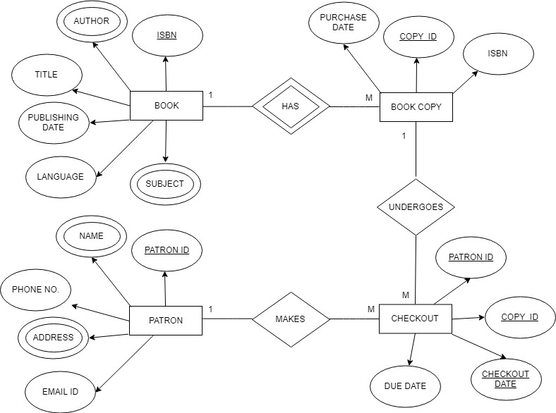

Notations in Chen Model:

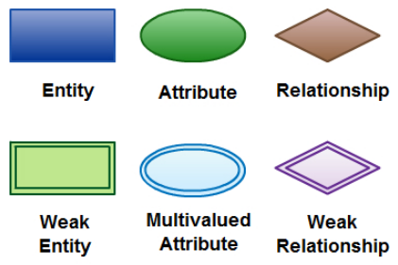

**Crow’s foot model**: (Note the model does not represent cardinality, but connectivity is shown)

CROW’S FOOT NOTATION- CIRCULATION DEPARTMENT OF PUBLIC LIBRARY

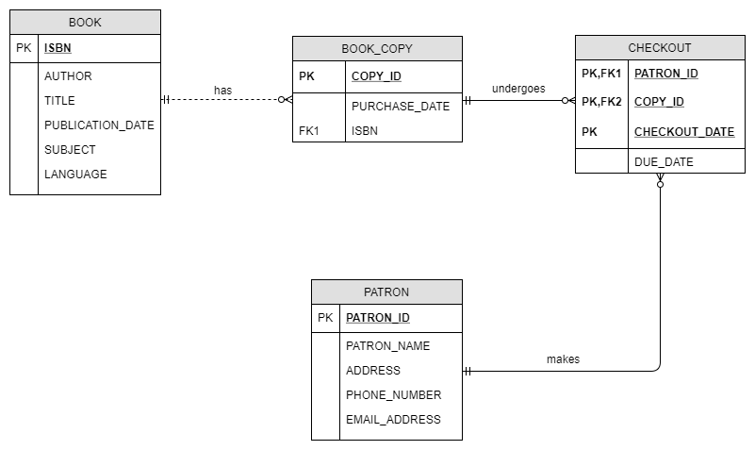

Business Rules:

* A BOOK may have 0 to many BOOK_COPIES available in the library.
* A BOOK_COPY can undergo multiple CHECKOUTs.
* A PATRON can make as many CHECKOUTs as he desires, or he may make no CHECKOUT at all.