Connect a GitHub Repo with AWS
Danford Amos
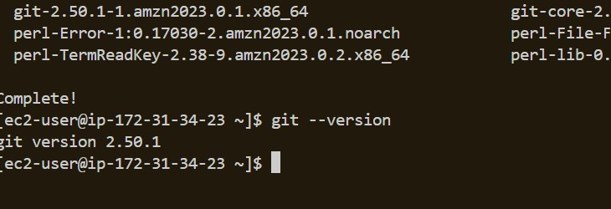
Introducing Today's Project!
In this project, I will demonstrate my understanding of the CI/CD process by creating and completing my first GitHub repository. I’m doing this project to learn how modern development teams build, test, and deploy code using automated pipelines. By working through this workflow myself, I gain hands‑on experience with version control, continuous integration, and continuous delivery — the core skills needed for real‑world software engineering.

Key tools and concepts
The primary services I used in this project were: Amazon EC2 — to provision and manage a virtual server for hosting and developing the application. VS Code — as the integrated development environment (IDE) for writing, editing, and managing code, including remote development through SSH. GitHub — to store the project’s source code in a remote repository, enabling version control, collaboration, and integration with future CI/CD workflows. Key concepts I learned include: Version control using Git to track changes, manage revisions, and synchronize code between local and remote repositories. Remote development by connecting VS Code to an EC2 instance through SSH to write and edit code directly on the server. Repository management including creating, initializing, committing, and pushing code to GitHub. Linux administration such as installing packages, updating the system, and managing permissions with sudo. Cloud infrastructure fundamentals through launching, configuring, and wo

Project reflection
This project took me a few focused hours to complete, including configuring the EC2 environment, installing Git, setting up the GitHub repository, connecting VS Code via SSH, and documenting the workflow.
I completed this project today to strengthen my practical understanding of cloud infrastructure, version control, and remote development workflows. By working through each step—from launching an EC2 instance to configuring Git, GitHub, and VS Code—I reinforced key DevOps concepts through hands‑on experience. Completing the project today also allowed me to apply newly learned skills immediately, build momentum in my learning path, and continue progressing toward my broader goal of mastering cloud technologies and CI/CD practices.
This project represents the second phase in a multi‑part DevOps series focused on building a complete CI/CD pipeline. I will proceed with the next project in the series in the near future, following a structured progression through each stage of the pipeline. Completing this phase has established the foundational components required for the subsequent steps, and I will continue advancing through the series in a systematic and timely manner....

Git and GitHub
Git is a version control system that records changes to your code and makes collaboration easy by keeping a complete history of every update. In this step, I installed Git on the EC2 instance to enable version control for the project. Git is required to track code changes, manage revisions, and synchronize updates with our remote GitHub repository. To install Git on the Amazon Linux system, I executed the following commands: sudo dnf update -y sudo dnf install git -y The first command updates all system packages, and the second installs Git along with its dependencies. Once installed, Git becomes available for initializing repositories, committing changes, and pushing code to GitHub.
GitHub is a cloud‑based platform that hosts Git repositories and provides tools for version control, collaboration, and project management. We are using GitHub in this project to store our code in a centralized location, track changes over time, and maintain a shared repository that supports development, collaboration, and future CI/CD automation.
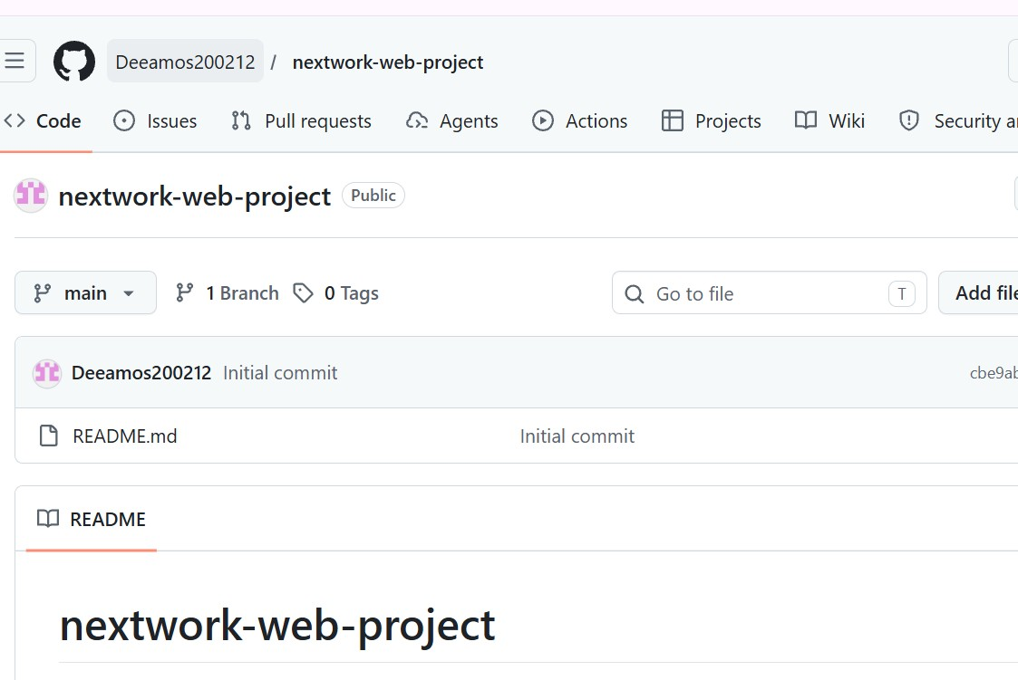

My local repository
A Git repository is a structured storage location that contains a project’s files along with the complete history of all changes tracked by Git. It includes the metadata, commit history, branches, and configuration information required for version control. A repository may exist locally on a developer’s machine or remotely on a platform such as GitHub, enabling synchronization, collaboration, and consistent source‑of‑truth management across development environments.
Running git init initializes Git inside our web app project folder, allowing Git to start tracking changes locally. The terminal confirmed that the repository was created and that we are on the default main branch. A branch in Git represents an independent version of the code where changes can be made safely. Once the work on a branch is complete, those changes are merged back into the main branch to update the primary codebase.
A branch in Git is an independent line of development that lets you make changes safely without affecting the main codebase. After running git init, Git created the default main branch, which serves as the primary version of the project until additional branches are created and merged.
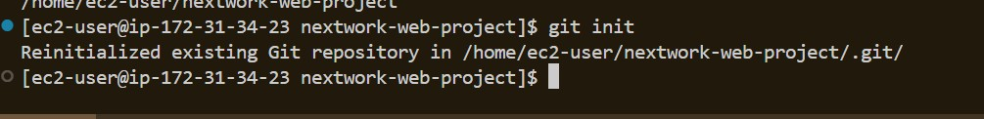

To push local changes to GitHub, I ran three commands

git add
The first command I ran was git add ., which stages all the changes in our project folder. The staging area in Git is a space where you review and collect the changes you want to include in your next commit. Only the files added to the staging area will be committed, giving you control over exactly which updates become part of the project’s history

git commit
The second command I ran was git commit -m, which saves all staged changes into the project’s history. The -m flag allows us to include a descriptive commit message, such as “made changes to index.jsp,” so we can clearly understand what was updated in that commit.. git push
The third command we ran was git push -u origin master, which uploads our committed changes to the remote repository named origin. The -u flag sets the remote branch as the default upstream branch, allowing future pushes and pulls to be done without specifying the remote or branch name.

Authentication
When I pushed my commits to GitHub, Git asked for my credentials because GitHub requires authentication before allowing any changes to a repository. This ensures that only authorized users can modify the code. By entering my credentials, GitHub verifies my identity and confirms that I have permission to push updates to the remote repository.

Local Git identity
Git requires your name and email because it is a version control system that tracks who made each change to the code. Every commit includes this identity information so Git and GitHub can clearly show which user contributed specific updates to the project...
When I ran the git log command, I noticed that Git was showing “ec2-user” as the author of my commits. This happened because Git had not yet been configured with my actual name and email. Since Git is a version control system that tracks who made each change, it used the EC2 instance’s default username and hostname as the author information.
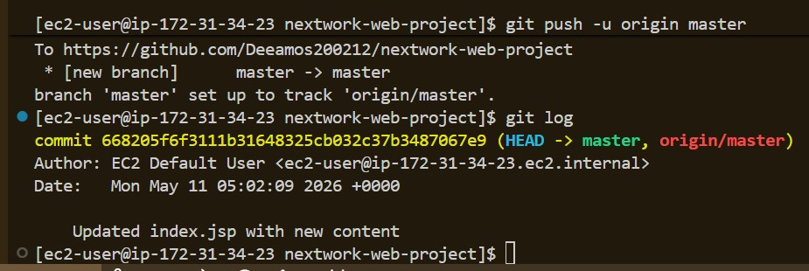

GitHub tokens
GitHub authentication was successful because GitHub verified my username and credentials, confirming that I am an authorized user with permission to push changes to the repository. Once my identity was validated, GitHub allowed the code upload to proceed.

Making changes again
I wanted to see Git working in action, so we made another change to our index.jsp file. At first, I didn’t see the update appear in my GitHub repository because we hadn’t staged, committed, or pushed the new changes yet. Git only updates the remote repository after we run the full workflow: git add, git commit, and git push.
I finally saw the updated changes in my GitHub repository after running the same three Git commands (git add, git commit, and git push) and then refreshing the index.jsp file in GitHub. This confirmed that the new changes were successfully uploaded from my EC2 instance to my remote repository.
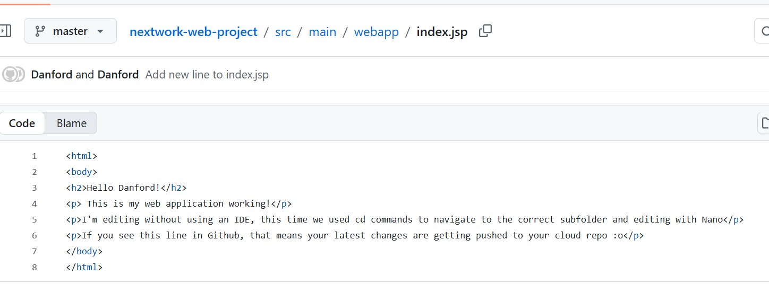

Setting up a READMe file
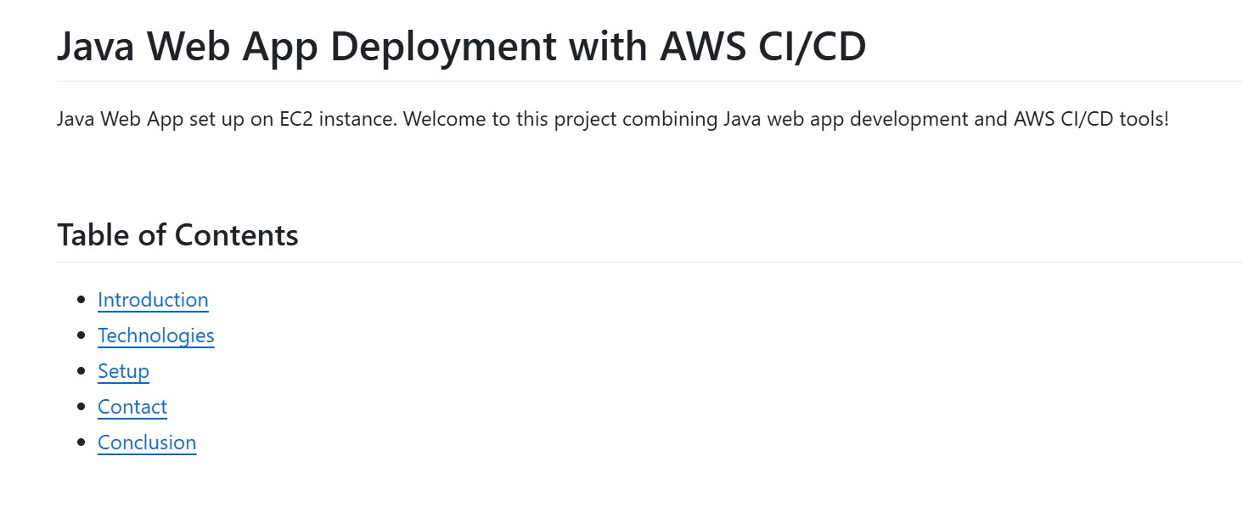
As a finishing touch to my GitHub repository, I added a README file. A README is a Markdown document stored at the root of the repository that introduces the project, explains what it does, and provides instructions on how to use it. I created the file on my EC2 instance by running touch README.md, then added content and pushed it to GitHub, where it now appears on the main repository page.
A README file is a Markdown document that lives at the root of a GitHub repository and provides an overview of the project. It explains what the project does, how to use it, how to set it up, and any important details a user or developer needs to know. GitHub automatically displays the README on the repository’s main page.
My README file has 5 sections that outline. Introduction Technologies Setup
Contact Conclusion

