

Lab Task #5
Introduction to Python
Name: ___Deeba__Omarzad________________
CMS ID: _______00000578323______________
Tasks:
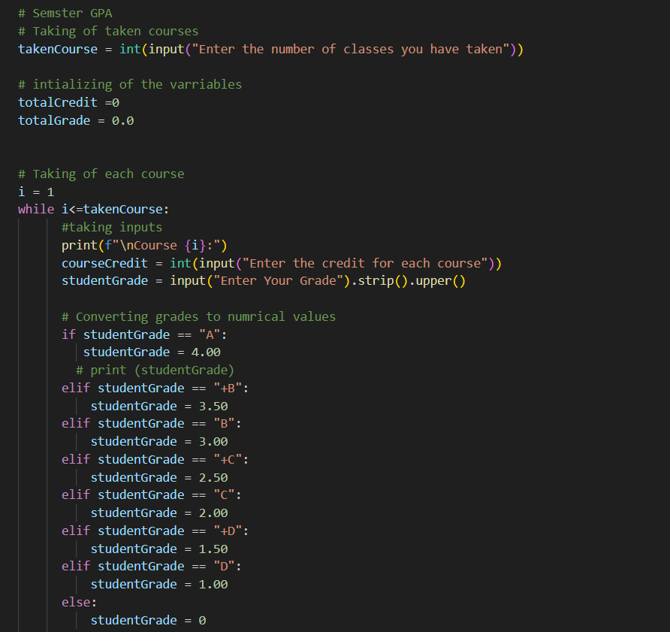
- Write a program that asks the user for the number of courses they took this semester.
For each course, take the credit hours and grade (like A, B+, C, etc.) from the user.
Then calculate the semester GPA using NUST’s GPA scale.
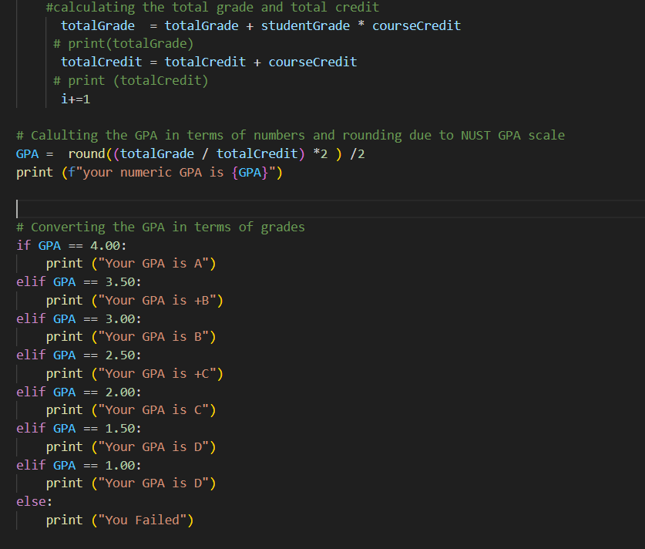
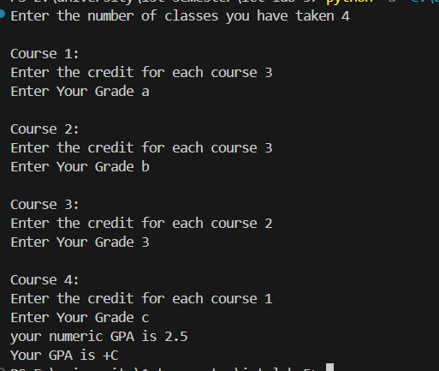

- Ask the user to enter an integer. Check whether it is even or odd and print an appropriate message.
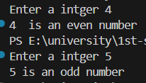
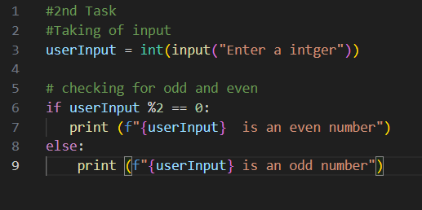

- Take the total number of classes and the number of classes attended by the user. Calculate the attendance percentage and tell if the student is allowed to sit the exam (minimum 75% required). 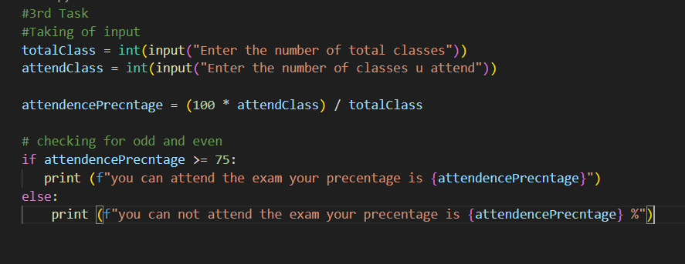
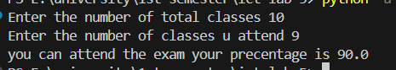

- Take any integer from the user. Print the reverse of that integer. You must not convert the integer into the string and must not use any of the pre-defined functions.
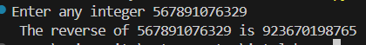
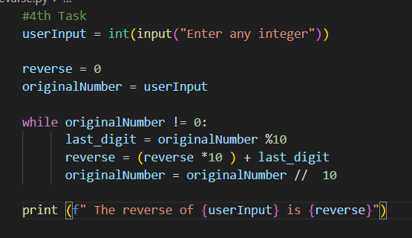

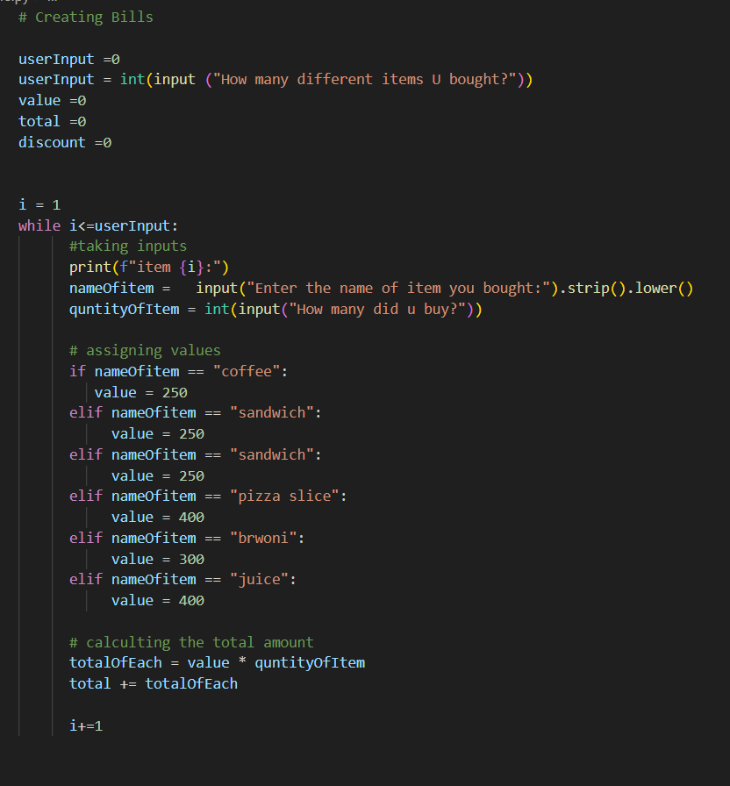
- Nicely formatted bill:

