DATA SCIENCE AND VISUALIZATION TEAM_10
WEEK 7
REPORT
Dimensionality Reduction and Feature Selection
TEAM MEMBERS:
25BAD011 – ARIHARAN S
25BAD018 – DEEBIKA M
25BAD037 – HEMANTH M

1. Aim
To apply Principal Component Analysis (PCA) to the engineered retail sales dataset, study cumulative explained variance, and use Random Forest feature importance to rank variables associated with predicting log-transformed total spending.

2. Dataset and Software
Dataset source: Kaggle – Retail Store Sales: Dirty for Data Cleaning (https://www.kaggle.com/datasets/ahmedmohamed2003/retail-store-sales-dirty-for-data-cleaning).
The uploaded notebook reports 12,575 rows and 11 original columns. The workflow uses Pandas and NumPy for data preparation, Matplotlib and Seaborn for visualizations, and scikit-learn for preprocessing, PCA and Random Forest regression.

3. Preparing the Feature Matrix
The notebook follows the Week 6 feature-engineering workflow. Transaction Date is converted to datetime and split into Transaction Year, Transaction Month, Transaction Day and Transaction DayOfWeek. Transaction ID, Customer ID and the raw date are dropped from the model feature set.
fe_df = df.copy()
fe_df['Transaction Date'] = pd.to_datetime(fe_df['Transaction Date'])
fe_df['Transaction Year'] = fe_df['Transaction Date'].dt.year
fe_df['Transaction Month'] = fe_df['Transaction Date'].dt.month
fe_df['Transaction Day'] = fe_df['Transaction Date'].dt.day
fe_df['Transaction DayOfWeek'] = fe_df['Transaction Date'].dt.dayofweek
The notebook reports skewness values of -0.0344 for Price Per Unit, -0.0359 for Quantity and 0.8809 for Total Spent. Because the absolute skewness of Total Spent exceeds 0.75, log1p is applied to that column. StandardScaler is used on numerical features and OneHotEncoder(drop='first') encodes the categorical features. The resulting engineered dataset has 12,575 rows and 18 columns.

4. Principal Component Analysis (PCA)
PCA is a dimensionality-reduction technique that transforms the original features into principal components, ordered by how much variance they explain. The notebook fits PCA to the 18-feature engineered dataset and plots cumulative explained variance, with reference lines at 90% and 95%.
pca = PCA()
pca.fit(engineered_df)
cumulative_variance = np.cumsum(pca.explained_variance_ratio_)
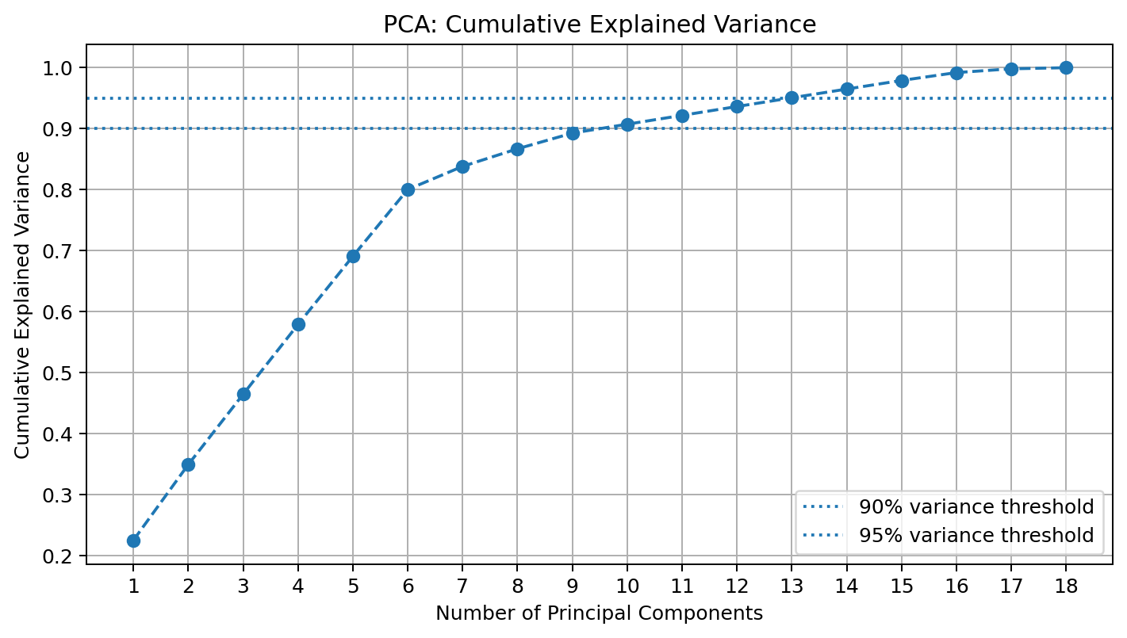
Figure 1. Cumulative explained variance across principal components.
According to the notebook output, 10 principal components retain 90.74% of the variance, while 13 components retain 95.07%. Thus, 10 components provide a more compact representation at the 90% threshold; 13 components retain more information at the 95% threshold.

5. Explained Variance by Component
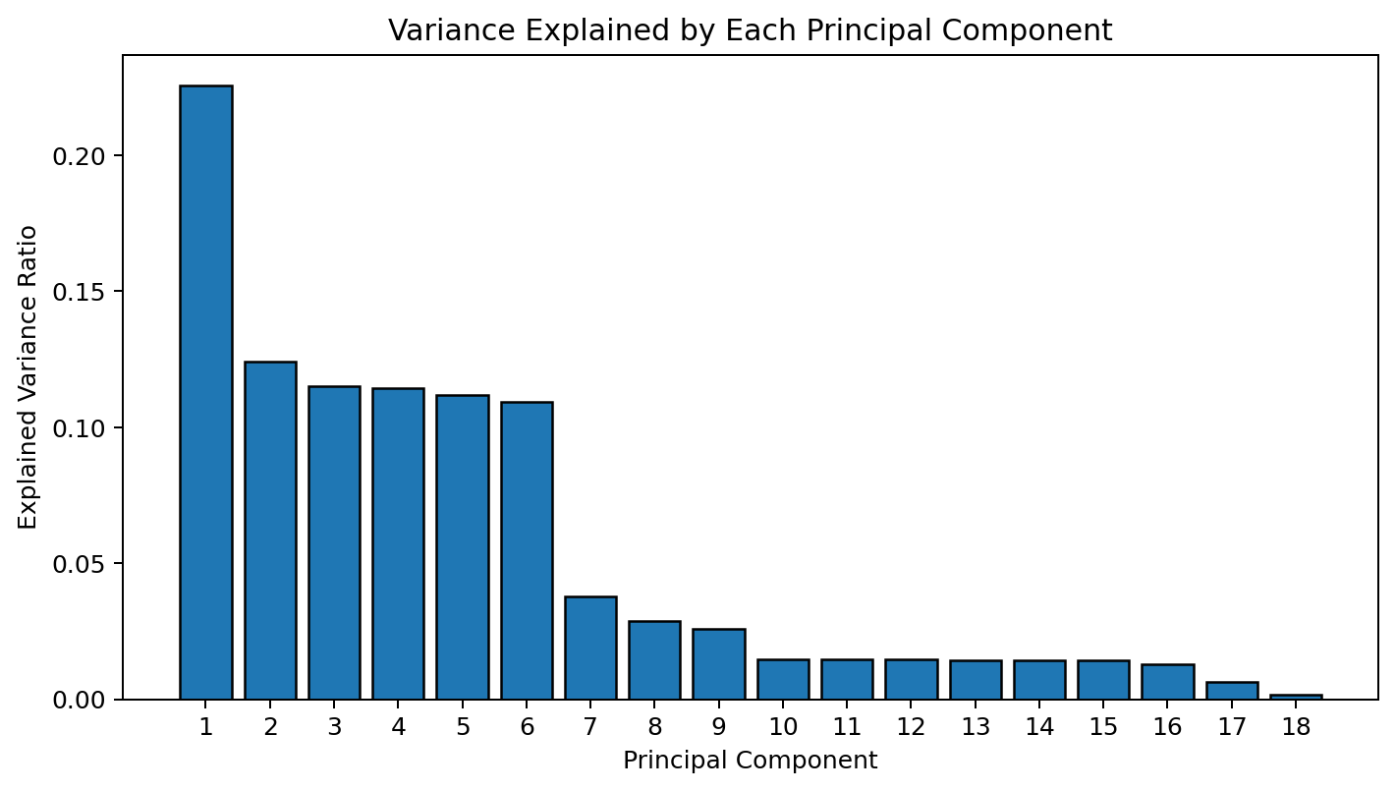
Figure 2. Individual explained variance ratios.
Component | Explained variance | Cumulative variance
PC1 | 0.2257 (22.57%) | 0.2257 (22.57%)
PC2 | 0.1240 (12.40%) | 0.3497 (34.97%)
PC3 | 0.1152 (11.52%) | 0.4649 (46.49%)
PC4 | 0.1143 (11.43%) | 0.5792 (57.92%)
PC5 | 0.1118 (11.18%) | 0.6910 (69.10%)
PC6 | 0.1094 (10.94%) | 0.8004 (80.04%)
PC7 | 0.0379 (3.79%) | 0.8383 (83.83%)
PC8 | 0.0288 (2.88%) | 0.8671 (86.71%)
PC9 | 0.0257 (2.57%) | 0.8928 (89.28%)
PC10 | 0.0146 (1.46%) | 0.9074 (90.74%)
PC11 | 0.0145 (1.45%) | 0.9219 (92.19%)
PC12 | 0.0145 (1.45%) | 0.9364 (93.64%)
PC13 | 0.0143 (1.43%) | 0.9507 (95.07%)
PC14 | 0.0143 (1.43%) | 0.9650 (96.50%)
PC15 | 0.0141 (1.41%) | 0.9791 (97.91%)
PC16 | 0.0129 (1.29%) | 0.9920 (99.20%)
PC17 | 0.0062 (0.62%) | 0.9982 (99.82%)
PC18 | 0.0018 (0.18%) | 1.0000 (100.00%)
PC1 explains 22.57% of total variance, PC2 explains 12.40%, and PC3 explains 11.52%. The contribution of each component generally decreases as additional components are included. All 18 components together account for 100% of the variance.

6. Feature Selection Using Random Forest
The notebook uses RandomForestRegressor with 100 trees and random_state=42. The target is Total Spent_log, while the remaining 17 engineered features are used as predictors. The model's feature_importances_ attribute provides a ranking of predictors based on their contribution to the fitted trees.
X_fs = engineered_df.drop(columns=['Total Spent_log'])
y_fs = engineered_df['Total Spent_log']
rf = RandomForestRegressor(n_estimators=100, random_state=42)
rf.fit(X_fs, y_fs)
importances = rf.feature_importances_
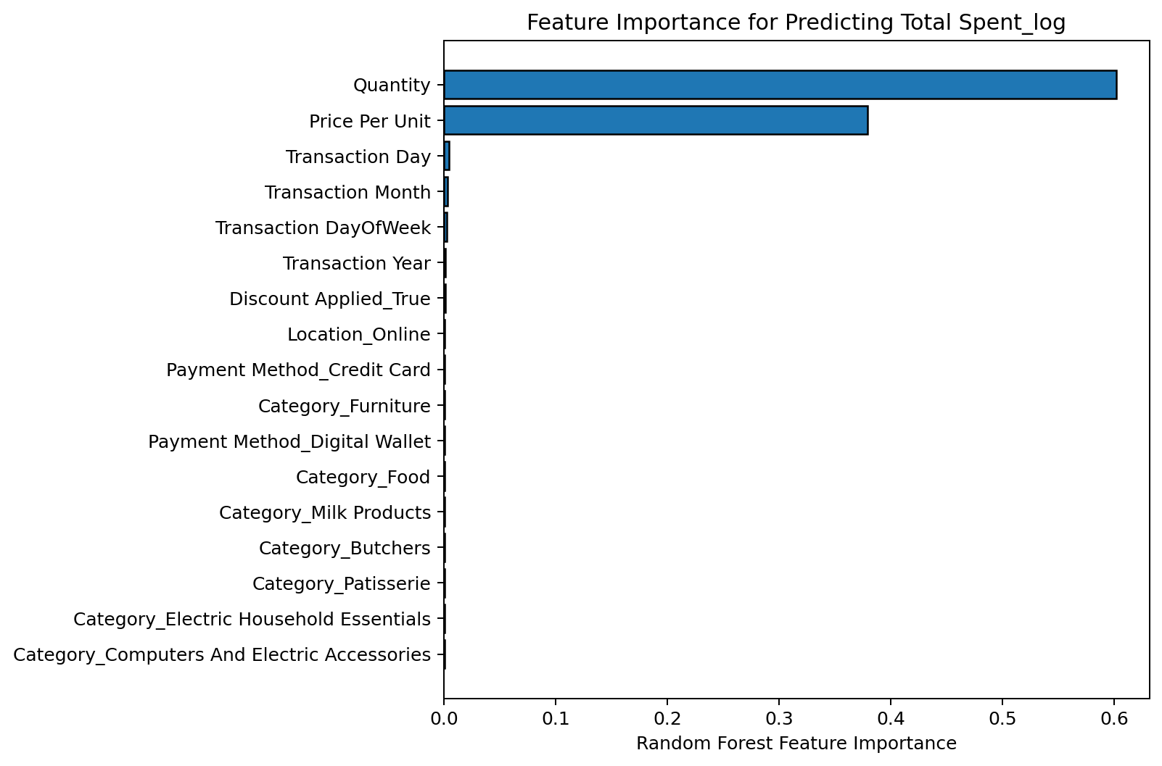
Figure 3. Random Forest feature importance scores.
Rank | Feature | Importance score
1 | Quantity | 0.6014
2 | Price Per Unit | 0.3792
3 | Transaction Day | 0.0045
4 | Transaction Month | 0.0033
5 | Transaction DayOfWeek | 0.0027
6 | Transaction Year | 0.0015
7 | Discount Applied_True | 0.0011
8 | Location_Online | 0.0008
9 | Payment Method_Credit Card | 0.0007
10 | Category_Furniture | 0.0007
11 | Payment Method_Digital Wallet | 0.0007
12 | Category_Patisserie | 0.0006
13 | Category_Food | 0.0006
14 | Category_Butchers | 0.0006
15 | Category_Milk Products | 0.0006
16 | Category_Electric Household Essentials | 0.0005
17 | Category_Computers And Electric Accessories | 0.0004
Quantity ranks first with an importance score of 0.6014, followed by Price Per Unit at 0.3792. Together, they account for approximately 98.06% of the reported importance. The remaining features have much smaller scores in this fitted model. This is consistent with total spending being closely associated with the number of units purchased and the unit price.

7. Interpretation and Limitations
- PCA is unsupervised and summarizes variation across the feature matrix; it does not identify the best predictors for a specific target.
- Random Forest feature importance is supervised and ranks predictors for Total Spent_log; it is not the same method as PCA.
- The notebook does not use a train/test split or cross-validation for the Random Forest importance analysis. These scores are exploratory and do not prove predictive performance on unseen data.
- Price Per Unit and Quantity are closely related to Total Spent, so their high importance should not be interpreted as a causal effect.
- The notebook plots explained variance but does not create a reduced PCA dataset or compare model performance before and after PCA.

8. Summary of Methods
Task | Method used | Purpose / result
Feature preparation | Date-part extraction; remove identifiers | Create useful model inputs
Skewness correction | log1p on Total Spent | Reduce right skew (0.8809)
Preprocessing | StandardScaler and OneHotEncoder | Scale numerical variables and encode categories
Dimensionality reduction | PCA and cumulative explained variance | 10 components for 90.74%; 13 for 95.07%
Feature selection | RandomForestRegressor feature importance | Quantity and Price Per Unit rank highest

9. Conclusion
The Week 7 notebook demonstrates two complementary approaches for analyzing engineered retail sales data. PCA summarizes the variation across the 18 features: 10 components preserve approximately 90.74% of variance and 13 preserve approximately 95.07%. A Random Forest regressor ranks Quantity and Price Per Unit as the most important predictors for log-transformed total spending. Together, these methods illustrate dimensionality reduction and feature selection, while the notebook's results remain exploratory because no held-out model evaluation is included.

