**Installation:**

Need to install Python3

Need to install sqlite3

**Compilation/Build:**

Convert the program into set uid program first and then proceed.

The program uses sqlite3 to store the data and also to retrieve the data.

Regular Expressions are used to check for allowed inputs.

Phone no regular expression- ("\d{5,6}|\(\d{3}\)\d{3}-\d{3,}|" + "\d\(\d{3}\)\d{3}-\d{3,}|" + "\d{3}-\d{4}|\+\d{1,2}\(\d{3}\)\d{3}-\d{3,}|"+

"\+\d{1,2}\s\(\d{2}\)\s\d{3}-\d{3,}|" + "\d{5}\.\d{5}")

Name regular expression-(r"^([A-Za-z]*[\s',]*)?([a-zA-Z']*[',\s-]*[a-zA-Z.']*[',\s-]*)$")

The process is shown below

**Assumptions:**

1. Format of input is known to the user.
2. The input for name and phone no is entered consecutively.

**Pros :**

1. Understandable Code
2. Reusable code
3. The Code will only insert the arguments into the database if its in the allowed format.
4. One phone no cannot be added twice with different names

**Cons:**

1. Where we store the data is a temporary storage not a permanent one.

**Description:**

The form of the input hould be **<executable name> <mode> <arguments>**

So in this **Phonebook.py ADD “Deeja Chhabra” “1234567”**

The arguments must be given in double quotation marks

For eg: **“Deeja Chhabra and “1234567” in the above command**.

The modes shall be given in capitak letters only.

For eg:

**ADD <name> <phone>**

Delete using phone no

**DEL <phone>**

Delete using Name

**DEL <name>**

LIST

So , that is

ADD <deeja> <234567>

DEL <deeja>

DEL <234567>

First we need to install python

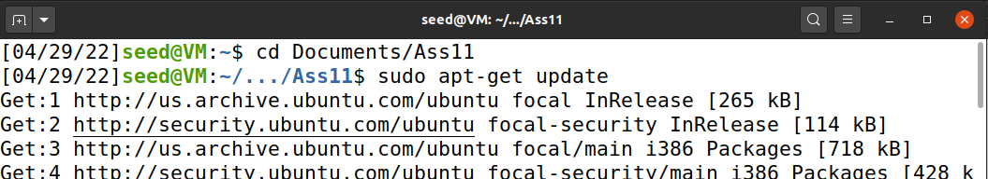

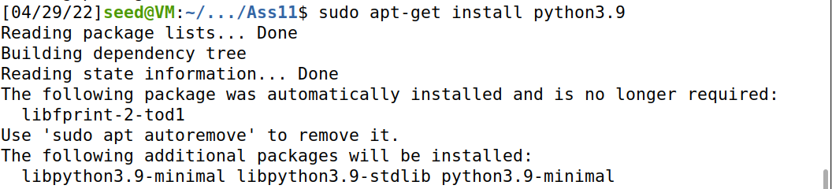

Installing sqlite3

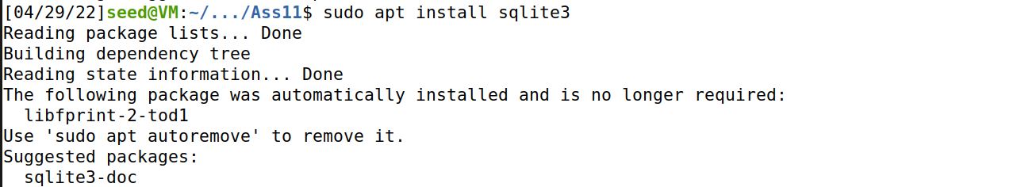

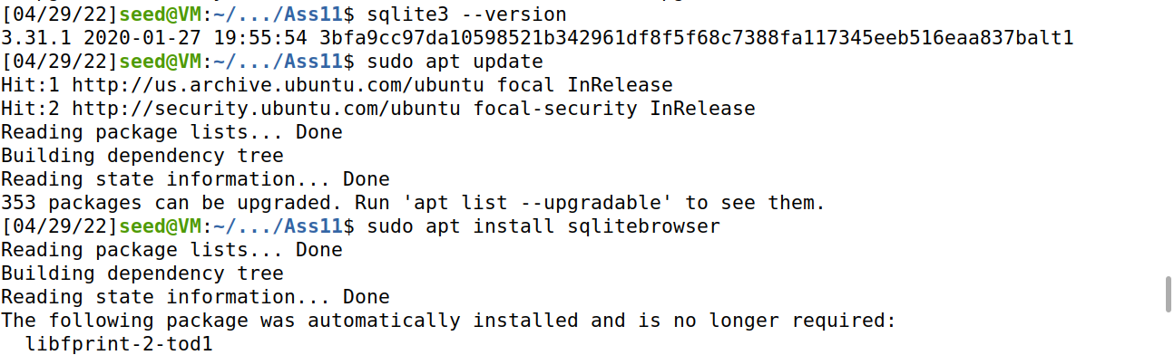

**SETUID conversion:**



Use :

Sudo chown root phonebook.py

Sudo chmod 4755 phonebook.py

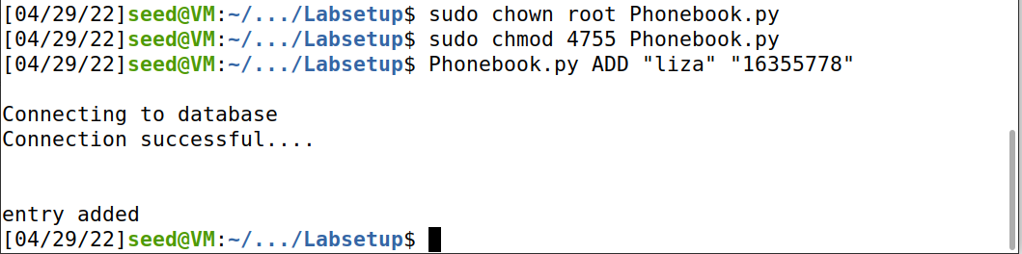

LIST operation:

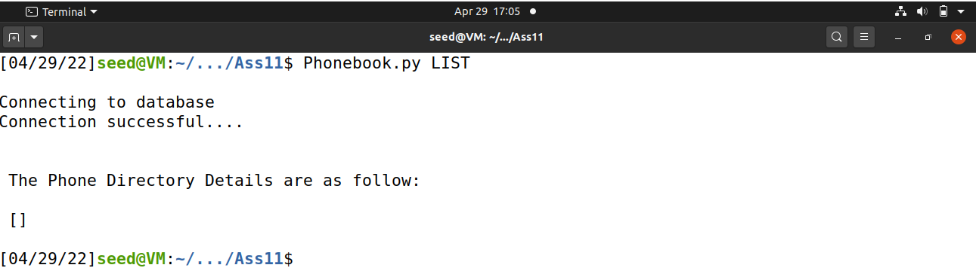

Add operation:

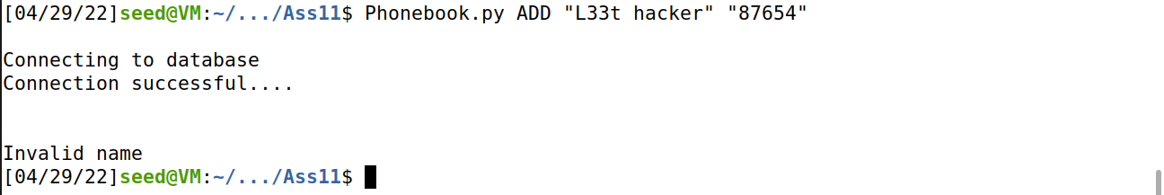

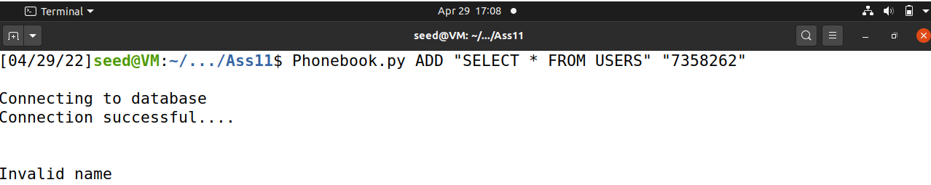

For valid name:

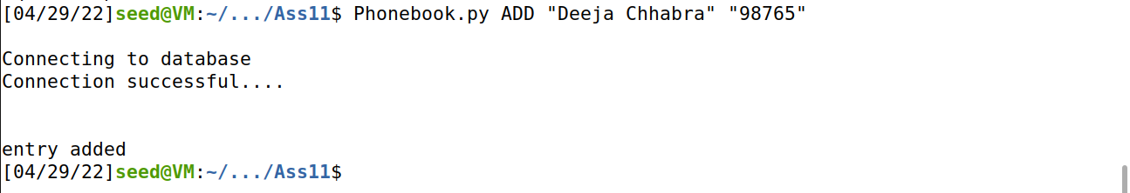

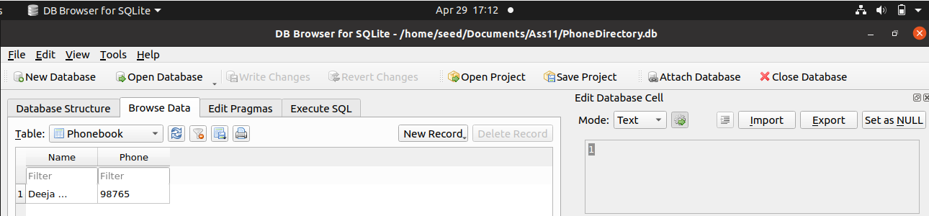

After 4 more insertions:

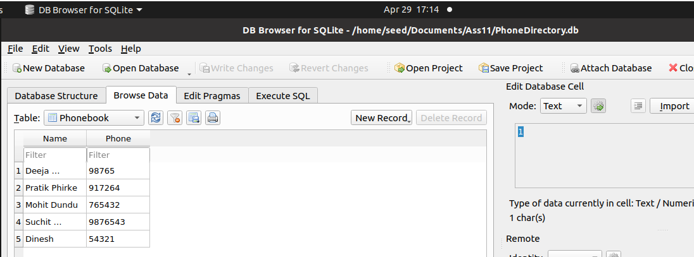

Delete Operation:

Delete via Name:

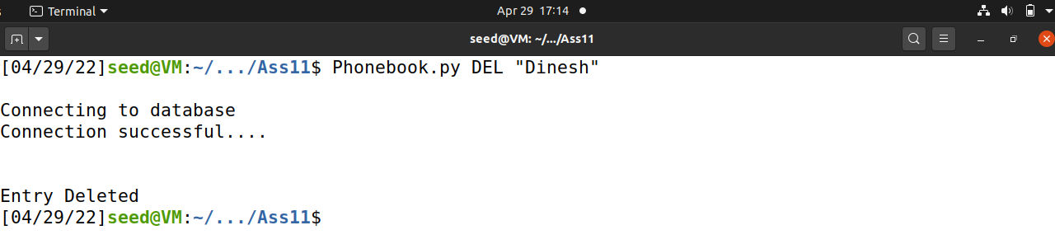

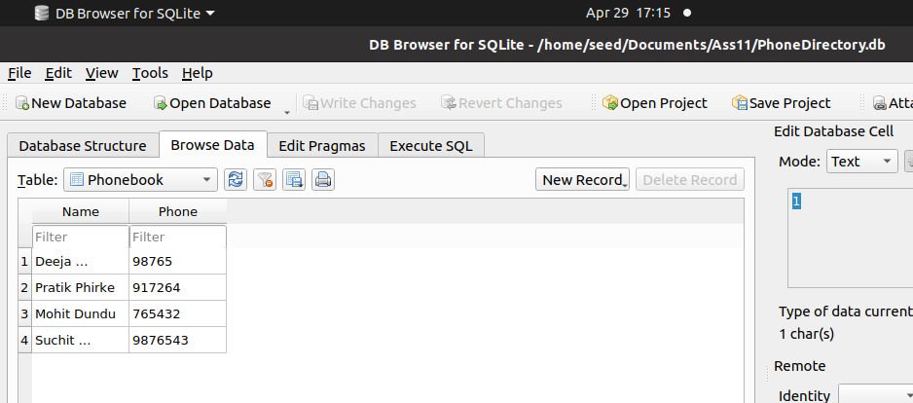

Deleting via phone no:

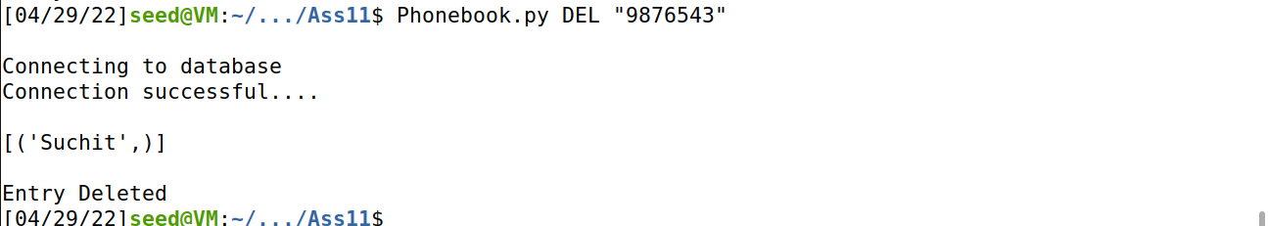

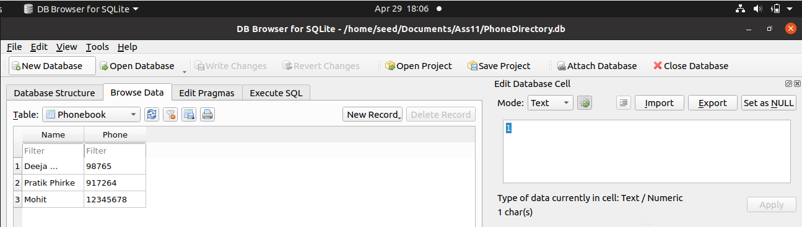

List operation:

