**WEEK #4 - Chapter 32 – Magnetic FIeld**

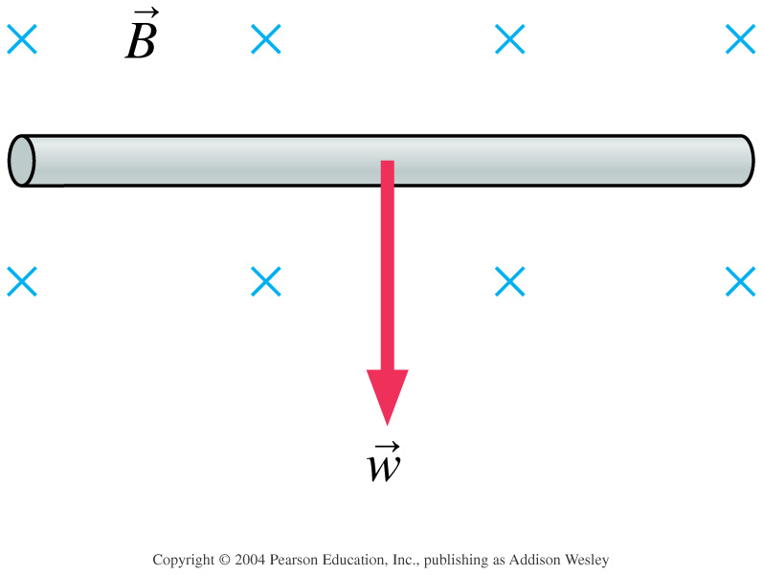

A 0.1 T uniform magnetic field (B) is horizontal, parallel to the floor. A straight segment of 1.0 mm diameter copper wire, also parallel to the floor, is perpendicular to the magnetic field. What current through the wire, and in what direction, will allow the wire to “float” in the magnetic field?