**WEEK #5 - Chapter 33 – Electromagnetic Induction**

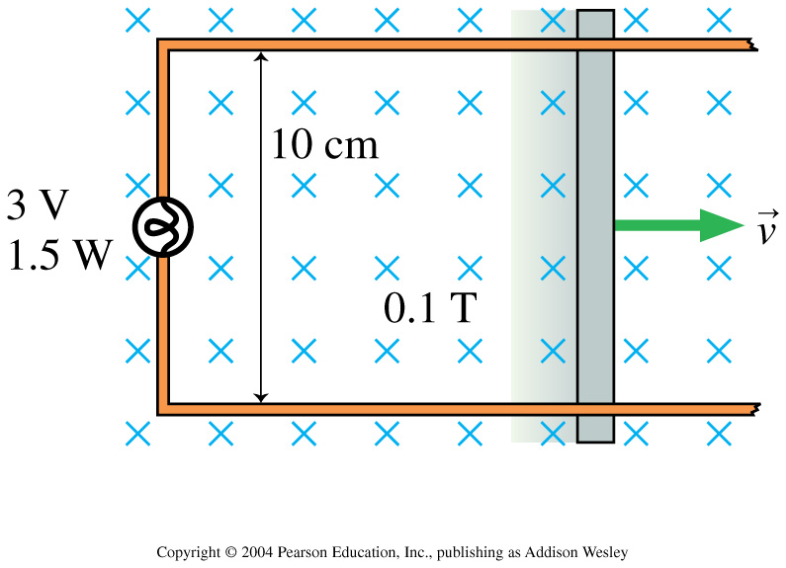

A circuit consists of a flashlight bulb, rated at 3.0V 1.5W and ideal wires with no resistance. The right wire of the circuit, which is 10 cm long, is pulled at a constant speed, v through a perpendicular magnetic field of strength 0.1T.

1. What speed must the wire be pulled to light the light bulb at full brightness?
2. What force is needed to keep the wire moving?