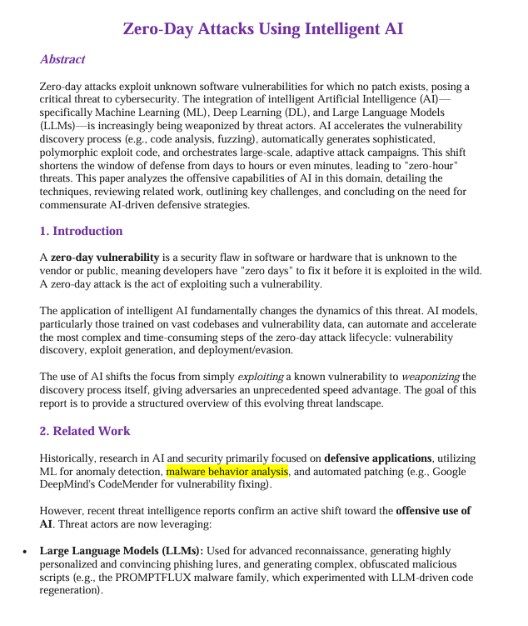

Test text: hellloo

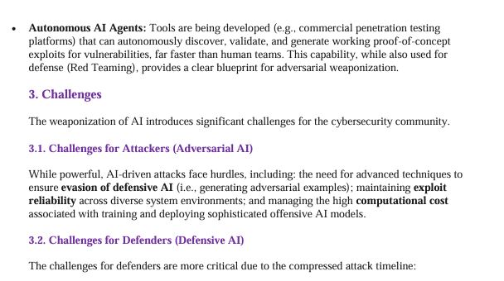
Speed Disparity (Zero-Hour Threats): The primary challenge is the speed at which AI can discover and weaponize vulnerabilities, drastically shortening the defensive window from days to minutes. • Data Scarcity and Generalization: AI detection models, especially supervised learning models, struggle with a lack of labeled zero-day data, as these attacks are inherently unknown. This results in poor generalization ability for novel threats. • Adversarial Attacks: Defensive AI models are vulnerable to model poisoning and evasion attacks, where threat actors subtly manipulate data or input to deceive the security system. • Explainability (XAI): The often opaque nature of Deep Learning models complicates incident response, as human analysts struggle to understand why the AI flagged an anomaly or made a specific decision.

