Zero-Day Attacks Using Intelligent AI

Abstract
Zero-day attacks exploit unknown software vulnerabilities for which no patch exists, posing a critical threat to cybersecurity. The integration of intelligent Artificial Intelligence (AI)—specifically Machine Learning (ML), Deep Learning (DL), and Large Language Models (LLMs)—is increasingly being weaponized by threat actors. AI accelerates the vulnerability discovery process (e.g., code analysis, fuzzing), automatically generates sophisticated, polymorphic exploit code, and orchestrates large-scale, adaptive attack campaigns. This shift shortens the window of defense from days to hours or even minutes, leading to "zero-hour" threats. This paper analyzes the offensive capabilities of AI in this domain, detailing the techniques, reviewing related work, outlining key challenges, and concluding on the need for commensurate AI-driven defensive strategies.
1. Introduction
A zero-day vulnerability is a security flaw in software or hardware that is unknown to the vendor or public, meaning developers have "zero days" to fix it before it is exploited in the wild. A zero-day attack is the act of exploiting such a vulnerability.
The application of intelligent AI fundamentally changes the dynamics of this threat. AI models, particularly those trained on vast codebases and vulnerability data, can automate and accelerate the most complex and time-consuming steps of the zero-day attack lifecycle: vulnerability discovery, exploit generation, and deployment/evasion.
The use of AI shifts the focus from simply exploiting a known vulnerability to weaponizing the discovery process itself, giving adversaries an unprecedented speed advantage. The goal of this report is to provide a structured overview of this evolving threat landscape.

2. Related Work
Historically, research in AI and security primarily focused on defensive applications, utilizing ML for anomaly detection, malware behavior analysis, and automated patching (e.g., Google DeepMind's CodeMender for vulnerability fixing).
However, recent threat intelligence reports confirm an active shift toward the offensive use of AI. Threat actors are now leveraging:
- Large Language Models (LLMs): Used for advanced reconnaissance, generating highly personalized and convincing phishing lures, and generating complex, obfuscated malicious scripts (e.g., the PROMPTFLUX malware family, which experimented with LLM-driven code regeneration).
- Autonomous AI Agents: Tools are being developed (e.g., commercial penetration testing platforms) that can autonomously discover, validate, and generate working proof-of-concept exploits for vulnerabilities, far faster than human teams. This capability, while also used for defense (Red Teaming), provides a clear blueprint for adversarial weaponization.

3. Challenges
The weaponization of AI introduces significant challenges for the cybersecurity community.

3.1. Challenges for Attackers (Adversarial AI)
While powerful, AI-driven attacks face hurdles, including: the need for advanced techniques to ensure evasion of defensive AI (i.e., generating adversarial examples); maintaining exploit reliability across diverse system environments; and managing the high computational cost associated with training and deploying sophisticated offensive AI models.

3.2. Challenges for Defenders (Defensive AI)
The challenges for defenders are more critical due to the compressed attack timeline:
- Speed Disparity (Zero-Hour Threats): The primary challenge is the speed at which AI can discover and weaponize vulnerabilities, drastically shortening the defensive window from days to minutes.
- Data Scarcity and Generalization: AI detection models, especially supervised learning models, struggle with a lack of labeled zero-day data, as these attacks are inherently unknown. This results in poor generalization ability for novel threats.
- Adversarial Attacks: Defensive AI models are vulnerable to model poisoning and evasion attacks, where threat actors subtly manipulate data or input to deceive the security system.
- Explainability (XAI): The often opaque nature of Deep Learning models complicates incident response, as human analysts struggle to understand why the AI flagged an anomaly or made a specific decision.

4. Methods Using AI
Intelligent AI is used throughout the zero-day attack chain to create sophisticated exploits.
Attack Phase | AI/ML Techniques Used | Mechanism of Weaponization
Vulnerability Discovery | Reinforcement Learning (RL)-based Fuzzing, Deep Learning for Code Analysis | AI agents rapidly analyze vast codebases, guiding fuzzers to vulnerability-triggering code paths and prioritizing weaknesses based on exploitability likelihood.
Exploit Generation | Large Language Models (LLMs), Generative AI, Sequence-to-Sequence Models | LLMs are leveraged to generate functional, proof-of-concept exploit code, and dynamically rewrite malware code for polymorphism to bypass detection.
Targeting & Delivery | Predictive Analytics, Natural Language Processing (NLP) | AI analyzes threat intelligence to identify high-value targets, predict effective exploitation vectors, and generate personalized, contextually relevant phishing lures for delivery.
Evasion & Persistence | Generative Adversarial Networks (GANs), Reinforcement Learning | GANs generate malicious network traffic that mimics legitimate traffic to bypass signature-based detection. RL is used to develop malware that learns and adapts its behavior in real-time to evade Endpoint Detection and Response (EDR) systems.

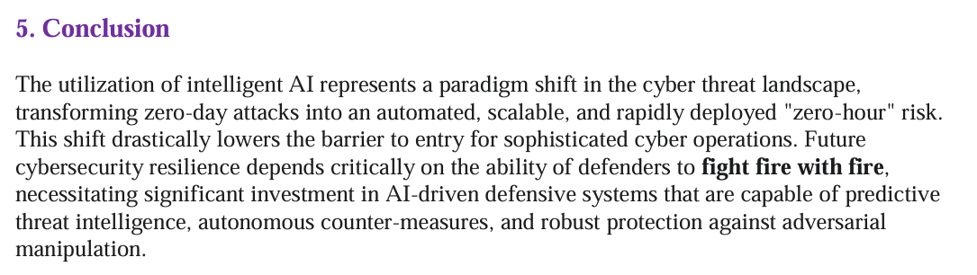

References
- Google Threat Intelligence Group (GTIG). (2025). GTIG AI Threat Tracker: Advances in Threat Actor Usage of AI Tools. Google Cloud Blog.
- Ayodele, A., Adetunla, A., & Akinlabi, E. (2024). The Role of AI in Zero-Day Attack Detection and Mitigation. ResearchGate.
- C8 Secure. (2025). How AI is Accelerating Cyber Threats: The Rise of Zero-Hour Attacks.
- Palo Alto Networks Unit 42. (2025). LANDFALL: New Commercial-Grade Android Spyware in Exploit Chain Targeting Samsung Devices.
- ResearchGate. (2025). A Survey of AI-Based Zero-Day Attack Detection Methods.
- Google DeepMind. (2025). Introducing CodeMender: an AI agent for code security.

