**STEPS TO INSTALL AND CONFIGURE AUTHORITATIVE KNOTDNS IN UBUNTU**

**Step 1**

* Visit official website of knotdns <https://www.knot-dns.cz/download/>
* Download ubuntu package

1.Update apt package index and install necessary packages:

* sudo apt-get update

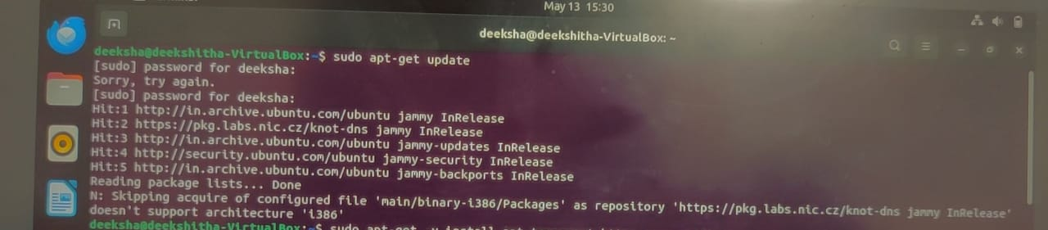

* sudo apt-get -y install apt-transport-https ca-certificates wget

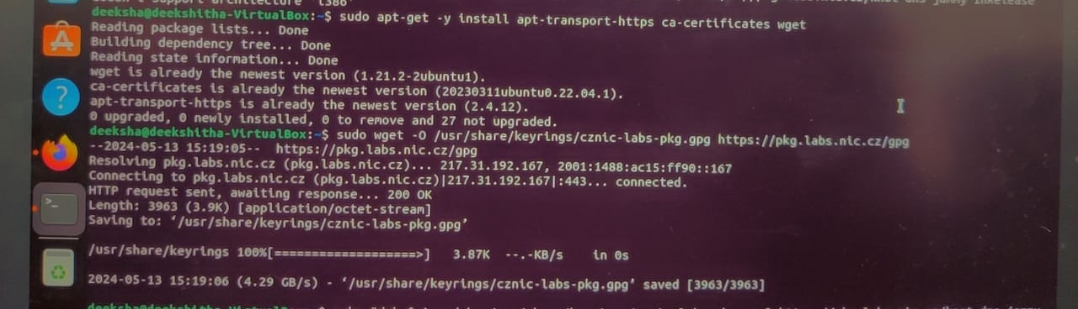

2.Add CZ.NIC Labs Packaging GPG key:

* sudo wget -O /usr/share/keyrings/cznic-labs-pkg.gpg <https://pkg.labs.nic.cz/gpg>

3.Setup the knot-dns repository

* echo "deb [signed-by=/usr/share/keyrings/cznic-labs-pkg.gpg] https://pkg.labs.nic.cz/knot-dns jammy main" | sudo tee /etc/apt/sources.list.d/cznic-labs-knot-dns.list

4.Update apt package index with knot-dns repo enabled:

* sudo apt-get update
* sudo nano /etc/apt/preferences.d/knot

by adding following lines:

Package: knot knot-* libdnssec* libzscanner* libknot*

python3-libknot*

Pin-Priority: 1001

Pin: version 3.1.*

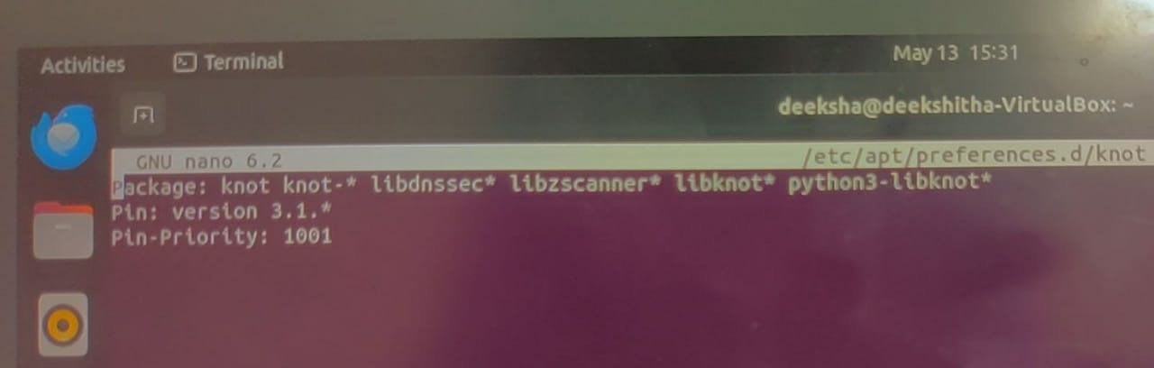

5.Install packages using apt:

* sudo apt-get install knot

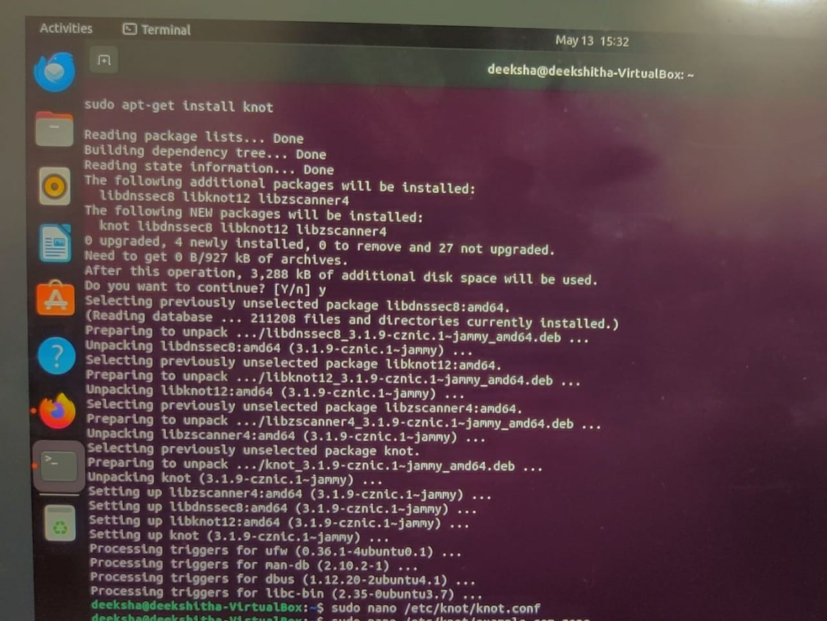

This completes the installation process.

**Step 2**

Open terminal and follow the steps

1.sudo nano /etc/knot/knot.conf

Open conf file and make following changes

* listen: 127.0.0.1
* And add Zone path to your file

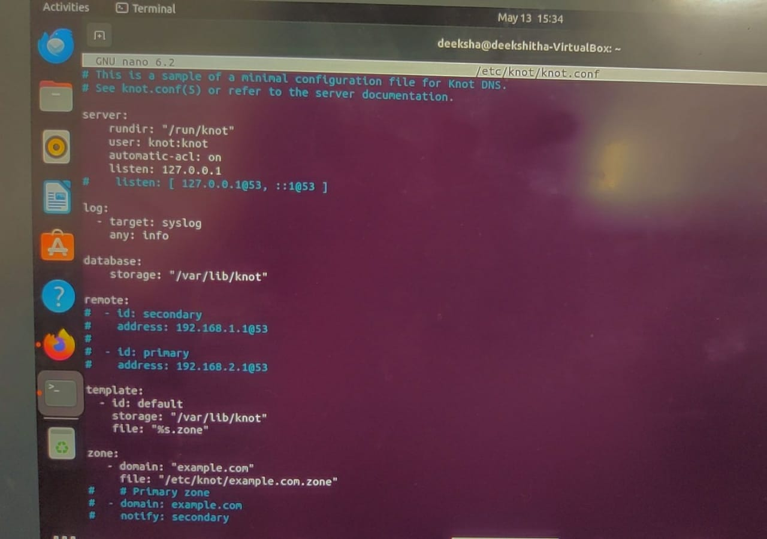

2.sudo nano /etc/knot/example.com.zone

Open zone file and add following contents

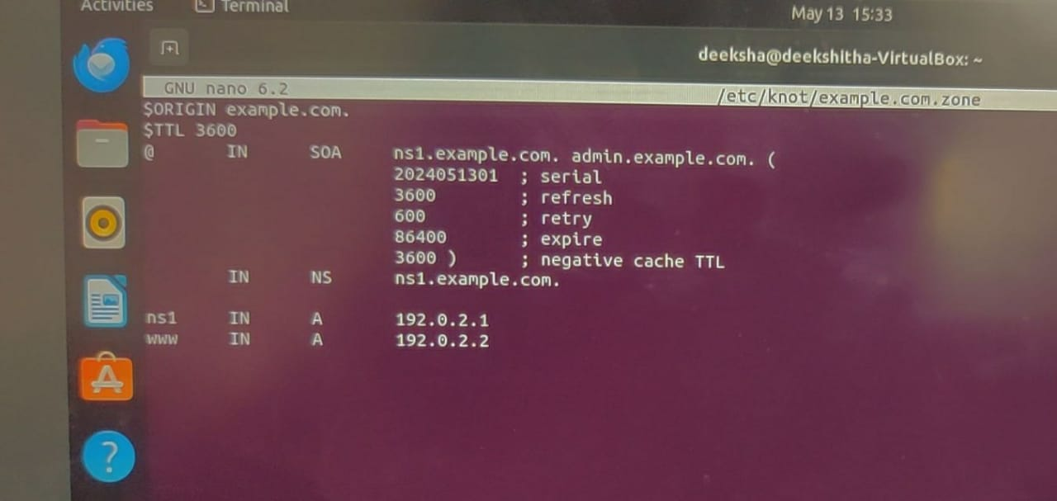

3.Start the knotdns by following command

* Sudo systemctl start knot.service

4.Edit the resolv.conf file

* Sudo nano /etc/resolv.conf

Make the following changes

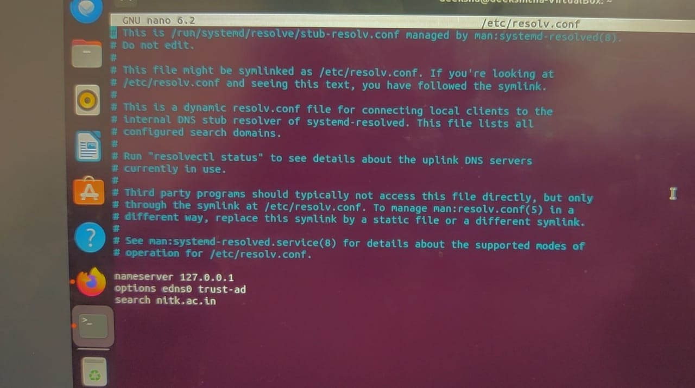

5.Restart the knot server

* Sudo systemctl restart knot.service

6.Check the status of server

* Sudo systemctl status knot.service

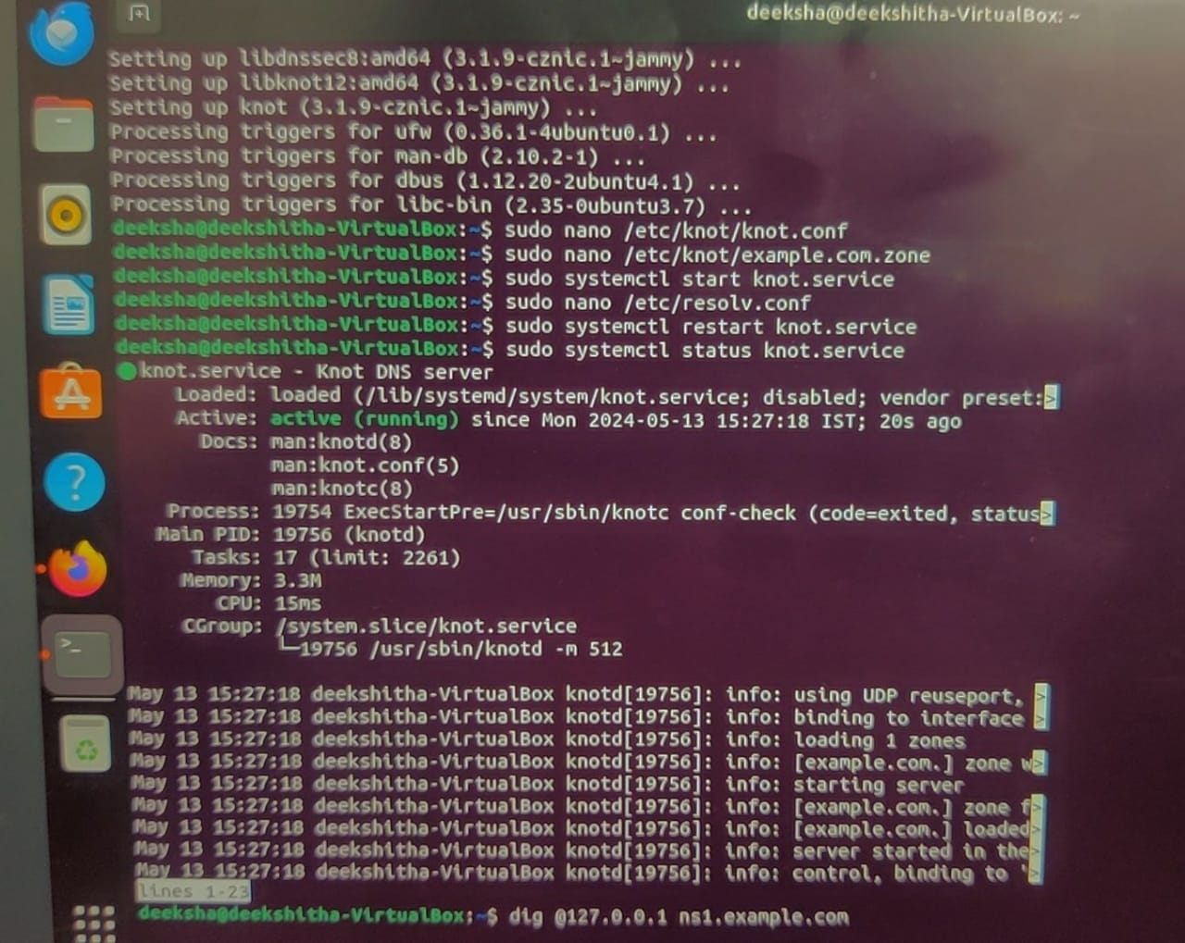

7.Run at localhost and verify whether you get the same IP mentioned in zone file

* dig @127.0.0.1 ns1.example.com
* dig @127.0.0.1 www.example.com

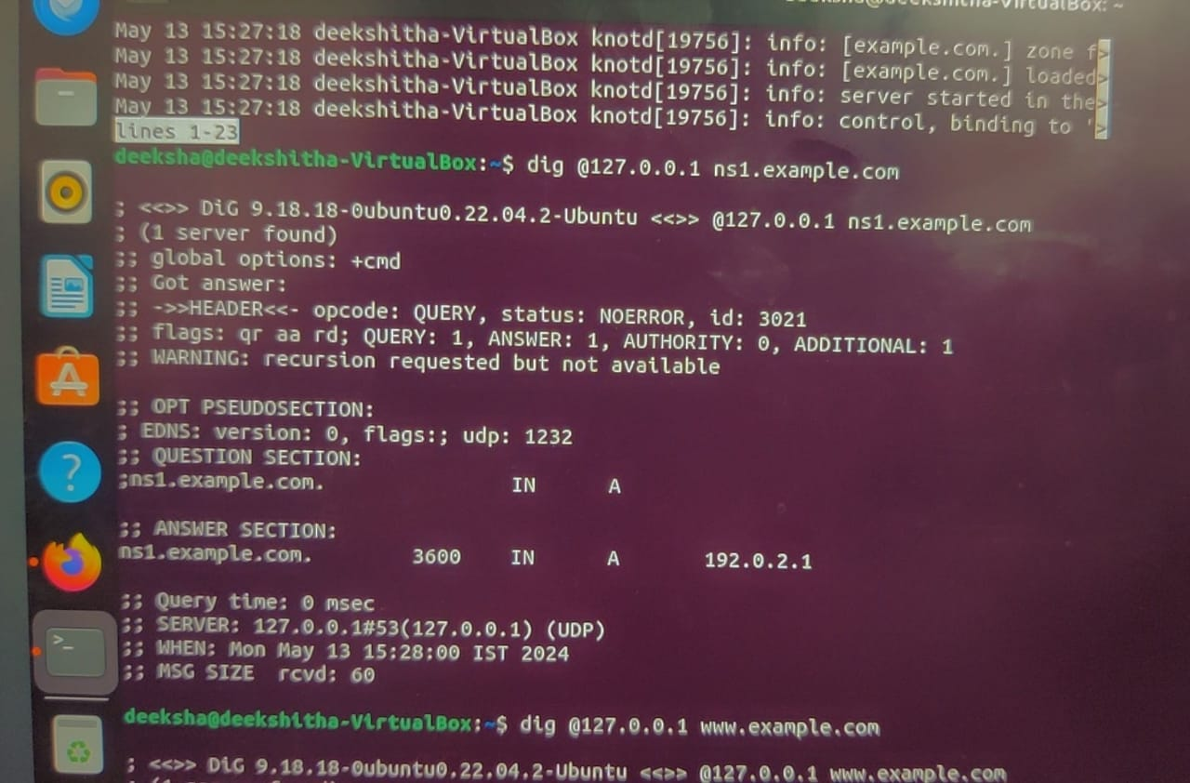

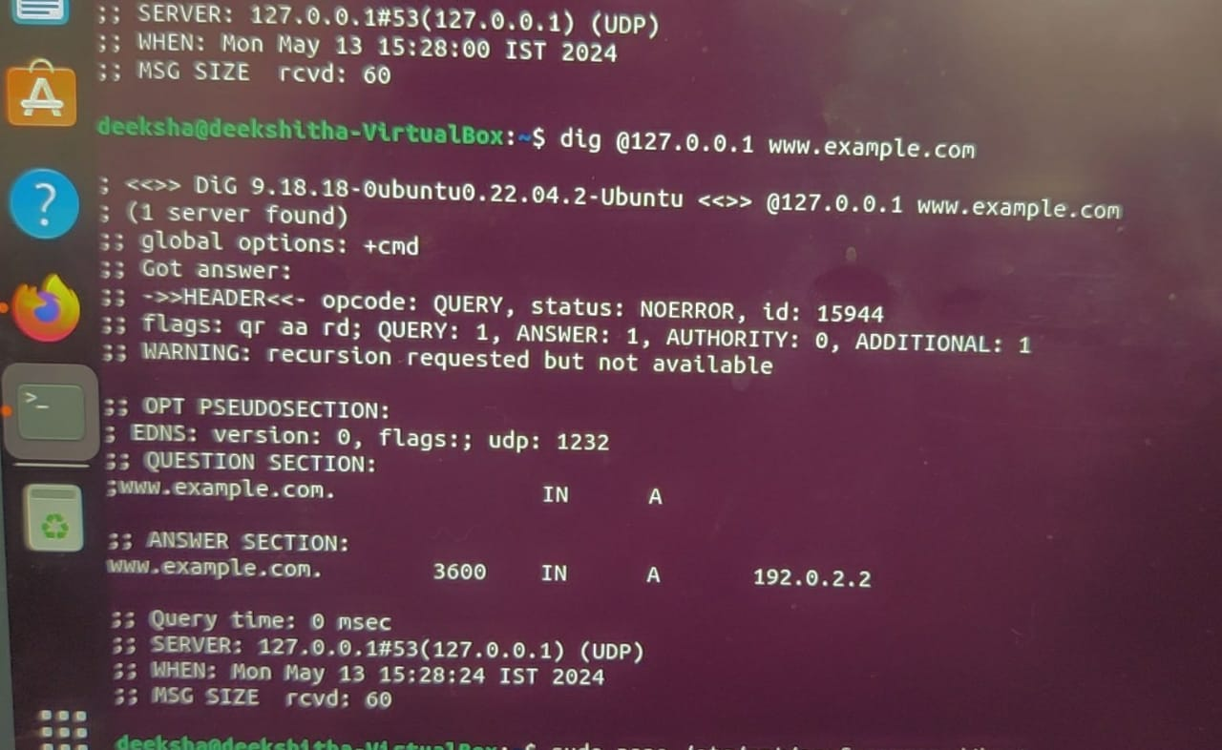

**STEPS TO INSTALL AND CONFIGURE RECURSIVE KNOT-RESOLVER IN UBUNTU**

**Step 1**

1.Visit the official website of knot-resolver <https://www.knot-resolver.cz/download/>

2.Follow the below mentioned steps

* wget <https://secure.nic.cz/files/knot-resolver/knot-resolver-release.deb>

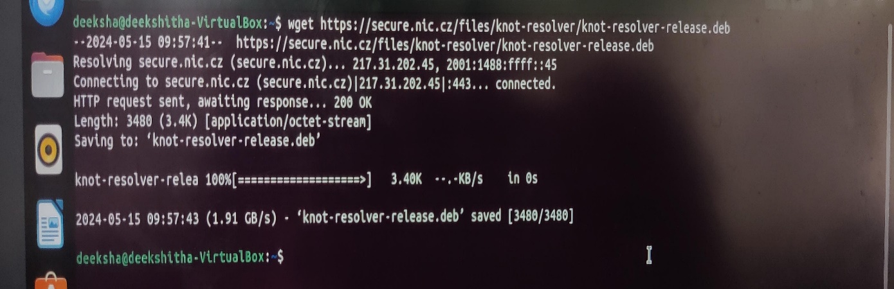

* sudo dpkg -i knot-resolver-release.deb
* sudo apt update
* sudo apt install -y knot-resolver

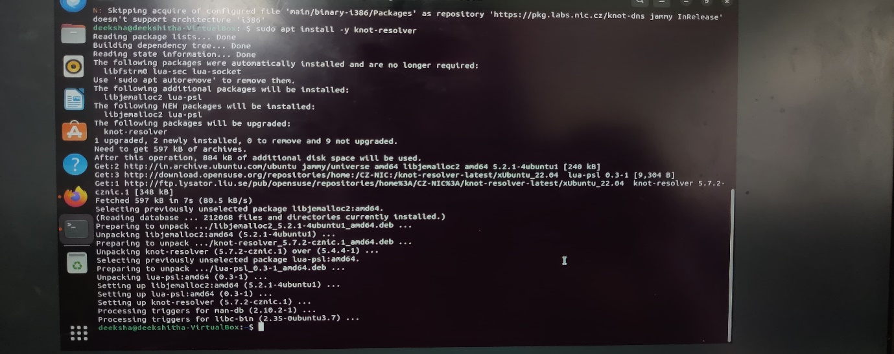

3.Set up the conf file and include the following lines

Note:Make sure to cross check the port number being used(unique port number)

* Sudo nano /etc/knot-resolver/kresd.conf

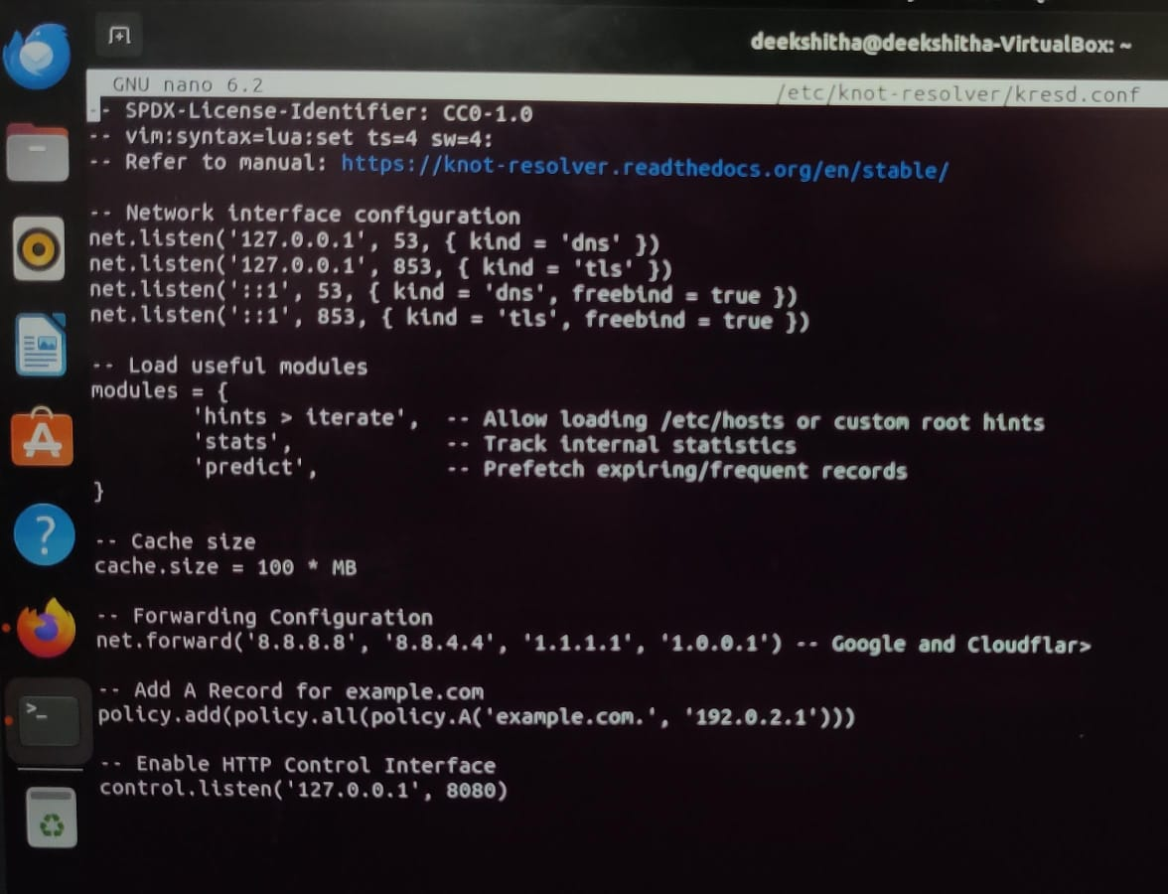

4.Start and check the status of kresd

Note:Make sure to include both the lines in same command

* sudo systemctl restart kresd

sudo systemctl status kresd

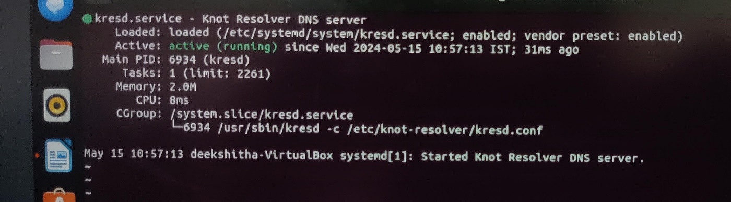

5.Check the recursive server

* dig @localhost example.com

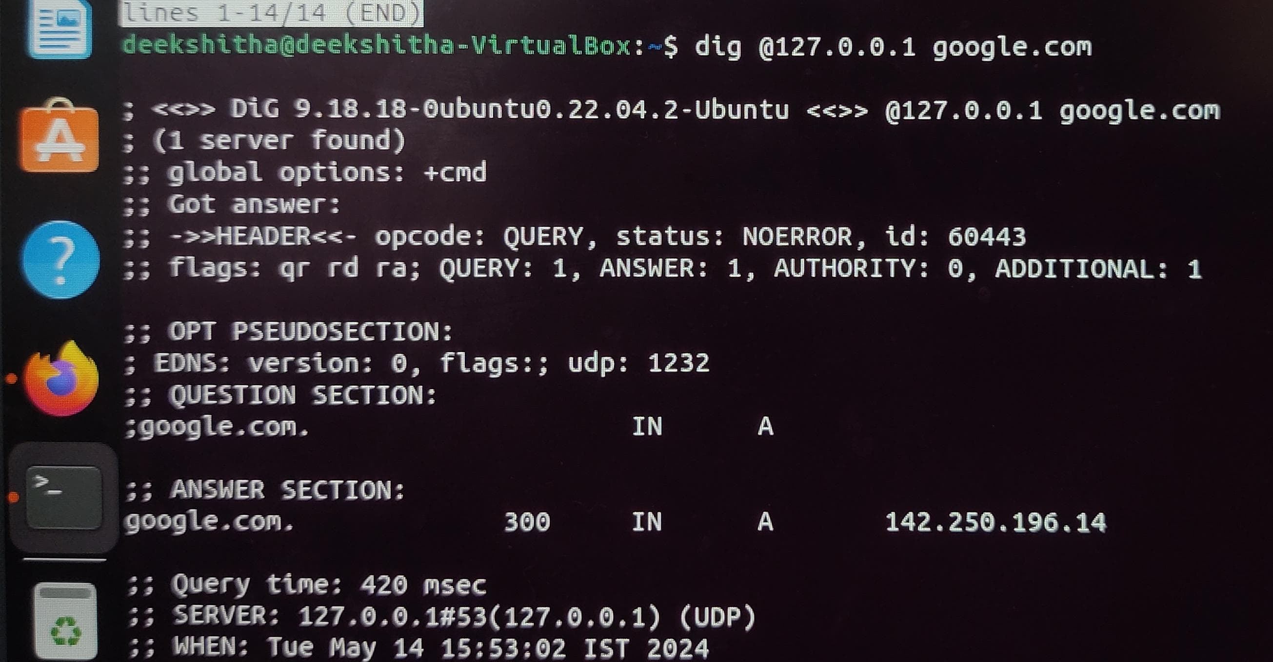

* dig @127.0.0.1 google.com

