Assignment5
1. Consider the two regular expressions
r = a ∗ + b∗
s = ab ∗ + ba∗ + b ∗ a + (a ∗ b)∗
a. Find a string corresponding to r but not to s.
b. Find a string corresponding to s but not to r.
c. Find a string corresponding to both r and s.
d. Find a string in {a, b}∗ corresponding to neither r nor s.
2. Construct the FAs from simppler FAs.
a. The language of all strings in which every a is followed immediately by bb.
b. The language of all strings that begin or end with aa or bb.
c. The language of all strings not containing the substring aaa. And the language of all strings not containing the substring bba.
d. The language of all strings containing both bab and aba as substrings.
3. Convert the NFA given in the fgure to DFA.
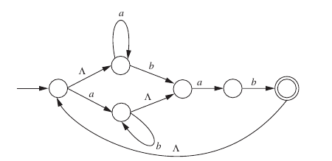
a)

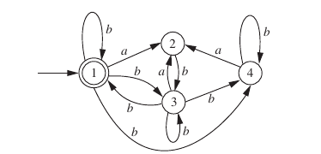
b)

4. For each of the following regular expressions, draw an NFA accepting the corresponding language, so that there is a recognizable correspondence between the regular expression and the transition diagram.
a. (a + b)∗ (abb + ababa)(a + b)∗
b. (a ∗ bb)∗ + bb∗ a ∗

