MNOR I
1. The following are the state diagrams of two DFAs, M1 and M2 . Answer the following questions about each of these machines. (3)
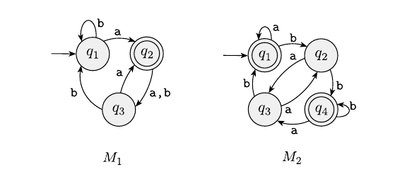
a. What is the start state?
b. What is the set of accept states?
c. What sequence of states does the machine go through on input aabb?
d. Does the machine accept the string aabb?
e. Does the machine accept the string ε?
f. Give the formal description of the machines M1 and M2 .

2. Construct the L(M1 ) ∪ L(M2 ) corresponding to M1 and M2 given in Question No.1. (5)
3. Construct the DFA L(M1 ) ∪ L(M2 ) for the two NFA given below. (6)

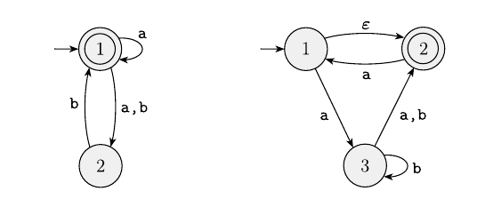
4. Convert the following regular expressions to NFAs, Σ = {a, b}. (3)
a(abb) ∗ ∪b

5. Prove that the language D = {w| w contains an equal number of occurrences of the substrings 01 and 10} is regular or not. (3)

