**EX:No.5 221501028**

**27/03/25**

**IMPLEMENT PROGRAMS FOR ESTIMATING & ELIMINATING TREND IN TIME SERIES DATA- AGGREGATION, SMOOTHING**

**AIM:**

To develop a Python program that estimates and eliminates trends in the "Autism Screening for Toddlers" dataset by simulating a time series, using aggregation and smoothing techniques, and visualizing the results.

.

**ALGORITHM:**

1. Load the dataset and simulate a time series by assigning synthetic timestamps.
2. Calculate the total score from screening variables (A1 to A10) and clean the data.
3. Aggregate the data to a weekly level to estimate the trend.
4. Apply a moving average to smooth the data and further estimate the trend.
5. Detrend the data by subtracting the smoothed series and visualize the results.

**PROCESS:**

**i**mport pandas as pd

import numpy as np

import matplotlib.pyplot as plt

**# Load the Autism Screening for Toddlers dataset**

df = pd.read_csv('Toddler Autism dataset July 2018.csv') # Replace with actual file path

**# Simulate a time series by adding a timestamp (since the dataset lacks explicit time data)**

date_rng = pd.date_range(start='2018-01-01', periods=len(df), freq='D') # Daily frequency for demo

df['timestamp'] = date_rng

df.set_index('timestamp', inplace=True)

**# Calculate Total_Score as the sum of A1 to A10 scores**

df['Total_Score'] = df[['A1_Score', 'A2_Score', 'A3_Score', 'A4_Score', 'A5_Score',

'A6_Score', 'A7_Score', 'A8_Score', 'A9_Score', 'A10_Score']].sum(axis=1)

**# Clean data (handle any potential missing values)**

df['Total_Score'] = df['Total_Score'].fillna(method='ffill').fillna(method='bfill').fillna(0)

**# Aggregate daily data to weekly data using mean**

weekly_data = df['Total_Score'].resample('W').mean()

**# Plot aggregated weekly data**

plt.figure(figsize=(12, 4))

weekly_data.plot(title='Weekly Aggregated Total Autism Screening Scores')

plt.xlabel('Date')

plt.ylabel('Total Score')

plt.show()

**# Apply 7-day moving average for smoothing on the original daily data**

df['smoothed'] = df['Total_Score'].rolling(window=7, center=True).mean()

**# Plot original and smoothed data**

plt.figure(figsize=(12, 4))

df[['Total_Score', 'smoothed']].plot(title='Smoothed Total Autism Screening Scores (7-day MA)')

plt.xlabel('Date')

plt.ylabel('Total Score')

plt.show()

**# Detrend by subtracting the smoothed series from the original**

df['detrended'] = df['Total_Score'] - df['smoothed']

**# Plot detrended data**

plt.figure(figsize=(12, 4))

df['detrended'].plot(title='Detrended Total Autism Screening Scores')

plt.axhline(0, color='gray', linestyle='--')

plt.xlabel('Date')

plt.ylabel('Detrended Score')

plt.show()

**OUTPUT:**

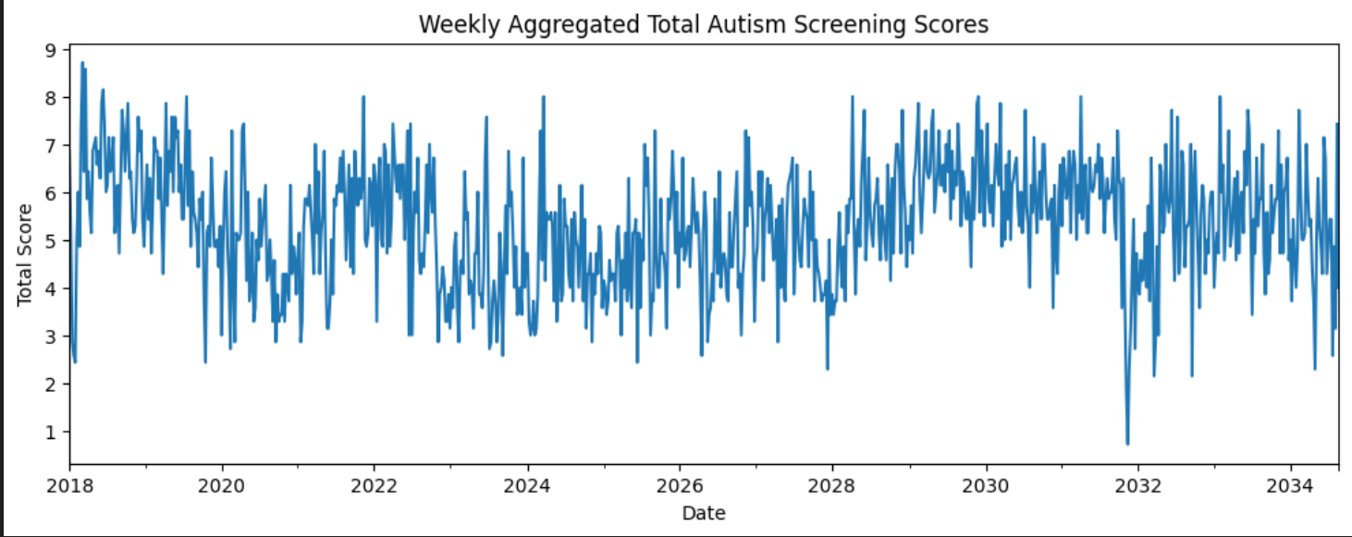

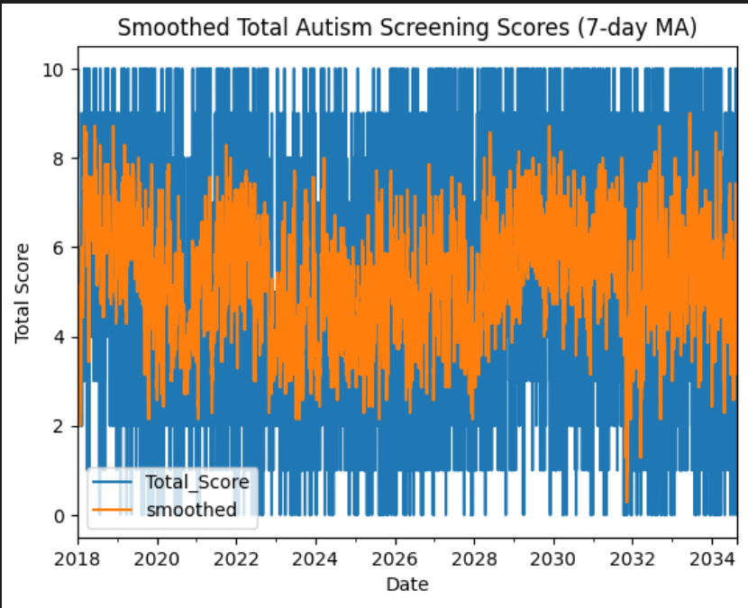

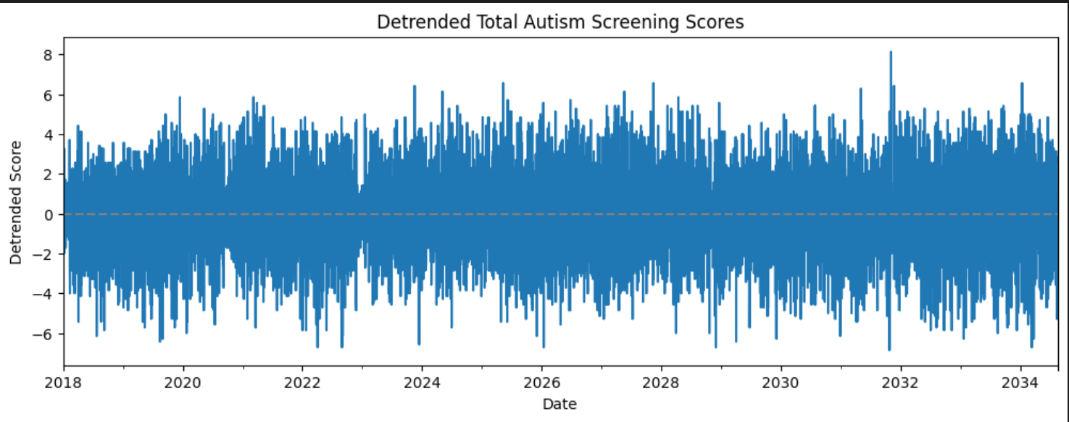

**RESULT:**

The program successfully simulates a time series from the "Autism Screening for Toddlers" dataset, estimates trends using aggregation and smoothing, and eliminates them through detrending.