Learning to Discover Social Circles in Ego Networks

TEAM MEMBERS :
Deeksha Singh [201505627]
Aman Arora
Pulkit Agarwal

INTRODUCTION :

Online social networks allow users to follow streams of posts generated by hundreds of their friends
and acquaintances. Users’ friends generate overwhelming volumes of information and to cope with
the ‘information overload’ they need to organize their personal social network

DATASET USED :

Kaggle provided dataset for some egos on Facebook, Twitter, & Gplus. Having information about its own profile features, features of his social network, links between members of its social network, & list of circles for testing our model.

Here are two useful sources of data that help with this task. The first is the set of edges of the ego-network. And the other would be the profile information of user and his network elements.

APPROACH :

We would like to leverage both profile information and network structure in order to identify the circles.

Using the network Structure information, what node is connected to each other. We expect that circles are formed by densely-connected sets of alters.

Graph representation of ego node – 414[Facebook data]

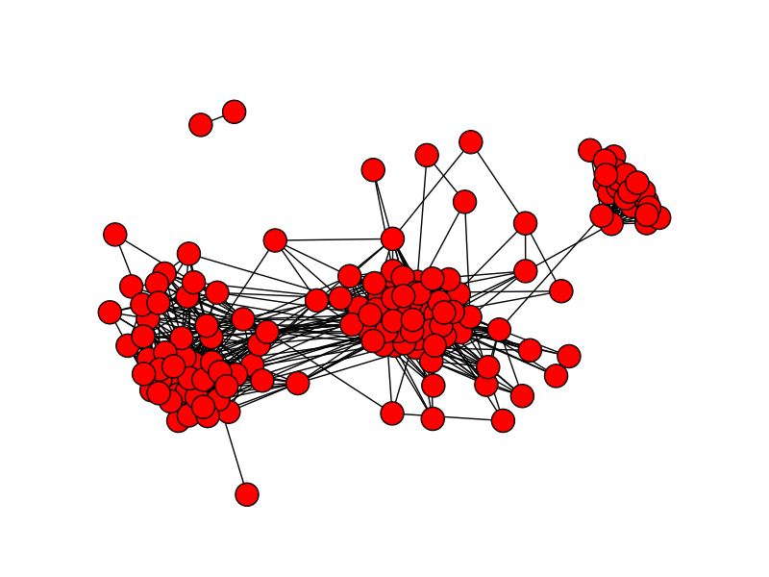
We use graph methods of community detection to find out the densely related nodes. Newman Girwin's algorithm & Lovain are two such algorithms that work on directed edges of the social network [provided as egonode.edges file], and result into a neighbourhood set related to each node in the network.

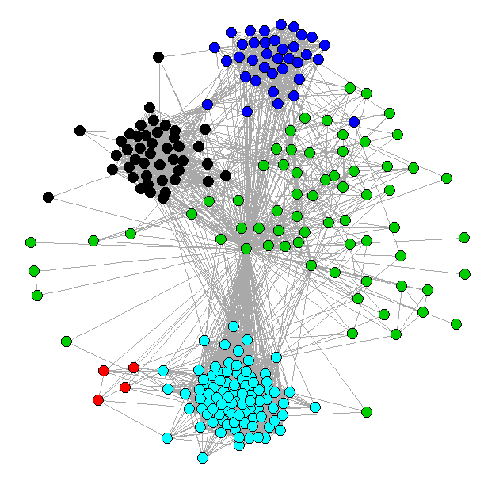

Following is the description of the methods used -

a. Newman-Girvan:

It is a divisive method that detect edges that connect different communities and remove them until clusters are disconnected.It involves four major steps:

1. Compute Edge centrality
2. Remove the edge with the highest centrality
3. Update Centralities
4. If |Edges| > 0 , go to step 2

Instead of trying to construct a measure which tells us which edges are most central to communities, we focus instead on those edges which are least central , If a network contains communities or groups that are only loosely connected by a few inter-group edges, then all shortest paths between different communities must go along one of these few edges

- Edge Betweenness : It is defined to be the number of shortest paths between vertex pair that run along the edges,summed over all vertex pairs.This can be calculated in O(mn) on the graph where m is the no of edges and n is the no of vertices.
The algorithm can be thought of as progressing from the root of the dendrogram to the leaves, rather than the other way round, the branches of the tree rep-resenting the order of splitting of the network as edges are removed, and the communities are taken to be the components of the graph, as in the single linkage cluster-ing method. Horizontal crosssections of the dendrogram represent possible community divisions with a larger or smaller number of communities depending on the posi-tion of the cut.

- Dendogram -> output of newman-girvan
There are two principal disadvantages of the algorithm of Girvan and Newman:

1. It provides no guide to how many communities a network should be split into. To address this problem, Newman and Girvan proposed that the divisions the algorithm generates be evaluated using a measure they call modularity, which is a numerical index of how good a particular division is. Then the modularity is defined to be
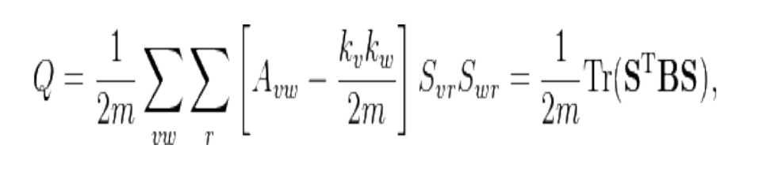
It lies between [-1/2, 1). Higher the modularity better the classification of communities

2. The other main disadvantage of the algorithm of Gir-van and Newman is that it is slow. Since there are m edges to be removed in total and each iteration of the al-gorithm takes O(mn) time, the worst-case running time of the algorithm is O(m2n), or O(n3) on a sparse graph

b. Louvain:

The problem of community detection requires the partition of a network into communities of densely connected nodes, with the nodes belonging to different communities being only sparsely connected. Precise formulations of this optimization problem are known to be computationally intractable. Several algorithms have therefore been proposed to find reasonably good
partitions in a reasonably fast way. The quality of the partitions resulting from these methods is often measured by the so-called modularity of the partition. The modularity of a partition is a scalar value between -1 and 1 that measures the density of links inside communities as compared to links between communities. In the case of weighted networks (weighted networks are networks that have
weights on their links, such as the number of communications between two mobile phone users), it is defined as

Our algorithm is divided in two phases that are repeated iteratively. Assume that we start with a weighted network of N nodes.
1. We assign a different community to each node of the network. So, in this initial partition there are as many communities as there are nodes.
2. For each node i we consider the neighbours j of i and we evaluate the gain of modularity that would take place by removing i from its community and by placing it in the community of j.
3. The node i is then placed in the community for which this gain is maximum (in case of a tie we use a breaking rule), but only if this gain is positive. If no positive gain is possible, i stays in its original community.
This process is applied repeatedly and sequentially for all nodes until no further improvement can be achieved and the first phase is then complete. This simple algorithm has several advantages. First, its steps are intuitive and easy to implement, and the outcome is unsupervised. Moreover, the
algorithm is extremely fast, i.e., computer simulations on large ad-hoc modular networks suggest that its complexity is linear on typical and sparse data. This is due to the fact that the possible gains in modularity are easy to compute with the above formula and that the number of communities decreases drastically after just a few passes so that most of the running time is concentrated on the first iterations.

Modularity Metrics : This metrics measures the strength of division of a network into modules. Networks with high modularity have dense connections between the nodes within modules but sparse connections between nodes in different modules.
Modularity is basically the fraction of the edges that fall within the given groups minus the expected such fraction if edges were distributed at random. So the higher the better.
Limitation and Time complexity:

The limitation of the method for the experiments that we performed was the storage of the network in main memory rather than the computation time. By construction, the algorithm unfolds a complete hierarchical community structure for the network, each level of the hierarchy being
given by the intermediate partitions found at each pass. In this algorithm, however, only the verification of the accuracy of the top level of this hierarchy has been done, namely the final partition found by the algorithm, and the accuracy of the intermediate partitions has still to be shown. Louvain typically executes in nlogn, although this is an experimental
result and it's not possible to prove it.

For some ego-node, no significant information about circles can be got from graphs because of huge density of graphs.

[ego node-102340116189726655233 graph gplus data]

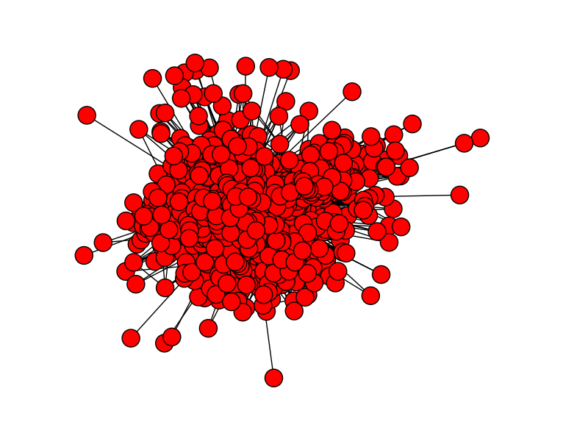
CONCLUSION :

Social circles are identified in the form of community formation from a netwrok of node.
Using the project user will be able to segregate its social network, and further use semi-supervised learning techniques to name each of these circles by identifying the common attribute because of which the community is formed.

The discovery of social circles yeilds an accuracy of about 50% using the graph algorithms implemented in the project(for facebook data).

