Learners have to come up with a Report to support the answers to the following questions and suggestions

Objective Questions:
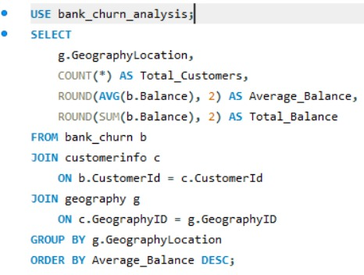
- What is the distribution of account balances across different regions?
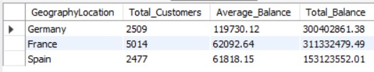
OUTPUT:

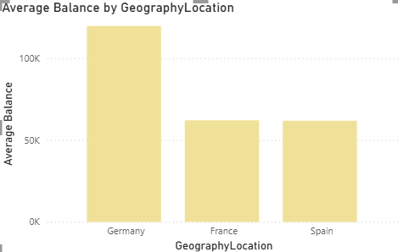
Charts:
Approach:
There are currently three regions in the dataset: France, Germany, and Spain. To determine the distribution of account balances, we calculate the total balances and group them by the regions (Geography).
Insight:
From this donut chart that we used to visualize the distribution of balances across different regions, we draw an insight that France has the highest account balance.

- Identify the top 5 customers with the highest Estimated Salary in the last quarter of the year. (SQL)
Code:
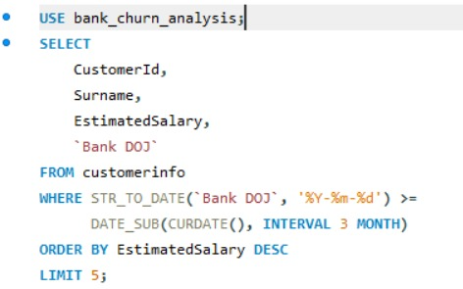

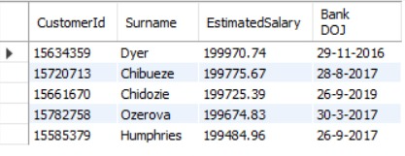
Output:

Approach:

We want to understand whether customers who own a credit card tend to hold multiple bank products.
Use the bank_churn table, which contains HasCrCard and NumOfProducts.
HasCrCard = 1 identifies customers with a credit card.
Calculate the average NumOfProducts for those customers.
Also count the customers and show the minimum and maximum products held for additional context.
- Calculate the average number of products used by customers who have a credit card. (SQL)
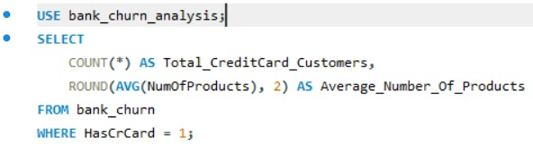
Query:
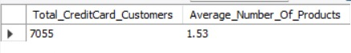
Output:
Approach
We will use the bank_churn table to identify customers with credit cards and calculate the average number of products they hold.
- HasCrCard = 1 means the customer has a credit card.
- NumOfProducts indicates the number of bank products held.
- AVG() calculates the average, and COUNT() counts the qualifying customers.

- Determine the churn rate by gender for the most recent year in the dataset.
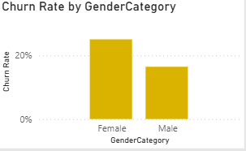
CHART:
Approach
We will join bank_churn with customerinfo using CustomerId, then join gender using GenderID to identify each customer's gender. We’ll use Bank DOJ to filter customers who joined in the most recent year available in the dataset. The churn rate is calculated as the percentage of customers who exited within each gender group.
Recommendations:
The churn rate was calculated separately for each gender among customers who joined in the most recent year available in the dataset. The gender with the higher percentage represents the group with the higher observed churn rate in this cohort. The bank should investigate related behavioral and service factors before designing targeted retention strategies.

- Compare the average credit score of customers who have exited and those who remain. (SQL)

Query:
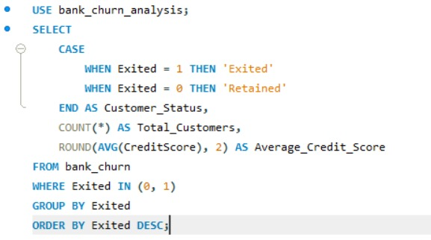

Output:
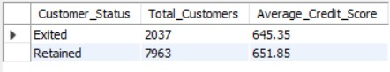
Insights:
- Exited customers have a lower average: This may suggest that customers with lower credit scores are more represented among those who left, warranting further investigation.
- Exited customers have a higher average: Credit score alone may not explain churn; other factors such as service experience, product usage, or account activity may matter.
- The averages are similar: Credit score may provide limited separation between the two groups when considered on its own.
Remember, comparing averages does not prove that credit score causes customers to leave. The size of each group also matters when interpreting the results.
Recommendations
- Combine credit score with tenure, balance, age, product count, and active-member status for a broader churn analysis.
- Investigate other characteristics of the exited group rather than targeting customers based on credit score alone.
- Consider building a churn-risk model using multiple variables to identify customers who may need retention support.
- Which gender has a higher average estimated salary, and how does it relate to the number of active accounts? (SQL)
Query:
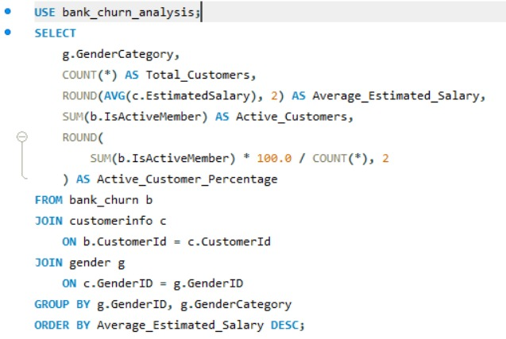
Output:
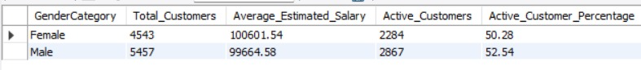
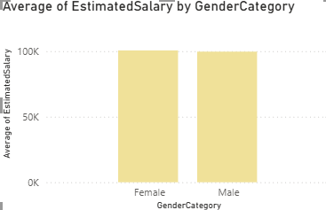
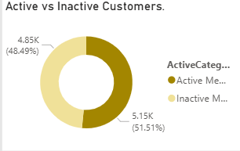
CHART:
Insights and Recommendation:
The analysis compares average estimated salary and active-customer percentage across genders. The gender with the higher average estimated salary was Female, while the gender with the higher active-customer percentage was Male ,This comparison helps the bank understand differences in customer income estimates and engagement, supporting more informed customer-segmentation and retention strategies.
- Segment the customers based on their credit score and identify the segment with the highest exit rate. (SQL)
Query:
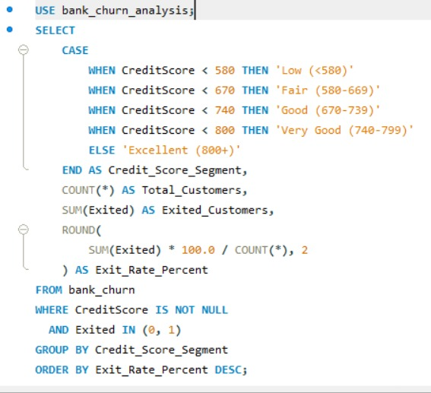
Output:
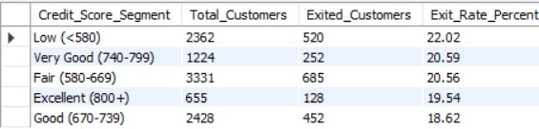
Insights and Recommendation:
Customers were grouped into credit score segments, and the exit rate was calculated for each group. The segment with the highest exit rate was < 580, with an exit rate of 22.02%. The bank should investigate the characteristics and service experiences of this group and combine credit score with other churn indicators before implementing targeted retention strategies.
Chart:
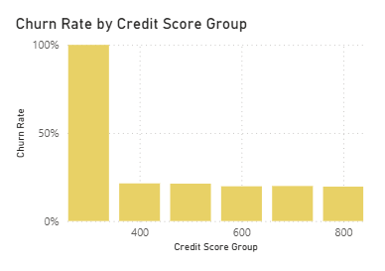
- Find out which geographic region has the highest number of active customers with a tenure greater than 5 years. (SQL)
Query:
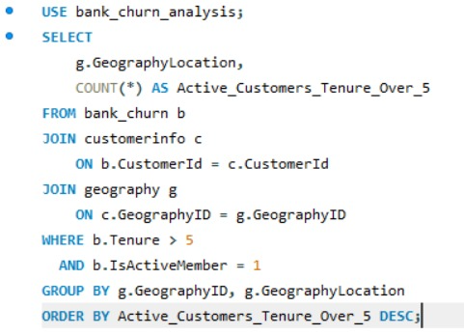

Output:
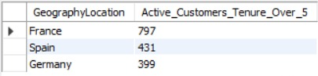
Approach
We’ll join bank_churn with customerinfo to connect customers to their geography, then join geography to display the region names. We’ll filter for customers with tenure greater than 5 and IsActiveMember = 1. Finally, we’ll count the qualifying customers in each geography and sort from highest to lowest.
Insights and Recommendations:
The analysis identified France as the geography with the highest number of active customers whose tenure exceeds five years, with France customers. This indicates a substantial base of established, active customers in that region. The bank should continue supporting these customers and compare regional active-customer percentages to better understand engagement and retention performance.
Chart:
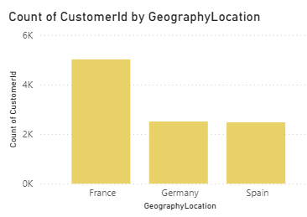
- What is the impact of having a credit card on customer churn, based on the available data?

Query:
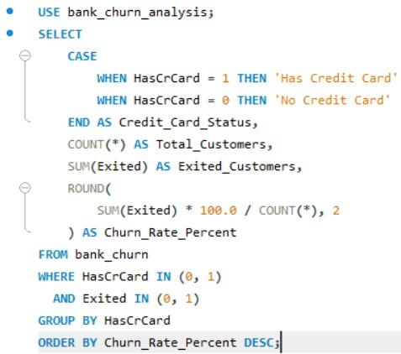

Output:
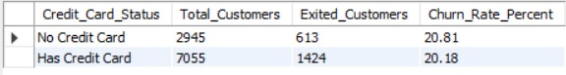
Insights and Recommendations:
The analysis compared churn rates between customers with and without credit cards. The churn rate for credit-card holders was 20.18%, compared with 20.81% for customers without credit cards. This difference suggests that credit-card ownership may be associated with churn behavior. The bank should examine additional customer characteristics before deciding on retention strategies.
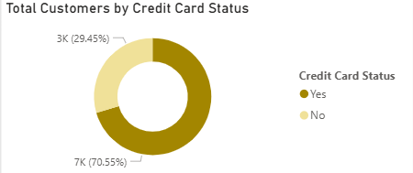
CHART:

- For customers who have exited, what is the most common number of products they have used?
Query:
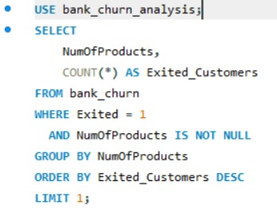
Output:
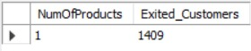
Charts:
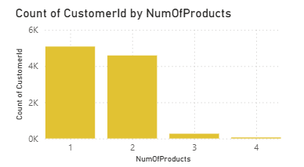
Insights and Recommendations:
The analysis identified 1 product(s) as the most common number of products held by exited customers, accounting for [insert count] customers. This identifies the largest product-count group among customers who left the bank. The bank should compare churn rates across all product-count groups and investigate other customer characteristics before designing retention strategies.
- Examine the trend of customers joining over time and identify any seasonal patterns (yearly or monthly). Prepare the data through SQL and then visualize it.
Approach
We’ll use the Bank DOJ column in customerinfo to analyze when customers joined the bank. We’ll convert the text date into a date format, group customers by month and year, and count the number of new customers in each period. This will help identify joining trends and possible seasonal patterns.
Insights and Recommendations
The monthly customer acquisition analysis was conducted using the bank joining date in DD-MM-YYYY format. Monthly joining counts can reveal customer growth trends and potential seasonal patterns. The bank can use these findings to improve marketing campaign timing and investigate periods of weaker acquisition.
Chart:
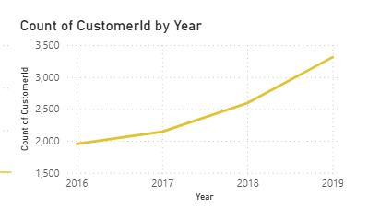

- Analyze the relationship between the number of products and the account balance for customers who have exited.
Query:
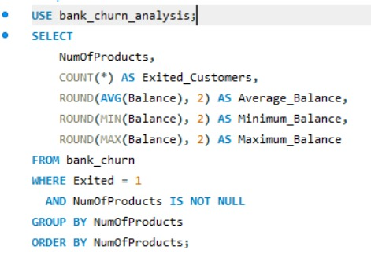
Output:
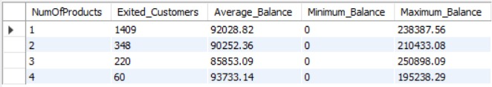
Approach
We’ll use the bank_churn table and filter for exited customers (Exited = 1). We’ll group these customers by NumOfProducts and calculate their average account balance and customer count. Comparing the average balances across product groups helps us identify patterns between product ownership and balances among customers who left.
Insights and Recommendations
The analysis compared average account balances across product-count groups among exited customers. The results show that 4 had the highest average balance of 93733.14 . This helps the bank understand the balance profiles of customers who left and identify segments for further investigation. A comparison with retained customers is recommended before drawing conclusions about retention strategies.

- Identify any potential outliers in terms of balance among customers who have remained with the bank.

Approach
We’ll analyze customers who remained with the bank (Exited = 0) using the Balance column in bank_churn. We’ll calculate the first quartile (Q1), third quartile (Q3), and interquartile range (IQR) to establish statistical outlier thresholds. Balances below \(Q1 - 1.5 \times IQR\) or above \(Q3 + 1.5 \times IQR\) will be flagged as potential outliers.
Insights and Recommendations
Account balances among retained customers were examined using the interquartile range method. Customers with balances below the lower threshold or above the upper threshold were classified as potential outliers. These customers can be investigated further to understand unusual balance patterns and identify appropriate customer-engagement opportunities.
Chart:
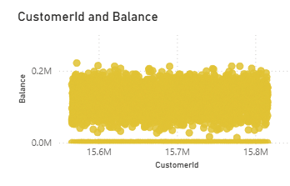
- How many different tables are given in the dataset, out of these tables which table only consists of categorical variables?
Approach:
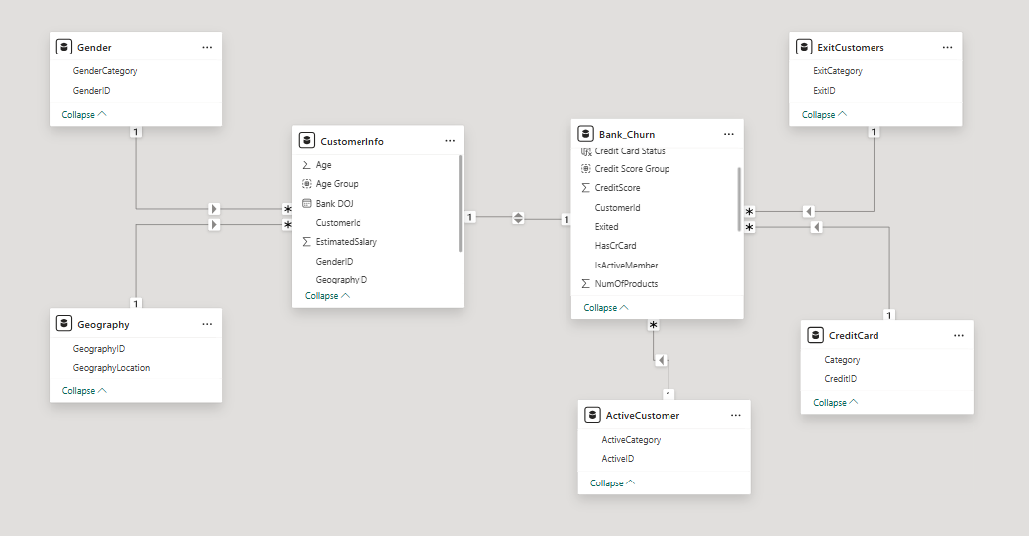
We’ll check the tables in your bank_churn_analysis schema and count them. Then we’ll inspect the columns to identify tables whose fields contain categories or labels rather than numerical measures. Based on the structures you shared, Gender, Geography, ExitCustomer, CreditCard, and ActiveCustomer appear to be lookup tables containing category labels and IDs.
There were 7 different tables given in the dataset, and out of these, 5 tables contain only categorical variables which are: Gender, Geography, Active_Customer, Exit_Customer, Credit_Card.
- Using SQL, write a query to find out the gender-wise average income of males and females in each geography id. Also, rank the gender according to the average value. (SQL)
Approach
We’ll check the tables in your bank_churn_analysis schema and count them. Then we’ll inspect the columns to identify tables whose fields contain categories or labels rather than numerical measures. Based on the structures you shared, Gender, Geography, ExitCustomer, CreditCard, and ActiveCustomer appear to be lookup tables containing category labels and IDs.
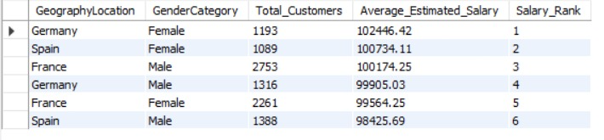
Insights:
The average estimated salary was calculated for each gender within each geography, and the combinations were ranked from highest to lowest. The highest-ranked combination was Females in Germany , with an average estimated salary of 102446.42 .
These results can help the bank understand customer-segment differences and support more informed customer analysis.

- Using SQL, write a query to find out the average tenure of the people who have exited in each age bracket (18-30, 30-50, 50+).
Approach
Join bank_churn with customerinfo using CustomerId to access customers’ ages and tenure. Filter the data to include only exited customers (Exited = 1). Group customers into the three requested age groups and calculate the average tenure for each group.
Query:

Chart:
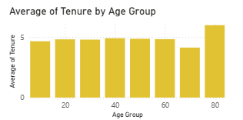
- Is there any direct correlation between salary and the balance of the customers? And is it different for people who have exited or not?
Correlation Analysis:
Those almost perfectly flat trendlines confirm exactly that: there is absolutely zero correlation between a customer's salary and their account balance, regardless of whether they stay or leave.
Chart:
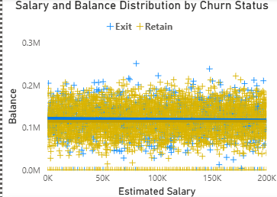
- Is there any correlation between the salary and the Credit score of customers?

Correlation Analysis:

The dots are scattered entirely at random from top to bottom and left to right. This visually confirms a correlation score of practically zero.

- The Retained Line (Yellow): This line is perfectly horizontal. For loyal customers, salary and credit score have absolutely zero impact on one another.

- The Exited Line (Blue): The blue line tilts slightly downward. This indicates a very weak negative correlation. It suggests that among the customers who left the bank, those with higher salaries tended to have slightly lower credit scores.
Chart:
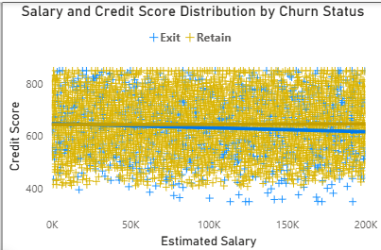
- Rank each bucket of credit score as per the number of customers who have churned the bank.
Approach:
Use the bank_churn table and divide customers into credit score segments using CASE. Filter for churned customers (Exited = 1) and count the number of churned customers in each segment. Use the RANK() window function to rank segments from the highest churn count to the lowest.
Query:
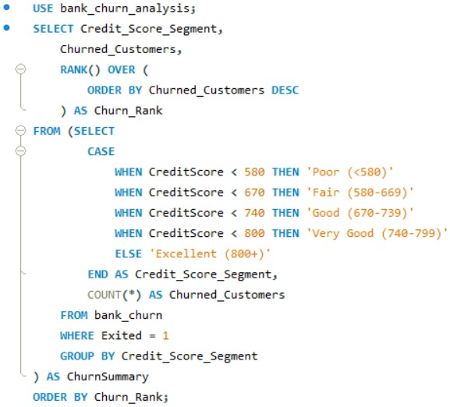
Output:
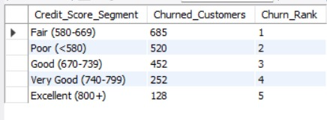
Chart:
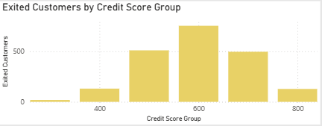
Insights
The results identify credit score between 580-669 segment has the highest number of churned customers. A higher churn count does not necessarily mean that segment has the highest churn rate, because the total number of customers in each segment may differ.
- According to the age buckets find the number of customers who have a credit card. Also retrieve those buckets that have lesser than average number of credit cards per bucket.
Approach
Join bank_churn with customerinfo using CustomerId to obtain customers’ ages and credit card status. Group customers into age ranges and count credit card holders in each group (HasCrCard = 1). Compare each age group’s count with the average number of credit card holders across all age groups to identify groups below average.
Output:
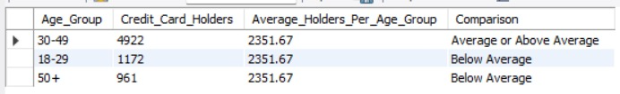

Insights
The output shows the number of credit card holders in each age group and whether each group’s count is below the average across the age groups. Groups with larger counts may simply have more customers, so the results do not necessarily indicate a higher credit card ownership rate.
- Rank the Locations as per the number of people who have churned the bank and average balance of the customers.
Approach:
Join bank_churn with customerinfo and geography to identify each customer’s location. Group the results by geography, count churned customers (Exited = 1), and calculate their average account balance. Use RANK() to rank locations from the highest to the lowest churn count.
Query:
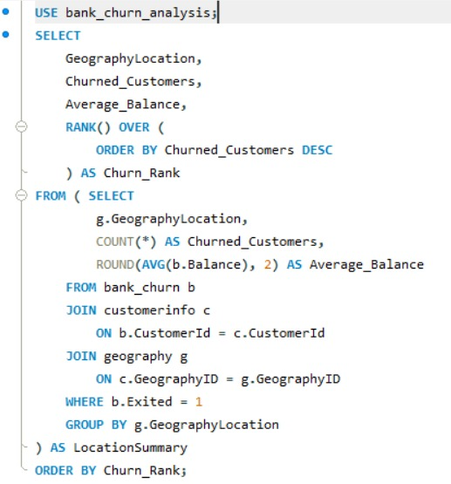
Output:
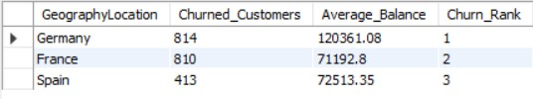
Insights:
The results show which geographical location has the highest number of churned customers and the average account balance of those customers. Locations with higher churn counts may need closer investigation, but counts alone do not show which location has the highest churn rate.
- As we can see that the “CustomerInfo” table has the CustomerID and Surname, now if we have to join it with a table where the primary key is also a combination of CustomerID and Surname, come up with a column where the format is “CustomerID_Surname”.
Approach:
To make customer records easier to identify, combine the CustomerId and Surname columns from the customerinfo table. Use the CONCAT() function to join both values with an underscore between them. The resulting column will display each customer’s ID and surname in a single field.
Query:
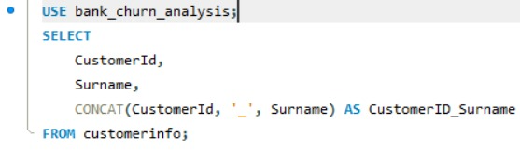
Output:
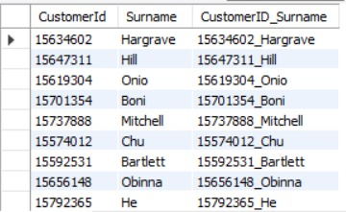
Insights
Combining the customer ID and surname creates a single, readable identifier for each customer record. This can make customer lists easier to review and help identify records when preparing reports.
Recommendations
Used the combined column in reports and customer analysis to make records easier to recognize. Keep CustomerId as the primary identifier for database joins, since surnames may be shared by multiple customers and the combined column is best used for display purposes.

- Without using “Join”, can we get the “ExitCategory” from ExitCustomers table to Bank_Churn table? If yes do this using SQL.

Approach:

The correlated subquery:

SELECT b.*,
(
SELECT e.ExitCategory
FROM exit_customer e
WHERE b.Exited = e.ExitID
) AS ExitCategory
FROM bank_churn b;

This approach avoids using a traditional JOIN operation and directly fetches the ExitCategory, using a correlated subquery within the SELECT statement.

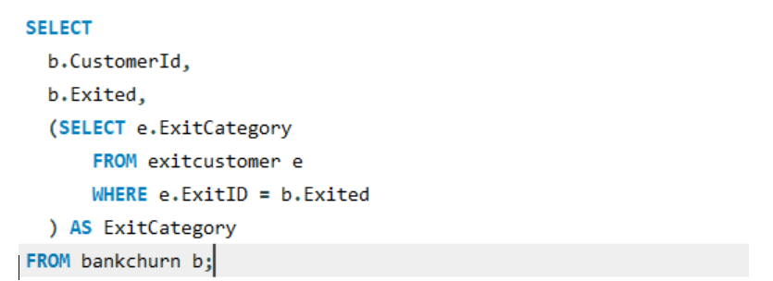

Insights & Recommendation
- The query uses a correlated subquery to fetch ExitCategory for each customer.
- It avoids using JOIN by matching Exited with ExitID inside the subquery.
- This approach works well for small datasets, but may be slower than JOIN for large data.
- It helps understand alternative ways of combining data across tables
- Were there any missing values in the data, using which tool did you replace them and what are the ways to handle them?

Missing Values Analysis
During the data-cleaning process, the dataset was carefully checked for blank or missing values across all columns. The analysis confirmed that there were no major missing values, showing that the dataset was complete, consistent, and suitable for further analysis.
Handling Methods for Missing Values
If missing values were identified, the following methods could be used:
❖ Numerical Data: Missing values can be replaced with the mean or median.
❖ Categorical Data: Missing values can be filled using the most frequently occurring value (mode).
❖ Removing Rows: Rows with a small number of missing values can be removed when appropriate.
❖ Imputation: Missing values can be estimated based on business requirements or relevant data patterns.
❖ In this project, Excel and Power BI were used for data cleaning and validation to maintain data consistency.
Insights
❖ The dataset is complete and suitable for analysis because no major missing values were identified.
❖ Proper treatment of missing data helps ensure that the analysis remains accurate and dependable.
❖ Maintaining clean and consistent data supports reliable insights and better business decisions.
- Write the query to get the customer IDs, their last name, and whether they are active or not for the customers whose surname ends with “on”.
Approach
Using the customerinfo table to identify customers whose surnames end with “on” using the LIKE operator. Since active status is stored in the bank_churn table, retrieve it using a subquery based on CustomerId, without using a JOIN.
Query:
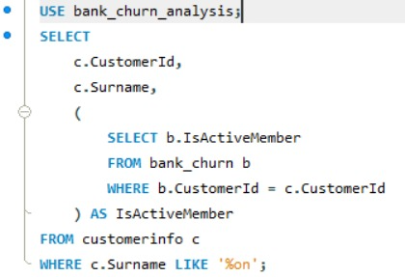
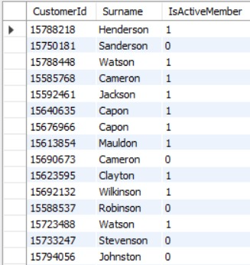

Insights
The query returns customers whose surnames end in “on”, along with their active-member status. A value of 1 indicates an active member, while 0 indicates an inactive member.
Recommendations
Reviewing the active status of these customers to understand their engagement with the bank. If some are inactive, the bank can consider personalized communication or suitable banking offers to encourage them to use its services more regularly.
- Can you observe any data disrupency in the Customer’s data? As a hint it’s present in the IsActiveMember and Exited columns. One more point to consider is that the data in the Exited Column is absolutely correct and accurate.

Yes. 735 customers have Exited = 1 but IsActiveMember = 1 – 36% of all exited customers (7.35% of the dataset). A customer who has left the bank cannot be an active member.
Fix: since Exited is correct, the new column IsActiveMember_Corrected sets IsActiveMember = 0 for every exited customer. Active members drop from 5,151 (51.5%) to 4,416 (44.2%).
IsActiveMember (as given) | Exited = 0 | Exited = 1
0 (inactive) | 3,547 | 1,302
1 (active) | 4,416 | 735 ← impossible

INSIGHTS & RECOMMENDATIONS
- Impact: without the fix the bank would over-state engagement of the customers who already left; after correction every exited customer is inactive and active-member churn is 0% – so for predictive modelling use the original flag, for reporting current activity use the corrected one.
- Additional observation: Tenure only takes values 3–7 and is inconsistent with Bank DOJ (e.g., a 2019 joiner with 7 years’ tenure) – it is used as provided; the source system should be audited.

Subjective Question:

- Customer Behavior Analysis: What patterns can be observed in the spending habits of long-term customers compared to new customers, and what might these patterns suggest about customer loyalty?
Long-term customers are not more valuable or more loyal than new ones. Balance, products, activity and card ownership are almost identical across tenure groups, and churn is ~20% in all of them.
Analysis and Findings
The spending behaviour of long-term and new customers was compared using average account balance, number of products used, and customer activity level. For this analysis, long-term customers were distinguished from new customers based on their tenure with the bank.
The results show that new customers have a slightly higher average balance of approximately 76.6K, compared with 76.3K for long-term customers. New customers also use a slightly higher average number of products (1.56) than long-term customers (1.51). The percentage of active customers is nearly similar, at 52.14% for new customers and 51.03% or long-term customers.
These results suggest that long-term customers maintain relatively stable banking relationships, but their balances and product usage do not increase significantly over time. New customers show slightly higher product usage and activity, which may be influenced by onboarding offers or initial engagement efforts. However, these differences are small and do not, by themselves, prove that one group is more loyal than the other.
Recommendations
The bank should focus on strengthening relationships with long-term customers through personalised services, loyalty benefits, and relevant product offers. Regularly reviewing their activity and product usage can help identify customers whose engagement is declining. For new customers, a structured onboarding process and timely follow-up can encourage continued use of banking services and build long-term relationships.
The findings can also be compared with Objective Q8, which examines active customers with more than five years of tenure, and Objective Q10, which identifies the most common number of products among exited customers. These comparisons can provide further insight into customer engagement and the relationship between product usage and churn.
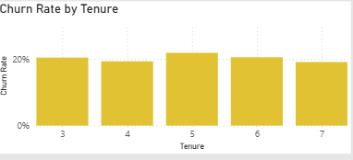
Chart:
- Product Affinity Study: Which bank products or services are most commonly used together, and how might this influence cross-selling strategies?
The data shows that customers with fewer products tend to have a lower churn rate compared to those who have purchased more products.

Query:
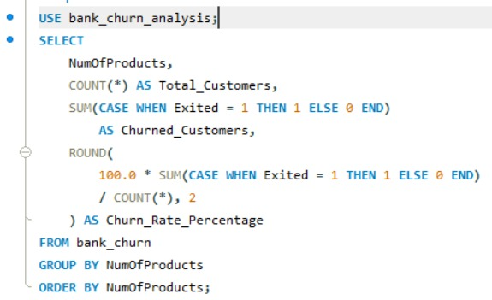

Output:

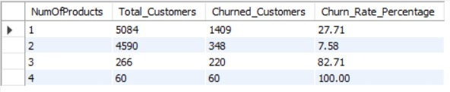

Analysis and Findings
Product affinity analysis helps the bank understand customer product usage and identify opportunities to offer suitable additional products. In the available dataset, the main product-related fields include `NumOfProducts` and `HasCrCard`. These fields can be used to examine product ownership and compare customer churn across different levels of product usage.
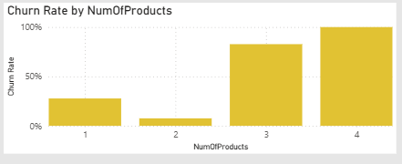
The analysis indicates that customers with fewer products tend to have a lower churn rate than customers with more products. This suggests that product ownership alone does not guarantee customer loyalty, and customers using multiple products may require further investigation to understand their needs and satisfaction. However, the available data does not identify individual combinations of specific banking products, so the most commonly used product combinations cannot be confirmed from these fields alone
Recommendations
The bank should identify customers who use only one product and assess whether they could benefit from other suitable services. For example, eligible customers could be offered a credit card or another relevant banking product based on their needs and usage patterns. Cross-selling should focus on customer requirements rather than simply increasing the number of products held.
The bank should also monitor churn rates by number of products and credit card ownership to evaluate whether its cross-selling efforts improve retention. This analysis is related to Objective Q3, which calculates the average number of products among credit card holders, Objective Q9, which compares churn rates between credit card holders and non-holders, and Objective Q10, which identifies the most common number of products among exited customers.

- Geographic Market Trends: How do economic indicators in different geographic regions correlate with the number of active accounts and customer churn rates?
Analysis and Findings
The analysis shows clear differences between the three regions. Germany has the highest average account balance, around 120K, but it also has the highest churn rate at about 32.44% and the lowest customer activity, at around 50%.
Spain performs better, with the highest activity level of about 53% and a lower churn rate of around 16.67%. France also shows good customer activity of around 52% and a churn rate of approximately 16.15%.
This suggests that having a higher account balance does not necessarily mean customers are more loyal. Germany's results indicate that other factors, such as customer experience, engagement, or product suitability, may be affecting retention.
The average salaries are fairly similar across the three regions, so salary alone does not appear to explain the differences in churn. Also, the available data does not include external economic indicators, so we cannot directly confirm whether economic conditions are causing the regional differences.
Recommendations
- Focus more on Germany, where churn is highest.
- Investigate possible reasons such as customer service, product satisfaction, and engagement.
- Study successful customer engagement practices in Spain and France.
- Do not use account balance alone to identify loyal customers.
- Add external information such as income, inflation, unemployment, and economic growth to understand regional differences better.
- Use these findings to design region-specific retention campaigns rather than using the same strategy everywhere.
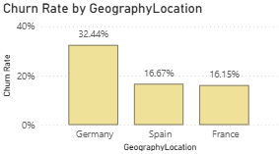
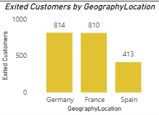
Charts:

- Risk Management Assessment: Based on customer profiles, which demographic segments appear to pose the highest financial risk to the bank, and why?
Analysis and Findings
Customer demographic and banking data were analysed to identify segments with higher churn rates and potential financial risk. The analysis considered age, gender, geography, account balance, and customer activity to understand which groups may require closer monitoring.
The results indicate that customers aged 50 and above have the highest reported churn rate, at approximately 45.45%, followed by customers aged 30–50 at 18.37%. Customers aged 18–30 have the lowest reported churn rate, at around 7.56%. Female customers also show a higher reported churn rate of approximately 25.07%, compared with 16.46% for male customers. Geographically, Germany presents a potential financial concern because customers in this region have higher average account balances but also a higher churn rate.
These findings suggest that older customers, female customers, and high-balance customers in Germany deserve further investigation. When customers with substantial balances leave, the bank may lose valuable deposits and future business opportunities. However, these demographic patterns indicate associations rather than the reasons customers leave, so further analysis is needed before drawing conclusions about the causes of churn.
Recommendations
The bank should prioritise retention efforts for segments with higher observed churn rates. For customers aged 50 and above, it could review service accessibility, personalised support, and satisfaction with existing banking products. The bank should also investigate feedback from female customers to identify whether there are differences in service experience or product requirements.
In Germany, the bank should focus on engaging high-balance customers through regular communication and relevant financial services. Customer retention efforts should be based on individual needs and actual churn risk rather than demographic characteristics alone. The bank should continue monitoring churn rates across age groups, gender, and geography to evaluate whether these actions improve retention.

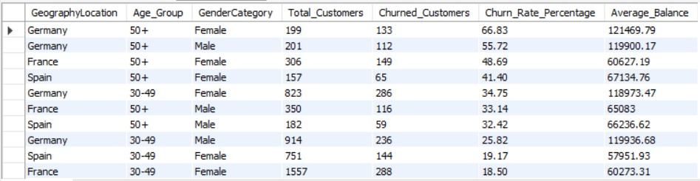
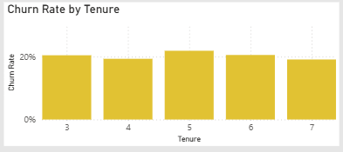
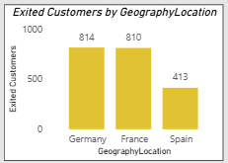
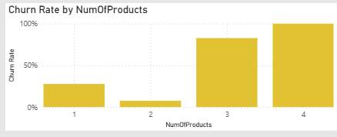
Charts:

- Customer Tenure Value Forecast: How would you use the available data to model and predict the lifetime (tenure) value in the bank of different customer segments?
Analysis and Findings
Customer lifetime value can be estimated by examining how long customers remain with the bank and the financial value they contribute. In this project, the available variables include `Tenure`, `Balance`, `NumOfProducts`, `EstimatedSalary`, `IsActiveMember`, `Exited`, `Age`, and `GeographyLocation`. These fields can be used to compare customer segments and identify groups that have high financial value or a greater likelihood of leaving the bank.
The analysis in the project indicates that customers aged 50 and above have relatively high customer value but also show a higher churn rate, particularly in Germany. This suggests that customers who contribute substantial financial value may still be at risk of leaving. Younger customers appear to have lower churn in the reported analysis, which may make them an important segment for building long-term customer relationships. These patterns should be validated against the SQL results before being treated as final findings.
Recommendations
The bank should develop a customer value model using account balance, number of products, tenure, activity level, and churn status. Customers can be grouped into high-, medium-, and low-value segments, and their churn rates can be compared to identify customers who are both valuable and at risk of leaving.

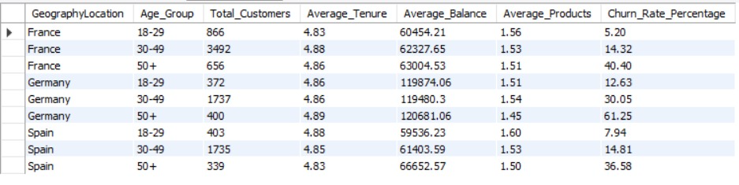
For a more accurate lifetime value forecast, the bank would need additional information such as customer revenue, transaction history, service costs, and the dates customers joined or exited. Since the current dataset does not contain detailed revenue and cost information, it can support a customer value comparison but cannot calculate a complete profit-based lifetime value. The bank should use the analysis to prioritise retention efforts and regularly review whether its strategies improve customer retention.

- Marketing Campaign Effectiveness: How could you assess the impact of marketing campaigns on customer retention and acquisition within the dataset? What extra information would you need to solve this?
The dataset has no campaign information, so effectiveness cannot be measured directly. The only indirect signal is the acquisition seasonality (Q11): the same months spike every year (Sep, Nov, Dec), which could be campaigns – campaign dates would confirm.
Analysis and Findings
The impact of marketing campaigns can be assessed by examining customer acquisition, retention, and churn patterns over time. In the available dataset, the `Bank DOJ` field in the `customerinfo` table can be used to analyse customer joining trends, while the `Exited` field in `bank_churn` can be used to calculate churn rates. These measures provide an overview of customer growth and retention, but they do not directly show whether marketing campaigns influenced customer behaviour.
The main limitation is that the dataset does not contain campaign details, such as which customers received an offer, the marketing channel used, or when a campaign took place. Therefore, it is not possible to determine which campaigns attracted new customers or helped existing customers stay with the bank. Changes in customer acquisition or churn over time may have other causes and should not automatically be attributed to marketing activities.
Additional Information Required
To measure campaign effectiveness accurately, the bank would need campaign IDs, customer participation records, campaign dates, marketing channels, campaign costs, and customer responses such as clicks, applications, or product sign-ups. It would also be useful to track whether customers who received a campaign subsequently opened an account, purchased a product, or remained with the bank.
Recommendations
The bank should link marketing campaign records with its customer database and monitor acquisition rate, conversion rate, retention rate, churn rate, and return on marketing investment. Comparing customers who received a campaign with similar customers who did not receive it would help determine whether the campaign made a measurable difference. This would allow the bank to identify successful campaigns, improve future marketing decisions, and allocate its budget more effectively.
- Customer Exit Reasons Exploration: Can you identify common characteristics or trends among customers who have exited that could explain their reasons for leaving?

Analysis and Findings
To understand why customers may have left the bank, the profiles of exited customers were compared with those of retained customers. Factors such as age, gender, geography, credit score, account balance, number of products, tenure, credit card ownership, and active-member status were considered to identify patterns associated with customer churn.
The analysis in this project indicates that customers aged 50 and above have a higher churn rate than younger customers. Female customers also show a higher reported churn rate than male customers, while Germany has a higher churn rate than France and Spain. The analysis of product usage and customer activity can provide further information about the characteristics of customers who have left. These patterns help identify groups that may require attention, but they do not establish the actual reasons for leaving.
The current dataset records whether a customer has exited, but it does not contain detailed feedback or confirmed reasons for the decision. Therefore, factors such as dissatisfaction with services, better offers from competitors, or changing financial needs should be treated as possible explanations rather than confirmed causes.
Recommendations
The bank should focus on customers in segments with higher observed churn rates and investigate their experiences before deciding on retention measures. Customer feedback surveys, exit interviews, and complaint records could help identify the main reasons for leaving. The bank should also monitor changes in account activity, product usage, and tenure to identify customers who may be at risk of exiting.

Based on the findings, the bank can develop targeted retention strategies, including personalised services, relevant product offers, and improved customer support. Regular monitoring of churn across demographic and geographic segments would help evaluate whether these actions improve customer retention.
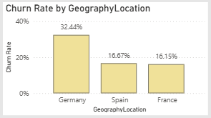
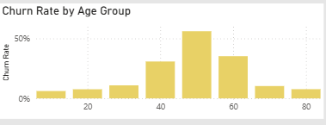
Chart:

- Are 'Tenure', 'NumOfProducts', 'IsActiveMember', and 'EstimatedSalary' important for predicting if a customer will leave the bank?
Analysis and Findings
The importance of `Tenure`, `NumOfProducts`, `IsActiveMember`, and `EstimatedSalary` can be assessed by comparing these variables between customers who have exited the bank and those who have remained. These features represent the length of the customer relationship, the number of products used, the customer's activity status, and their estimated salary. Examining their relationship with the `Exited` field helps identify patterns that may be useful for predicting customer churn.
Among these variables, customer activity and product usage can provide useful indications of engagement with the bank. Customers who use fewer products or are inactive may require closer attention, while tenure can help show how churn varies across different stages of the customer relationship. Estimated salary may help describe customer segments, but salary alone does not necessarily indicate loyalty or the likelihood of leaving.
These variables should therefore be considered potential predictors rather than confirmed causes of churn. Their actual predictive importance would need to be tested using a statistical or machine-learning model. The available descriptive analysis can identify associations, but it cannot establish which variable is the strongest predictor on its own.
QUERY:
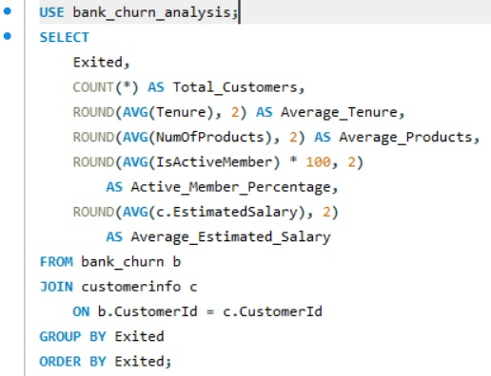

Output:

Recommendations
The bank should monitor customer activity, product usage, and tenure to identify groups that may be at greater risk of leaving. Customers with low engagement could be offered relevant products or personalised communication, while customers at different stages of tenure could receive suitable retention support. Estimated salary should be used alongside other customer characteristics rather than as the sole basis for targeting.
To determine the actual importance of each feature, the bank could build a churn prediction model using historical customer data and compare model performance with and without these variables. This would help identify the most useful indicators and support more focused retention strategies.
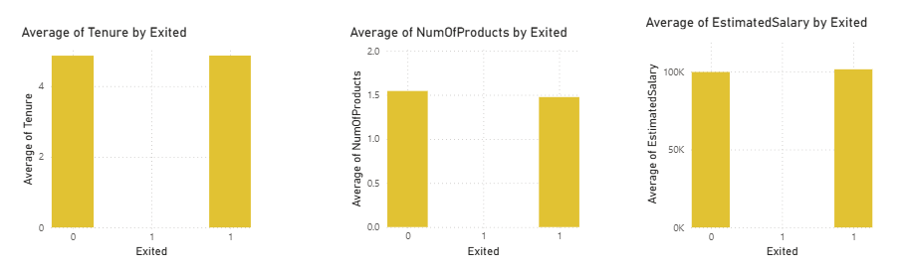
Chart:
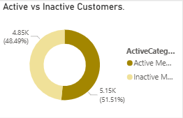

- Utilize SQL queries to segment customers based on demographics and account details.
Analysis and Findings
Customer segmentation was performed using demographic information and banking details to understand the different groups within the bank's customer base. Customers can be grouped according to age, gender, geographical location, account balance, tenure, number of products, and active-member status. This makes it easier to compare customer behaviour and identify groups that may require different banking services or retention strategies.
The segmentation helps the bank understand how customer characteristics vary across groups. For example, comparing churn rates by age group and geography can highlight segments with higher exit rates, while grouping customers by product usage and activity status can help identify differences in engagement. These results can support more focused decision-making instead of applying the same strategy to every customer.
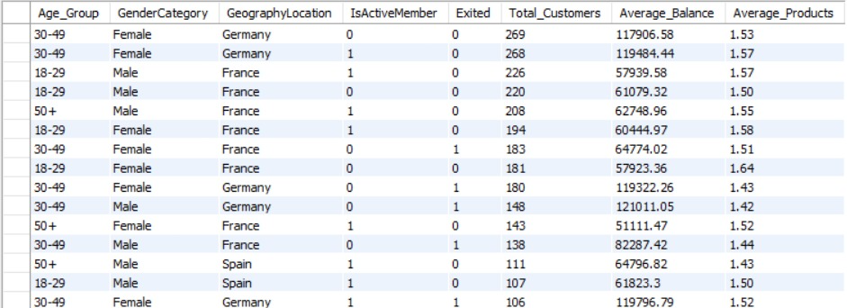
Recommendations
The bank should use customer segments to develop more relevant services and communication strategies. Customers with low activity or limited product usage can be considered for engagement campaigns, while customers in higher-churn segments can be reviewed to understand their needs and potential reasons for leaving. High-balance customers may also require appropriate relationship management, although account balance alone should not determine their risk level.
Customer segmentation should be reviewed regularly as customer behaviour changes over time. Combining demographic information with account details and churn status can help the bank improve customer engagement, personalise offers, and allocate retention resources more effectively.
- How can we create a conditional formatting setup to visually highlight customers at risk of churn and to evaluate the impact of credit card rewards on customer retention?
Analysis and Approach
Conditional formatting can be used in Power BI to highlight customers who may require attention based on their activity status, number of products, account balance, and exit status. A table visual can display customer details and use different colours to make important patterns easier to identify. For example, customers who have already exited can be highlighted in red, while inactive customers who have not exited can be highlighted in amber for further review.
To assess credit card rewards, customers with and without credit cards can be compared using their churn rates. In the available dataset, the `HasCrCard` field identifies credit card ownership, but there is no information about reward programme participation or redemption. Therefore, the analysis can compare churn between credit card holders and non-holders, but it cannot directly measure the effect of credit card rewards on customer retention.
Findings and Insights
The objective analysis in Q9 found that customers without credit cards had a churn rate of 20.81%, compared with 20.18% for credit card holders. The difference is small, suggesting that credit card ownership alone may not have a substantial relationship with churn in this dataset. However, these figures do not establish whether credit card rewards improve retention, because reward usage and participation were not recorded.
Conditional formatting can help the bank identify customer groups that may need further investigation. It also makes it easier to distinguish customers who have exited from those who remain customers but are currently inactive.
Recommendations
The bank should create a Power BI table with conditional formatting based on customer status and relevant risk indicators. Red can be used for exited customers, amber for inactive customers who have not exited, and neutral colours for other records. These colours should support investigation rather than automatically classify every inactive customer as likely to churn.
To evaluate credit card rewards properly, the bank should collect information on reward eligibility, enrolment, redemption, campaign costs, and customer activity before and after participation. Comparing similar customers who use rewards with those who do not would provide a more reliable assessment of whether the programme improves retention. The bank can then adjust its rewards programme based on measured results.
Chart:
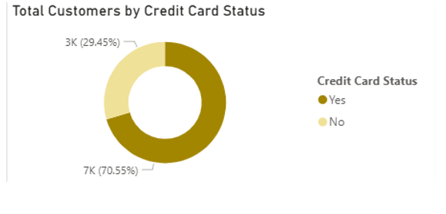

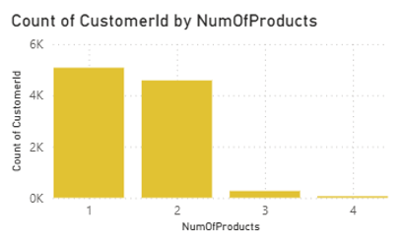
- What is the current churn rate per year and overall as well in the bank? Can you suggest some insights to the bank about which kind of customers are more likely to churn and what different strategies can be used to decrease the churn rate?
Analysis and Findings
The bank's churn rate can be analysed by calculating the percentage of customers who have exited the bank, both overall and across different customer groups. The `Exited` field is used to identify customers who have left the bank, where 1 represents an exited customer and 0 represents a retained customer. Customer joining dates can also be examined to understand changes in customer acquisition over time.
The overall churn rate can be calculated directly from the available customer records. However, the dataset does not contain a customer exit date, so it cannot reliably show the actual churn rate for each calendar year in which customers left. Instead, joining-year analysis can show how many customers joined in each year and how many of those customers are recorded as exited. This should not be interpreted as the number of customers who left during that particular year.
The overall churn rate stands at 20.37%
In 2016, it was 19.27%, rising to 22.35% in 2017, then decreasing to 20.21% in 2018, and slightly decreasing to 19.86% in 2019.
Customers over the age of 50 and those with fewer products are more prone to leaving. By offering attractive rewards, promotions, and security features to these customer segments, the bank could potentially retain them for a longer duration.
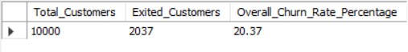

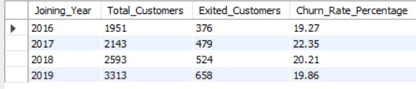
Recommendations
The bank should monitor the overall churn rate and compare it across customer segments such as age, geography, product usage, and activity status. Customers who are inactive or use fewer products can be approached with relevant services and personalised communication. In regions with higher churn, the bank should investigate customer feedback, service quality, and product suitability before selecting retention measures.
For accurate year-by-year churn reporting, the bank should maintain customer exit dates in addition to joining dates. This would allow the bank to measure when customers leave, identify changes over time, and assess whether retention campaigns are effective. Regular monitoring of churn rates and customer engagement can help the bank improve retention and make better-informed business decisions.
Chart:
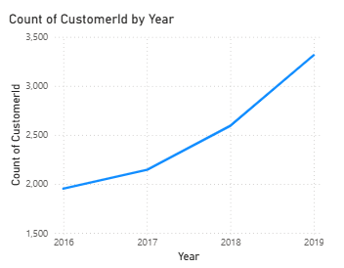
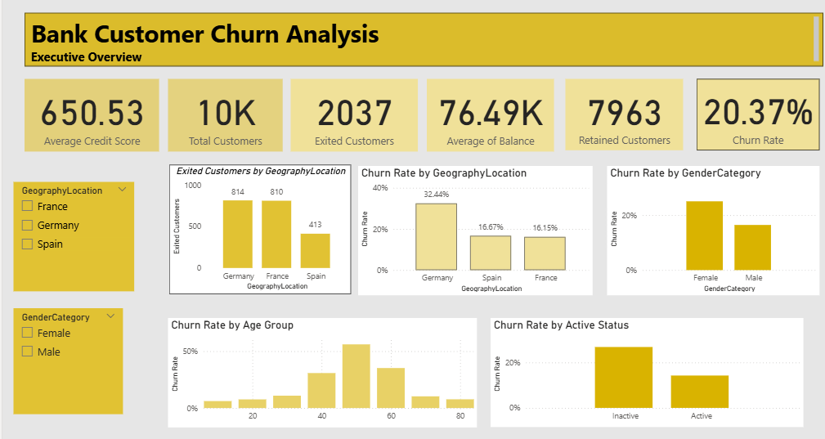
- Create a dashboard incorporating all the KPIs and visualization-related metrics. Use a slicer in order to assist in selection in the dashboard.
Approach and Implementation
A Power BI dashboard was created to present the key findings of the Bank Customer Churn Analysis in a single interactive report. The dashboard includes important KPIs such as total customers, active customers, exited customers, retained customers, overall churn rate, average account balance, and average credit score. Different visualisations were used to analyse churn by geography, gender, age group, customer activity, credit card ownership, and number of products.
Interactive slicers were added to allow users to filter the report by geography, gender, age group, and tenure or product count, depending on the dashboard page. These filters make it easier to examine specific customer segments and compare their behaviour. The dashboard was organised into three pages: Executive Overview, Customer & Churn Analysis, and Product & Customer Behaviour.
Insights and Benefits
The dashboard provides a clear overview of the bank's customer base and highlights important churn patterns. The Executive Overview helps management monitor overall performance, while the other two pages allow a more detailed examination of customer characteristics and product usage. The charts make it easier to identify regions and customer groups with higher churn rates and to understand how activity status and product count relate to customer exits.
Recommendations
The bank should use the dashboard regularly to monitor churn and customer engagement. Customer groups showing higher churn rates should be investigated further, and suitable retention strategies should be developed based on their needs and behaviour. The dashboard should also be updated when new customer data becomes available so that management can track changes over time and evaluate whether retention efforts are effective.

- How would you approach this problem, if the objective and subjective questions weren't given?

1. Understand the goal: reduce churn and grow profitable segments; agree KPIs with stakeholders (churn %, active %, balance, products).
2. Audit & clean: types, nulls, duplicates, logical checks (e.g., exited-but-active) and join the six tables.
3. Explore: univariate distributions, churn by every dimension, correlation matrix, outliers.
4. Segment: Geography × Age × Gender × Products × Activity; size the balance at risk.
5. Model: logistic regression / random forest for churn drivers; survival analysis for tenure value.
6. Visualise & act: Power BI dashboard, risk list, recommendations with expected impact, plus the data gaps (campaigns, product names, exit reasons, transactions).

Approach

If no specific questions were provided, I would begin by understanding the bank's business objectives and exploring the available customer data to identify potential business problems. I would examine customer demographics, account balances, tenure, product usage, activity status, and exit status to understand the customer base and determine where the bank might be losing customers or missing opportunities.
I would then use SQL to perform exploratory data analysis, validate data quality, calculate key performance indicators, and compare churn across customer segments. Rather than analysing every variable in isolation, I would focus on relationships that could support business decisions—for example, whether churn is higher among inactive customers, customers using fewer products, or customers in particular geographical regions. I would use Power BI to present these findings through KPI cards, comparative charts, and interactive slicers.

Business Insights and Priorities

The analysis would help establish a baseline for customer retention and identify segments that warrant further investigation. In this project, the overall churn rate is approximately 20.37%, with 2,037 exited customers out of 10,000. The dashboard also indicates that churn differs across geographical regions and customer activity levels. These patterns provide a starting point for investigating why customers leave and which groups should receive attention first.
I would prioritise opportunities based on their potential business impact, not simply on the size of a chart or the number of customers in a segment. For example, a segment with a high churn rate and substantial account balances may deserve attention because customer exits could affect the bank's deposit base. However, these observations would need to be validated using customer-level analysis and additional information before deciding on the exact intervention.

Recommendations
Based on the findings, I would recommend that the bank develop targeted retention initiatives for customer segments with higher observed churn. Possible actions include personalised communication, relevant product offers, and follow-up with inactive customers to understand their needs. Each initiative should be tested on a defined customer group and evaluated against measurable outcomes, such as reduction in churn rate, improved customer activity, and increased product adoption.

Conclusion
Without predefined questions, I would follow a structured, data-driven approach: understand the business problem, assess data quality, explore customer behaviour, identify and validate important patterns, and translate the findings into measurable business actions. The objective would not simply be to produce reports, but to help the bank make better decisions, retain valuable customers, and improve long-term customer relationships.

- In the “Bank_Churn” table how can you modify the name of the “HasCrCard” column to “Has_creditcard”?
Approach
To improve the readability of the database schema, I would rename the `HasCrCard` column to `Has_creditcard` using the `ALTER TABLE` statement in MySQL. Since the column stores whether a customer owns a credit card, the new name makes its purpose clearer and easier to understand during analysis. The existing values would remain unchanged; only the column name would be modified.
SQL Query
```sql
USE bank_churn_analysis;

ALTER TABLE bank_churn
RENAME COLUMN HasCrCard TO Has_creditcard;
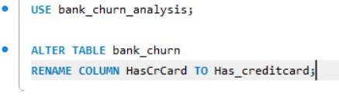

Validation
After executing the query, I would excecute `DESCRIBE bank_churn;`
