Predictive Modeling and Optimization in Logistics Systems
Week 4 Internship Technical Report | E-Commerce Delivery-Time Forecasting
Prepared for YuvaIntern | Data: synthetic demonstration derived from Week 2–3 coursework

1. Executive summary
This project predicts order delivery duration in days using features available at order placement, compares a mean baseline with ridge regression and random forest, and demonstrates an operational prioritization scenario. The analysis uses 79 synthetic order records. Models are evaluated using a chronological 63/16 train/test split and three-fold expanding-window time-series cross-validation within the training partition. Results do not establish deployable predictive accuracy.

2. Business problem and dataset
Problem: estimate Delivery_Days before dispatch to identify shipments requiring additional attention. Input features are Quantity, Unit_Price, Region, Product, order month and order weekday. Target: Delivery_Days (numeric). The dataset is a simulated extension of the Week 2 cleaned logistics records and Week 3 EDA data, not an operational transport database. Shipment volume and costs in earlier coursework are illustrative.
Excluded from modeling: Delivery_Days_Scaled, Delivery_On_Time_Proxy and Transport_Cost_Simulated, because they encode the outcome or may depend on actual delivery duration. Identifiers and Total_Value are also excluded to reduce leakage and redundancy.

3. Data preparation and validation
- Sort orders by Order_Date and Order_ID to preserve chronological order.
- Drop records with missing target or order date; use median imputation and standard scaling for numeric features.
- Impute categorical values and one-hot encode Region and Product, allowing unseen categories.
- Fit all preprocessing operations within each model pipeline, preventing cross-validation leakage.
- Reserve the latest 20% of records as an untouched test set; use TimeSeriesSplit(3) only on training data.

4. Model selection and evaluation
A mean regressor provides a necessary baseline. Ridge regression models regularized linear associations. Random forest captures nonlinear patterns and interactions. All hyperparameters are fixed in advance for a reproducible teaching demonstration; no systematic tuning was performed. Select the candidate by lowest mean cross-validation MAE on training data only.
Model | CV MAE | Test MAE | Test RMSE | Test R²
Mean baseline | 2.46 | 2.5 | 2.75 | -0.0
Ridge regression | 2.734 | 2.476 | 2.792 | -0.031
Random forest | 2.409 | 2.588 | 3.056 | -0.235
MAE is the mean absolute forecast error in days; RMSE penalizes large errors more heavily; R² measures performance relative to predicting the test-set mean. Negative test R² indicates weaker fit than that reference. Random forest wins training cross-validation (2.409 MAE) but its test MAE (2.588) is worse than the mean baseline (2.500). The test set is only 16 records, so estimates are unstable.
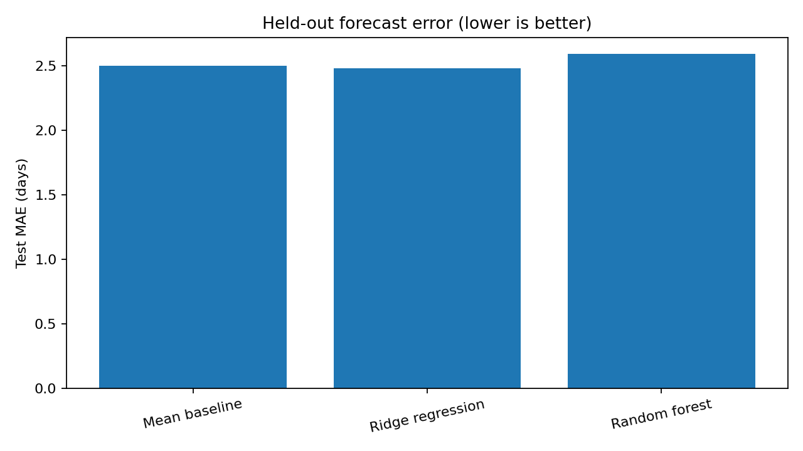
Figure 1. Test MAE comparison across models.
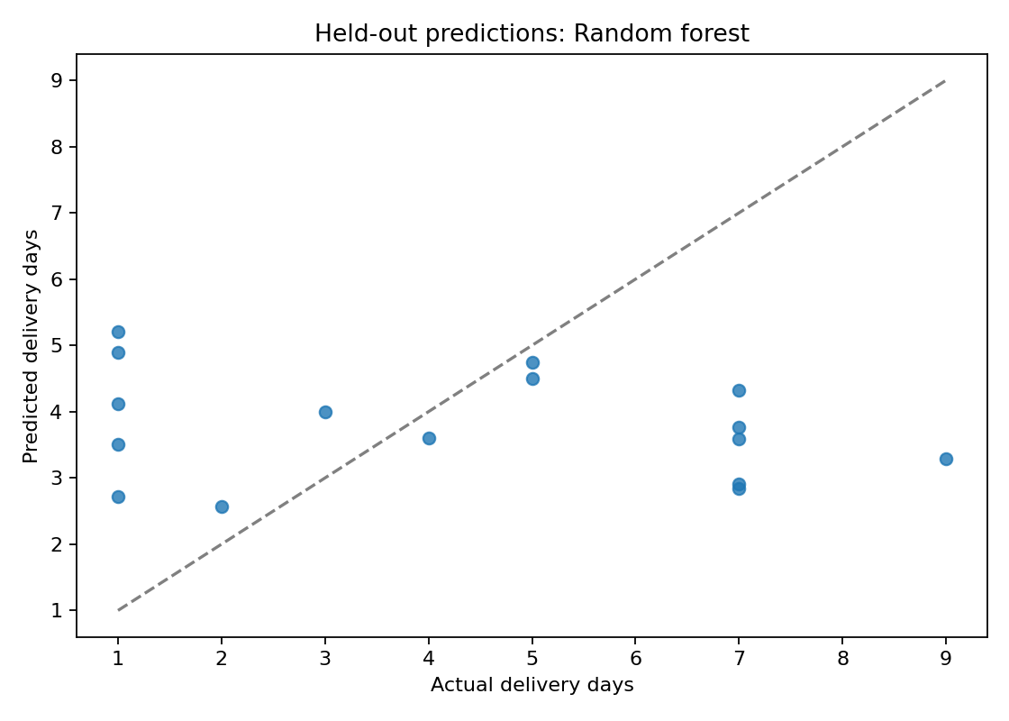
Figure 2. Actual versus predicted delivery duration for the cross-validation-selected random forest.

5. Optimization proposal: dispatch attention allocation
An illustrative operational rule ranks the 16 held-out orders by predicted delivery duration and flags the five highest predictions for expedited-dispatch review. This simulates scarce staff capacity, not a solved vehicle-routing or mathematical cost optimization problem. A logistics team could compare alternative review capacities, verify urgency against service-level agreements, and add route distance, carrier, warehouse load and cost information before implementation.
Do not interpret the flagged shipments as confirmed delays: predictions are imperfect and no causal improvement, savings or service-level lift has been measured. A pilot should compare flagged versus control shipments and track realized lateness, intervention costs and delivery-time changes.

6. Implementation excerpts
X_train, X_test = X.iloc[:cut], X.iloc[cut:]
cv = TimeSeriesSplit(n_splits=3)
scores = -cross_val_score(model, X_train, y_train, cv=cv, scoring="neg_mean_absolute_error")
model.fit(X_train, y_train)
predictions = model.predict(X_test)
priority = predicted_delivery_days.rank(ascending=False) # conceptual ranking
The complete executable implementation is provided in src/model_delivery.py, with outputs in report/ and visualizations/.

7. Recommendations and limitations
- Collect more diverse historical orders, actual promised dates, origin/destination distances, carrier identifiers, route conditions and dispatch capacity.
- Evaluate time-based stability across multiple holdout periods; compare against simple baselines before choosing a complex model.
- Use real business cost estimates and explicit constraints for any future linear-programming or routing optimization.
- Avoid claiming forecast accuracy or cost savings from the synthetic dataset; validate on real logistics records before operational use.

8. Conclusion
The workflow demonstrates leakage-aware preparation, chronological validation, multiple forecasting models and a capacity-constrained dispatch review proposal. Results show why model selection must consider both cross-validation and held-out performance. The principal next step is collecting realistic logistics predictors and testing interventions prospectively.

References and provenance
Scikit-learn documentation: Pipeline, ColumnTransformer, TimeSeriesSplit, RandomForestRegressor, Ridge, DummyRegressor and regression metrics (https://scikit-learn.org/stable/). Dataset: Week 3 synthetic analysis dataset, reused locally; not an external real-world source.

