Advanced Data Analysis and Visualization in Logistics
  - Week 3 Internship Report | E-Commerce Logistics Performance
Prepared for: YuvaIntern | Student: Deeksha | Date: 27-10-2026

1. Executive summary
This report applies exploratory data analysis to 79 cleaned, hypothetical e-commerce orders carried forward from Week 2. It evaluates shipment volume, delivery duration, regional differences and an explicitly simulated transportation-cost variable. The analysis produced six charts, descriptive statistics, a correlation matrix and reproducible Python outputs. Results demonstrate how visual analytics can guide logistics investigations without claiming verified real-world business performance.

2. Dataset and simulation methodology
Input fields: Order_ID, Order_Date, Product, Quantity, Unit_Price, Region and Delivery_Days. Shipment_Volume is defined as the number of units in each order; it is not a parcel count. Order_Value = Quantity × Unit_Price. Transportation cost is synthetic: (80 + 12 × Shipment_Volume + 18 × Delivery_Days) × regional multiplier. Multipliers: North 1.15, South 1.00, East 1.10, West 1.05. Cost values are illustrative units, not actual prices or verified currency amounts. A delivery-within-four-days flag is a demonstration threshold rather than contractual on-time delivery.

3. Analytical workflow
Read the Week 2 cleaned CSV; validate required fields and numeric types; derive shipment volume, order value and simulated transportation cost; compute mean, median, standard deviation, quartiles and region summaries; calculate Pearson correlations; generate and save six visualizations; export analysis-ready CSV files and metric text output. The script uses Pandas, NumPy, Matplotlib and Seaborn.

4. Key descriptive statistics
Metric | Observed/simulated result
Orders analyzed | 79
Units ordered | 449
Mean delivery time | 4.23 days
Median delivery time | 3.00 days
Within illustrative 4-day threshold | 58.23%
Mean simulated transportation cost | 240.15 illustrative units
Total simulated transportation cost | 18,971.90 illustrative units
Total order value | 2,003,050 (dataset units)

5. Regional performance
Region | Orders | Units | Mean days
East | 19 | 75 | 4.00
North | 21 | 81 | 4.24
South | 17 | 204 | 3.82
West | 22 | 89 | 4.73
West has the highest mean delivery time (4.73 days), making it a sensible candidate for route and dispatch investigation. South has the largest shipment volume (204 units), which may justify closer capacity monitoring. These differences are descriptive and do not establish causality.

6. Visualizations and interpretation

Histogram — delivery-time distribution
A histogram displays the frequency of delivery durations and reveals concentration, skew and longer-duration orders. It is suitable for a single numerical variable.
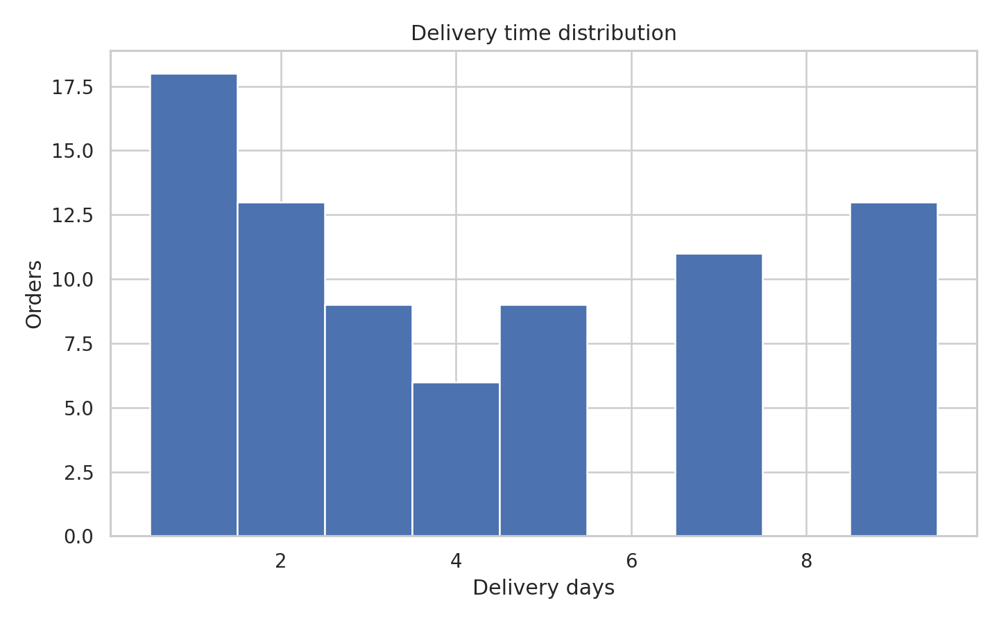

Bar chart — units by region
Bars compare shipment volume across discrete regions; South contributes the largest volume (204 units).
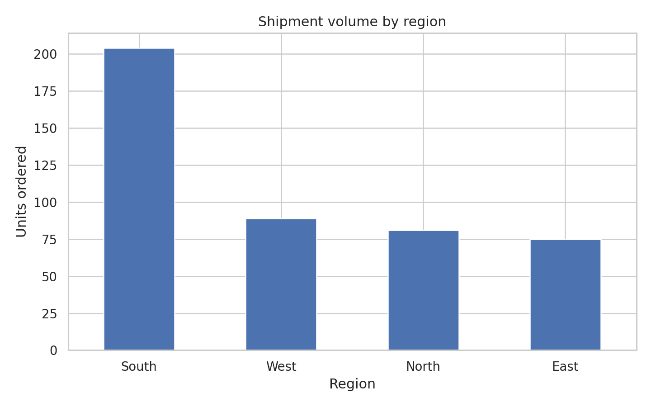

Boxplot — delivery duration by region
Boxplots compare medians, spread and extreme values across regions; West merits closer review due to its higher mean duration.
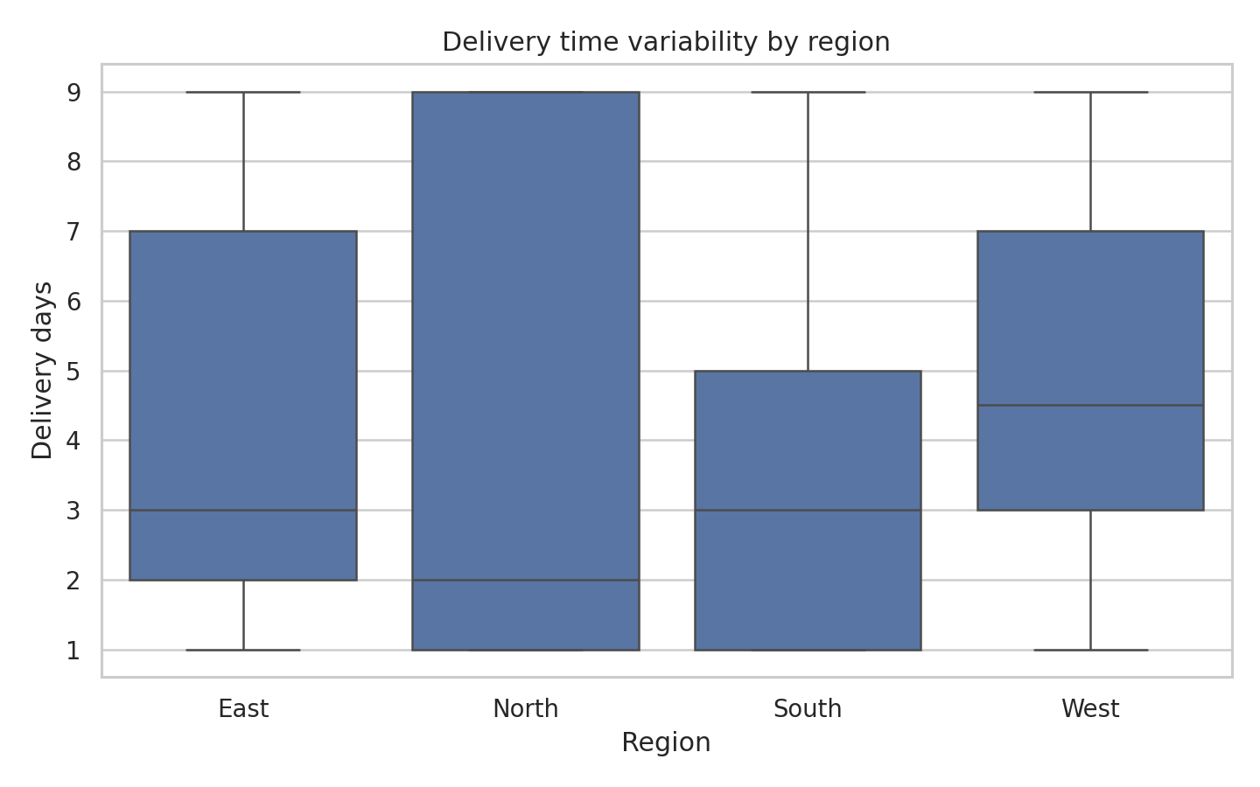

Scatter plot — simulated cost versus units
A scatter plot shows the relationship between two numerical variables. The cost formula directly includes shipment volume, so the positive association is partly built in.
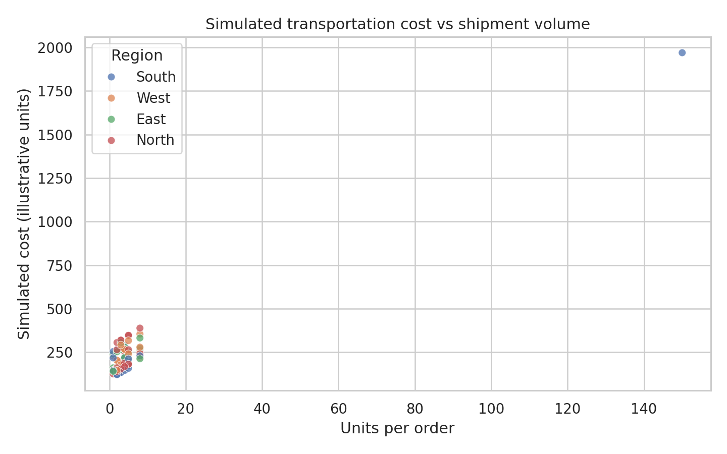

Heatmap — numerical correlations
A heatmap summarizes pairwise Pearson correlations. Shipment volume and simulated transportation cost correlate at about 0.960, a formula-driven relationship rather than independent evidence.
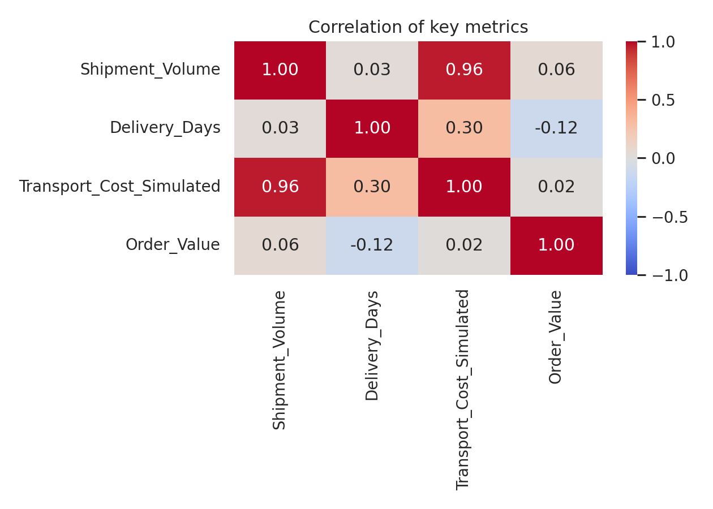

Line chart — monthly units ordered
A line chart displays temporal aggregation. The limited sample period cannot support strong conclusions about long-term trends or seasonality.
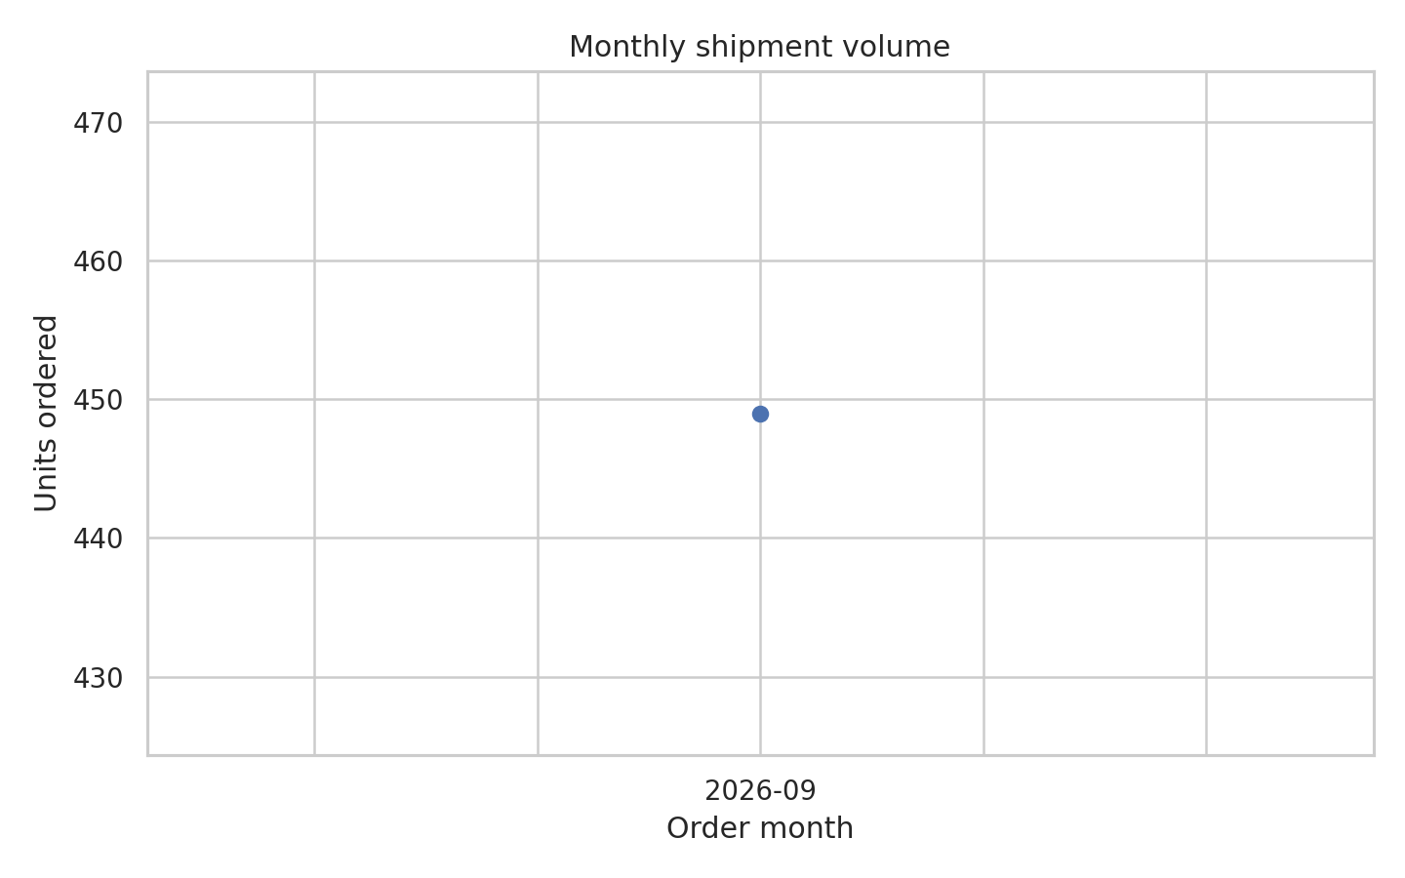

7. Python code illustration
df = pd.read_csv('data/week2_cleaned_logistics.csv', parse_dates=['Order_Date'])
df['Shipment_Volume'] = df['Quantity']
df.groupby('Region')['Delivery_Days'].agg(['mean', 'median', 'std'])
sns.heatmap(df[['Shipment_Volume', 'Delivery_Days']].corr(), annot=True)
The complete executable script is provided in src/analyze_logistics.py and saves all visualizations under visualizations/.

8. Recommendations and decision-making
- Investigate West-region dispatch schedules, carrier routes and service-level agreements before concluding there is a systemic delay.
- Monitor capacity in South because it has the highest simulated unit volume; confirm whether a few unusually large orders dominate this result.
- Collect actual freight invoices, distances, promised delivery dates, parcel weights and carrier IDs before attempting real cost optimization or SLA measurement.
- Track mean and median delivery time alongside upper-percentile delays, since averages alone may conceal slow shipments.

9. Limitations and reflection
The source data is synthetic, transportation cost is formula-generated, the dataset is small, and the four-day delivery threshold is assumed. The strong cost–volume correlation follows directly from the constructed formula. Observational summaries cannot prove why delays occur. Despite these limitations, the workflow illustrates how well-documented data preparation and visualization support transparent, testable logistics decisions.

10. Conclusion
Week 3 demonstrates reproducible EDA, descriptive statistics, correlation analysis and multiple justified visualizations. The results provide specific hypotheses for future investigation and a technical foundation for predictive modeling using genuine operational data.

References
Pandas documentation: https://pandas.pydata.org/docs/
Matplotlib documentation: https://matplotlib.org/stable/
Seaborn documentation: https://seaborn.pydata.org/
Week 2 synthetic cleaned dataset: data/week2_cleaned_logistics.csv

