## Deeksha Rawat, Shivansh Gupta, Krutuparna Paranjape, Pulak Gautam, Pratik Ranjan

Department Of Economics Submitted to : **Prof. SK Mathur**

# Abstract

In today’s dynamic global commerce environment, marked by unparalleled interconnect- edness and rapid technology breakthroughs, trade bloc formation and the proliferation of bilateral trade agreements have emerged as critical variables defining the trajectory of inter- national trade. This paradigm shift emphasises governments’ strategic obligation to seize the possibilities provided by increasing global markets and reduce trade obstacles to boost economic competitiveness and support long-term prosperity. Despite the difficulties of eco- nomic globalisation, the efficacy and fairness of international trade agreements continue to be scrutinised and debated.

This research aims to provide a thorough examination of the diverse dynamics of mod- ern international commerce, with a focus on comprehending the ramifications of global economic integration fostered by these agreements. The study tries to determine the ex- tent to which trade agreements improve trade flows, stimulate investment, and promote economic growth by examining important elements such as tariff reductions and market liberalisation. Furthermore, the study aims to disentangle the complex interplay between trade agreements and larger socioeconomic issues such as income inequality and shared culture, giving significant insights into the changing face of global trade regulation and cooperation.

# Introduction

In May 2022, India and 13 partners launched the Indo-Pacific Economic Framework for Prosperity (IPEF).Partner countries include USA, Australia, Brunei, Fiji, Indonesia, Japan, Malaysia, New Zealand, the Philippines, Singapore, South Korea, Thailand, and Vietnam. IPEF partners, which collectively represent 40% of global GDP, are diverse in size and economic development.The initiative is not designed as a traditional comprehensive U.S. free trade agreement (FTA), but IPEF aims to establish “high-standard commitments” in four pillars - (1) Connected Economy i.e. select trade issues, (2) Resilient Economy i.e. supply chains, (3) Clean Economy i.e. clean energy, decarbonization & infrastructure and,

(4) Fair Economy i.e. tax & anti-corruption issues).

Our motive is to study the impact of such a rising number of trade agreements in the recent past for developing countries like India. We do this by analysing the IPEF agreement and the possible implications when India leaves the Framework. We use structural gravity model for the analysis and identify the effect on key parameters, if India leaves the trade bloc.

The Structural Gravity Model [1] is a developed economic technique to analyse inter- national trade dynamics and policy implications. This approach, led by famous researchers such as James Anderson and Eric van Wincoop [2], outperforms its predecessors by incorpo- rating subtle aspects such as trade costs, market sizes, tariffs, and non-tariff barriers into its analytical framework. Unlike previous gravity models, which had strong theoretical under- pinnings, the Structural Gravity Model provides a solid theoretical framework for analysing trading patterns. Its rise was accelerated by the work of Anderson (1979) and Bergstrand

(1985), who set the framework for adding elements such as product diversification and Constant Elasticity of Substitution (CES) spending.

# Research Gap

The current research landscape centres mostly around the application of recognised ap- proaches such as the Gravity model and General Equilibrium Impact Analysis to examine trade dynamics in the western region. However, there is a significant void in the literature about the application of these analytical frameworks to growing economies, such as India. Given the increasing significance of international commerce for developing countries such as India, there is a pressing need for policymakers to evaluate the implications of participation in trade agreements.

Policymakers may get crucial insights into the predicted impacts of trade agreements on many economic variables, such as trade volumes, employment levels, and income distri- bution, by utilising extensive analytical techniques like the Gravity model and General Equilibrium Impact Analysis.

Furthermore, understanding the nuances of trade agreements is critical for developing ef- fective policies that maximise the advantages of international commerce while minimising any potential risks. As a result, this study tries to fill a vacuum in the literature by pro- viding a thorough examination of the possible effects of trade agreements on the Indian economy. Using a rigorous analytical methodology, this study aims to offer policymakers with evidence-based suggestions for optimising their participation in international trade agreements and fostering sustainable economic growth.

# Literature Review

With increasing Globalisation and growing need to understand and predict trade patterns, there has been a resurgence in the use of the Gravity model. Researchers are trying to estimate trade flows and analysing trade agreements using this model.

The foundation for the Gravity model was laid by Tinberg (1962) in his remarkable work. He conceptualised it on the famous Newton’s law of gravitation, the trade between two countries is directly proportional to their GDPs and inversely proportional to their distance. Through his paper he established the importance of GDP and distance between the countries in shaping trade patterns, establishing a framework for further research.

*Xni* = *GYiaYnbϕni*

Helpman(1987) introduced a new element that analysed the relation between income inequality in trading partners and trade volume. As income inequality decreases between trading partners, more balanced trade takes place. This leads to an increase in trade volume between these countries. Anderson and Wincoop (2003) [2] revolutionised the gravity model by introducing multilateral trade resistances. This model is known as the structural gravity model. They explained the longstanding border puzzle as the traditional gravity model failed to explain the observation that trade between countries sharing a border was higher than expected. Multilateral resistance terms explained the impact of a country’s trade with other countries on its bilateral trade flows. Following is the typical gravity equation, which

relates bilateral trade (*Xij*) between exporter *i* and importer *j* to exporter output (*Yi*), importer expenditures (*Ej*), global output (*Y* ), bilateral trade costs (*τij*), the elasticity of substitution (*σ*), and outward and inward multilateral resistances (Π*i* and *Pj*).

*X* = *YiEj* ( *τij* )1*−σ*

*ij Y*

Π*iPj*

Eaton and Kortum linked trade volume to trade barriers corresponding to technology and geography. As different countries are at different technological levels of production, some countries can produce more efficiently than others. This affects trade volume. Simi- larly geographical location of a country also affects trade volume.

Chaney (2008) introduced the role of firm level characteristics and market structure in shap- ing trade flows. Chaney divided the international trade in intensive and extensive margins of trade. He referred intensive margin as the amount of goods traded between countries, while the extensive margin as the variety of products traded.

Baier and Bergstrand (2007) studied the implications of NAFTA and analysed whether NAFTA has led to trade diversion or trade creation.This paper provided insights into ef- fects of the agreement and its implications for regional trade in North America.

Head and Mayer (2014) [3] provides great insights into theoretical foundations, empir- ical applications, methodological advancements, and policy implications of Gravity model. Merely exponentiating the coefficients on dummy variables is called PTI( Partial Trade Impact). Anderson (2011) emphasized the modular nature of the structural gravity model - the determination of output and expenditures occurs in a different module from the alloca- tion of bilateral flows. The trade impact that observes this feature of the model is labelled as Modular Trade Impact (MTI). General Equilibrium Trade Impact (GETI) is the case where wages (and therefore GDPs) also adjust to trade cost changes

We use General Equilibrium Gravity Analysis with PPML (Pseudo-Poisson Maximum Likelihood estimator) model, given by Anderson, Larch and Yotov (2017) [4], builds upon Constant Elasticity Of Substitution Structural Gravity model with exporter and importer fixed effects, Anderson, van Wincoop (2003) [2].

# Objectives

The objective of this research study is to utilise the structural gravity model to investigate the comprehensive impacts of the Indo-Pacific Economic Framework for Prosperity (IPEF) on **bilateral trade among its member nations**, with a particular focus on assessing its effects on India. We aim to analyse whether the agreement is truly beneficial to India or not, shedding light on the specific advantages or challenges it presents for the Indian economy.

Our broader aim is to enhance our understanding of and contribute to the literature regarding the consequences of collaborative efforts in promoting economic prosperity within the vast Indo-Pacific region, with India as a key focal point. By focusing on India within the framework, we seek to provide valuable insights into the potential benefits of such trade agreements and frameworks for the participating countries, as well as their implications for policymakers and businesses in other developing countries.

Through our analysis, we intend to estimate the elasticities of trade costs associated with various barriers within the IPEF, gaining insights into the determinants of interna- tional trade and the specific factors influencing trade barriers for India. Additionally, we will conduct a counterfactual analysis of India leaving IPEF to predict and **compare the export levels and economic development** statuses of India under the current scenario with those that would have been observed had the framework not been established. This comparative analysis will help ascertain the true impact of the IPEF on India’s economic progress and trade dynamics.

Furthermore, we aim to examine the general equilibrium effects of the Indo-Pacific Eco- nomic Framework for Prosperity **on all participating countries**, including India, to assess its effectiveness in facilitating bilateral trade flows and fostering economic development. The findings of our study will not only provide valuable insights into the potential benefits of such trade agreements for the participating countries but will also have important impli- cations for policymakers and businesses in other countries that have either signed or are considering signing similar agreements with their trading partners.

# Hypothesis Testing

We propose the following hypotheses:

1. Opting Out of IPEF has a significant positive impact on India’s GDP, decline in IMR and OMR terms, and a significant increase in exports
2. If India opts out of IPEF, we hypothsize that smaller countries in the IPEF framework such as Fiji, Brunei, Indonesia etc witness a decline in their exports as well as GDP whereas larger nations such USA and China witness an increase in their exports, GDP etc owing to differential chnages in multilateral resistances.
3. We hypothesize that the smaller nations would witness a substantial increase in intra- national trade corresponding to a decline in their international trade as listed above.

We also further hypothesize that PTI (Partial Trade Impact), MTI (Modular Trade Impact), GETI (General Equilibrium Trade Impact) are higher in presence of the following factors compared to when they are absent(yes-values higher than no-values).

# Data Description and Sources

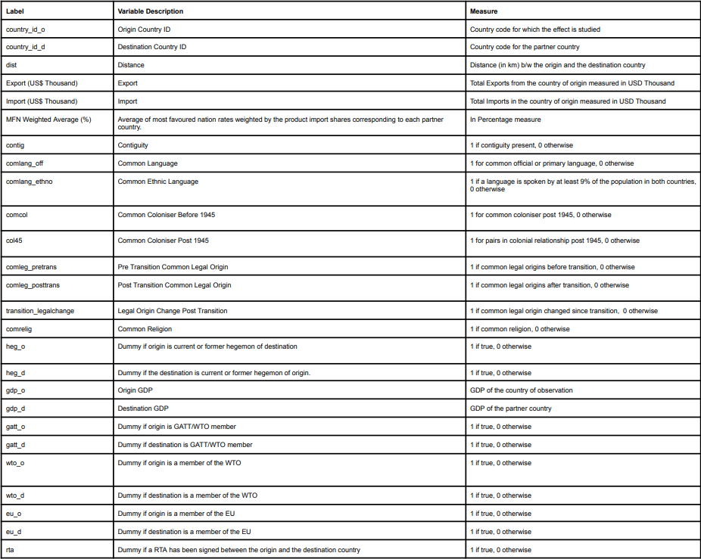

We used data corresponding to 20 countries, of which 14 are IPEF countries and other 6 non-IPEF trading partners of India. The non-IPEF trading partners were chosen as they would constitute the bulk on Indian trade.

To sum up, the chosen countries encompass:

* IPEF: Australia, Brunei, Fiji, India, Indonesia, Japan, Republic of Korea, Malaysia, New Zealand, Philippines, Singapore, Thailand, Vietnam, and the USA.
* Other Trading Partners: China, UAE, Saudi Arabia, Russia, and South Korea.

Data used in our exercise as described above has been taken from the following sources:

1. CEPII’s gravity dataset : The data related to distance, common colony, language and ethnic and legal background and other corresponding dummies were taken from this dataset.
2. WITS : The data regarding bilateral trade, import and export, and tariffs was collected from the WITS website.

The data was then integrated to create a square dataset which was later used for conducting the analysis. A more detailed description of the variables and dummies used in the analysis is provided in the shown table.

# Methodology

## Preliminary tests on gravity model

We conducted two preliminary test to check whether the collected data empirically follows the gravity model.

1. Check whether GDP is directly related to the Exports

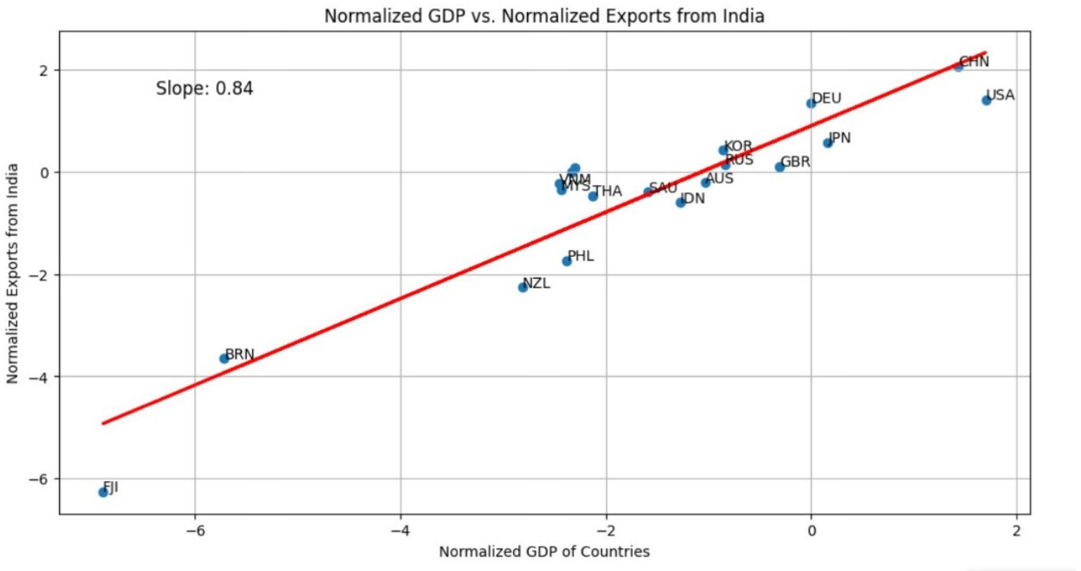

Figure 1: Plotting Normalized Exports(from India) vs GDP

1. Check whether Distance is inversely related to the Exports

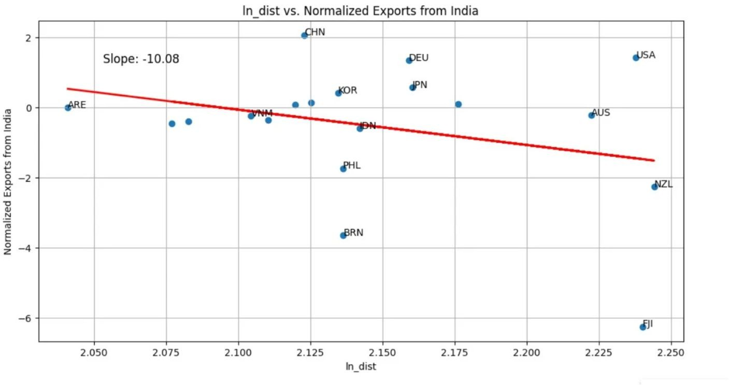

Figure 2: Plotting Normalized Exports(from India) vs Log(distance)

## Theory

The three step procedure we followed to obtain the general equilibrium effects of trade policy with the PPML estimator is as follows:

1. Baseline Scenerio : This step delivers the ‘baseline’ estimates and ‘baseline’ GE in- dexes.
   1. Estimate Baseline Gravity :

*Xij* = *exp*(*Tijβ* + *πi* + *χj*) ∗ *ϵij*

*Xij* = *exp*(*β*1*ln*DIST*ij* + *β*2*Comlangij* + *β*3*Contiguityij* + *β*4*lnRTAij* + *β*4

* 1. Construct baseline GE indices :

*Yi* = Σ*n Xni* and *Xn* = Σ*i Xni*

1. Conditional Scenario : This step delivers the ‘Conditional’ gravity estimates and ‘Con- ditional’ GE indexes, which allow for changes in the IMRs and OMRs in response to changes in trade costs, but do not take output and expenditure changes into account.
   1. Estimate Conditional Gravity : *Xij* = *exp*(*Tijcβ*ˆ + *πic* + *χjc*) ∗ *ϵijc*
   2. Construct ‘Conditional’ GE Indices : ‘Conditional’ GE scenario can be calculated by the change in real GDP, i.e.

*W*ˆ*i*

= *Yic/P*˜*ic* =

*Yi/Pi*

˜

*P*˜*i* ∀

*P*˜*ic*

*, i*

Where moving from the middle to the rightmost equality recognizes that output is kept exogenous in the ‘Conditional’ scenario , i.e., *Yic* = *Yi*

1. Full Endowment Scenario. This step delivers the ‘Full Endowment’ gravity estimates and ‘Full Endowment’ GE indexes, which in addition to changes in the IMRs and OMRs capture changes in output and expenditure.
   1. Estimate ‘Full Endowment’ Gravity :

˜1*−σ* *c*

*t*

˜ *c*

*c*

˜1*−σ* ˜1*−σ*

*X*˜*c* =

*ij*

*Yi E*˜*j* Π*i Pj* *X*

*t*˜1*−σ*

*ij*

Π*i*

*Pj*

*ij*

*YiEj* ˜1*−σ* *c* ˜1*−σ* *c ij*

where *t*˜1*−σ* = exp **T *β***˜ and *t*˜1*−σ* *c* = exp **T***c* ***β***˜

*ij*

*ij*

*ij*

*ij*

* 1. Construct ‘Full Endowment’ GE Indexes : The percentage change in welfare in the ‘Full Endowment’ GE scenario can again be calculated by the change in real

GDP, i.e., *W* = *Y*˜*c/P*˜*c ,* ∀*i*

^*i i* *i*

˜

*Yi/Pi*

To summarise, the estimates are obtained as follows:

**PTI***in* = *ϕ*^*in* = *ϕ′in/ϕin* = exp (*β* (*B′in* − *Bin*))

*X′*

**MTI** = *in* = **PTI**

Ω

Φ

× *i* × *n*

*in Xin*

*′*

**GETI***in* = *Xin* = **MTI***in* × *Yi Xn* = *Y*^*iX*^*n* Φ^*in* = *π*^*inY*^*n*

*in* Ω*′* Φ*′*

*′ ′*

*Xin*

*YiXn* Ω^ *i*Φ^ *n*

## Welfare *W*

= *Y*^ *c/P*^*c* = *P*^

^*i i i* *i*

*Yi/P*^*i*

*P*^*c*

*i*

## Code Explaination

* + 1. Python Code Methodology

The *OneSectorGE* model in the *gegravity* package [1] replicates the structural model of Yotov et al. (2016) [4]:

*YiEj*  *τij* 1*−σ*

*X* = ( ) (1)

*ij Y*

Π*iPj*

Π = Σ ( *τij* )1*−σ Ej*

(2)

*i P Y*

*j*

*j*

*P* 1*−σ* = Σ ( *τij* )1*−σ Yi*

(3)

*j* Π *Y*

*i*

*j*

1

*p* = ( *Yi* ) 1*−σ* 1

(4)

*i Y γi*Π*i*

(1) is the typical gravity equation, which relates bilateral trade (*Xij*) between exporter *i* and importer *j* to exporter output (*Yi*), importer expenditures (*Ej*), global output (*Y* ), bilateral trade costs (*τij*), the elasticity of substitution (*σ*), and outward and inward multi- lateral resistances (Π*i* and *Pj*). The multilateral resistance (MR) terms are defined by (2) and (3).

The *gegravity* Python package offers a comprehensive suite of tools designed for esti- mating general equilibrium (GE) structural gravity models and conducting counterfactual simulations. This package is particularly valuable for researchers and analysts working in the field of international trade.

One of the key features of the package is its ability to calculate theory-consistent estimates

of the structural multilateral resistance terms proposed by Anderson and van Wincoop (2003). These estimates are derived from standard econometric gravity results, providing researchers with a reliable method for incorporating these important factors into their mod- els.

Additionally, the package includes functionality for simulating GE effects resulting from various counterfactual experiments. For example, researchers can use the package to sim- ulate the potential impacts of new trade agreements or changes to other types of trade costs. This capability allows analysts to explore different scenarios and assess the poten- tial outcomes of policy changes or other external factors on international trade patterns. Overall, the *gegravity* package is a valuable tool for researchers and analysts seeking to bet- ter understand the complexities of international trade and its impact on the global economy.

## Steps Involved in Python Methodology:

* + - 1. Install the necessary dependencies if they are not already installed. Additional Pack- ages to be installed include econometric gravity packages - ***gme***, ***gegravity*** package and, data manipulation package - ***pandas***.

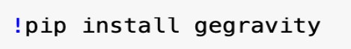

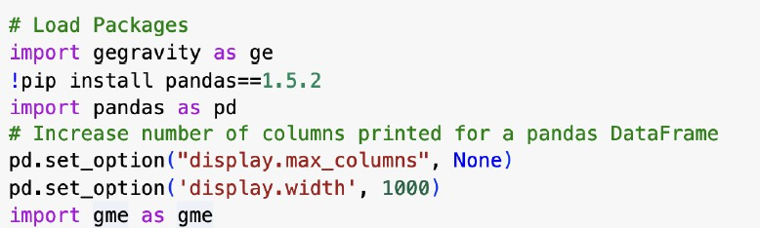

* + - 1. Load the data needed to both estimate trade costs using an econometric gravity model and parameterize the baseline GE gravity model.

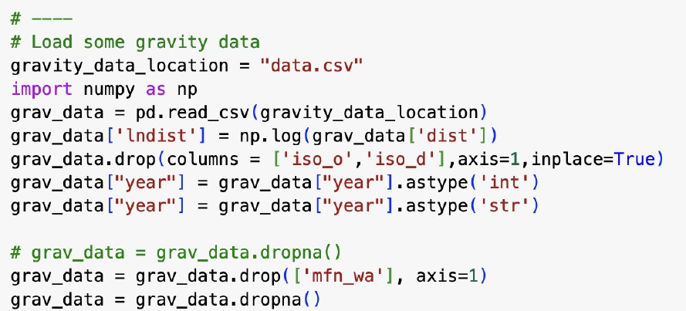

* + - 1. The gegravity package relies heavily on the gme package, which contains a collec- tion of gravity modeling tools. Using the gme package, we can structure the gravity data, define an econometric gravity model, estimate the model using Poisson Pseudo Maximum Likelihood (PPML), and store all relevant inputs and outputs in a single convenient Python object that is used by gegravity.

Define the Estimation data structure using the loaded data. Specify the columns in

which certain variables can be found such as the importer, exporter, and year identi- fiers as well as the trade flows.

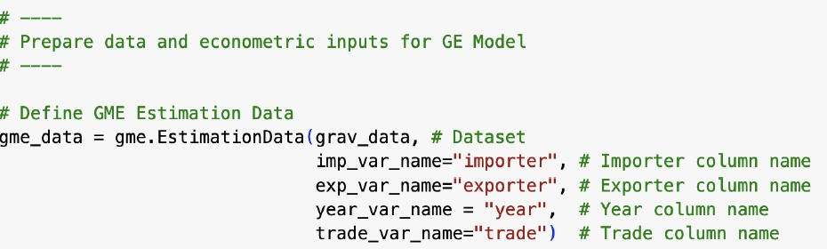

* + - 1. After the data structure is defined, create and estimate an econometric gravity model. Doing so requires the user to specify the data structure to use; the column to use as the “left hand side” (LHS), dependent variable; the columns to use as “right hand side” (RHS), independent variables; and the type of fixed effects to add to the model (importer and exporter, in this example).

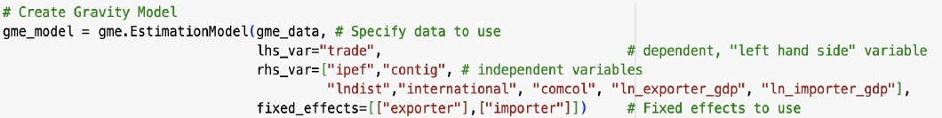

* + - 1. Once *ge model* object is defined, we can continue with estimation and, results can printed to the console.

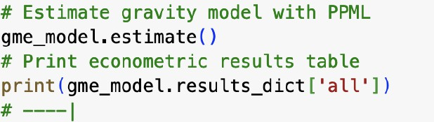

* + - 1. With the gravity model econometrically estimated, which provides the basis for con- structing bilateral trade costs, we can **define the gegravity GE model**. The *ge model*, *OneSectorGE*, utilizes the information that is already stored in the Es- timationModel, which includes the estimating data, trade cost parameter estimates, and other information like column identifiers.

Given that, defining the GE model requires only the specification of a few more in- puts such as the year to use (the GE model is static and based on a single year), the columns containing output and expenditures, a reference importer to use and an elasticity of substitution (*σ*).

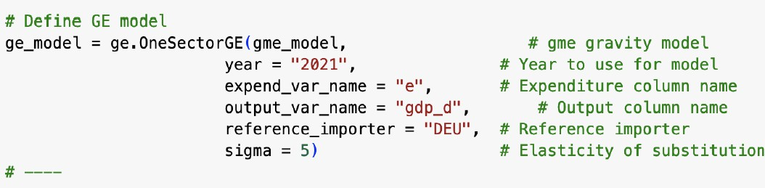

* + - 1. The next step is to **build the baseline model**. This step constructs some needed parameters from the input data and, most importantly, estimates the baseline outward (OMR) and inward (IMR) multilateral resistance terms.

After the model solves and the baseline is constructed, the baseline IMR and OMR terms can be retrieved from the model. The estimates of this baseline model are as shown below.

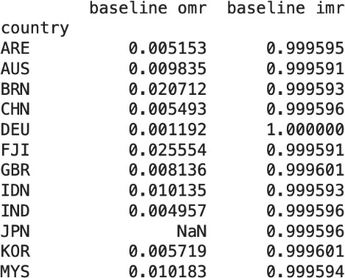

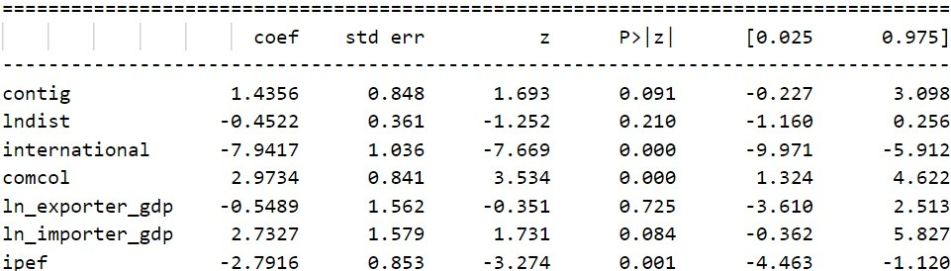

* + - 1. With the baseline solved, the model can be used to **conduct counterfactual policy experiments**.

An experiment modifies some of the trade cost measures (e.g. distance, contiguity, common language, pta, or international border) for certain countries and solves a counterfactual version of the model based on these alternative trade costs.

For example, here we simulated the results for India leaving IPEF.

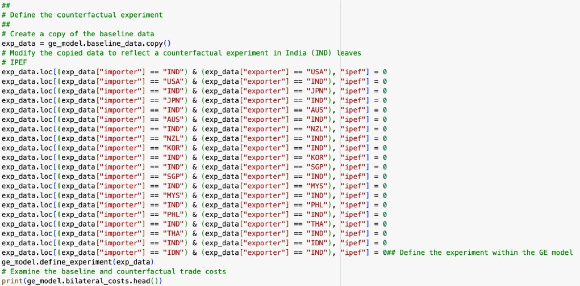

* + - 1. Finally, with the counterfactual model also solved, a wide variety of results can be returned from the model.At the country level, the model determines percentage change in factors such as total imports and exports, factory gate prices, real GDP, terms of trade, and the multilateral resistances It also produces counterfactual bilateral trade flows between each country pair and the estimated percentage change from the baseline.



* + 1. Stata Code Methodology

## Steps Involved in Stata Methodology:

* + - 1. Remove countries which have zero import or zero export from any other countries.
      2. Check whether the data is square, i.e.

No. of Rows = *nk* + *n* = *n*2

* + - 1. Calculate **Partial Trade Impact (PTI)**

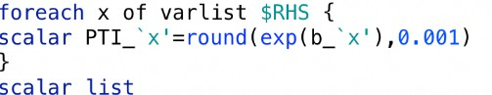

* + - 1. Calculate **Real MR terms** using contractual mapping (contracmapdn) and using earlier calculated estimates normalized w.r.t. estimates of the base country, DEU (Germany).

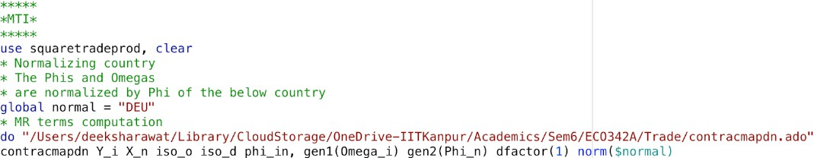

* + - 1. Calculate **MR terms in counterfactual scenario** (say, by revoking IPEF), and their ratios to the earlier calculated MR terms - gives MTI (modular trade impact) due to these variables.

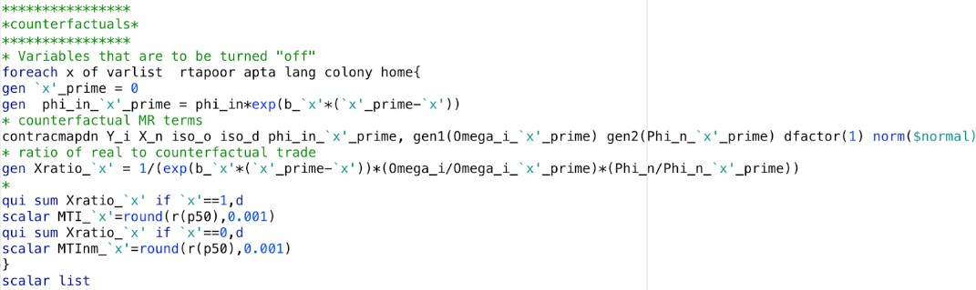

* + - 1. Adjust the income terms following the change in trade costs, to calculate **GETI and Welfare terms**.

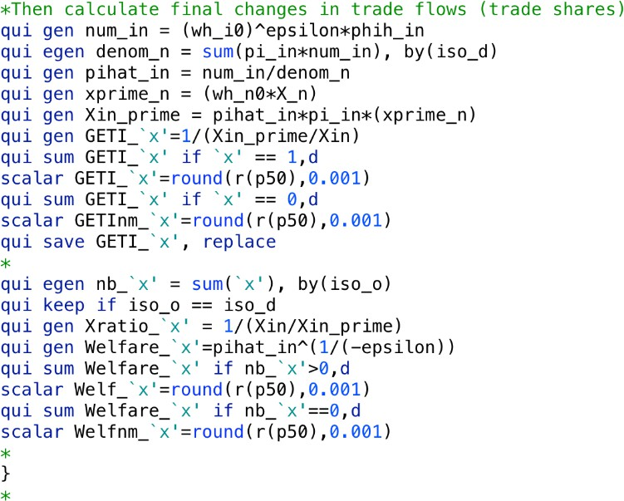

# Results

## Counter-factual Analysis Results

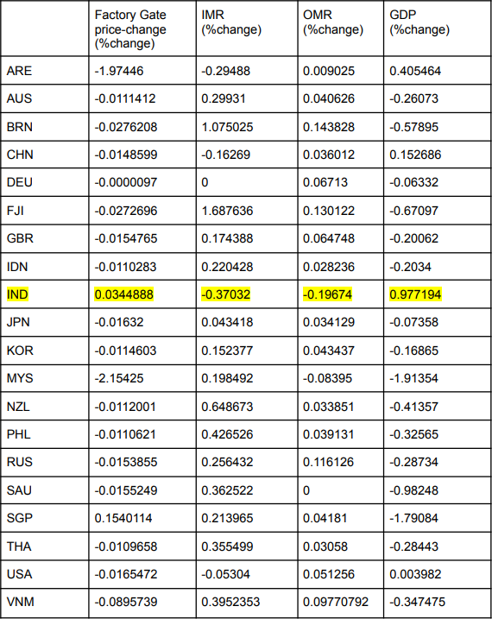

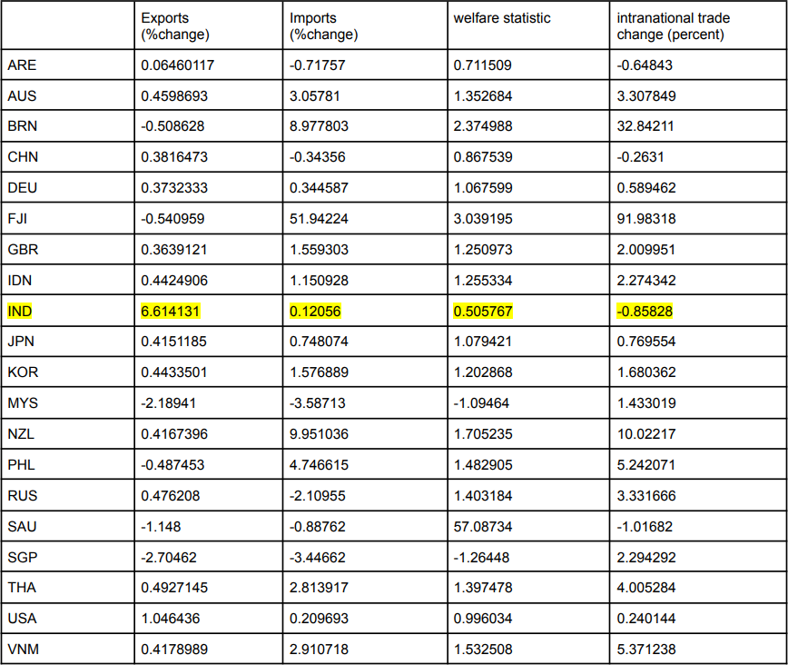

* + 1. Impact on India

Opting out of the IPEF would lead to a positive change in India’s GDP, given the significant positive change in India’s GDP(0.97One specific reason for this might be that leaving IPEF might allow India more flexibility in setting its trade policies and negotiating bilateral agree- ments tailored to its specific economic interests. This could potentially result in increased trade opportunities with certain countries, improved market access for Indian goods and services, and reduced regulatory burdens that may have been imposed by the IPEF. Additionally, India could also focus on strengthening its domestic industries and promoting domestic consumption, which could further boost economic growth. However, it’s essential to consider potential drawbacks such as the loss of access to certain markets or disruptions in existing trade relationships with IPEF member countries.

Overall we can say that while exiting the IPEF could offer India some opportunities for economic expansion, careful strategic planning and negotiation would be necessary to maximise the benefits and mitigate any potential downsides of such a decision.

* + 1. Impact on Smaller / Developing Countries

We would also like to discuss the potential impact of India leaving the IPEF (Indo Pacific Economic Framework) on global trade dynamics. According to the results obtained, If India were to exit the agreement, it could indeed have major repercussions, particularly for smaller nations like Indonesia, Brunei, Fiji, Malaysia etc which tend to have higher trade with our country particularly owing to such trade agreements.

India is likely to have significant trade relationships with these smaller nations within the framework of the IPEF. If it withdraws, the loss of access to the Indian market could indeed result in trade barriers for these countries. India might seek to strengthen trade ties with larger economies like the USA, China, and Japan, potentially diverting trade flows away from smaller nations.

In essence, India’s departure from the IPEF would lead to a redistribution of trade patterns, with smaller countries facing challenges in maintaining their previous levels of trade with India while larger countries might see an increase in their trade volumes with India, due to more tailored agreements. This underscores the interconnectedness of global trade agreements and the potential ripple effects of a member country’s decision to exit such agreements.

* + 1. Impact on Larger Countries

According to the results obtained, if India leaves the IPEF, larger countries like the USA and China could potentially benefit from increased bilateral trade with India. Both the USA and China are major global economic players with significant trade influence.

For the USA, India’s exit from the IPEF could present an opportunity to negotiate bilateral trade deals that could potentially result in increased exports of American goods and services to India. Similarly, China, with its growing economic presence, could also seek to deepen its trade ties with India outside the constraints of the IPEF agreement.

India’s departure from the IPEF might lead to a reconfiguration of global trade rela- tionships, with larger economies seeking to capitalise on the opportunity to strengthen their economic ties with India. The results obtained confirm to this as USA and China have a significant positive change in GDP and exports.

* + 1. Intra-national Trade

We observe that Intra-National Trade increases for smaller countries if India decides to leave IPEF.With India’s departure from the IPEF, smaller countries could experience higher trade costs.

Faced with higher barriers to international trade, smaller countries may increasingly focus on their domestic markets. This shift towards intra-national trade involves conducting business within their own borders rather than engaging in cross-border trade.

## PTI, MTI, GETI Results

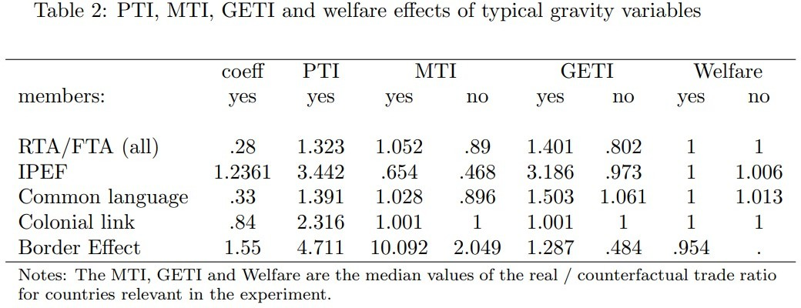

We observe that the ‘yes’ values are significantly higher than ‘no’ values for all factors that contribute to reduction in trade costs including RTA, IPEF, Common Language etc for each of three indices of PTI, MTI, GETI.

We consult to the country-specific results that we obtained earlier which point out that India benefits from leaving the trade framework in terms of percentage changes in IMR, OMR, exports, GDP etc.

# Code and Plagiarism Report

* **Plagiarism Report** : The plagiarism report can be found in the following link:

[*https://drive.google.com/file/d/1mGyL9xBBS6i2IeV2hvj5-tQMCXD 2ou5/view?usp=drive link*](https://drive.google.com/file/d/1mGyL9xBBS6i2IeV2hvj5-tQMCXD_2ou5/view?usp=drive_link)

* **Code, Data & Results** : Code, data and estimation results can be found in the following link: [*https://drive.google.com/drive/folders/1x9ZxVi5TSnSIIfMjGmEvG9eBQyBDWZyh*](https://drive.google.com/drive/folders/1x9ZxVi5TSnSIIfMjGmEvG9eBQyBDWZyh)

# References

1. Gravity Cookbook, [*https://sites.google.com/site/hiegravity/*](https://sites.google.com/site/hiegravity/)
2. Anderson, Wincoop, *Gravity with Gravitas: A Solution to the Border Puzzle*, American Economic Review vol. 93, no. 1, March 2003 170-192
3. Head, K. and T. Mayer, 2021, *The United States of Europe: A gravity model evaluation of the four freedoms*, Journal of Economic Perspectives 35(2): 23-48
4. Anderson, J. E., Larch, M., Yotov, Y. V., 2017, *Trade and investment in the global economy*, NBER Working Paper No. 23757.
5. McCallum, J., 1995, *National Borders Matter: Canada-U.S. Regional Trade Patterns*, American Economic Review 85, 615-623.