**Project- 3**

**How to connect the private server to internet using NAT gateway (Jump server/bastion host**

**Virtual Private Cloud**

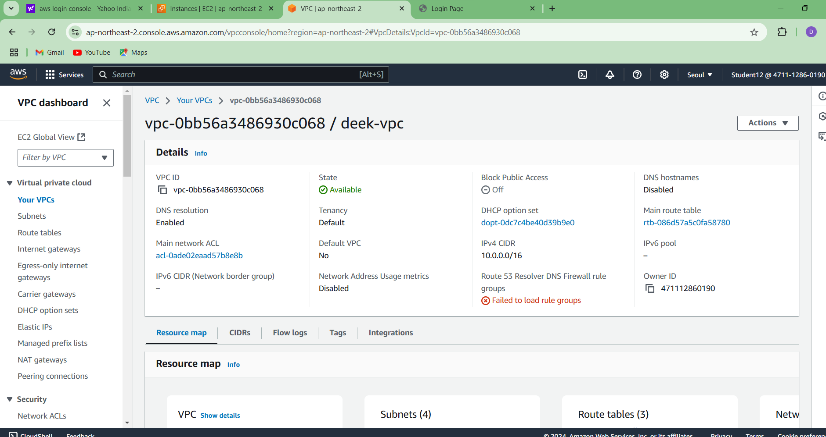

**Internet Gateway**

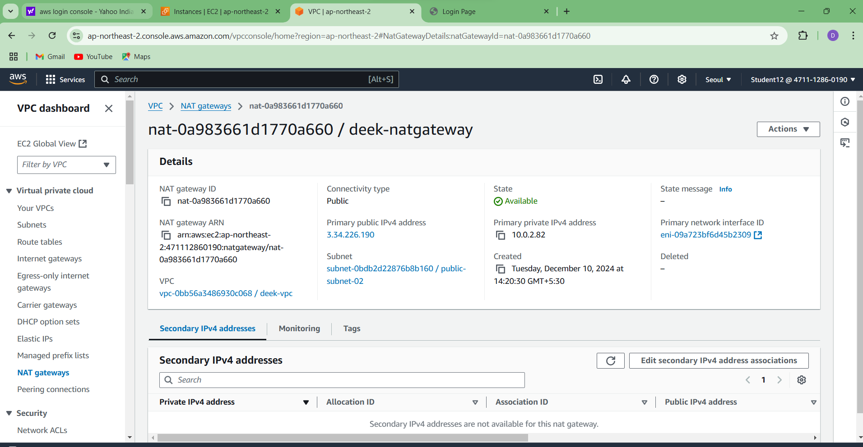

**Create Subnets**

Steps

1. In the VPC dashboard, select Subnets.

2. Click the create subnet button to create 2 public and 2 private subnets.

3. Select the VPC created.

4. Provide with the subnet name, availability zone and IPv4 subnet CIDR block for both private and public subnets.

**Public subnet1**

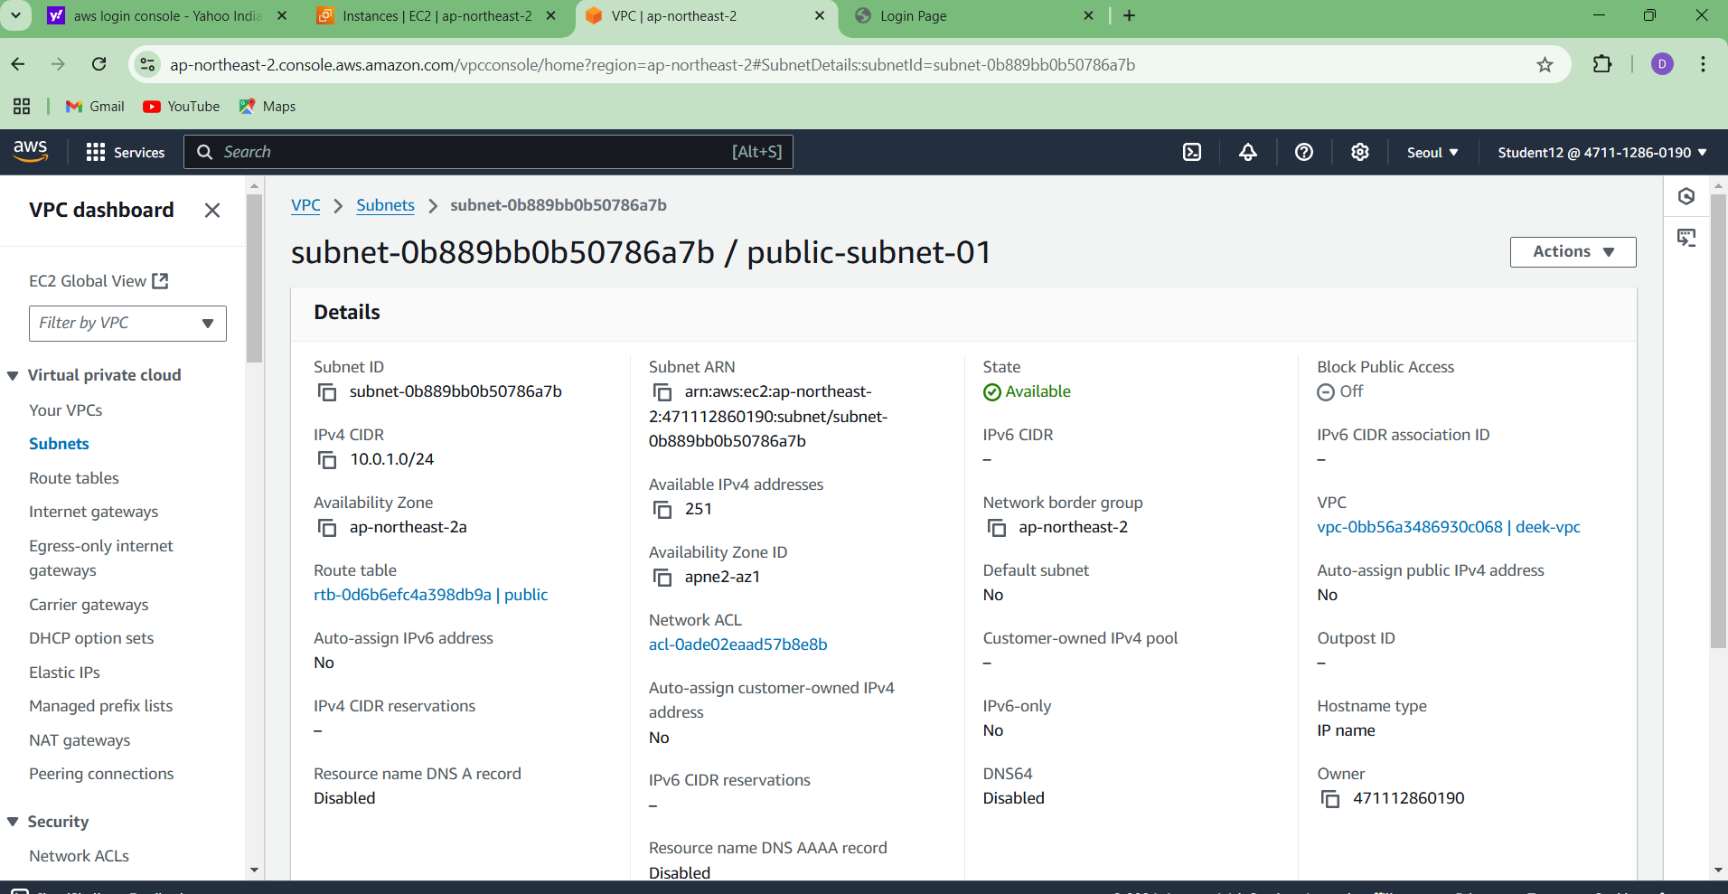

**Public subnet2**

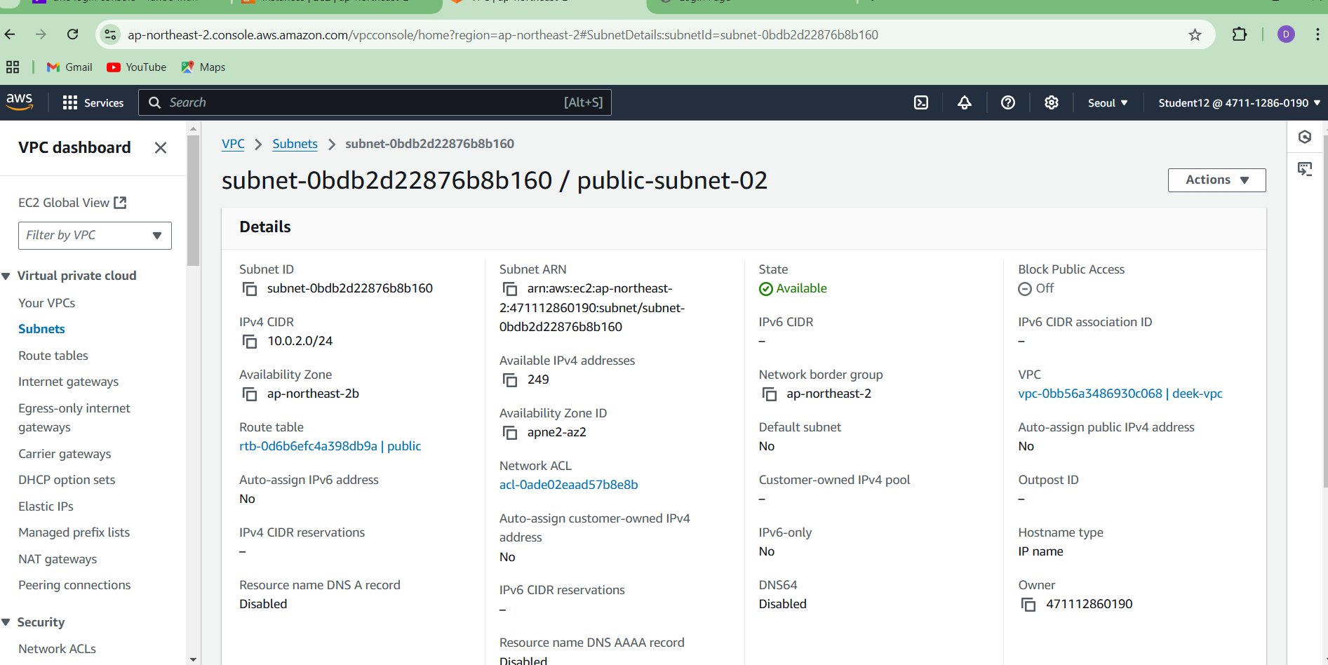

**Private subnet 1**

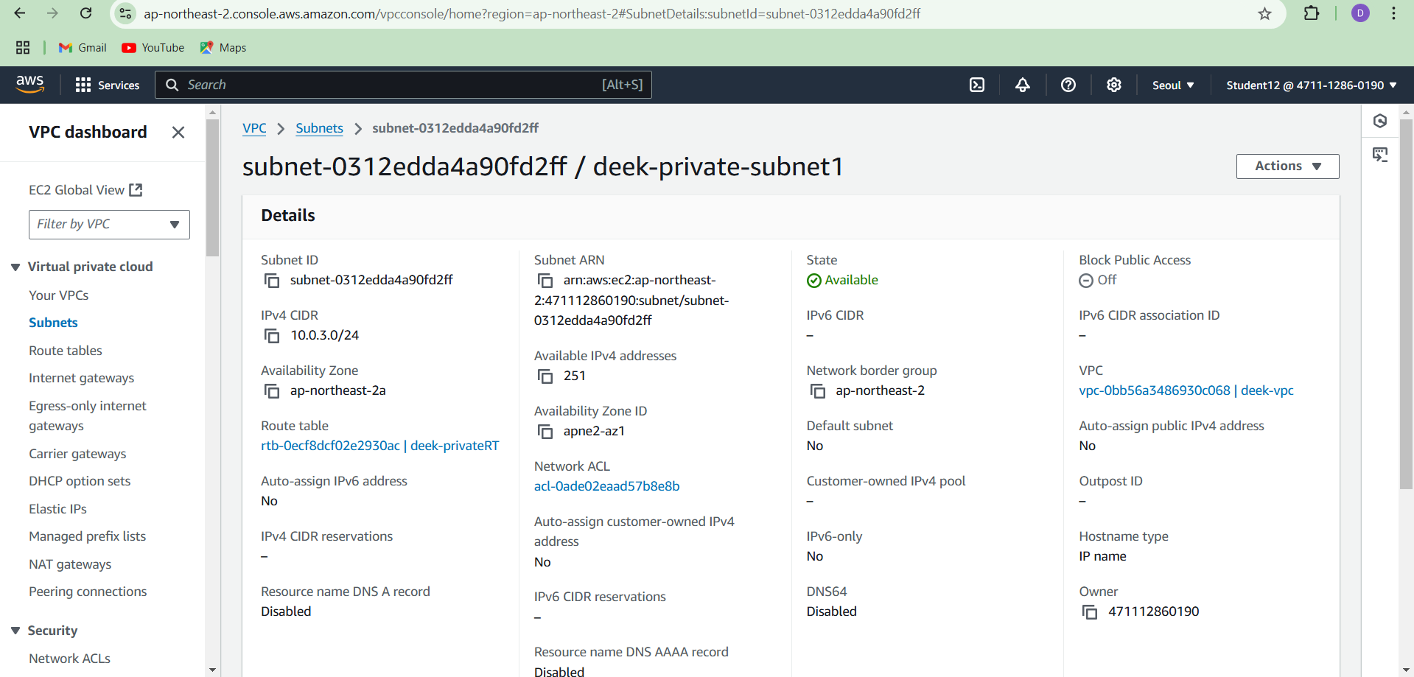

**Private subnet2**

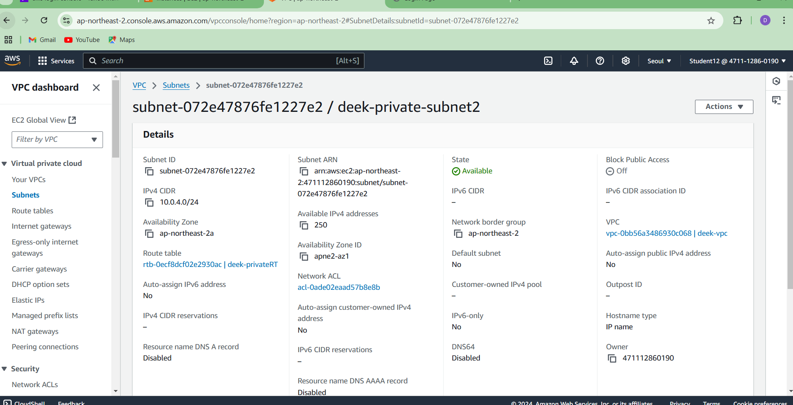

**Create Route Table**

Steps

1. In the VPC dashboard, select Route Table.

2. Click the create route table button.

3. Provide the name as deek-private-RT and the created VPC.

4. Under the Subnet Association, click Edit subnet association.

5. Check the private subnets and save association.

**Private route table**

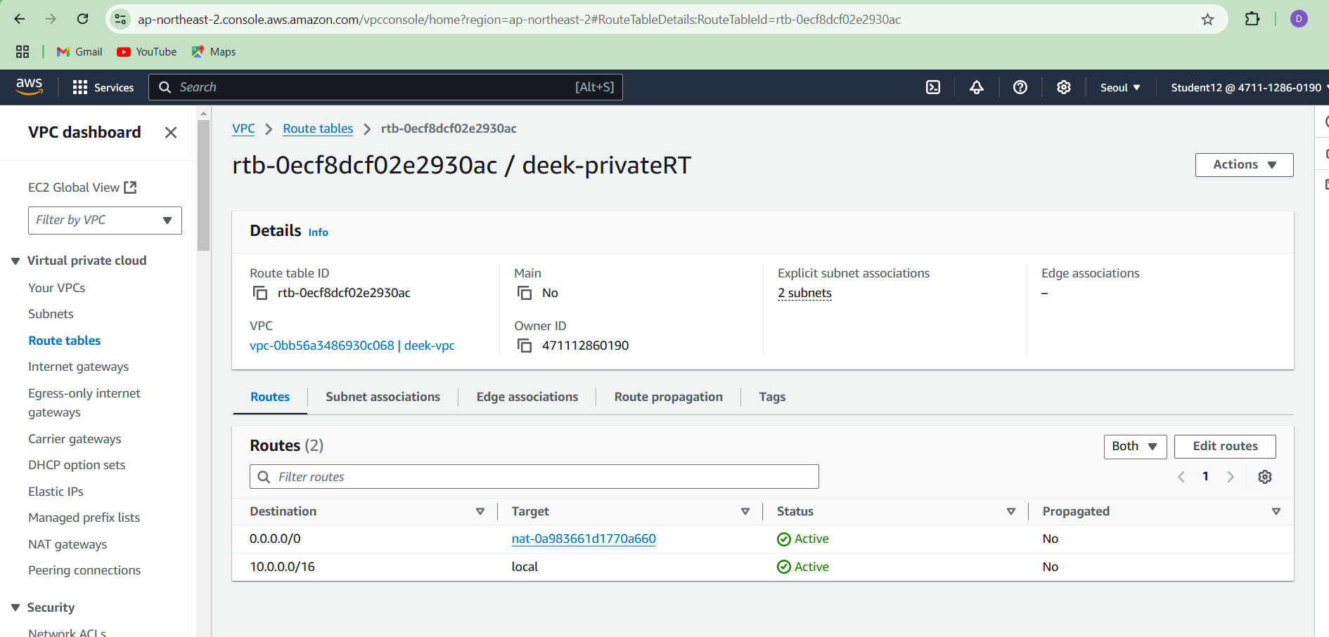

**Public server**

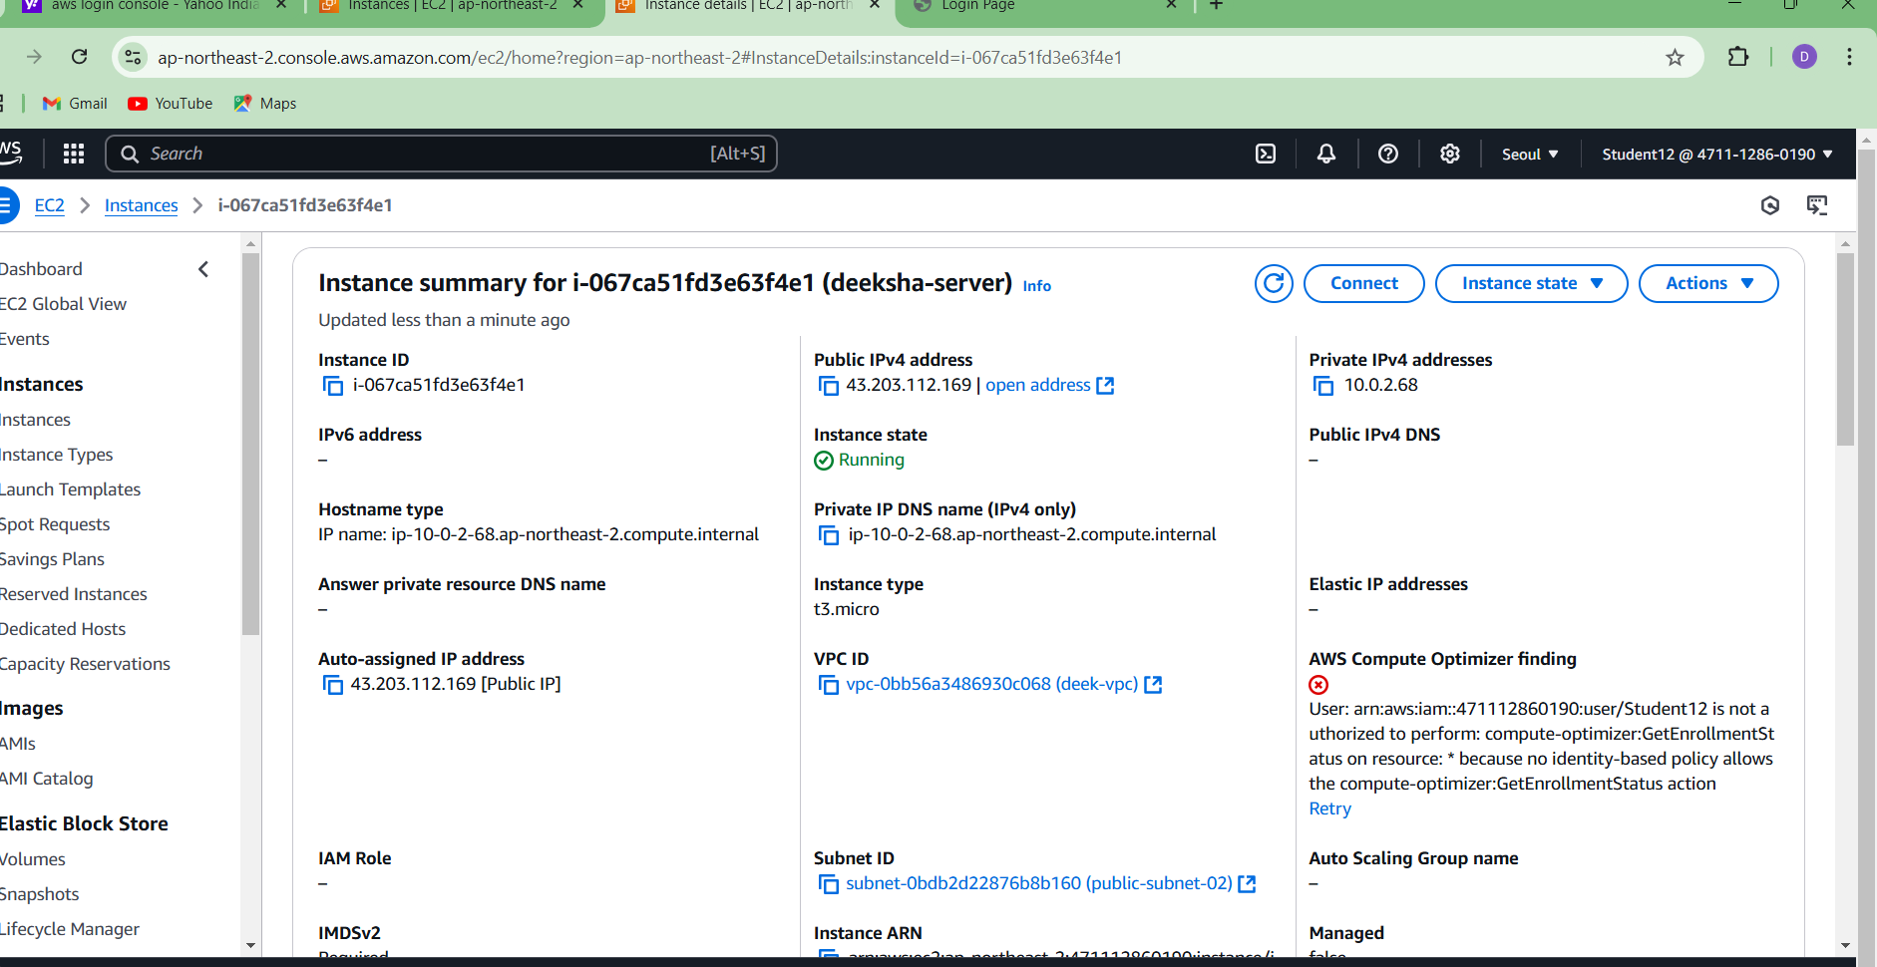

**Private sever**

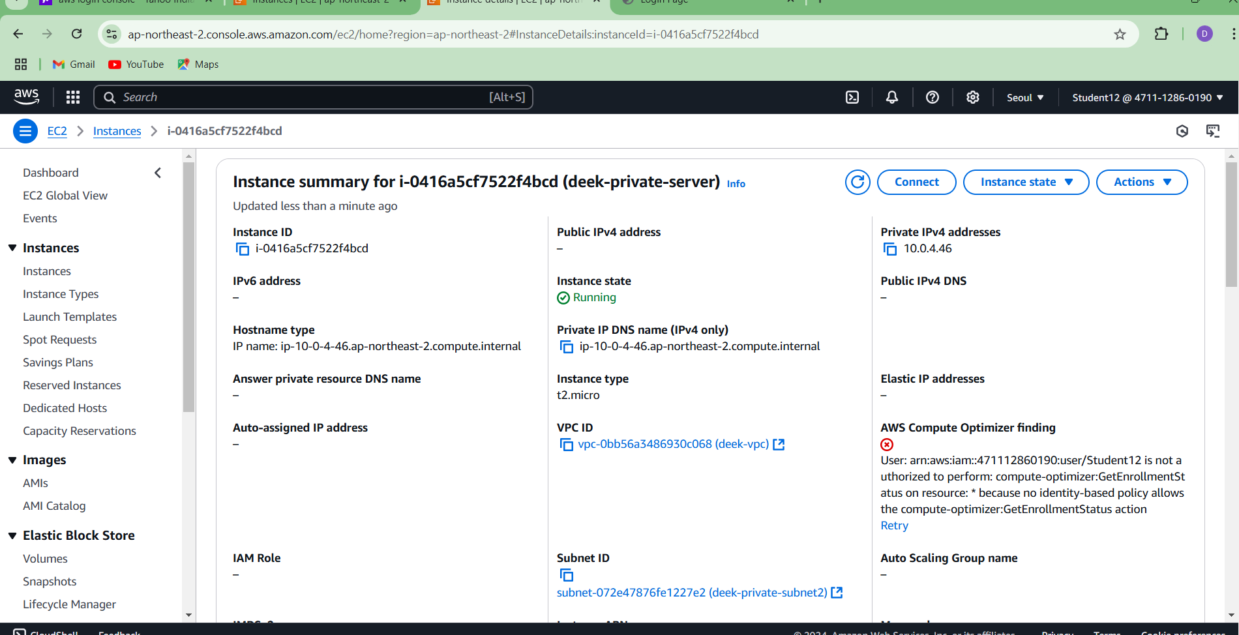

**Create NAT gateway**

**Steps**

**1.** In the VPC dashboard, select **NAT Gateways**.

**2.** Click the create NAT Gateway.

**3**. Provide the name as deek-natgateway and select the created public subnet and the allocate Elastic IP allocation ID.

**4.** In the route table check the private-RT and provide the target as NAT gateway.

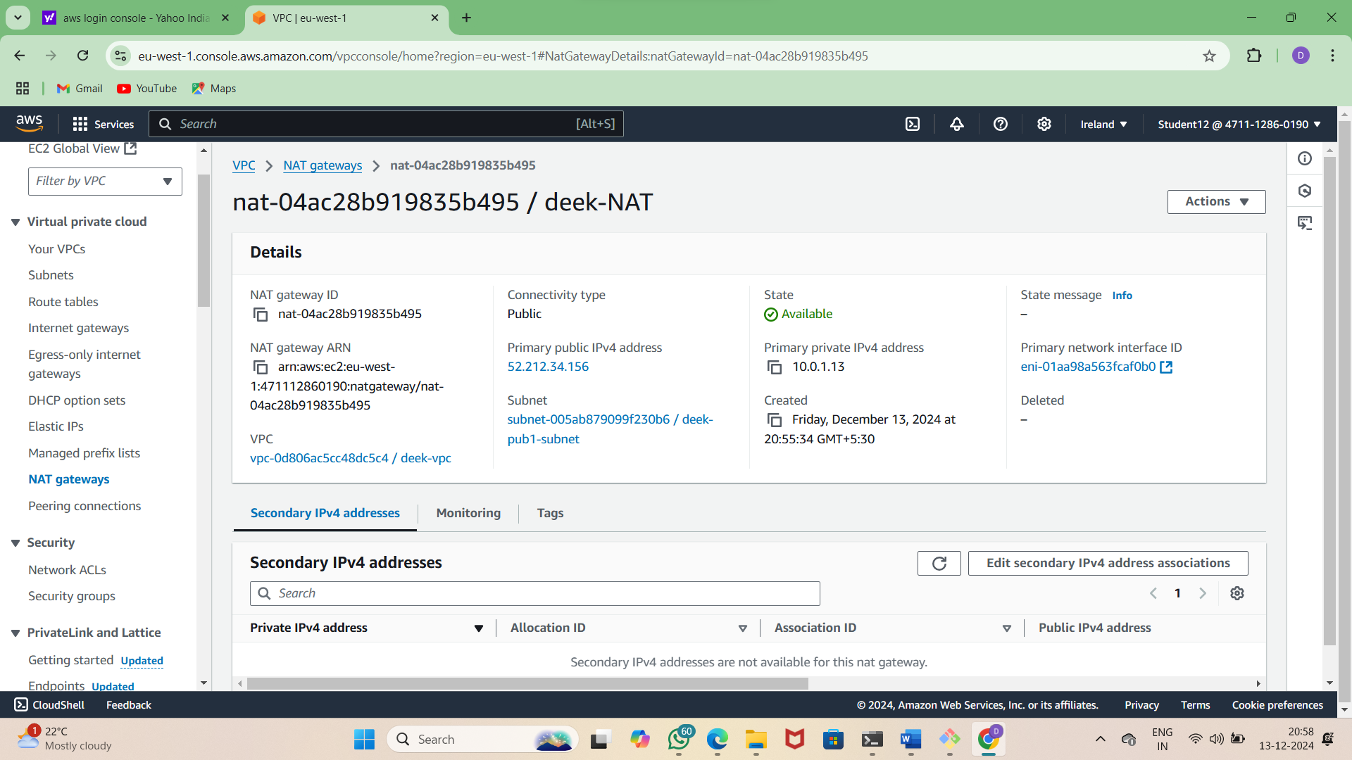

**Connection of public**

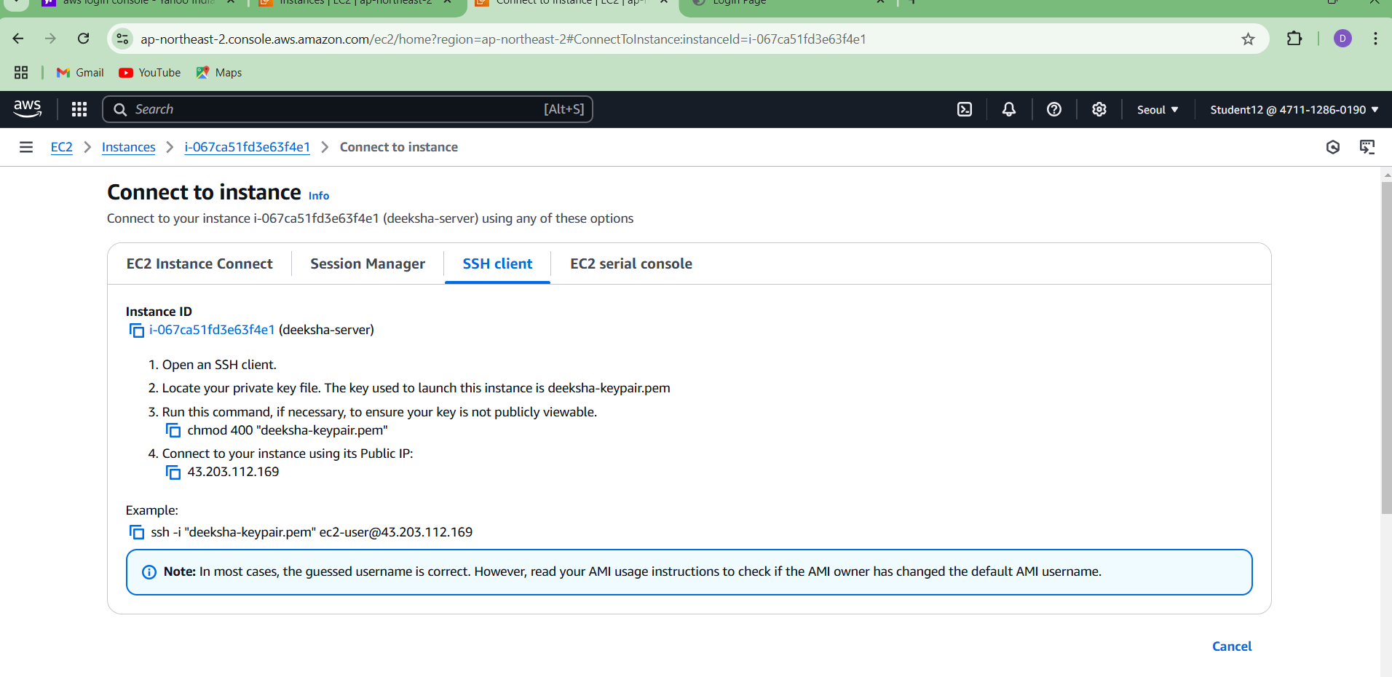

**Connection of private subnet**

