**Project - 4**

Hosting a static website using S3 Buckets

**S3 Bucket**

Steps:

1. Go to search bar and type s3. Click on s3.

2. In S3 dashboard, go to general purpose buckets and click on create bucket button.

3. In general configuration, select bucket type as general purpose and give name as deeksha12.

4. Click on create bucket button. Your bucket is created.

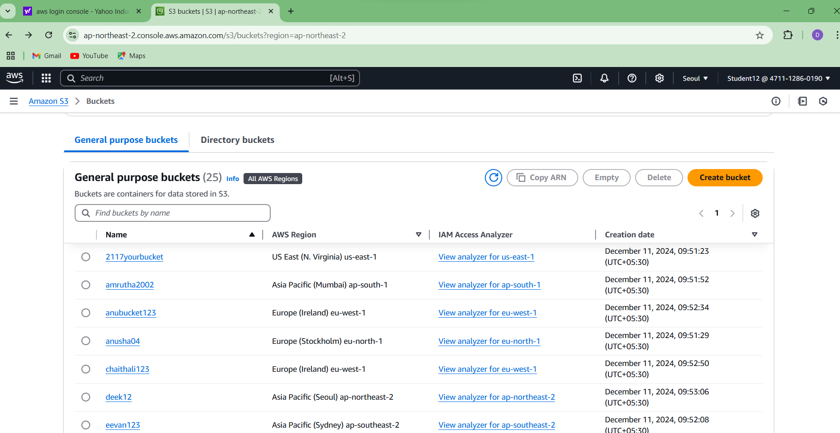

**Uploading a file**

1. Click on created bucket.

2. Bucket window gets opened and click on upload button.

3. In upload window, select files and folders and Click on add files and select the file you want to add.

4. Then click on upload. Your file is uploaded.

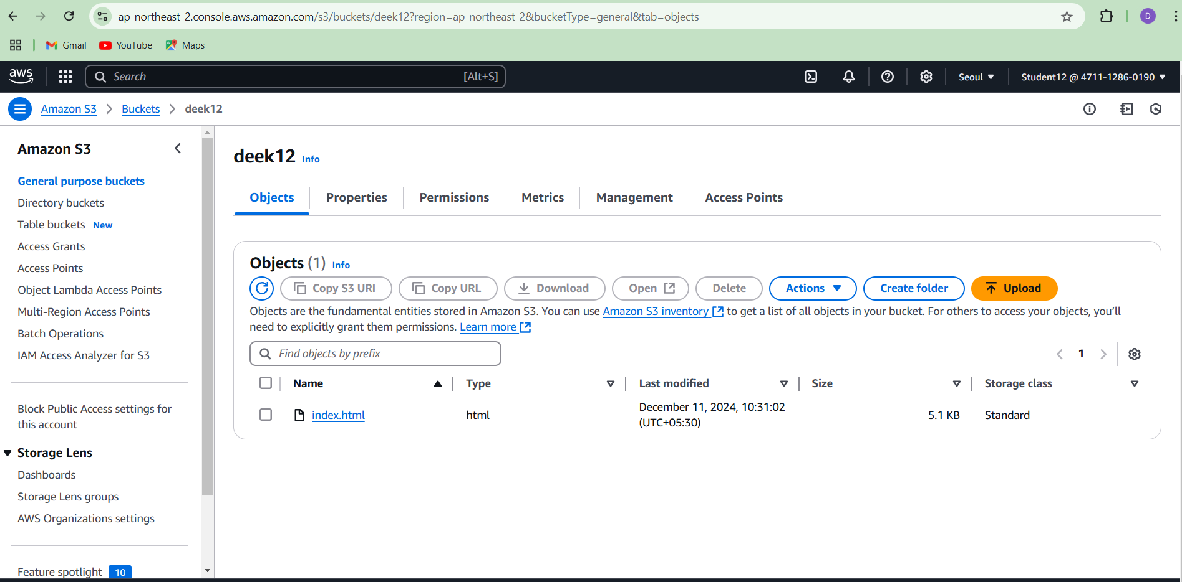

**Static website hosting**

Steps:

1. Select the properties, go to static website hosting and click on edit.

2. Give index document name as file name that is dailyping.html and click on save changes button.

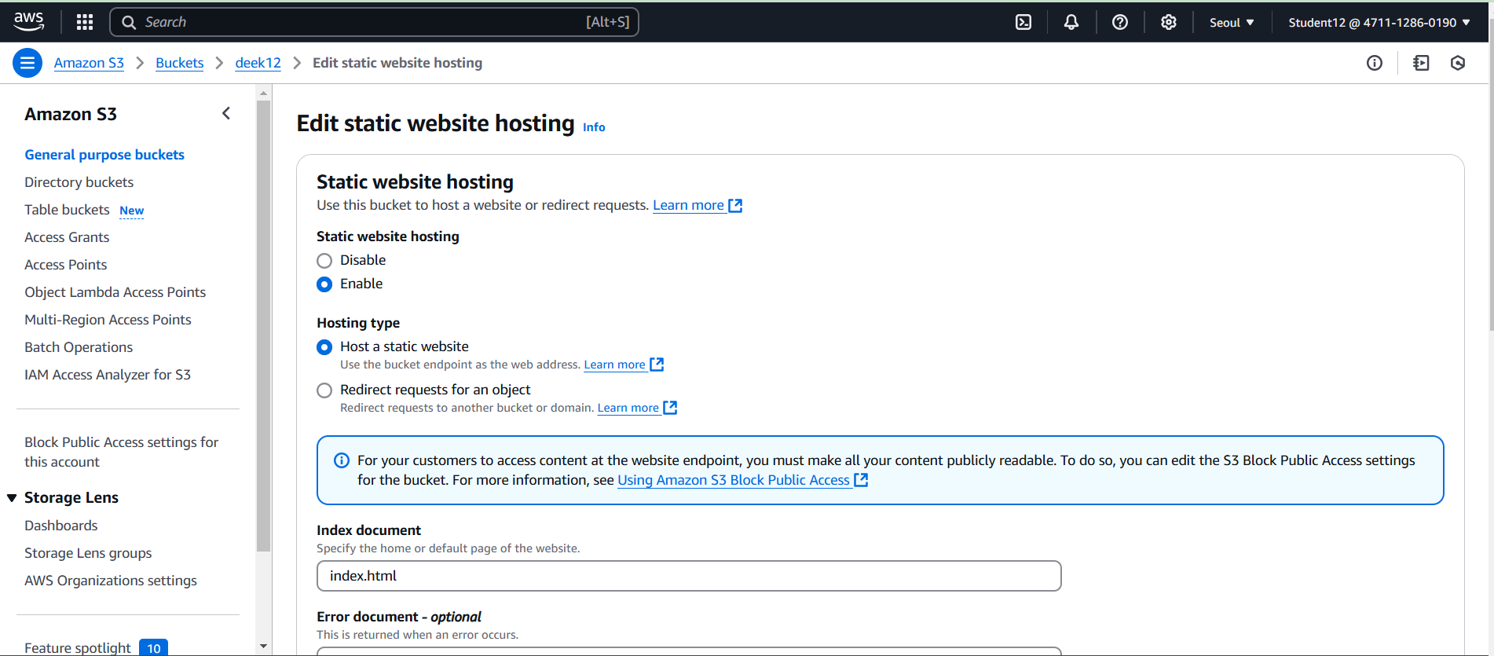

**Bucket Setting**

Steps:

1. Go to permission, select block public access and click on edit.

2. Under block public access (bucket setting), uncheck the block all public access and click on save changes button.

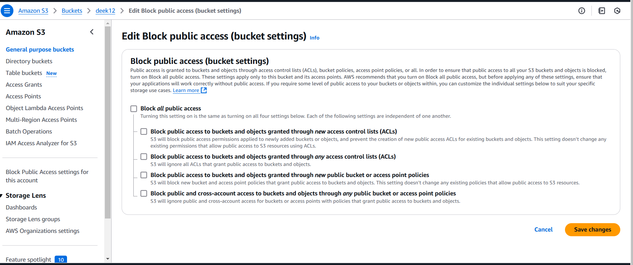

**Setting Permission for website access and add bucket policy**

Steps:

1. Go to google browser and type bucket policy for static website.

2. You will get setting permission for website access and click on it.

3. You will get add bucket policy

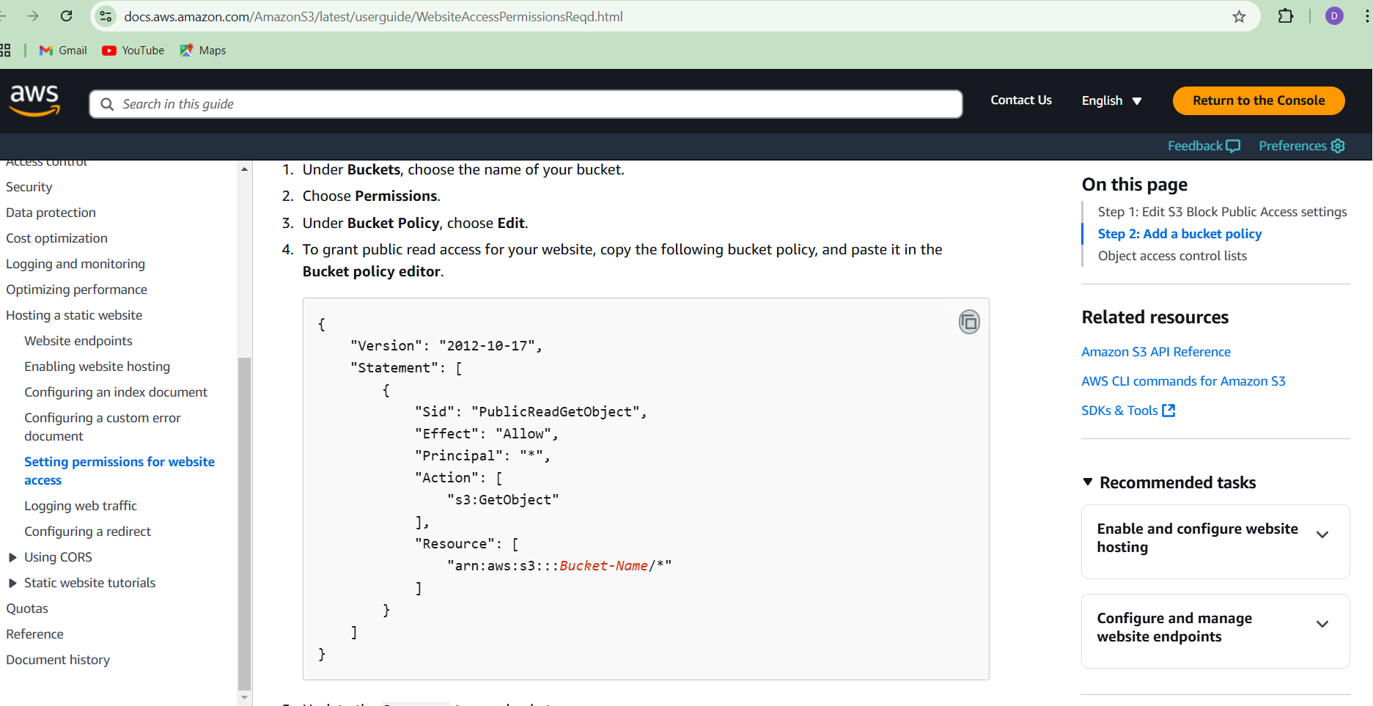

**Bucket policy**

Steps:

1.In permission, select bucket policy and click on edit.

2.Paste the code copied from the editor and change the ‘Bucket-Name’ as deeksha12 (created bucket name).

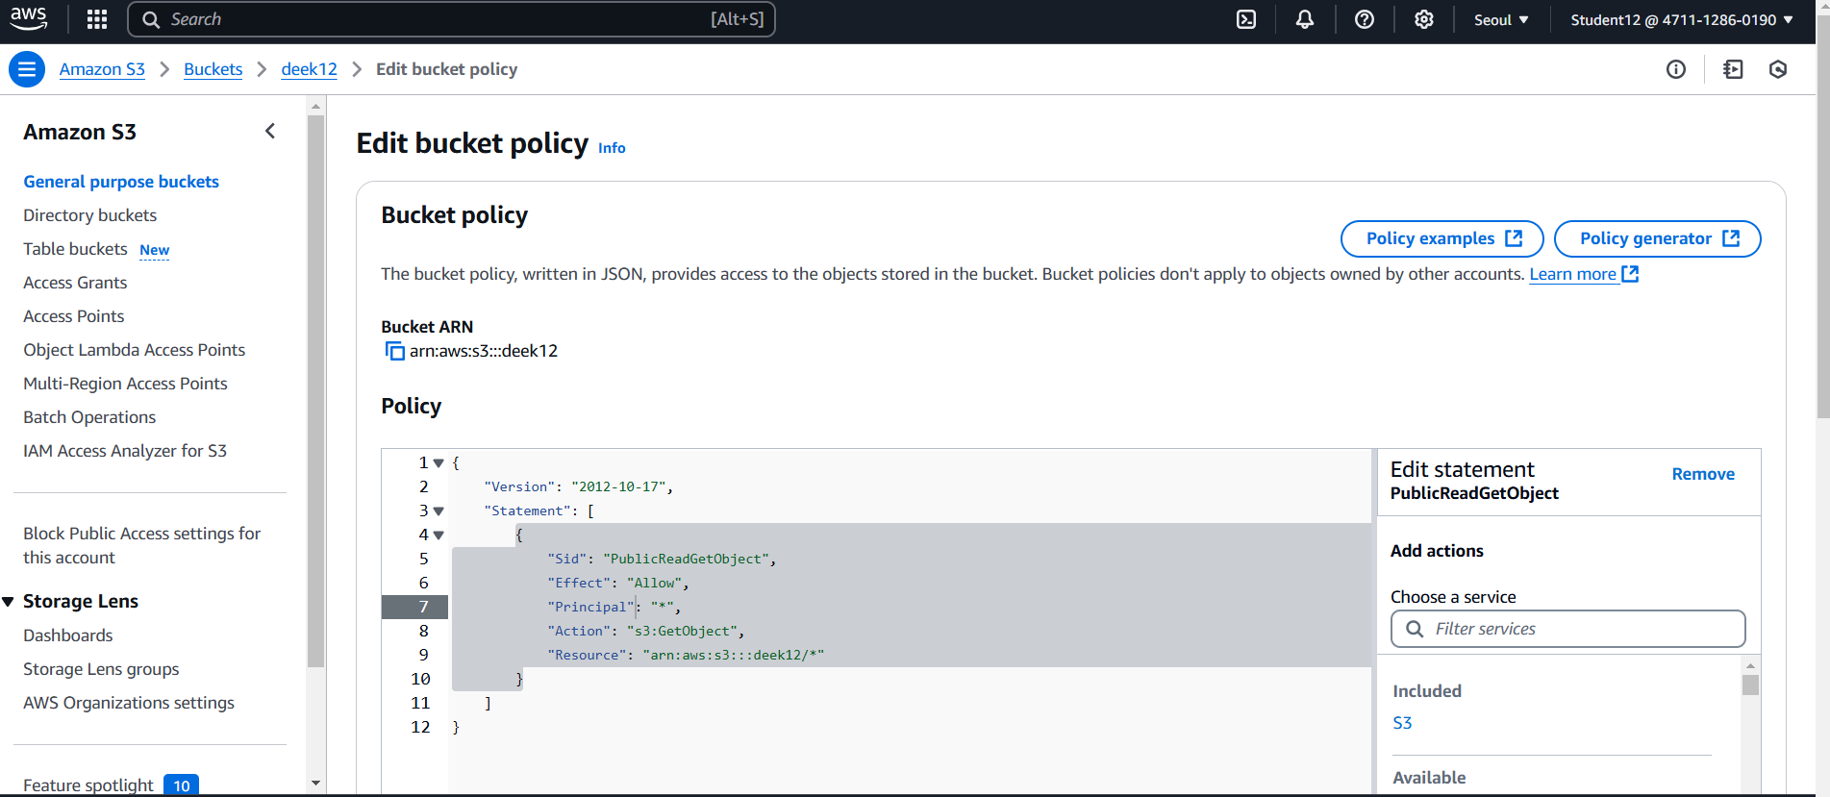

**Static website hosting url**

Steps:

In properties, under static website hosting, copy the bucket website endpoint url and paste it on google browser.

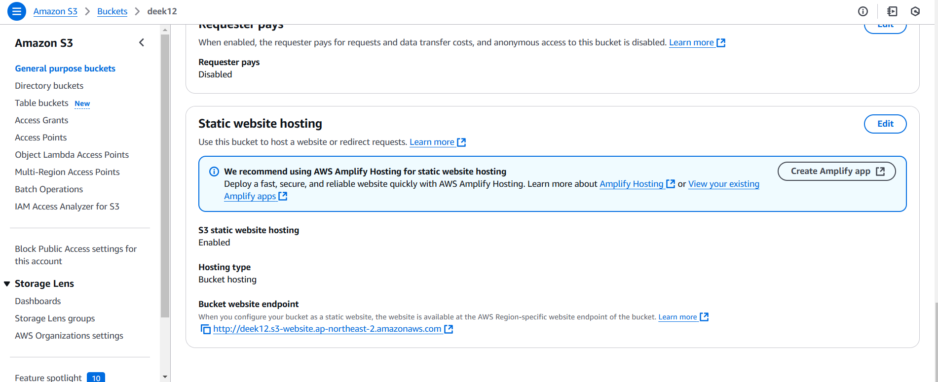

**Final result**

