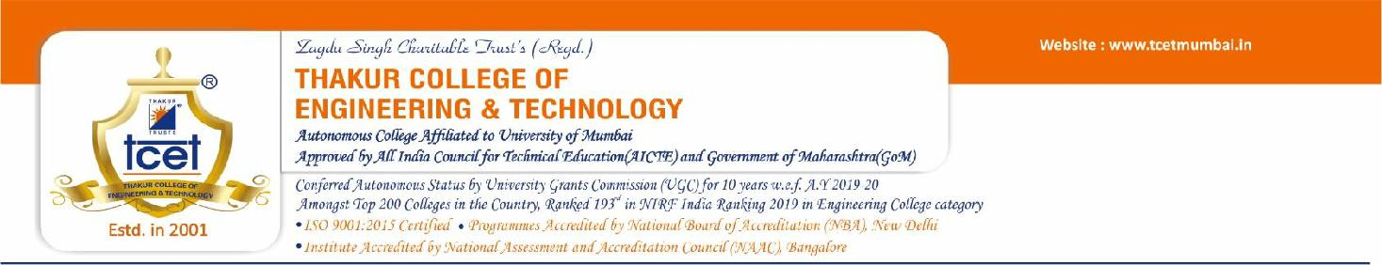

**CERTIFICATE**

This is to certify that ABHISHEK PANDITA(18-ITB06-22), PRASAD NAYAK(18-ITB11-22), DEEKSHA RAI(18-ITB12-22), the students of Second Year INFORMATION TECHNOLOGY Engineering at Thakur College of Engineering and Technology, have satisfactorily completed the requirements of the PROJECT under Employability Skills Development Programme- 2020 while working on “EVENT MANAGEMENT SYSTEM”.

**Mr.Namdeo Badhe T&P Coordinator**

**Mr. Amol Dapkekar**

**Training Coordinator**

**Dr. Zahir Aalam Professor (TPO)**

**Dr. B. K. Mishra**

**Principal**

**Internal Examiner:**

**External Examiner:**

**Signature with Date: ……………..**

**Signature with Date: …………..**

**Name: ……………………………..**

**Name: …………………………..**

PLACE: Mumbai

DATE:

