# User Flows for use case - Compose an email in outlook

## Scenario 1 - Send an email with all details populated

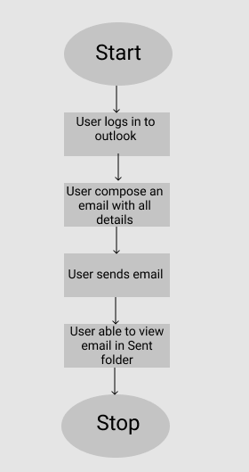

## Scenario 2 - Send an email with attachments

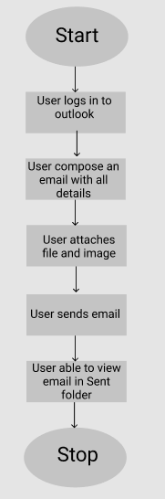

## Scenario 3 - Save the email as draft while composing

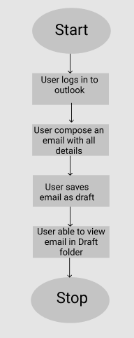

## Scenario 4 - Delete email while composing

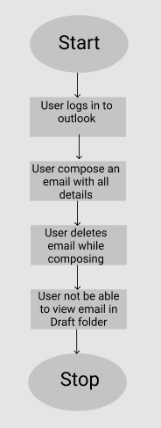

## Scenario 5 - Delete the email without composing

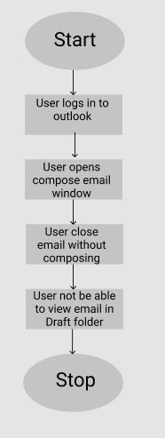

## Scenario 6 - Error while sending an email without recipient address

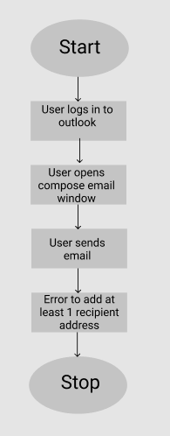

## Scenario 7 - Error while sending an email with an incorrect recipient address

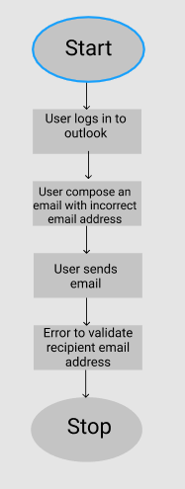

## Scenario 8 - Warning before sending an email without subject

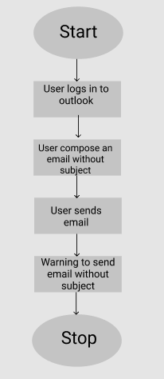

## Scenario 9 - Send email with empty body

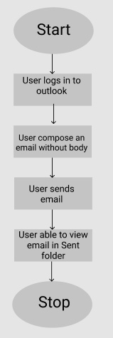

## Scenario 10 - Warning while sending an email with attachment/attach text in email body

