# User Flows for use case - Create an event in outlook calendar

## Scenario 1 - Create an online event

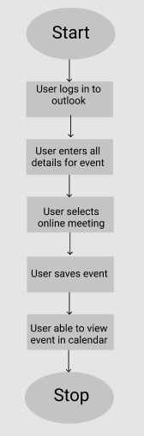

## Scenario 2 - Create a recurring online event

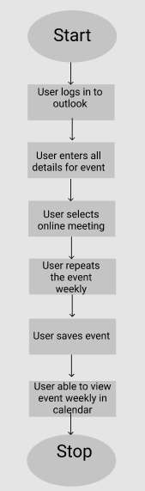

## Scenario 3 - Create all day event

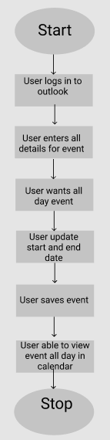

## Scenario 4 - Create a private event without response options

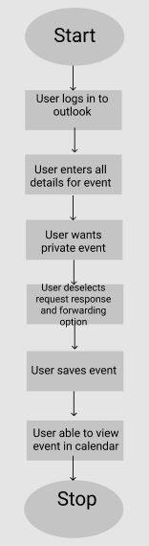

## Scenario 5 - Discard an online event while composing

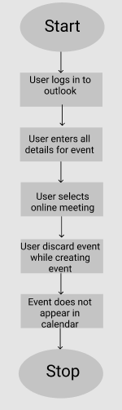

## Scenario 6 - Delete the event without editing

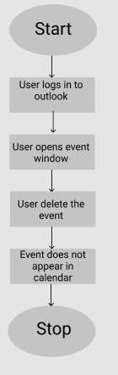

## Scenario 7 - Warning on over lapping event

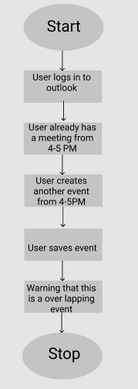

## Scenario 8 - Error on blank event creation

