# User Flows for use case - Add a contact in outlook

## Scenario 1 - Add a contact with all details

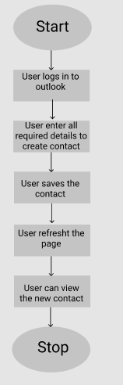

## Scenario 2 - Add a contact

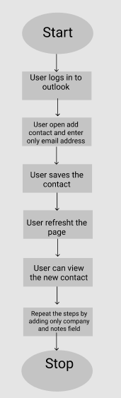

## Scenario 3 - Add a duplicate contact

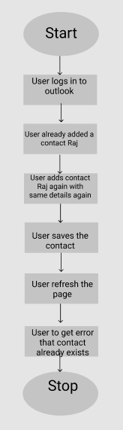

## Scenario 4 - Contact should not be created with only one detail

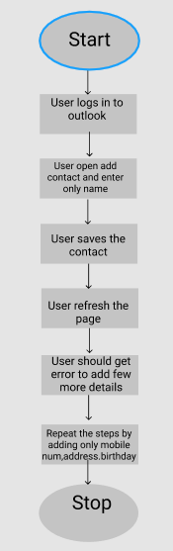

## Scenario 5 - Discard the contact while adding

