Mini Project

Part 1

1. Create a simple database on EC2 which will contain a shipment table, a customer table as well as an item table.

**Shipment table:**

create table SHIPMENT (

SHIPMENTID VARCHAR(50),

SHIPMENTDATE VARCHAR(10),

CUSTOMERID VARCHAR(50),

ITEMID VARCHAR(50),

QUANTITY INT,

FOREIGN KEY fk_shipmentitemid(ITEMID) REFERENCES ITEMS(ITEMID),

FOREIGN KEY fk_shipmentcustid (CUSTOMERID) REFERENCES CUSTOMER(CUSTID)

);

**Customer table:**

create table CUSTOMER (

CUSTID VARCHAR(50),

NAME VARCHAR(50),

STREET VARCHAR(50),

CITY VARCHAR(50),

STATE VARCHAR(50),

ZIPCODE VARCHAR(50),

TELEPHONE VARCHAR(50),

AVAILABLE_CREDIT INT(10),

PRIMARY KEY(CUSTID)

);

**Items table:**

create table ITEMS (

ITEMID VARCHAR(50),

ITEMNAME VARCHAR(50),

PRICE INT(10),

PRIMARY KEY(ITEMID)

);

1. Populate all tables with some sample data. You can use Mockaroo.com to generate data if you like. I have posted a tutorial on this.

I used mockaroo.com to generate the data. I am attaching the sql scripts generated by mockaroo.

1. Write a couple of Web pages which use AJAX. One should allow the user to lookup all the orders for a customer. The other should list all items.

Please find the attachments for the html and php pages.

1. Submit your code as well as your schema for this part. Please note that all of this should be run in the Cloud on EC2.

**Screen shot of the queryItems.html on EC2:**

ec2-54-152-46-140.compute-1.amazonaws.com/queryItems.html

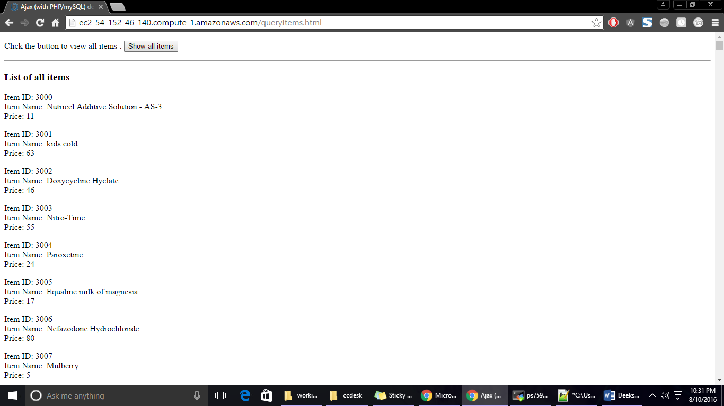

**Screen shot of the queryOrders.html running on EC2:**

ec2-54-152-46-140.compute-1.amazonaws.com/queryOrders.html

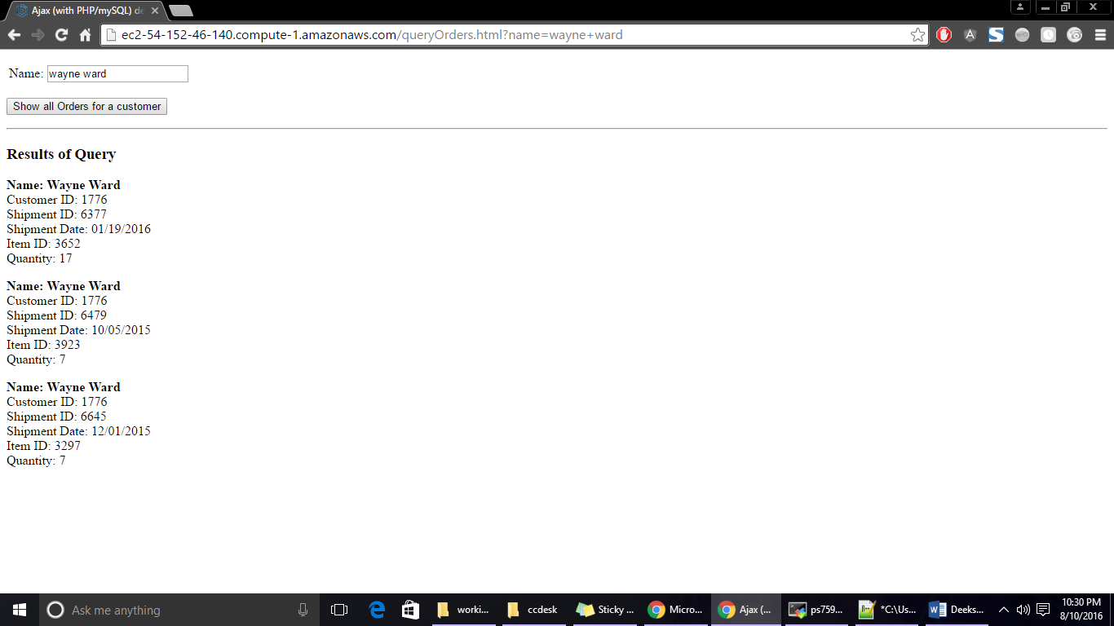

**Schema for customer, items and shipment table:**

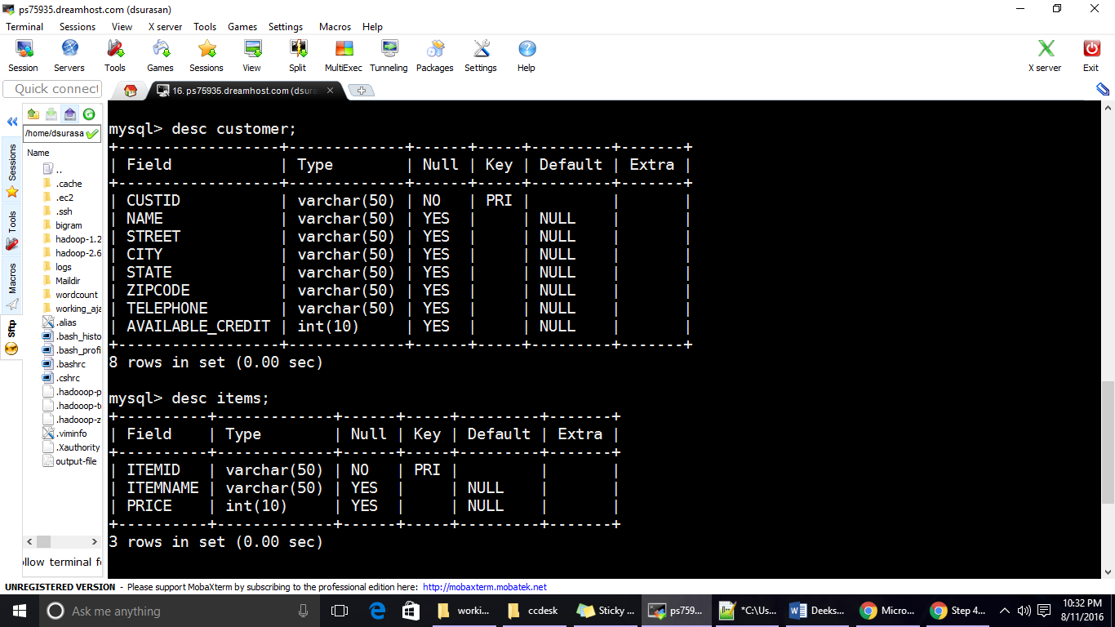

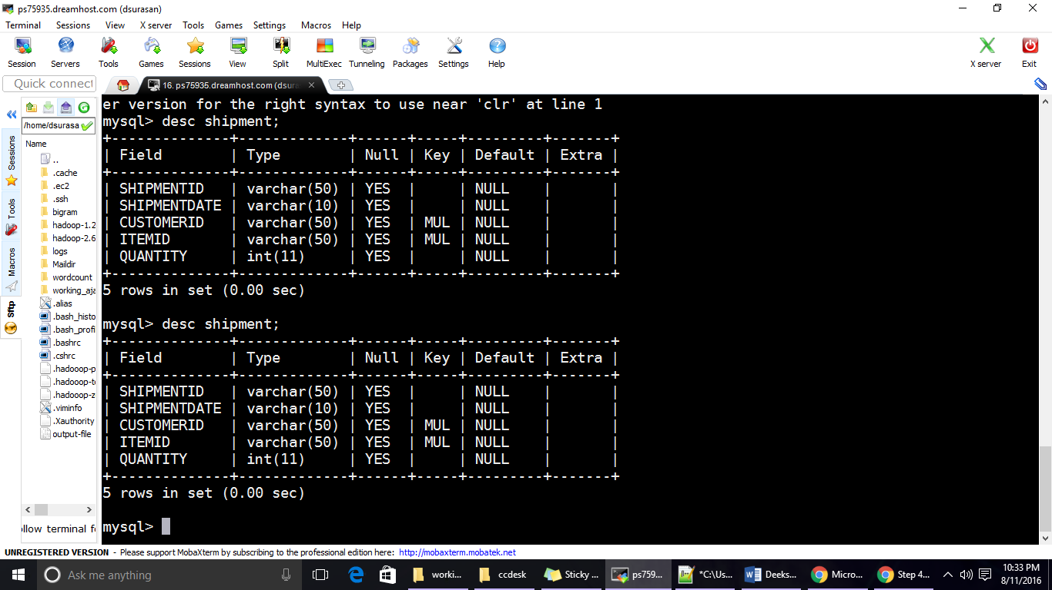

**Screen shot of the running EC2 instance:**

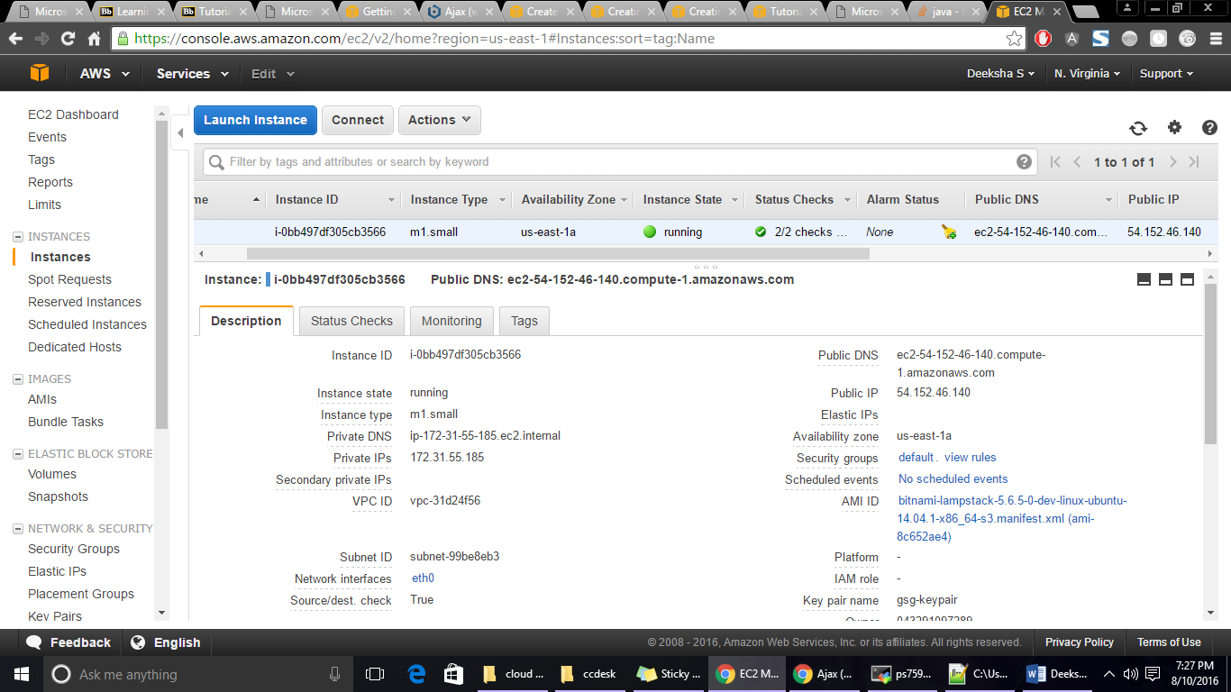

Part 2

1. Partition the application so that the application itself is on one instance and the database resides on a database instance.

**Screen shot of RDS MySQL server instance**

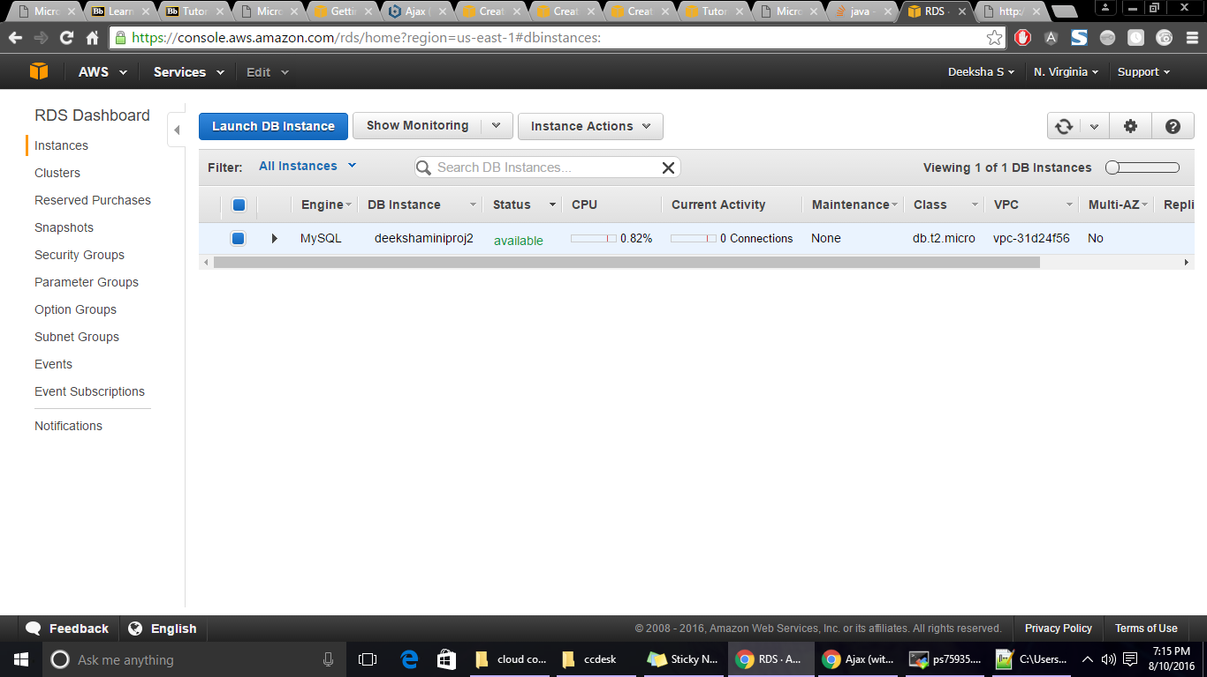

1. (Extra Credit) Use AWS Elastic Load Balancer to place a load balancer in front of your application

I created a load balancer and named it **my-ajax-lb.**

DNS name: my-ajax-lb-595936574.us-east-1.elb.amazonaws.com

**Using Elastic Load balancer:**

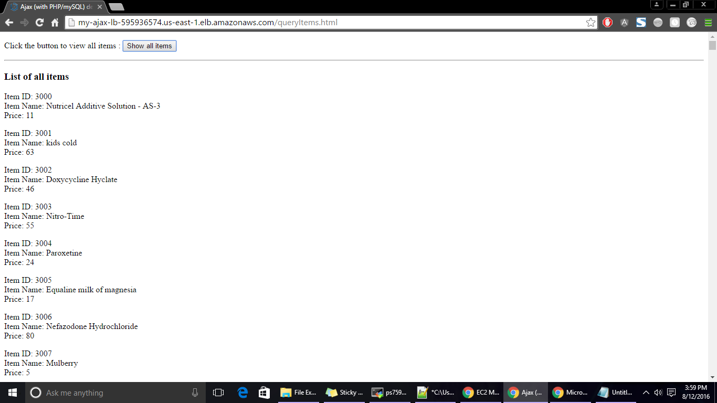

1. Submit screenshots of running instances

**Screen shots of Load balancer instance:**

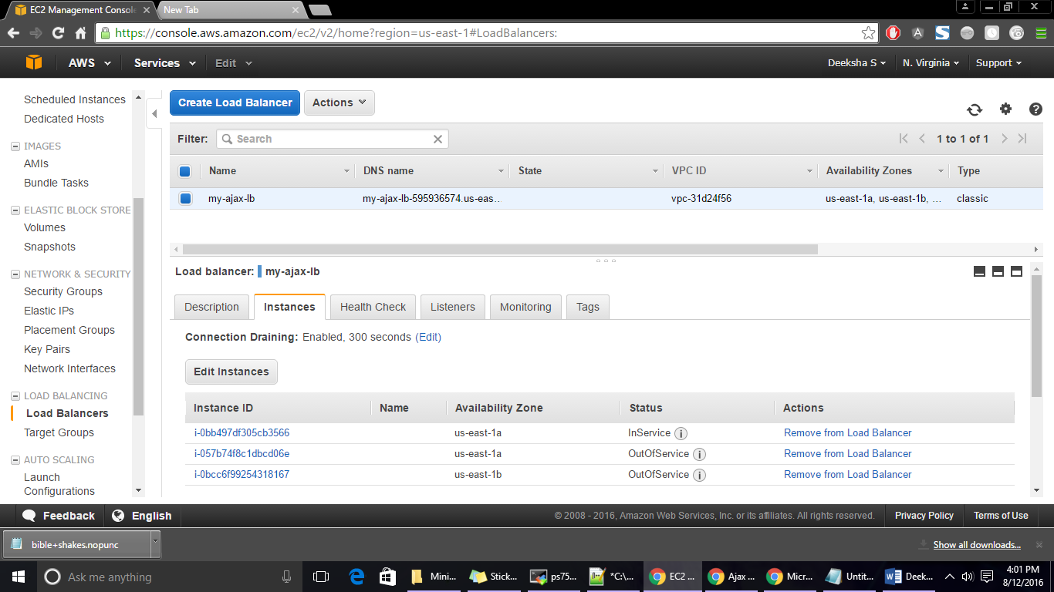

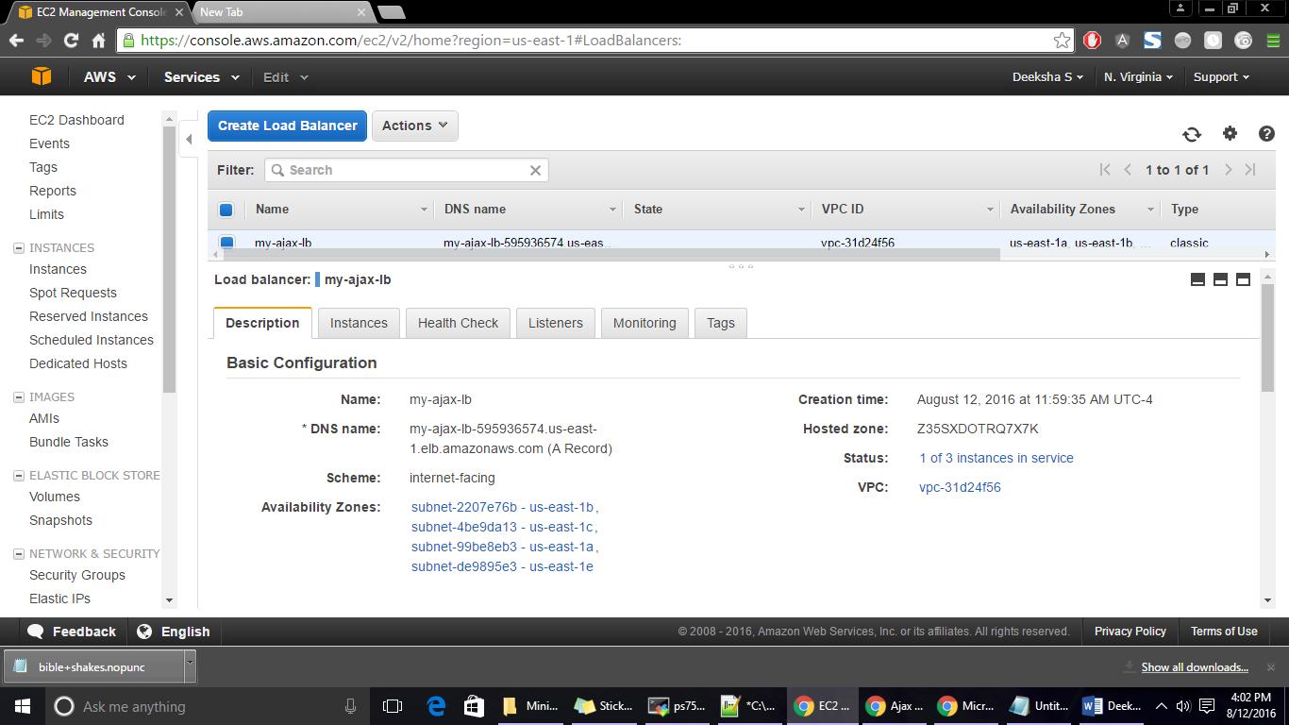

**Screen shot of RDS MySQL server instance**



**Screen shot of the running EC2 instance:**

