Practical: 03 SEPTEMBER 31, 2026

Problem Statement- 1: Implementation of DML commands of SQL with suitable examples
a) Insert
b) Update
c) Delete

Solution:
_____________________________________________________________________

CREATE TABLE Students (
Roll_No VARCHAR(10),
Name VARCHAR(50),
Branch VARCHAR(20),
Age INT,
City VARCHAR(50)
);
a)Inserting Initial Sample Records
INSERT INTO Students (Roll_No, Name, Age, City) VALUES ('CS001', 'ABHIRAM', 22, 'ALLAHABAD');
INSERT INTO Students (Roll_No, Name, Age, City) VALUES ('CS002', 'ALKA', 20, 'GHAZIABAD');
INSERT INTO Students (Roll_No, Name, Age, City) VALUES ('CS003', 'DISHA', 21, 'VARANASI');
INSERT INTO Students (Roll_No, Name, Age, City) VALUES ('CS004', 'ESHA', 21, 'DELHI');
INSERT INTO Students (Roll_No, Name, Age, City) VALUES ('CS005', 'MANMEET', 23, 'JALANDHAR');
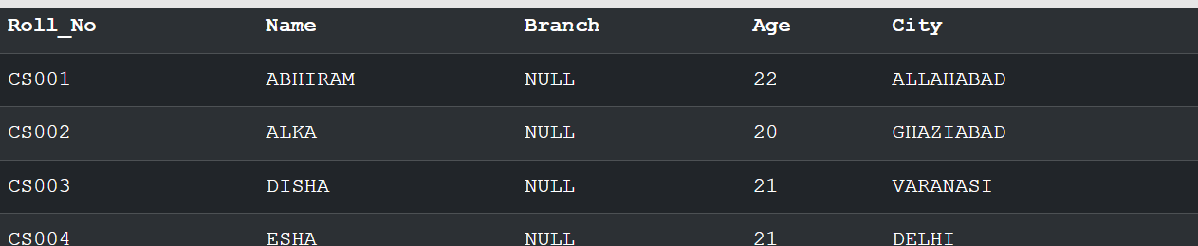

b)Inserting Data into Specified Columns Only

INSERT INTO Students (Name, City) VALUES ('Ram', 'Agra');

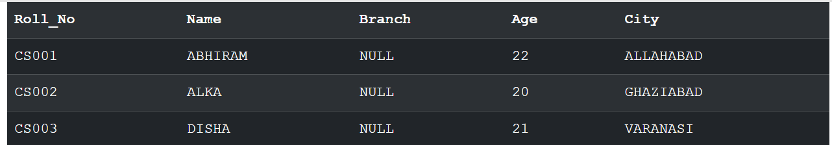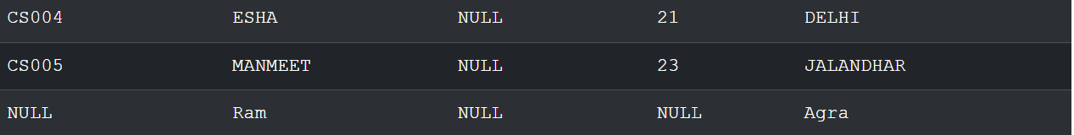

B) UPDATE Command Implementation
a. Modifying a Specific Record Using WHERE
Corrected query (fixing the OCR/typo in the lab sheet):

UPDATE Students
SET Name = 'Rahul', City = 'Agra'
WHERE Roll_No = 'CS001';

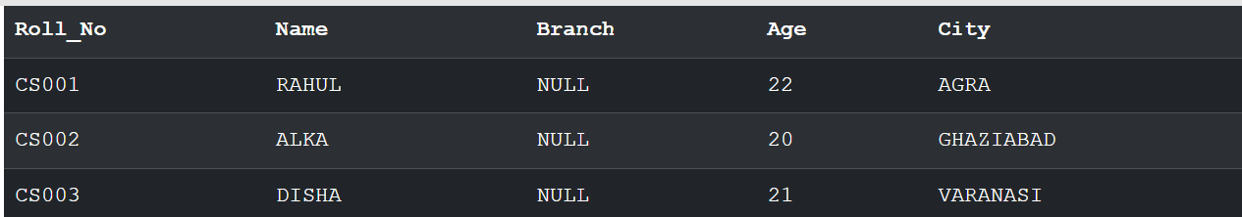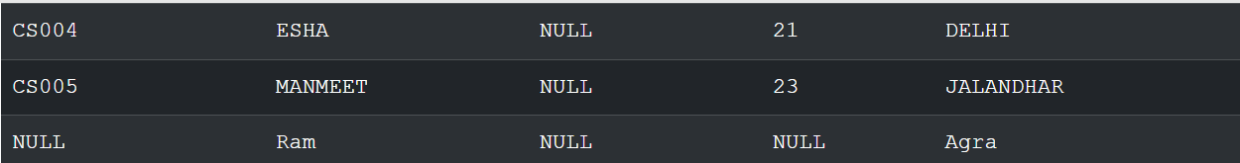

b. Updating All Records for a Particular Column
UPDATE Students
SET City = 'Gwalior';
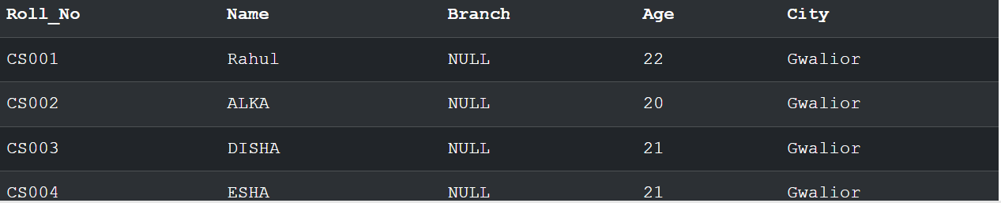

C) DELETE Command Implementation

- Deleting a Specific Record
DELETE FROM Students
WHERE Roll_No = 'CS001';
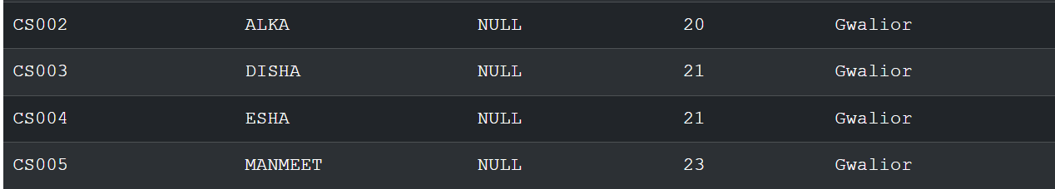

- Deleting All Records from the Table
DELETE FROM Students;

(no result to output)

_____________________________________

