SRINIVAS UNIVERSITY

INSTITUTE OF ENGINEERING & TECHNOLOGY

(SUBJECT : ADVANCED MACHINE LEARNING) (SUBJECT CODE : 24SAL051)
A INDIVIDUAL TASK REPORT ON

“STUDENT PERFORMANCE PREDICTION USING MACHINE LEARNING”
Submitted in the partial fulfilment of the requirements for the fifth semester

BACHELOR OF TECHNOLOGY IN AIML
Submitted by DEEKSHITH 01SU24AI024

UNDER THE GUIDENCE OF
Prof . Mahesh Kumar V B Department of AIML
SRINIVAS UNIVERSITY INSTITUTE OF ENGINEERING & TECHNOLOGY MUKKA, MANGALURU-574146

2026

SRINIVAS UNIVERSITY
INSTITUTE OF ENGINEERING AND TECHNOLOGY
MUKKA, MANGALURU-574146
Department of Artificial Intelligence and Machine Learning

CERTIFICATE

This is to certify that, Mr. Deekshith (01SU24AI024) has satisfactorily completed the assessment (Report) in Advanced Machine Learning (24SAL051) prescribed by the Srinivas University for the 5th semester B. Tech course during the year 2026.

MARKS AWAREDED

Staff In charge
Name: Prof . Mahesh Kumar V B Assistant Professor, Department of AIML Date: 11/09/2026

TABLE OF CONTENTS

No. | Section | Page
1. | Introduction | 5
2. | Problem Statement, Objectives and Scope | 6
3. | Dataset and Data Understanding | 7
4. | System Requirements and Development Environment | 9
5. | Methodology and System Architecture | 10
6. | Machine Learning Models | 11
7. | Implementation and Experimental Procedure | 12
8. | Results and Model Comparison | 13
9. | Discussion, Limitations and Applications | 16
10. | Conclusion, Future Scope and References | 18

ABSTRACT
House price prediction is an important application of machine learning that can help in analyzing property characteristics and identifying patterns associated with residential property prices. Traditional methods of estimating house prices may depend heavily on manual comparison and individual judgment. Machine learning provides a systematic approach by learning patterns from historical housing data and using those patterns to classify properties according to their price category. This project focuses on developing a machine learning-based classification system for predicting whether a house belongs to a Low Price or High Price category.
The project uses the Housing dataset, which contains information about residential properties and their characteristics. The dataset includes attributes such as area, number of bedrooms, number of bathrooms, number of stories, parking availability, main road access, guest room, basement, hot water heating, air conditioning, preferred area, furnishing status, and house price. The original price attribute is used to create a binary classification target. Houses with prices greater than the median house price are classified as High Price, while houses with prices less than or equal to the median are classified as Low Price. This transformation converts the original price prediction problem into a binary classification problem suitable for supervised machine learning.
Before applying the machine learning algorithms, the dataset is examined and preprocessed to make it suitable for model training. Numerical features are standardized using StandardScaler, while categorical features are converted into numerical representations using One-Hot Encoding. The prepared dataset is divided into training and testing sets using an 80:20 stratified split. The training data is used to develop the classification models, while the testing data is used to evaluate their performance on previously unseen house records.
Three supervised machine learning algorithms are implemented and compared in this project: Logistic Regression, Decision Tree Classifier, and Gaussian Naive Bayes. Logistic Regression is used as a probability-based approach for binary classification. Decision Tree Classifier makes predictions using a sequence of decision rules based on the input features and provides an interpretable tree structure. Gaussian Naive Bayes uses a probabilistic approach based on Bayes' theorem and the assumption of conditional independence between features. Using different classification techniques allows their performance to be compared under the same experimental conditions.
The performance of the three models is evaluated using Accuracy, Precision, Recall, F1-score, and Confusion Matrix. Accuracy provides the overall proportion of correctly classified houses, while Precision measures the correctness of the predicted positive class. Recall measures the ability of the model to correctly identify houses belonging to the target class, and the F1-score provides a balance between Precision and Recall. Confusion matrices are also used to examine the correctly and incorrectly classified Low Price and High Price houses.
The experimental results show that Logistic Regression achieved the highest overall accuracy of 83.49%, with Precision, Recall, and F1-score of 83.33%. Gaussian Naive Bayes achieved an accuracy of 80.73%, while Decision Tree Classifier achieved 79.82% accuracy. Based on the overall comparison of the evaluation metrics, Logistic Regression was identified as the best-performing model for the selected house price classification task.

.

INTRODUCTION

House price prediction is an important application of machine learning that can help in understanding the factors associated with residential property prices. House prices are influenced by several characteristics such as the size of the property, number of bedrooms and bathrooms, number of stories, parking availability, location-related facilities, and other amenities. Analyzing these factors manually can be difficult when a large number of property records are involved. Machine learning provides a systematic approach to identify patterns in historical housing data and use those patterns to make predictions.
This project focuses on developing a machine learning classification system for predicting whether a house belongs to a Low Price or High Price category. Instead of predicting the exact price of a house, the original price values are converted into two categories using the median house price as the threshold. This makes the problem a binary classification task and allows different classification algorithms to be compared based on their ability to distinguish between the two price categories.
The project uses the Housing dataset containing information about 545 residential properties. The dataset includes attributes such as area, bedrooms, bathrooms, stories, main road access, guest room, basement, hot water heating, air conditioning, parking, preferred area, and furnishing status. These features provide information about the physical characteristics and facilities of each property and are used as inputs for the machine learning models. The original price attribute is used to create the target variable, while the price itself is excluded from the input features to avoid directly providing the answer to the model.
Three supervised machine learning algorithms are implemented in this project: Logistic Regression, Decision Tree Classifier, and Gaussian Naive Bayes. Logistic Regression is used for binary classification by estimating the probability of a house belonging to the High Price category. The Decision Tree Classifier makes predictions through a series of feature-based decision rules and provides an interpretable tree structure. Gaussian Naive Bayes uses a probabilistic approach based on Bayes' theorem to classify the properties according to their price category.
Before applying the algorithms, the housing data is preprocessed to make it suitable for machine learning. Numerical features are standardized using feature scaling, while categorical features are converted into numerical representations using one-hot encoding. The processed dataset is divided into training and testing sets using an 80:20 stratified split. The training data is used to build the models, while the testing data is used to evaluate their performance on unseen property records.
The performance of the three models is compared using Accuracy, Precision, Recall, F1-score, and Confusion Matrix. These evaluation metrics provide a detailed understanding of how effectively each algorithm classifies houses into Low Price and High Price categories. The comparison helps identify the algorithm that provides the most suitable overall performance for the given housing dataset.
Overall, this project demonstrates the application of supervised machine learning to housing data through data preprocessing, feature transformation, model training, prediction, evaluation, and comparison. It provides a practical approach for categorizing residential properties based on their price levels and illustrates how machine learning can support data-driven analysis in the real estate domain.

PROBLEM STATEMENT, OBJECTIVES AND SCOPE
2.1 Problem Statement
House prices are influenced by multiple factors such as property area, number of bedrooms and bathrooms, number of stories, parking facilities, location-related features, and available amenities. When a large number of housing records are involved, manually analyzing these factors and determining the price category of a property can be difficult and time-consuming.
The problem addressed in this project is to develop a machine learning classification system that predicts whether a house belongs to a Low Price or High Price category based on its available property characteristics. The Housing dataset is used for this purpose, and the original house price is converted into a binary target using the median price as the threshold. Houses with prices greater than the median are classified as High Price, while the remaining houses are classified as Low Price.
Three machine learning algorithms—Logistic Regression, Decision Tree Classifier, and Gaussian Naive Bayes—are applied to the prepared dataset. Their performance is then evaluated and compared using suitable classification metrics to determine the most effective model for the house price classification task.
2.2 Objectives
The main objectives of the project are:
- To analyze the Housing dataset and understand the available property-related attributes.
- To preprocess the housing data and prepare it for machine learning classification.
- To convert the original house price into Low Price and High Price categories using the median price.
- To apply Logistic Regression for house price classification.
- To implement a Decision Tree Classifier for predicting house price categories.
- To implement Gaussian Naive Bayes for house price classification.
- To evaluate the models using Accuracy, Precision, Recall, F1-score, and Confusion Matrix.
- To compare the performance of the three machine learning algorithms.
- To identify the best-performing algorithm for classifying houses into Low Price and High Price categories.
2.3 Scope
The scope of this project is limited to the classification of residential properties into two categories: Low Price and High Price. The project uses the Housing dataset and considers property characteristics such as area, bedrooms, bathrooms, stories, parking, facilities, preferred area, and furnishing status as input features.
The project covers data understanding, preprocessing, categorical feature encoding, feature scaling, target creation, train-test splitting, model training, prediction, evaluation, visualization, and comparison of three machine learning classification algorithms.
The system is intended primarily as an academic machine learning project demonstrating the application of classification techniques to housing data. It focuses on identifying the price category of a property rather than predicting its exact market price. The results can be used as analytical information for understanding patterns in housing data and comparing the effectiveness of different classification algorithms.

DATASET AND DATA UNDERSTANDING

3.1 Dataset Description
The dataset used in this project is the Housing dataset, which contains information about residential properties and their prices. The dataset consists of 545 records and 13 attributes. These attributes describe different characteristics and facilities of the houses, which can be used to analyze the factors associated with house prices.
The main objective of using this dataset is to classify houses into two categories, Low Price and High Price, based on their original price. The price column is used to create the target variable, while the remaining property-related attributes are used as input features.
Dataset Summary
Property | Value
Dataset | Housing.csv
Number of Records | 545
Number of Original Attributes | 13
Input Features | 11
Original Target | price
Classification Target | high_price
Task | Binary Classification
Median Price | 4,340,000
3.2 Dataset Variables
Variable | Type | Description
price | Numerical | Original price of the house
area | Numerical | Area of the property
bedrooms | Numerical | Number of bedrooms
bathrooms | Numerical | Number of bathrooms
stories | Numerical | Number of stories
mainroad | Categorical | Whether the property has main road access
guestroom | Categorical | Availability of a guest room
basement | Categorical | Availability of a basement
hotwaterheating | Categorical | Availability of hot water heating
airconditioning | Categorical | Availability of air conditioning
parking | Numerical | Number of parking spaces
prefarea | Categorical | Whether the property is located in a preferred area
furnishingstatus | Categorical | Furnishing condition of the property

3.3 Target Variable Creation
The original price attribute represents the actual house price. For this project, the exact price is converted into a binary classification target called high_price.
The median price of the dataset is 4,340,000. Houses with a price greater than the median are classified as High Price, represented by 1. Houses with a price less than or equal to the median are classified as Low Price, represented by 0.
Target Distribution
Class | Label | Number of Houses
Low Price | 0 | 275
High Price | 1 | 270
Total | — | 545
The target classes are relatively balanced, with 275 Low Price houses and 270 High Price houses. This balanced distribution provides a suitable basis for training and comparing the classification models.
This binary classification approach provides a clear and balanced way to predict whether a house belongs to the Low Price or High Price category. Since the median price is used as the threshold, the dataset is divided into two approximately equal classes, reducing the possibility of severe class imbalance. The newly created high_price variable is therefore used as the target variable for applying and comparing the selected machine learning classification algorithms.
The high_price target variable enables the machine learning models to learn the relationship between the characteristics of a property and its price category. Features such as area, number of bedrooms and bathrooms, stories, parking availability, and various house facilities are provided as input to the models. Based on these features, the models attempt to determine whether a given house is likely to fall into the Low Price or High Price category. This transformation makes the dataset suitable for evaluating classification algorithms and comparing their predictive performance.

.

SYSTEM REQUIREMENTS AND DEVELOPMENT ENVIRONMENT
4.1 Hardware Requirements
The project can be implemented on a standard computer because the Housing dataset contains only 545 records and the selected machine learning algorithms are computationally simple.
Component | Requirement
Processor | Intel Core i3 or equivalent
RAM | 4 GB or above
Storage | 1 GB free space
Internet | Required for package installation
No dedicated GPU is required for this project.
4.2 Software Requirements
The project is developed using Python in the Jupyter Notebook environment. The main software libraries used are:
Software / Library | Purpose
Python | Programming and implementation
Jupyter Notebook | Development and execution
Pandas | Data handling and preprocessing
NumPy | Numerical operations
Scikit-learn | Preprocessing, ML models, and evaluation
Matplotlib | Visualization
Scikit-learn is used for StandardScaler, OneHotEncoder, ColumnTransformer, Pipeline, train-test splitting, and implementation of Logistic Regression, Decision Tree Classifier, and Gaussian Naive Bayes.
4.3 Development Environment
The complete machine learning workflow is carried out in Jupyter Notebook. The Housing dataset is first loaded and processed using Pandas. Numerical features are standardized using StandardScaler, while categorical features are converted into numerical form using One-Hot Encoding.
The processed data is divided into training and testing sets using an 80:20 stratified split. The three classification algorithms—Logistic Regression, Decision Tree Classifier, and Gaussian Naive Bayes—are trained using the training data and evaluated using the testing data.
Accuracy, Precision, Recall, and F1-score are used to compare the performance of the models. Matplotlib is used for visualizing the results and model-related outputs.

METHODOLOGY AND SYSTEM ARCHITECTURE
5.1 Methodology
The methodology of the House Price Classification project consists of a sequence of steps used to prepare the Housing dataset, train machine learning models, and compare their performance. The process begins with loading and understanding the dataset, followed by target creation, preprocessing, model training, prediction, and evaluation.
First, the Housing dataset containing 545 records is loaded and examined. The median house price is calculated and used to create the high_price target variable. Houses with prices greater than the median are classified as High Price, while the remaining houses are classified as Low Price.
The input features are divided into numerical and categorical features. Numerical features are standardized using StandardScaler, while categorical features are converted into numerical form using One-Hot Encoding. The processed dataset is then divided into training and testing sets using an 80:20 stratified split.
Three classification algorithms are trained:
- Logistic Regression
- Decision Tree Classifier
- Gaussian Naive Bayes
The trained models are used to predict the price category of houses in the testing dataset. Their performance is evaluated using Accuracy, Precision, Recall, and F1-score. The results of all three models are compared to identify the best-performing algorithm.
Data Preprocessing
→ Numerical Features → StandardScaler
→ Categorical Features → One-Hot Encoding
The same training and testing data are used for all three algorithms to ensure a fair comparison. This methodology provides a systematic approach for classifying houses into Low Price and High Price categories and evaluating the effectiveness of different machine learning techniques
To improve the reliability of the machine learning workflow, preprocessing and model training are organized using a Pipeline and ColumnTransformer. This ensures that the same preprocessing steps are consistently applied to both training and testing data and helps prevent data leakage. The categorical variables are encoded without assigning any artificial numerical relationship between their categories, while numerical variables are scaled to a suitable range for algorithms that are sensitive to feature magnitude.
After training, the predictions generated by each model are analyzed using the selected evaluation metrics. A comparison of Accuracy, Precision, Recall, and F1-score helps determine how effectively each algorithm identifies High Price and Low Price houses. The model with the most suitable overall performance is selected as the best-performing model for the given classification task.
.

MACHINE LEARNING MODELS

6.1 Decision Tree Classifier
Decision Tree is a supervised machine learning algorithm that makes predictions using a sequence of decision rules based on the input features. In this project, it is used to classify houses into Low Price and High Price categories.
The tree selects important features and creates branches based on conditions. In the generated tree, features such as area, furnishing status, air conditioning, main road access, preferred area, bedrooms, bathrooms, stories, and parking are used for making decisions. Each branch represents a condition, and the final leaf node gives the predicted price category.

The Decision Tree provides an interpretable representation of how different property characteristics contribute to the classification of house prices.
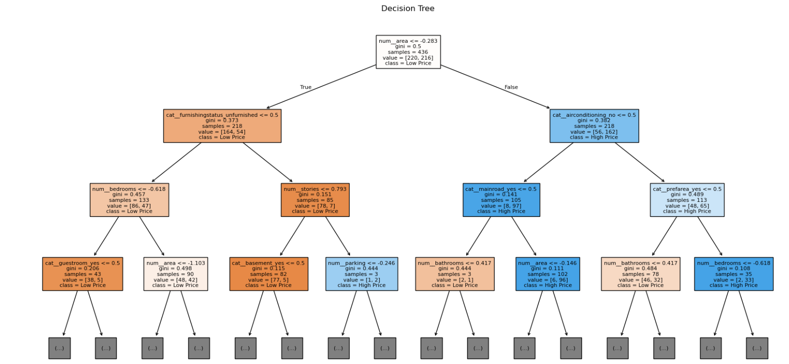

Decision Tree Classifier for House Price Classification

IMPLEMENTATION AND EXPERIMENTAL PROCEDURE
7.1 Implementation
The House Price Classification system is implemented using Python and Jupyter Notebook. The Housing dataset is first loaded using Pandas and examined to understand its structure and attributes. The original house price is used to create a binary target variable named high_price.
The median house price is calculated as 4,340,000. Houses with prices greater than the median are labelled as High Price (1), while the remaining houses are labelled as Low Price (0). The original price column is then removed from the input features.
The numerical features are standardized using StandardScaler, while categorical features are converted into numerical form using One-Hot Encoding. The processed dataset is divided into training and testing sets using an 80:20 stratified split, resulting in 436 training records and 109 testing records.
Three machine learning algorithms are implemented:
- Logistic Regression
- Decision Tree Classifier
- Gaussian Naive Bayes
Each model is trained using the same training dataset and then used to predict the price category of the testing records.
7.2 Experimental Procedure
The experiment follows a systematic procedure to ensure that all three models are evaluated under the same conditions.
- Load the Housing.csv dataset.
- Examine the dataset and identify numerical and categorical features.
- Calculate the median house price.
- Create the high_price target variable.
- Remove the original price column from the input features.
- Apply One-Hot Encoding to categorical features.
- Apply StandardScaler to numerical features.
- Split the data into 80% training and 20% testing sets using stratification.
- Train Logistic Regression, Decision Tree, and Gaussian Naive Bayes models.
- Generate predictions using the testing dataset.
- Evaluate each model using Accuracy, Precision, Recall, and F1-score.
- Compare the results and identify the best-performing model.
The same dataset split and evaluation metrics are used for all three algorithms to provide a consistent and fair comparison. The experimental results are then presented using tables and visualizations to clearly show the differences in model performance.

RESULTS AND MODEL COMPARISON
8.1 Model Performance
The three machine learning models were evaluated using Accuracy, Precision, Recall, and F1-score. The same testing dataset was used for all models to ensure a fair comparison.
Table 8.1 Model Performance Comparison
Model | Accuracy | Precision | Recall | F1-Score
Logistic Regression | 83.49% | 83.33% | 83.33% | 83.33%
Naive Bayes | 80.73% | 77.97% | 85.19% | 81.42%
Decision Tree | 79.82% | 84.78% | 72.22% | 78.00%
The results show that Logistic Regression achieved the highest overall accuracy of 83.49% and the highest F1-score of 83.33%. Naive Bayes achieved an accuracy of 80.73% and had the highest recall of 85.19%, indicating that it identified a larger proportion of High Price houses correctly. Decision Tree achieved an accuracy of 79.82% and the highest precision of 84.78%, but its recall was lower at 72.22%.
Figure 8.1: Comparison of Three Machine Learning Algorithms
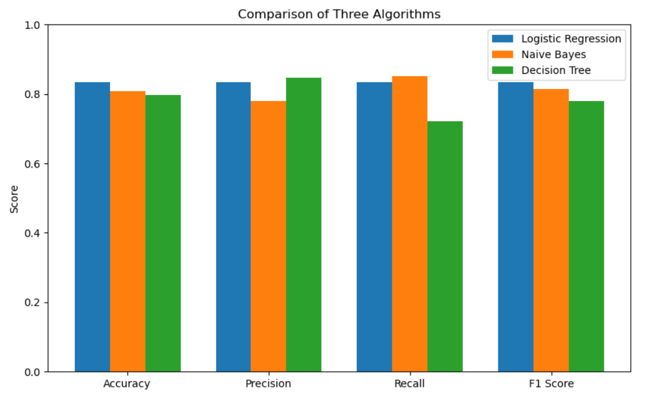 The comparison graph clearly shows the differences between the three algorithms across Accuracy, Precision, Recall, and F1-score. Logistic Regression provides the most balanced performance across all four metrics.

8.2 Naive Bayes Confusion Matrix
A confusion matrix is used to understand the classification results in more detail. The Naive Bayes confusion matrix shows the number of Low Price and High Price houses that were correctly and incorrectly classified.

Figure 8.2: Naive Bayes Confusion Matrix
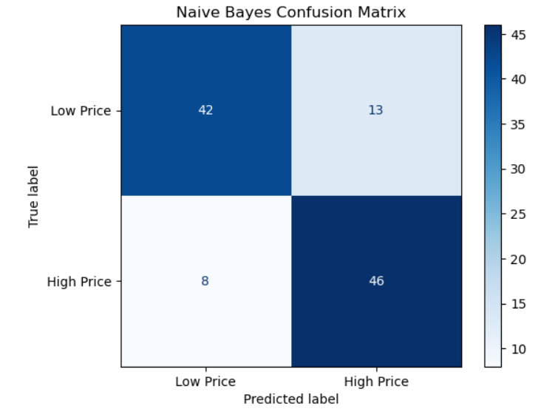 The confusion matrix contains the following results:
- 42 Low Price houses were correctly predicted as Low Price.
- 13 Low Price houses were incorrectly predicted as High Price.
- 8 High Price houses were incorrectly predicted as Low Price.
- 46 High Price houses were correctly predicted as High Price.
Therefore, Naive Bayes correctly classified 88 out of 109 test records. The matrix also shows that the model achieved a relatively high recall for the High Price class.
8.3 Comparison of Models
Logistic Regression performed best overall because it achieved the highest accuracy and F1-score among the three models. Its precision and recall were also well balanced, making it suitable for the given classification task.
Naive Bayes performed well in terms of recall and was able to correctly identify a high proportion of High Price houses. However, its precision and overall accuracy were lower than Logistic Regression.
Decision Tree achieved the highest precision but had considerably lower recall. This means that although its

DISCUSSION, LIMITATIONS AND APPLICATIONS
The experimental results show that machine learning can be effectively used to classify houses into Low Price and High Price categories based on their property characteristics. In this project, three supervised learning algorithms, namely Logistic Regression, Decision Tree Classifier, and Gaussian Naive Bayes, were trained and evaluated using the same training and testing data.
Logistic Regression achieved the highest overall accuracy of 83.49% and an F1-score of 83.33%. It also achieved a precision and recall of 83.33%, showing a good balance between correctly identifying High Price houses and avoiding incorrect classifications. This balanced performance makes Logistic Regression the most suitable model among the three tested algorithms.
Gaussian Naive Bayes achieved an accuracy of 80.73% and an F1-score of 81.42%. Its recall was the highest among the three models at 85.19%. This indicates that Naive Bayes was effective at identifying a large proportion of the actual High Price properties. However, its precision was lower at 77.97%, meaning that some properties predicted as High Price actually belonged to the Low Price category.
The Decision Tree Classifier achieved an accuracy of 79.82% and an F1-score of 78.00%. It obtained the highest precision of 84.78%, but its recall was only 72.22%. This indicates that although its High Price predictions were relatively precise, it failed to identify some properties that actually belonged to the High Price category. One advantage of the Decision Tree is its interpretability, as the decision-making process can be represented through a tree structure.
The comparison demonstrates the importance of using multiple evaluation metrics. Accuracy gives an overall measure of correct predictions, while precision and recall provide more detailed information about the classification performance. The F1-score combines precision and recall and is useful for identifying a model that provides a balanced performance.
Based on the overall results, Logistic Regression is selected as the best-performing model for the given House Price Classification task. It provides the highest accuracy and F1-score while maintaining balanced precision and recall.
9.2 Limitations
Although the developed system provides useful classification results, several limitations should be considered.
- Dataset Size: The Housing dataset contains only 545 property records. A larger dataset containing properties from different locations and markets could provide more reliable and generalizable results.
- Binary Target: The project classifies properties only into Low Price and High Price categories. It does not predict the exact price of a house or provide multiple price ranges.
- Feature Limitations: The prediction is based only on the features available in the dataset. Important factors such as exact geographical location, property age, nearby facilities, economic conditions, market demand, and current real estate trends are not included.
- Dataset Dependency: The performance of the models depends on the characteristics and quality of the available Housing dataset. The results may change when the models are applied to properties from another region or a different housing market.
- Limited Model Selection: Only Logistic Regression, Decision Tree, and Gaussian Naive Bayes are considered in this project. Other algorithms such as Random Forest, Support Vector Machine, or ensemble methods could produce different results.
- Single Train-Test Split: The models are evaluated using one 80:20 stratified train-test split. Using cross-validation or multiple experiments could provide a more robust estimate of model performance.
- Prediction Uncertainty: A machine learning classification represents an estimated category based on the available data. It cannot account for every factor that may influence the actual market value of a property.
9.3 Applications
The developed House Price Classification system can be used as an analytical tool for studying residential property data. By considering different property characteristics, the system can classify houses into Low Price and High Price categories and provide useful information for preliminary property analysis.
One possible application is in real estate analysis. Real estate professionals can use classification models to examine property characteristics and understand patterns associated with different price categories. The system can also assist in comparing properties based on their available facilities, size, structure, and other characteristics.
The system can be useful for property buyers as a preliminary decision-support tool. A buyer could provide information about a property and use the model to obtain an indication of whether the property falls into the Low Price or High Price category according to the patterns learned from the dataset.
Real estate companies can also use similar machine learning approaches for analyzing large collections of property records. Automated classification can help organize properties into different price groups and make the analysis of housing data faster.
The project can also be used for educational purposes to demonstrate the complete machine learning workflow, including data preprocessing, feature encoding, scaling, model training, prediction, evaluation, and comparison.
Potential applications include:
- Residential property classification
- Real estate data analysis
- Property comparison
- Preliminary price-category assessment
- Real estate decision-support systems
- Housing market analysis
- Academic demonstrations of machine learning
Overall, the project demonstrates that supervised machine learning can be applied to housing data to identify patterns and classify properties into different price categories. Among the tested algorithms, Logistic Regression provides the strongest overall performance for this dataset. However, the system should be considered an analytical support tool rather than a replacement for professional property valuation, particularly when making real-world financial decisions.

CONCLUSION AND FUTURE SCOPE
10.1 Conclusion
This project developed a machine learning-based system for classifying houses into Low Price and High Price categories using the Housing dataset. The dataset was preprocessed using feature scaling and one-hot encoding, followed by an 80:20 stratified train-test split.
Three classification algorithms were implemented: Logistic Regression, Decision Tree Classifier, and Gaussian Naive Bayes. Their performance was compared using Accuracy, Precision, Recall, and F1-score.
Logistic Regression achieved the best overall performance with 83.49% accuracy and an F1-score of 83.33%. Naive Bayes achieved 80.73% accuracy, while Decision Tree achieved 79.82%. Although Naive Bayes had the highest recall and Decision Tree had the highest precision, Logistic Regression provided the most balanced overall results.
The project demonstrates that machine learning can be effectively applied to housing data for price-category classification and model comparison.
10.2 Future Scope
The project can be further improved by:
- Using larger housing datasets from different locations to improve model generalization.
- Predicting the exact house price using regression algorithms.
- Adding features such as property age, location, nearby facilities, and market trends.
- Testing advanced algorithms such as Random Forest, SVM, and Gradient Boosting.
- Applying cross-validation and hyperparameter tuning for more reliable results.
- Developing a web application where users can enter property details and obtain a predicted price category.
- Incorporating updated housing-market data for more relevant predictions.
Future development can therefore transform the current academic model into a more comprehensive real-estate decision-support system.
REFERENCES
- Scikit-learn Developers, “Scikit-learn: Machine Learning in Python,” Scikit-learn Documentation. https://scikit-learn.org/
- Scikit-learn Developers, “DecisionTreeClassifier Documentation.” DecisionTreeClassifier Documentation
- Scikit-learn Developers, “OneHotEncoder Documentation.” OneHotEncoder Documentation
- Scikit-learn Developers, “Model Selection and Evaluation.” Model Selection and Evaluation
- pandas Development Team, “pandas Documentation.” pandas Documentation
- Matplotlib Development Team, “Matplotlib Documentation.” Matplotlib Documentation

APPENDIX A – IMPLEMENTATION SUMMARY

The implementation of the House Price Classification project was carried out using Python and Jupyter Notebook. The main steps are summarized below.
A.1 Dataset Loading
The Housing.csv dataset was loaded using Pandas. It contains 545 records and 13 attributes related to residential properties.
A.2 Target Variable Creation
The median house price was calculated as ₹4,340,000. Houses priced above the median were classified as High Price (1), while the remaining houses were classified as Low Price (0).
A.3 Data Preprocessing
- Numerical features were standardized using StandardScaler.
- Categorical features were converted into numerical form using OneHotEncoder.
- A ColumnTransformer was used to apply the appropriate preprocessing to each feature type.
A.4 Model Training
Three classification algorithms were implemented:
- Logistic Regression
- Decision Tree Classifier
- Gaussian Naive Bayes
The dataset was divided into 80% training data and 20% testing data using stratified splitting.
A.5 Model Evaluation
The models were evaluated using:
- Accuracy
- Precision
- Recall
- F1-score
- Classification Report
- Confusion Matrix
A.6 Final Results
Model | Accuracy | Precision | Recall | F1-Score
Logistic Regression | 83.49% | 83.33% | 83.33% | 83.33%
Naive Bayes | 80.73% | 77.97% | 85.19% | 81.42%
Decision Tree | 79.82% | 84.78% | 72.22% | 78.00%
Logistic Regression achieved the best overall performance and was selected as the best-performing model for this classification task.

