SPOTIFY MUSIC RECOMMENDATION SYSTEM USING PREDICTIVE ANALYSIS
Course End Project report submitted in partial fulfillment of the Requirements for the Award of the Degree of

BACHELOR OF ENGINEERING

in
ARTIFICIAL INTELLIGENCE AND DATA SCIENCE Applied
Predictive Analytics (22ADE57N.PE2)

By
Gondela Durga Gnana Deekshitha 160124771009 Gundlapally Ananya 160124771011
Vemula Akshaya 160124771026

Under the Mentorship of

Mrs. V. Vasuki Rohini Devi

DEPARTMENT OF ARTIFICIAL INTELLIGENCE AND DATA SCIENCE
CHAITANYA BHARATHI INSTITUTE OF TECHNOLOGY
HYDERABAD – 500075

October 2026

CHAITANYA BHARATHI INSTITUTE OF TECHNOLOGY
(AUTONOMOUS)

DEPARTMENT OF ARTIFICIAL INTELLIGENCE AND DATA SCIENCE


CERTIFICATE

This is to certify that the course end project report entitled CUSTOMER CHURN PREDICTION USING PREDICTIVE ANALYTICS AND MACHINE LEARNING being
submitted by
Gondela Durga Gnana Deekshitha 160124771009 Gundlapally Ananya 160124771011
Vemula Akshaya 160124771026
in partial fulfillment for the award of the Degree of Bachelor of Engineering in Artificial Intelligence and Data Science to the CHAITANYA BHARATHI INSTITUTE OF TECHNOLOGY, HYDERABAD carried out under my mentorship and supervision during the year 2026-27. The results presented in this case study report have not been submitted to any other university or Institute for the award of any degree.

Mrs. V. Vasuki Rohini Devi Assistant Professor

TABLE OF CONTENTS

Section | Page
1. Introduction | 1
1.1 Overview | 1
1.2 Problem Statement | 1
1.3 Objectives | 1
1.4 Project Scope | 2
2. Dataset Description | 2
2.1 Dataset Overview | 2
2.2 Important Attributes | 2
2.3 Dataset Summary | 3
3. Tools and Technologies | 3
4. Methodology | 4
4.1 Data Preprocessing | 4
4.2 Feature Selection | 4
4.3 Feature Scaling | 5
4.4 Similarity Computation | 5
4.5 Recommendation Generation | 5
5. Recommendation Algorithm | 6
5.1 Content-Based Filtering | 6
5.2 Cosine Similarity | 6
5.3 User Preference Profile | 7
6. Evaluation Measures | 7
7. Implementation and Results | 8
7.1 Implementation Workflow | 8
7.2 Dataset Exploration | 8
7.3 Recommendation Results | 9
7.4 Score Analysis | 10
8. Graphical Results and Interpretation | 10
9. Applications, Limitations and Future Enhancements | 12
10. Conclusion | 13
References | 13

CHAPTER 1: INTRODUCTION

Overview
Music streaming platforms provide access to large collections of songs. As the number of available tracks grows, users may find it difficult to discover music that matches their interests. A recommendation system helps address this problem by analysing information about songs and suggesting tracks that are similar to a user's listening preferences.
This project develops a Spotify music recommendation system using audio features available in the supplied dataset. It applies content-based filtering and cosine similarity to identify tracks whose audio characteristics resemble the preference profile derived from a user's listening history.

Problem Statement
A music listener may have a history containing many tracks with different audio characteristics. Manually searching for similar songs is time-consuming and may not consistently produce relevant suggestions. The problem addressed in this project is to build a recommendation approach that uses measurable audio features and a user's previously listened tracks to generate a ranked list of potentially relevant songs.

Objectives
    - Inspect and understand the supplied Spotify listening-history dataset.
    - Clean the dataset by handling missing values and duplicate records.
    - Select relevant numerical audio features for measuring song similarity.
    - Standardize selected features so that they are on a comparable scale.
    - Generate song-to-song similarity using cosine similarity.
    - Build an average audio-feature preference profile for each user.
    - Recommend the top 10 tracks for each user and save the results to a CSV file.
    - Explore recommendation scores and visualize the dataset and generated results.

Project Scope
The project is an offline educational implementation using the supplied CSV dataset and Jupyter Notebook. It generates recommendations from the tracks and audio features present in the dataset. It does not connect to a live Spotify account, stream music, or use real-time listening events. The recommendation score represents feature-vector similarity, not a measured user satisfaction score.

CHAPTER 2: DATASET DESCRIPTION

Dataset Overview
The project uses the uploaded Spotify dataset, which contains 28,469 records and 22 columns before preprocessing. Each record represents a track occurrence associated with a user and playlist, along with Spotify audio-feature information. The data contains 250 distinct users, 21,454 distinct track names, 6,185 distinct artist names and 1,078 distinct playlists.

Important Attributes

Attribute | Description
user_id | Identifier associated with a listener/user.
artistname | Name of the artist performing the track.
trackname | Name of the music track.
playlistname | Playlist in which the track appears.
song_id / id | Track identifier fields in the supplied data.
danceability | Audio feature describing how suitable a track is for dancing.
energy | Perceptual measure of intensity and activity.
loudness | Overall loudness of the track, represented in decibels.
speechiness | Detects the presence of spoken words in a track.
acousticness | Confidence measure of whether the track is acoustic.
instrumentalness | Likelihood that a track contains no vocals.
liveness | Detects the presence of an audience in the recording.
valence | Musical positiveness conveyed by a track.
tempo | Estimated overall tempo in beats per minute.
key, mode, duration_ms, time_signature | Additional musical and track metadata.

Dataset Summary

Measure | Observed value
Original rows | 28,469
Original columns | 22
Unique users | 250
Unique track names | 21,454
Unique artists | 6,185
Unique playlists | 1,078
Missing values reported | 0

Duplicate rows reported | 0
There are no missing values and no duplicate rows in the original dataset. The number of unique track names is lower than the number of records because the same track can occur in different users' histories or playlists.

CHAPTER 3: TOOLS AND TECHNOLOGIES

Tool / Library | Purpose in the project
Python | Main programming language used for data processing and recommendation logic.
Jupyter Notebook | Interactive environment used to execute code and inspect outputs.
Pandas | Loading CSV files, data cleaning, filtering, grouping and result export.
NumPy | Numerical operations on feature vectors.
Scikit-learn | StandardScaler and cosine_similarity implementations.
Matplotlib | Creating charts for exploratory analysis and recommendation scores.
Seaborn | Creating the audio-feature correlation heatmap.

CHAPTER 4: METHODOLOGY

Data Preprocessing
The Spotify CSV file is loaded into a Pandas DataFrame. The implemented recommendation system inspects the first records, shape, column names, data types and missing-value counts. Duplicate rows are checked and removed using drop_duplicates(). The recorded output shows 28,469 rows before duplicate removal, zero duplicate rows and the same 28,469 rows after the operation.
Missing text values in artistname, trackname and playlistname are filled with the label “Unknown”. Missing numerical values in the selected audio and metadata columns are filled using the median of the corresponding column. Then removes analysis_url, uri and type from the working DataFrame.

Feature Selection
Nine numerical audio features are selected for the recommendation model. User identifiers and descriptive track fields are retained for grouping and displaying recommendations, but are not used as dimensions in the similarity calculation.

Selected feature | Role
danceability | Indicates how suitable a track is for dancing, based on musical elements such as tempo, rhythm stability, beat strength and regularity.
energy | Represents the intensity and activity of a track. High-energy tracks generally sound fast, loud and active, while low-energy tracks sound calmer.
loudness | Measures the overall loudness of a track in decibels (dB). It helps distinguish quieter recordings from louder ones.
speechiness | Indicates how much spoken-word content is present in a track. Higher values are more associated with speech, while lower values are more associated with music.
acousticness | Represents the confidence that a track is acoustic. Higher values indicate a greater likelihood of acoustic instrumentation.
instrumentalness | Estimates whether a track contains no vocals. Higher values indicate a greater likelihood that the track is instrumental.
liveness | Indicates the likelihood that a recording was performed live. Higher values suggest the presence of an audience or live-performance characteristics.
valence | Describes the musical positivity conveyed by a track. Higher values tend to sound more cheerful or happy, while lower values tend to sound more sad or subdued.
tempo | Represents the estimated overall speed of a track, measured in beats per minute (BPM).

Feature Scaling
StandardScaler is applied to the nine selected features. Standardization transforms each feature using its training-data mean and standard deviation. This reduces the influence of different numerical ranges when calculating vector similarity. In this recommendation system, the scaler is fitted on the full dataset because the workflow is an unsupervised recommendation experiment rather than a supervised train-test model.

Similarity Computation
The recommendation system uses cosine_similarity from scikit-learn to calculate pairwise similarity between the standardized song feature vectors. The resulting similarity matrix has dimensions 28,469 × 28,469. Each cell represents the cosine similarity between one track record and another track record.
Cosine similarity compares the orientation of two feature vectors. A score closer to 1 indicates that the vectors point in a similar direction. In this implementation, the scores are used to rank candidate songs by audio-feature resemblance.

Recommendation Generation
For an individual song, the recommend_songs() function finds the first matching track name, retrieves its similarity scores against all records, sorts the scores in descending order and returns the most similar records after excluding the selected row.
For a user, the recommend_for_user() function selects the user's listening-history rows and calculates the mean of their standardized audio-feature vectors. This mean vector represents the user's average audio-feature preference profile. Cosine similarity is then calculated between the user profile and every song vector. Tracks already present in that user's history are removed, and the remaining candidates are sorted by recommendation_score.
The recommendation system generates 10 recommendations for each of the 250 users. It assigns ranks from 1 to 10, combines the outputs and exports the columns user_id, recommendation_rank, trackname, artistname and recommendation_score to spotify_recommendations.csv.

Recommendation workflow
- Load and inspect the Spotify dataset.
- Clean text and numerical columns and remove unnecessary fields.
- Select nine audio features and standardize them.
- Calculate the song-feature cosine similarity matrix.
- Build an average audio-feature profile for each user.
- Score candidate tracks against the user profile.
- Remove tracks already present in the user's history and rank candidates.
- Save the top 10 recommendations per user to a CSV file.

CHAPTER 5: RECOMMENDATION ALGORITHM

Content-Based Filtering
Content-based filtering recommends items that are similar to items a user has previously liked, consumed or interacted with. It relies on item attributes rather than requiring similarities between different users. In this project, the item attributes are Spotify audio features such as danceability, energy, acousticness, valence and tempo.
The user's listening history is summarized into one average feature vector. Candidate tracks whose feature vectors are similar to this profile receive higher recommendation scores.

Cosine Similarity
Cosine similarity is a measure of similarity between two non-zero vectors. It is calculated using the cosine of the angle between the vectors:
Cosine Similarity(A, B) = (A · B) / (||A|| × ||B||)
Here, A and B represent two audio-feature vectors, A · B is their dot product, and ||A|| and ||B|| are their vector magnitudes. A higher cosine similarity indicates a closer directional match between the feature vectors.

User Preference Profile
For a user with m listening-history tracks, the notebook computes the average of each standardized audio feature across those m tracks. This produces a single nine-dimensional profile. The profile is compared with the feature vector of each candidate track.

Advantages and Limitations of the Approach

Advantages | Limitations
Uses interpretable song attributes. | Quality depends on the audio features available.
Does not require ratings from many users. | Averaging history may hide different music moods or genres.
Can recommend items with similar audio characteristics. | May produce narrow or repetitive recommendations.
Can generate recommendations for each user in the dataset. | Does not directly measure whether a user enjoys the suggested track.

CHAPTER 6: EVALUATION MEASURES

Recommendation Similarity Score
The recommendation_score is the cosine similarity between the average standardized user profile and a candidate track's standardized audio-feature vector. A higher score means the candidate is more similar to the calculated profile under the selected features.

Average Recommendation Score
The average recommendation score summarizes the scores assigned to all generated recommendation rows. It provides a descriptive view of similarity values but does not measure recommendation accuracy or user satisfaction.

Top-N Recommendation
The system uses a Top-N strategy with N = 10. For each user, candidate tracks are sorted by recommendation score and the first 10 are retained. The exported file contains 250 × 10 = 2,500 rows.

Evaluation Limitations
The implemented recommendation system does not contain explicit relevance labels, user ratings, click-through data or a held-out test set. Therefore, classification metrics such as accuracy, precision, recall and F1-score are not applicable to the current output as implemented. The similarity score should not be described as model accuracy.
A further inspection of the saved recommendation file finds 342 repeated user-track-artist combinations among the 2,500 rows. This occurs because the source data can contain the same track in multiple playlists or records, and the user recommendation function removes history rows but does not deduplicate candidate tracks by track and artist. The current output therefore contains 2,500 recommendation rows, but fewer unique user-track-artist combinations.

Suggested Evaluation Improvements
    - Deduplicate candidate tracks by track identifier or by trackname and artistname before selecting the Top 10.
    - Use a chronological holdout: hide later listening events and test whether the system ranks them highly.
    - Measure Precision@K, Recall@K, MAP@K or NDCG@K when suitable relevance labels are available.
    - Collect user feedback such as likes, skips or saves to evaluate practical usefulness.
    - Compare the current content-based approach with popularity-based or collaborative-filtering baselines.

CHAPTER 7: IMPLEMENTATION AND RESULTS

Implementation Workflow
The implementation is organized into preprocessing, exploratory data analysis, recommendation-system development, evaluation and visualization sections. Pandas is used for data manipulation, scikit-learn for scaling and cosine similarity, and Matplotlib/Seaborn for plots.

Dataset Exploration
The dataset contains 250 users. The recommendation system reports an average of 113.876 track records per user, with a minimum of 103 and a maximum of 122 records per user.
The ten most common playlists are shown below. “Starred” is the most frequent playlist in the supplied dataset.

Playlist | Record count
Starred | 1391
Liked from Radio | 460
Favoritas de la radio | 412
2012 | 412
My Shazam Tracks | 148
01 | 138
Christmas | 126
Disney | 122
Deluxe | 122
2014's Best | 121
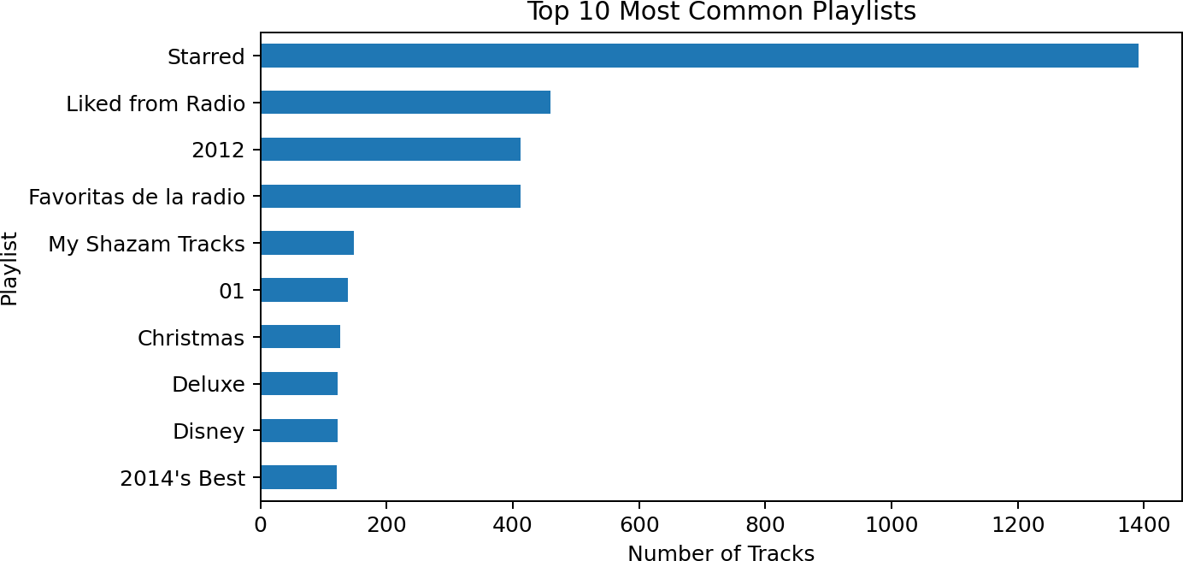

Figure 1: Top 10 most common playlists

Selected Audio Features
The recommendation system explores the distribution of all nine selected features using histograms. The features describe different aspects of a track, including rhythmic character, intensity, vocal content, acoustic character, live performance characteristics, mood and tempo.
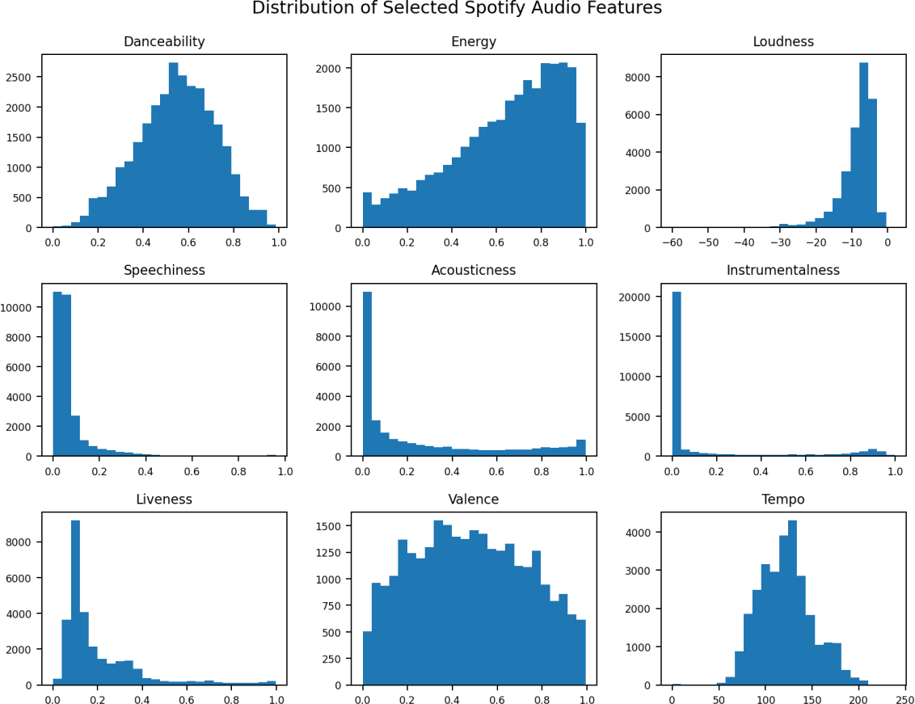

Figure 2: Distribution of the nine selected Spotify audio features

Recommendation Results
The recommendation function was executed for all 250 users. Each user received 10 ranked candidate tracks, resulting in 2,500 rows in the exported recommendation dataset. The CSV contains five fields: user_id, recommendation_rank, trackname, artistname and recommendation_score.

Output measure | Observed result
Users processed | 250
Recommendations per user | 10
Total recommendation rows | 2,500
Distinct track names in output | 1,778
Distinct artists in output | 1,150
Repeated user-track-artist combinations | 342

Example recommendations

Rank | Track | Artist | Score
1 | Divenire | Ludovico Einaudi | 0.980
2 | Divenire | Ludovico Einaudi | 0.980
3 | Divenire | Ludovico Einaudi | 0.980
4 | Divenire | Ludovico Einaudi | 0.980
5 | Mad World | Vitamin String Quartet | 0.980
6 | Brand New Angel | Jeff Bridges | 0.979
7 | Les professionnels | Air | 0.977
8 | Slow Walker | Béla Fleck and the Flecktones | 0.976
9 | New-York | Alexandra Streliski | 0.975
10 | Once Upon A Time | Tugores | 0.974
The above records are taken from the first user represented in the uploaded recommendations CSV. The user identifier is not reproduced in the report. The list is illustrative of the output format; it is not a human-rated relevance assessment.

Top Artists
The source dataset contains 6,185 unique artists. The most frequently occurring artists in the dataset are shown in Figure 3.
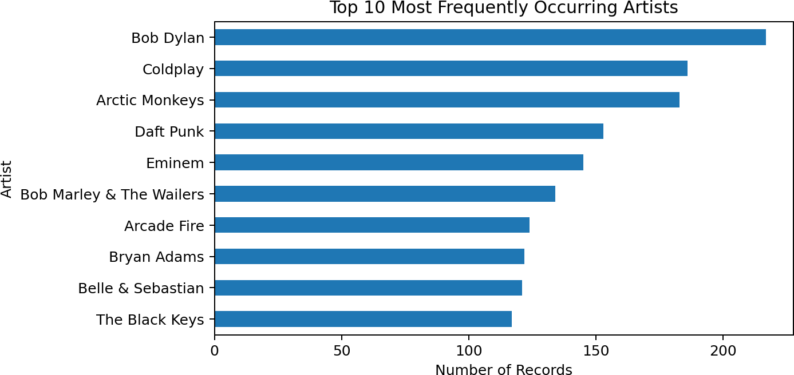

Figure 3: Top 10 most frequently occurring artists in the source dataset

CHAPTER 8: GRAPHICAL RESULTS AND INTERPRETATION

Recommendation Score Distribution
The saved recommendations have a mean score of 0.9369, a maximum of 0.9990 and a minimum of 0.7140. The median score is 0.9490. Most recommendation scores are concentrated toward the higher end of the observed range.
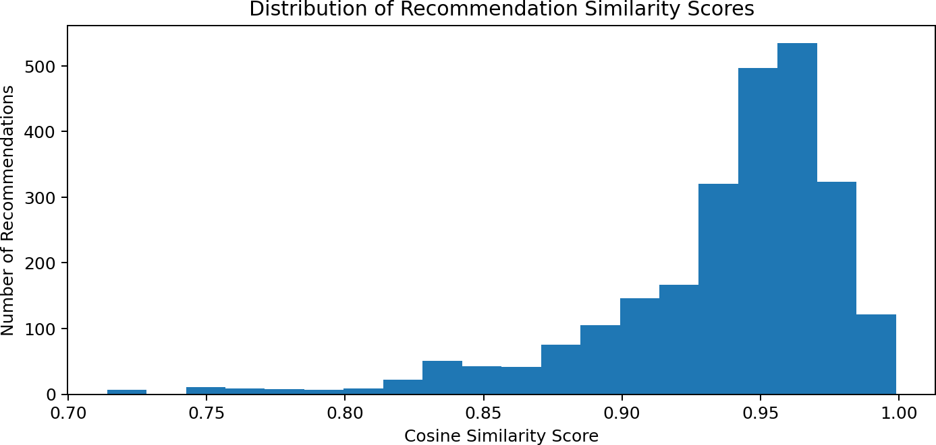

Figure 4: Distribution of cosine-similarity recommendation scores

Interpretation of the Score
The score distribution indicates that many recommended tracks have feature vectors that are directionally similar to their corresponding average user profiles. A high score is evidence of audio-feature similarity within this calculation. It does not establish that the listener will like the track, nor does it show that the system is more accurate than another recommendation method.

Sample User Recommendations
For the first user in the recommendation output, the mean similarity score of the first five ranked recommendations is 0.9800. This is a descriptive score calculated from the saved output.

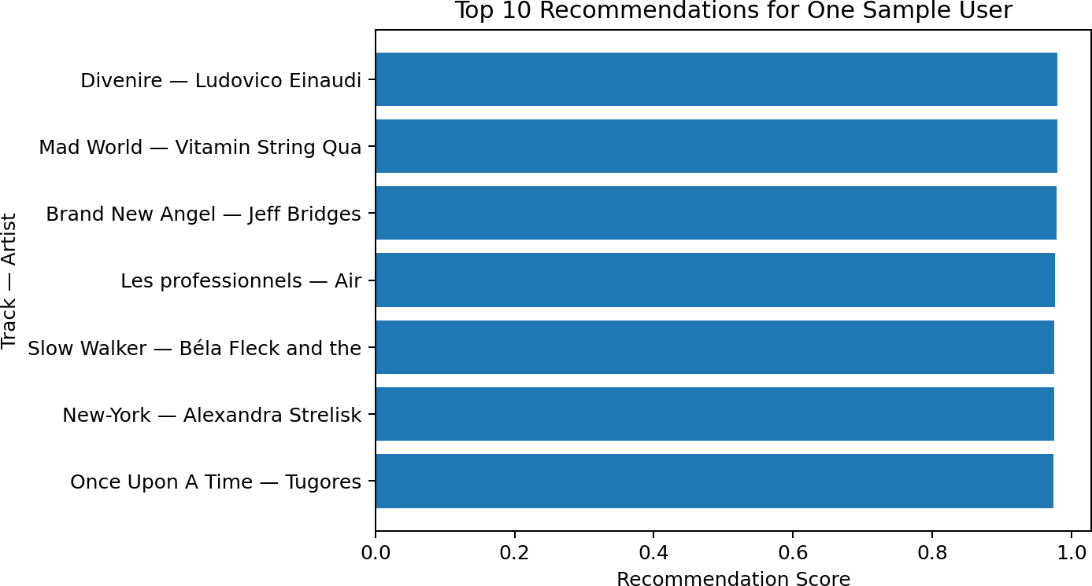

Figure 5: Top 10 recommendations for one sample user

CHAPTER 9: APPLICATIONS, LIMITATIONS AND FUTURE ENHANCEMENTS

Potential Applications
    - Personalized music discovery based on a listener's existing music history.
    - Creation of suggested listening queues using audio-feature similarity.
    - Exploration of tracks with similar musical characteristics.
    - Prototype recommendation support for music libraries and streaming applications.

Limitations
    - The system operates only on the supplied static dataset and is not connected to a live Spotify account or API.
    - The user profile is an average of the user's standardized audio features and may not represent multiple listening contexts.
    - Only nine audio features are used in the similarity calculation; genre, lyrics, artist relationships and explicit user feedback are not incorporated.
    - The recommendation score is a similarity measure, not accuracy, precision or user satisfaction.
    - Repeated track records can appear in the candidate list because the current user recommendation function does not deduplicate tracks before selecting the Top 10.
    - The notebook computes a 28,469 × 28,469 similarity matrix, which requires memory proportional to the square of the number of records.

Future Enhancements
    - Deduplicate tracks using song_id or id before ranking recommendations.
    - Add a hybrid model combining content-based similarity with collaborative filtering.
    - Include genre, artist, release year, language or other available metadata.
    - Use feedback such as likes, skips and playlist additions to personalize recommendations.
    - Evaluate using a chronological test split and ranking metrics such as Precision@K, Recall@K and NDCG@K.
    - Optimize similarity search using nearest-neighbour indexing rather than storing a full pairwise matrix for larger datasets.
    - Develop a simple web interface to accept a user or seed track and display recommendations.

CHAPTER 10: CONCLUSION
This project demonstrates the development of a Spotify music recommendation system using content-based filtering and cosine similarity. The supplied dataset contains 28,469 records associated with 250 users, 21,454 unique track names, 6,185 artists and 1,078 playlists. After preprocessing, nine audio features are standardized and used to represent tracks.
The system builds an average audio-feature profile for each user and compares this profile with candidate tracks using cosine similarity. It generates 10 recommendations for each of the 250 users and exports 2,500 recommendation rows. The overall mean recommendation score is 0.9369.
The project provides practical experience in data preprocessing, exploratory analysis, feature scaling, similarity computation and recommendation generation. The results show that audio-feature similarity can be used to produce ranked music suggestions. However, the current scores do not measure user satisfaction or recommendation accuracy. Deduplication, user-feedback collection and ranking-based evaluation are important next steps.

REFERENCES
- Spotify for Developers, “Get Track’s Audio Features” (audio feature concepts and metadata documentation). https://developer.spotify.com/documentation/web-api/reference/get-audio-features
- Scikit-learn, “StandardScaler.” https://scikit-learn.org/stable/modules/generated/sklearn.preprocessing.StandardScaler.html
- Scikit-learn, “cosine_similarity.” https://scikit-learn.org/stable/modules/generated/sklearn.metrics.pairwise.cosine_similarity.html
- Pandas, “DataFrame.” https://pandas.pydata.org/docs/reference/api/pandas.DataFrame.html
- Matplotlib, “Matplotlib Documentation.” https://matplotlib.org/stable/
- Jupyter, “Project Jupyter Documentation.” https://docs.jupyter.org/

