Assignment: Flask and MongoDB
Name: Deekshith
GitHub Repository: https://github.com/Deekshith1009/Flask_and_MongoDB_Deekshith.git

Task 1: JSON API Route
Task:
Create a Flask application with an /api route. When this route is accessed, it should return a JSON list. The data should be stored in a backend file, read from it, and sent as a response.
Command:
python app.py (run inside the backend folder)
Code Screenshot (backend/app.py):
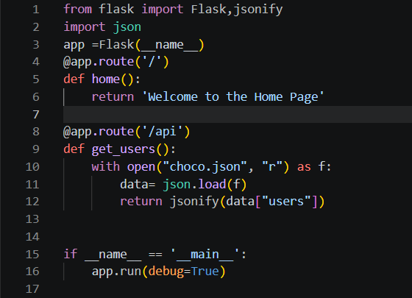
Backend Data File (choco.json):
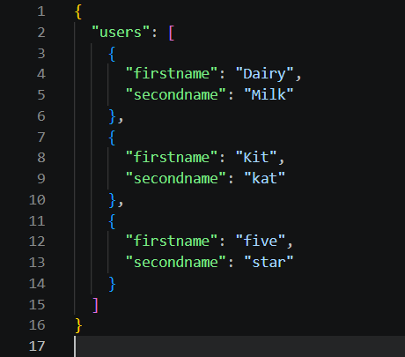
Output Screenshot (http://127.0.0.1:5000/api):
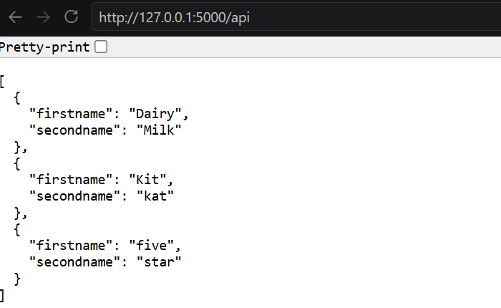
Explanation:
A Flask app is created with two routes. The /api route opens the backend file choco.json, reads it with json.load(), and picks the list stored under the "users" key. It then returns the list as a JSON response using jsonify(). Visiting /api in the browser displays the JSON list of three chocolates (Dairy Milk, Kit Kat, Five Star).

Task 2: Frontend Form with MongoDB Atlas
Task:
Create a form on the frontend that, when submitted, inserts data into MongoDB Atlas. On success, the user is redirected to another page displaying "Data submitted successfully". On error, the error is displayed on the same page without redirection.
Command:
python app.py (run inside the frontend folder)
Project Structure:
Flask_and_MongoDB_Deekshith/
.env (MongoDB connection string, not uploaded to GitHub)
.gitignore
backend/
app.py
choco.json
frontend/
app.py
templates/
index.html
success.html
Source Code (frontend/app.py):
import os
from pathlib import Path
from dotenv import load_dotenv
from flask import Flask, render_template, request, redirect, url_for
from pymongo import MongoClient
from pymongo.errors import PyMongoError

# Load .env from the project root (one folder above frontend)
ENV_PATH = Path(__file__).resolve().parent.parent / ".env"
load_dotenv(ENV_PATH, override=True, encoding="utf-8-sig")

MONGO_URL = os.getenv("MONGO_URL")
if not MONGO_URL:
raise RuntimeError(f"MONGO_URL is missing. Looked for: {ENV_PATH} (file exists: {ENV_PATH.exists()})")

app = Flask(__name__)

# Connection: client -> database -> collection
client = MongoClient(MONGO_URL, serverSelectionTimeoutMS=5000)
db = client["flask_and_mongodb"]
collection = db["users"]

@app.route("/", methods=["GET", "POST"])
def index():
if request.method == "POST":
name = request.form.get("name", "").strip()
email = request.form.get("email", "").strip()
message = request.form.get("message", "").strip()

# Basic validation: show the error on the same page
if not name or not email:
return render_template(
"index.html",
error="Name and email are required.",
name=name, email=email, message=message,
)

try:
collection.insert_one({"name": name, "email": email, "message": message})
except PyMongoError as e:
# Error: stay on the same page and show the error (no redirect)
return render_template(
"index.html",
error=f"Could not save your data: {e}",
name=name, email=email, message=message,
)

# Success: redirect to another page
return redirect(url_for("success"))

return render_template("index.html", error=None, name="", email="", message="")

@app.route("/success")
def success():
return render_template("success.html")

if __name__ == "__main__":
app.run(debug=True)

Form Template (templates/index.html):
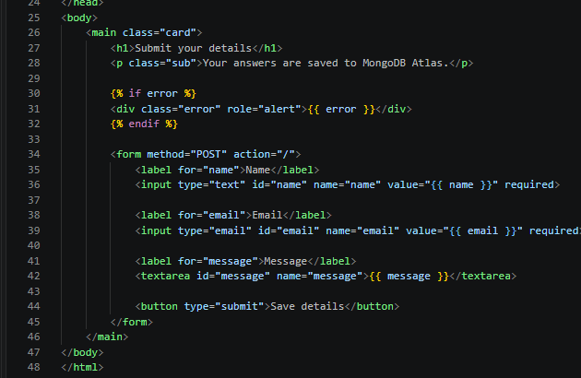
Success Template (templates/success.html):
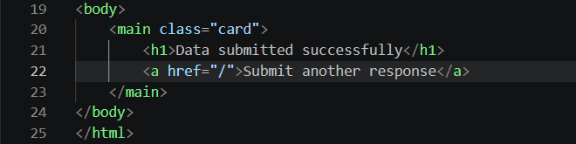

Output 1: The form page
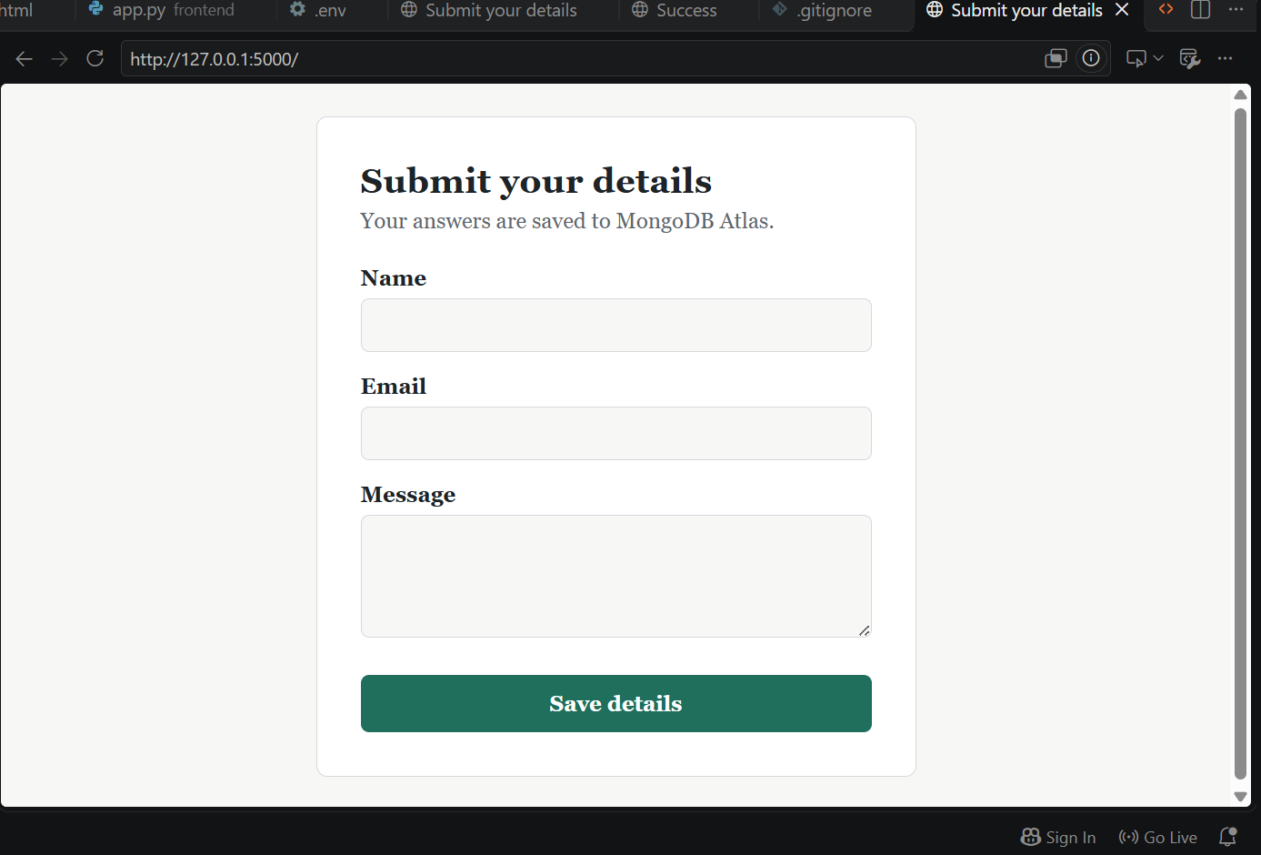
Output 2: Success page after submitting (terminal shows POST / 302, then GET /success 200)
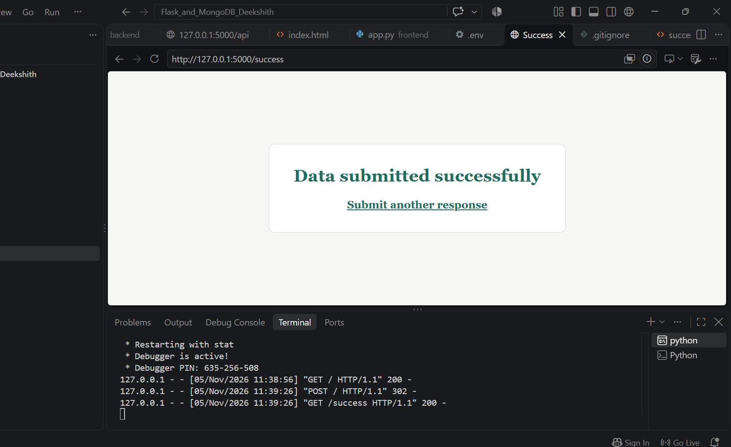

Output 3: Data stored in MongoDB Atlas (flask_and_mongodb > users)
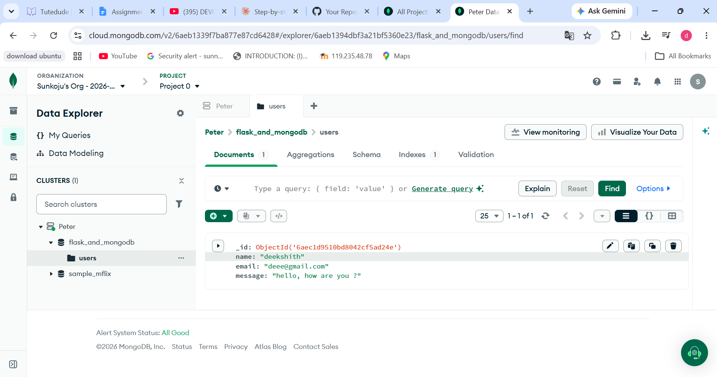
Output 4: Error displayed on the same page (no redirect, URL stays at /)
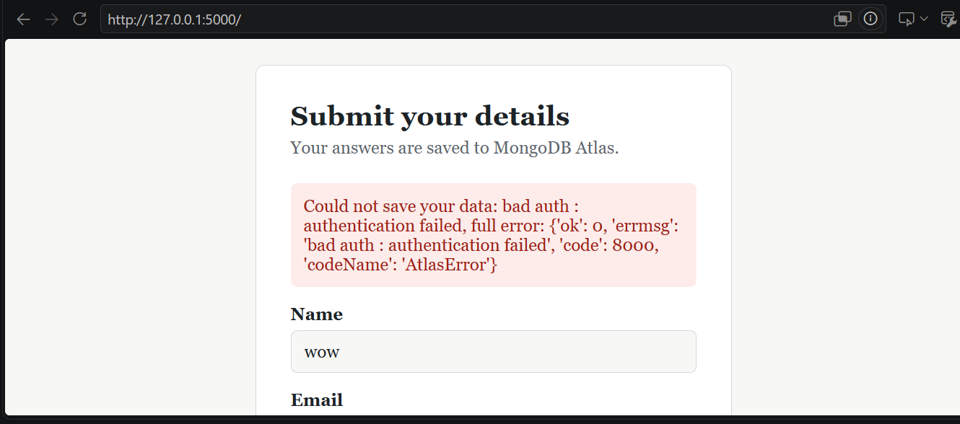
Explanation:
The connection string is stored in a .env file and loaded with python-dotenv, so the password is not written in the code. MongoClient connects to Atlas, db selects the database flask_and_mongodb and collection selects users.
The route "/" accepts GET and POST. A GET request shows the empty form. When the form is submitted (POST), the values are read with request.form and saved with insert_one(). If the insert succeeds, the user is redirected with redirect(url_for("success")) to the /success page, which shows "Data submitted successfully". If the insert fails, a PyMongoError is caught and index.html is rendered again with the error message, so the error appears on the same page without a redirect. The error case was tested with a wrong password, which produced an "authentication failed" message in the red box.

