Assignment 1: Linux Basics
Name: Deekshith
GitHub Repository: https://github.com/Deekshith1009/Linux_Basics_Deekshith.git

Task 1: Creating and Renaming Files/Directories
Commands:
mkdir test_dir
cd test_dir
touch example.txt
mv example.txt renamed_example.txt
ls
Screenshot:
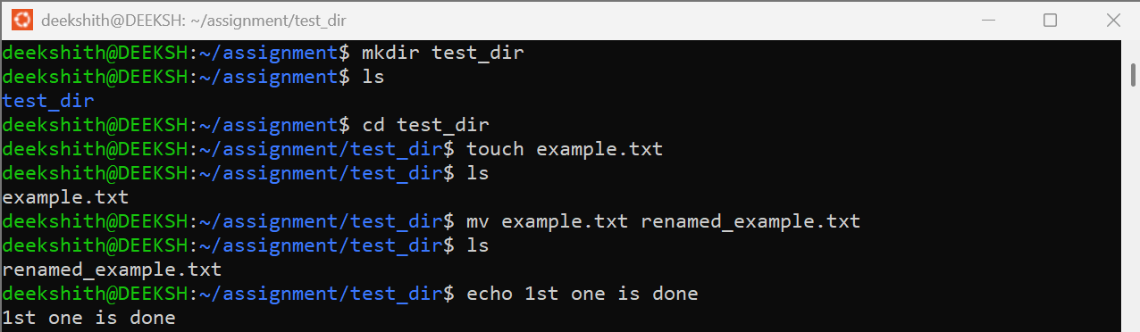
Explanation:
mkdir creates a new directory named test_dir. cd moves into it. touch creates an empty file called example.txt. mv renames example.txt to renamed_example.txt (mv moves or renames a file). ls lists the folder contents after each step to confirm the result.

Task 2: Viewing File Contents
Commands:
cat /etc/passwd
head /etc/passwd -n 5
tail /etc/passwd -n 5
Screenshot:
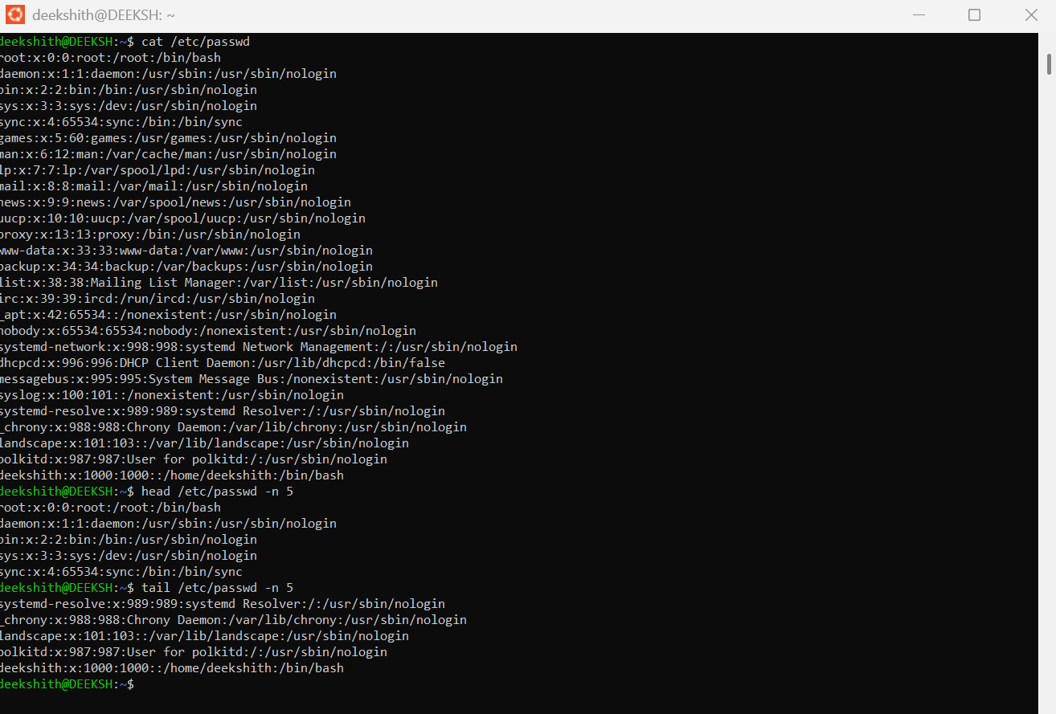
Explanation:
cat prints the entire contents of /etc/passwd, which lists the user accounts on the system. head -n 5 displays only the first 5 lines of the file. tail -n 5 displays only the last 5 lines of the file.

Task 3: Searching for Patterns
Commands:
cat /etc/passwd | grep root -n
Screenshot:
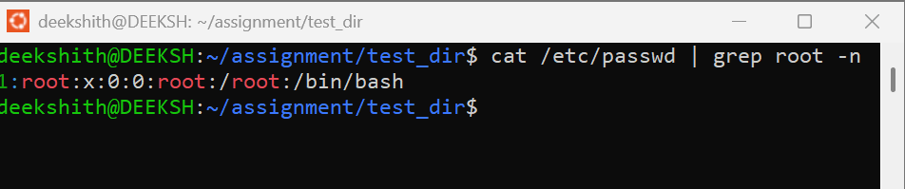
Explanation:
The pipe (|) sends the output of cat /etc/passwd into grep, which searches for lines containing "root". The -n option prints the line number, so the output shows that the root entry is on line 1.

Task 4: Zipping and Unzipping
Commands:
zip -r test_dir.zip test_dir
rm -r test_dir
unzip test_dir.zip
ls
Screenshot:
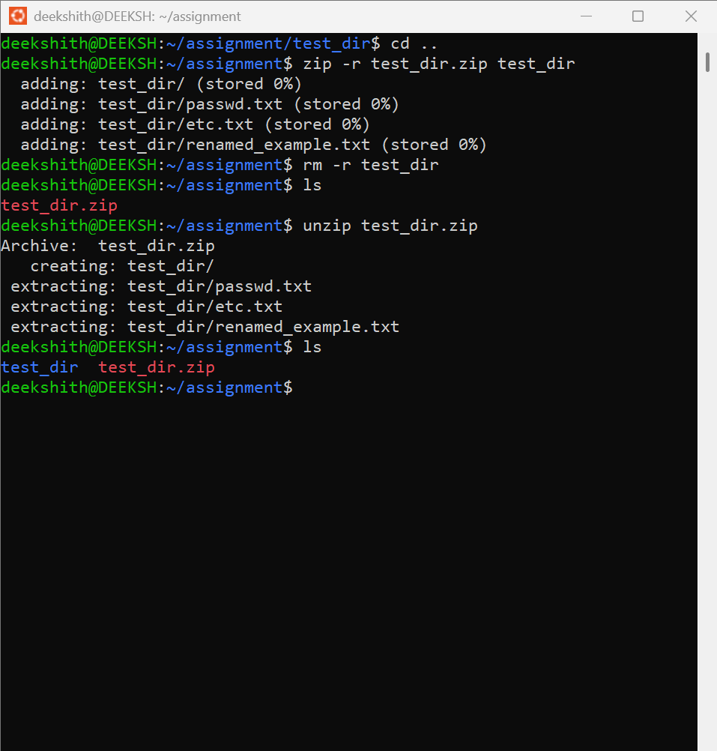
Explanation:
zip -r compresses the test_dir folder (and everything inside it) into test_dir.zip. rm -r deletes the original folder. unzip extracts the archive and restores test_dir with all its files, which ls confirms.

Task 5: Downloading Files
Commands:
wget https://www.linux.com/what-is-linux/
Screenshot:
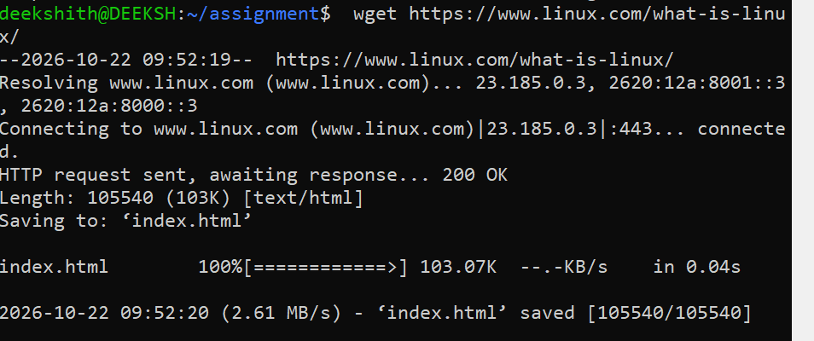
Explanation:
wget is a command-line tool that downloads files from a URL. It resolved the host, connected over HTTPS, received a 200 OK response and saved the page as index.html in the current directory.

Task 6: Changing Permissions
Commands:
chmod 444 secure.txt
ls -l secure.txt
Screenshot:
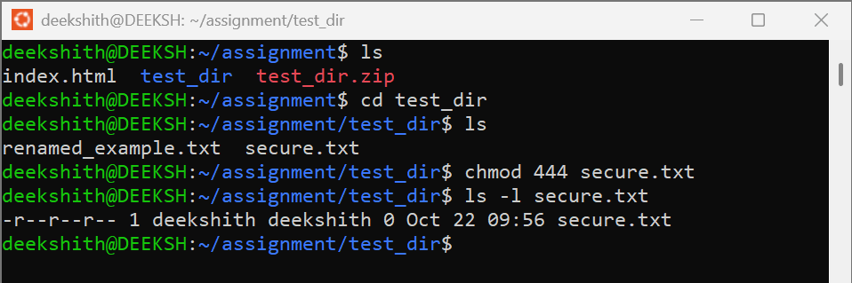
Explanation:
chmod 444 sets secure.txt to read-only for the owner, the group and everyone else (4 = read, 2 = write, 1 = execute; the three digits are owner, group, others). ls -l shows the permissions as -r--r--r--, confirming that no one has write access.

Task 7: Working with Environment Variables
Commands:
export MY_VAR="Hello, Linux!"
echo $MY_VAR
Screenshot:
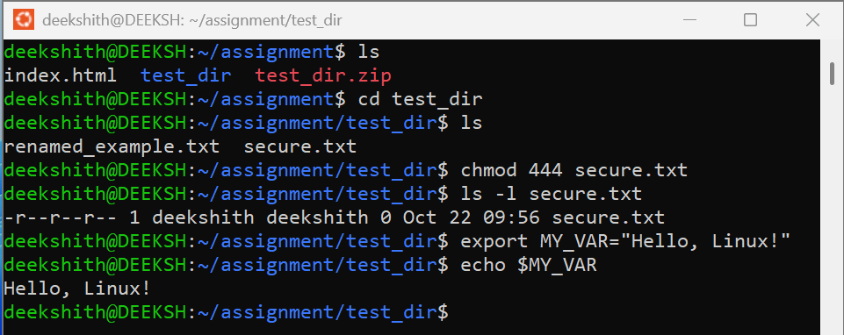
Explanation:
export creates an environment variable named MY_VAR and makes it available to the shell and the programs it starts. echo $MY_VAR prints the value stored in the variable.

