Assignment: Python Programming
Name: Deekshith
Objective: Practise core Python programming (conditionals, dictionaries and file handling).
GitHub Repository: https://github.com/Deekshith1009/Python_and_Bash_Deekshith.git

Task 1: Grade Checker
Command:
python Grade_Checker.py
Source Code:
std=int(input("Enter Score: "))
if std >= 90:
print("A Grade")
elif std >= 80:
print("B Grade")
elif std >= 70:
print("C Grade")
elif std >= 60:
print("D Grade")
elif std < 60:
print("F Grade")
else:
print("Give a Valid Number")
Screenshot (code and output):
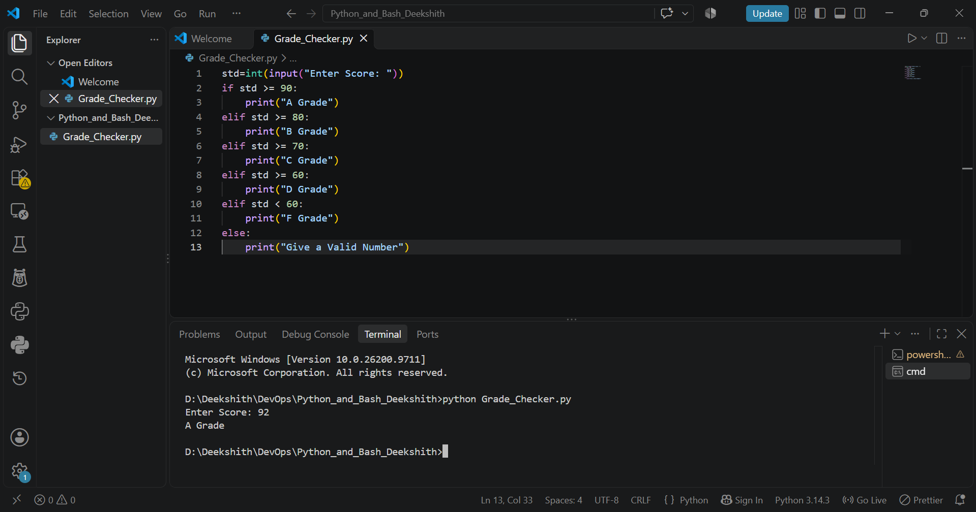
Explanation:
The program takes a score as input and uses an if / elif / else chain to print the grade: 90 and above is A, 80-89 is B, 70-79 is C, 60-69 is D and below 60 is F. For the input 92, the output is "A Grade".

Task 2: Student Grades (Dictionary)
Command:
python Student_Grades.py
Code Screenshot:
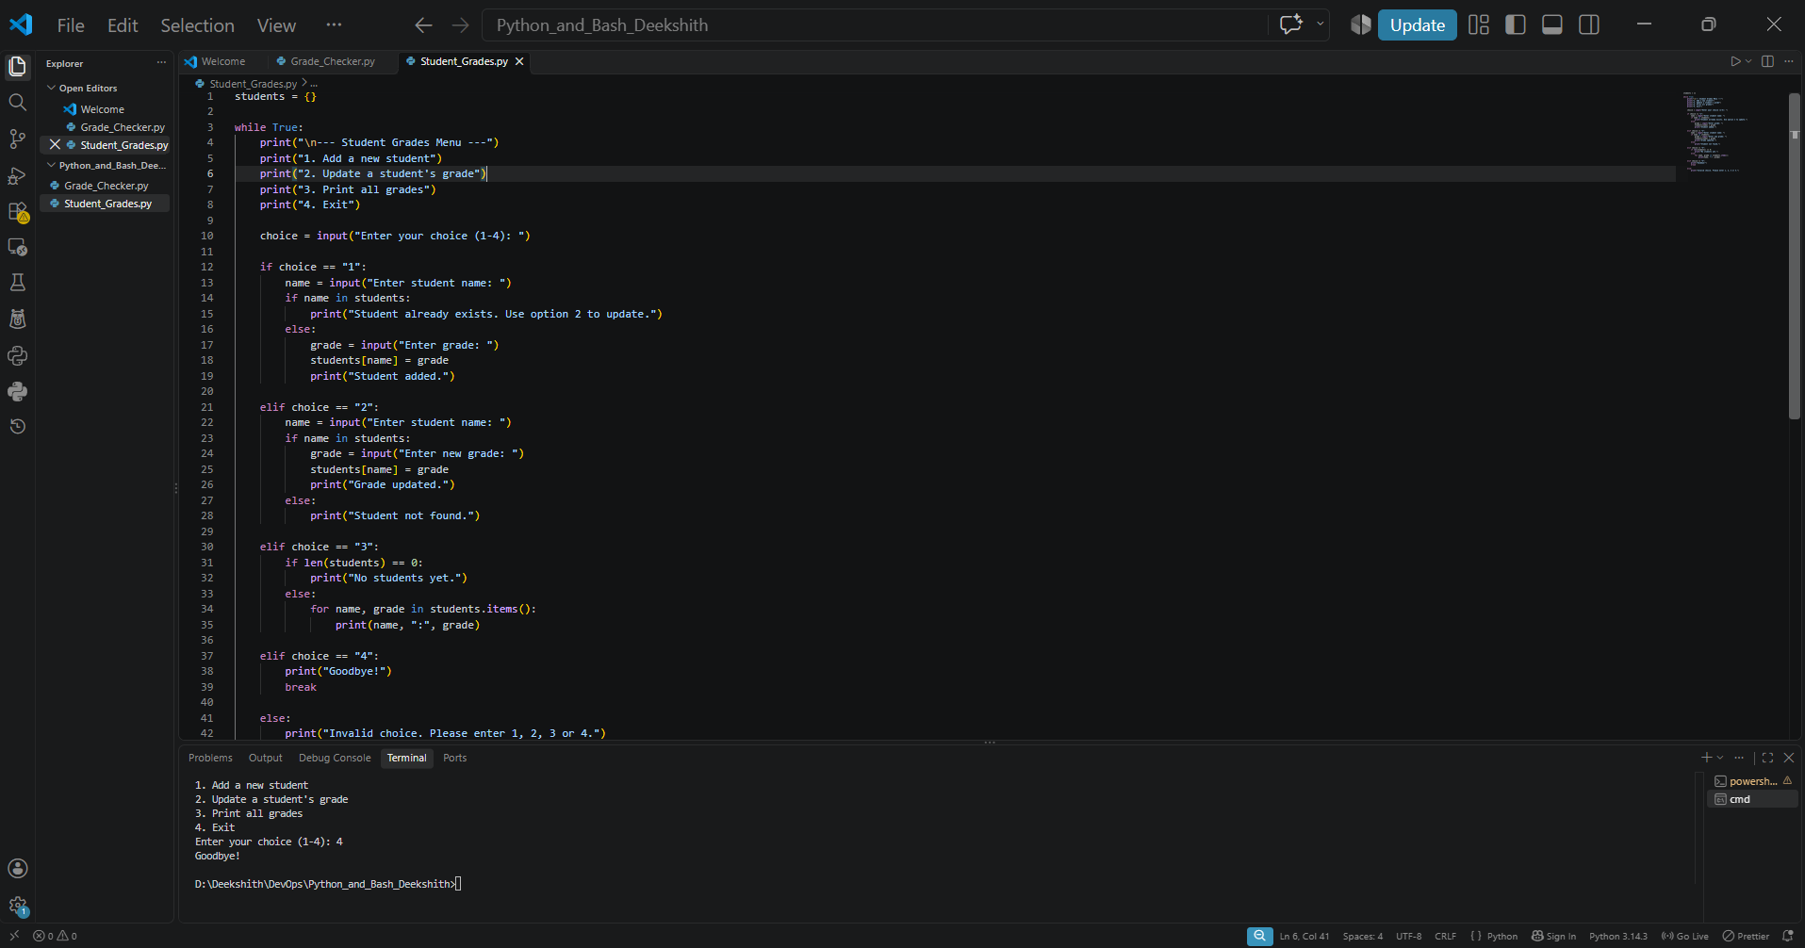

Output Screenshot:
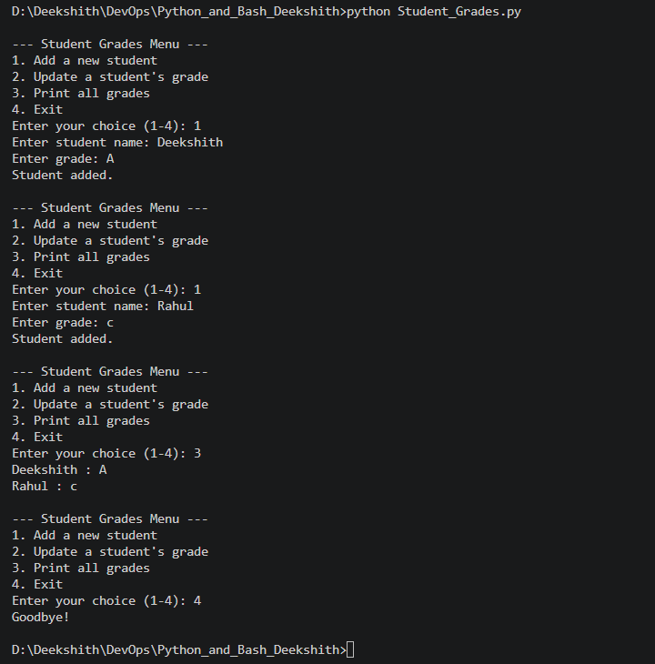
Explanation:
A dictionary named students stores each student name as the key and the grade as the value. A while loop shows a menu until the user chooses Exit. Option 1 adds a new student (if the name is not already present), option 2 updates the grade of an existing student, option 3 prints all names and grades using students.items(), and option 4 exits with break. if / elif / else statements handle each menu choice and invalid input. In the output, Deekshith (A) and Rahul (c) are added and then printed.

Task 3: Write to a File
Command:
python file1.py
Source Code:
file = open("student_notes.txt", "w")
file.write("Hello, this is my first file.\n")
file.write("I am learning Python and Bash.\n")
file.close()

print("File created and content written.")
Screenshot (code and output):
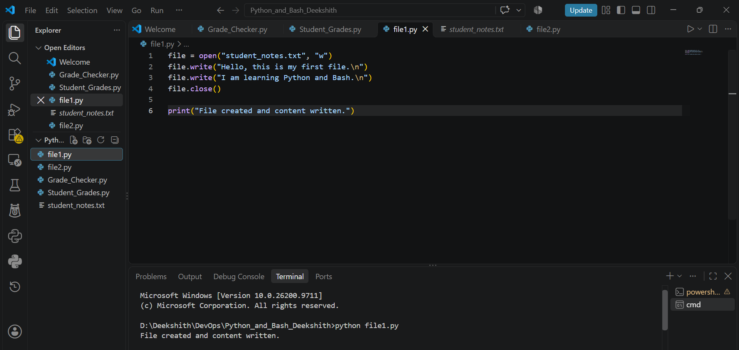
Created file (student_notes.txt):
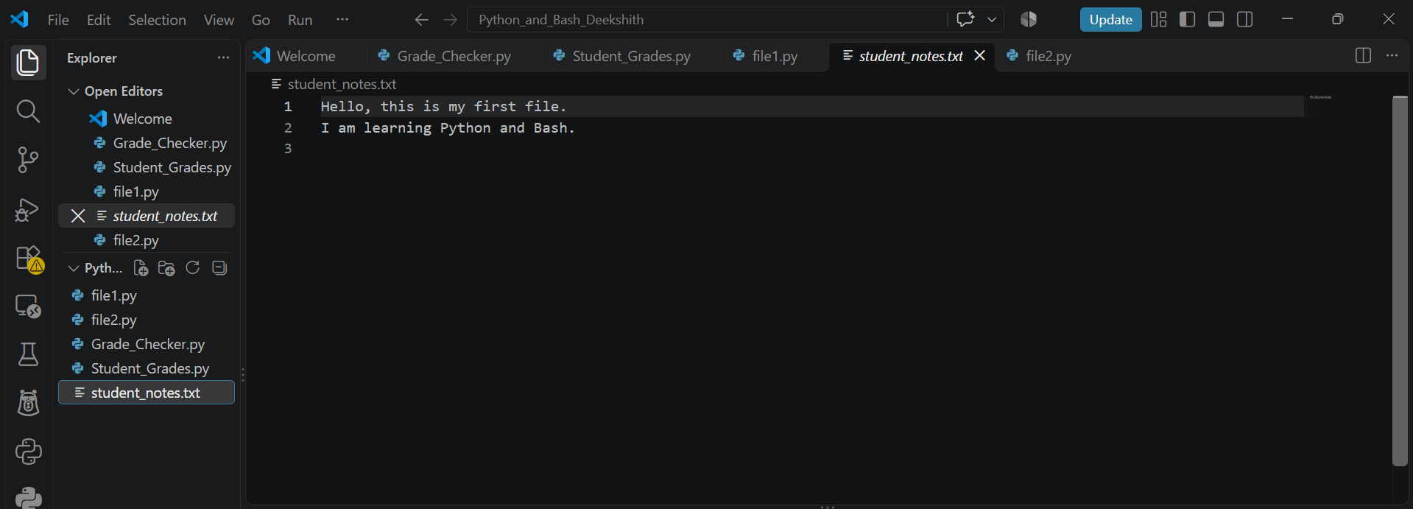
Explanation:
open("student_notes.txt", "w") opens the file in write mode and creates it if it does not exist. file.write() writes each line into the file, with \n adding a new line. file.close() closes the file so the content is saved. The program prints a confirmation message, and the created student_notes.txt contains the two lines that were written.

Task 4: Read from a File
Command:
python file2.py
Source Code:
file = open("student_notes.txt", "r")
content = file.read()
print(content)
file.close()
Screenshot (code and output):
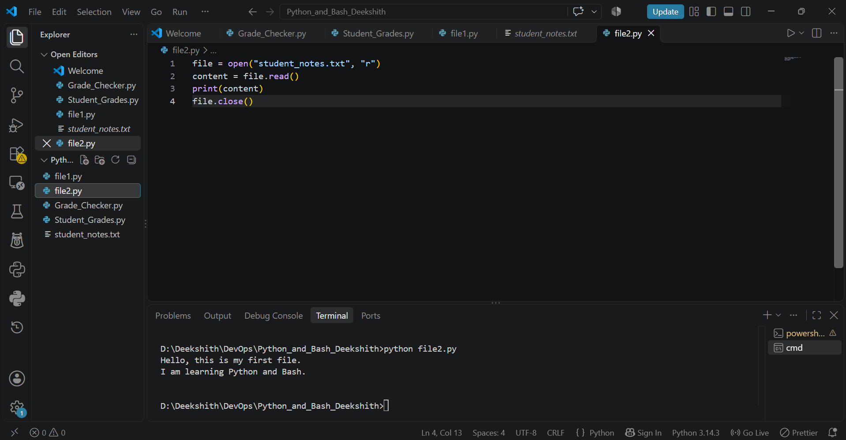
Explanation:
open("student_notes.txt", "r") opens the file created in Task 3 in read mode. file.read() reads the whole content into the variable content, print(content) displays it on the screen, and file.close() closes the file. The output shows the two lines that were written in Task 3.

